**DAILY ONLINE ACTIVITIES SUMMARY**

|  |  |  |  |  |  |  |  |  |
| --- | --- | --- | --- | --- | --- | --- | --- | --- |
| **Date:** | **22 June 2020** | | | | | **Name:** | **Keertana Ganesh Ganiga** | |
| **Sem & Sec** | **4th sem, 2nd year** | | | | | **USN:** | **4al18cs036** | |
| **Online Test Summary** | | | | | | | | |
| **Subject** | | **----------------** | | | | | | |
| **Max. Marks** | | **----** | | **Score** | | | **-----** | |
| **Certification Course Summary** | | | | | | | | |
| **Course** | **Cloud Computing with AWS** | | | | | | | |
| **Certificate Provider** | | | **GreatLearning** | | **Duration** | | | **12 hours** |
| **Coding Challenges** | | | | | | | | |
| **Problem Statement:1 program** | | | | | | | | |
| **Status: Executed** | | | | | | | | |
| **Uploaded the report in Github** | | | | | **Yes** | | | |
| **If yes Repository name** | | | | | <https://github.com/keertanaganiga/Lockdown_coding>  <https://github.com/keertanaganiga/Lockdown_certification>  <https://github.com/keertanaganiga/lockdown_reports> | | | |
| **Uploaded the report in slack** | | | | | **Yes** | | | |

#### *Certification Course Summary:*

#### Today I started new course Cloud Computing with AWS in Great Learning which is of 12 hrs. After the completion of course, certificate will be provided.

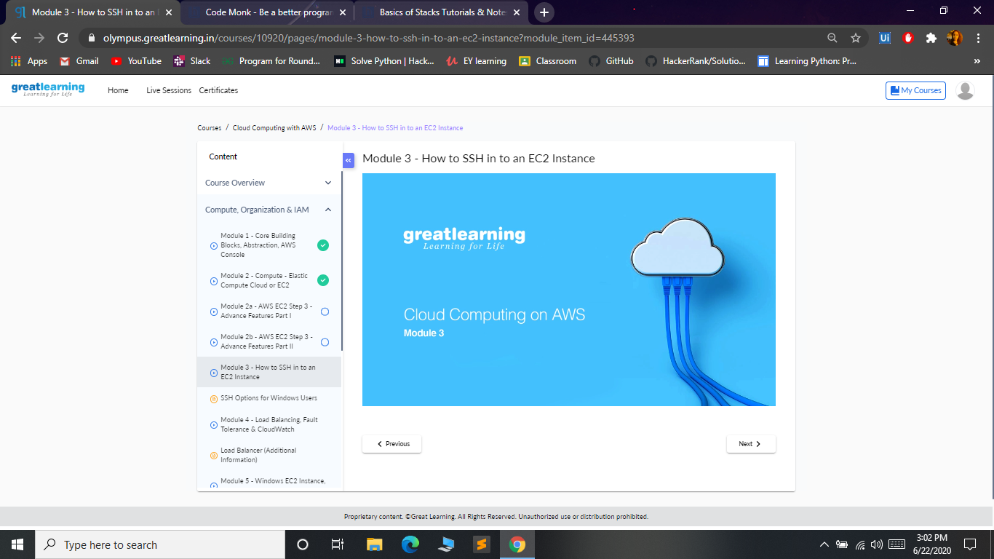

***Coding Challenges:***

Today I solved 1 coding challenge,

1. **Write a Java Program for Modular Exponentiation**

Given three numbers x, y and p, compute (xy) % p.  
Input: x = 2, y = 3, p = 5  
Output: 3  
Explanation: 2^3 % 5 = 8 % 5 = 3.

Input: x = 2, y = 5, p = 13  
Output: 6  
Explanation: 2^5 % 13 = 32 % 13 = 6.

