**DAILY ONLINE ACTIVITIES SUMMARY**

|  |  |  |  |  |  |  |  |  |
| --- | --- | --- | --- | --- | --- | --- | --- | --- |
| **Date:** | **24 July 2020** | | | | | **Name:** | **Keertana Ganesh Ganiga** | |
| **Sem & Sec** | **4th sem, 2nd year** | | | | | **USN:** | **4al18cs036** | |
| **Online Test Summary** | | | | | | | | |
| **Subject** | | **---** | | | | | | |
| **Max. Marks** | | **--** | | **Score** | | | **---** | |
| **Certification Course Summary** | | | | | | | | |
| **Course** | Python Data Structure | | | | | | | |
| **Certificate Provider** | | | **Coursera** | | **Duration** | | | **19 hrs** |
| **Coding Challenges** | | | | | | | | |
| **Problem Statement: python program** | | | | | | | | |
| **Status: executed** | | | | | | | | |
| **Uploaded the report in Github** | | | | | **Yes** | | | |
| **If yes Repository name** | | | | | <https://github.com/keertanaganiga/Lockdown_coding>  <https://github.com/keertanaganiga/Lockdown_certification>  <https://github.com/keertanaganiga/lockdown_reports> | | | |
| **Uploaded the report in slack** | | | | | **Yes** | | | |

#### Online class: Today “How to develop Pythonic coding rather than Python coding” was conducted from 11:00-1:30 PM. Which contains two sessions. Today was the last session.

#### 

#### 

#### Certification Course Summary:

#### Today I continued new course in Coursera, Python Data Structure which is of 19 Hrs course.

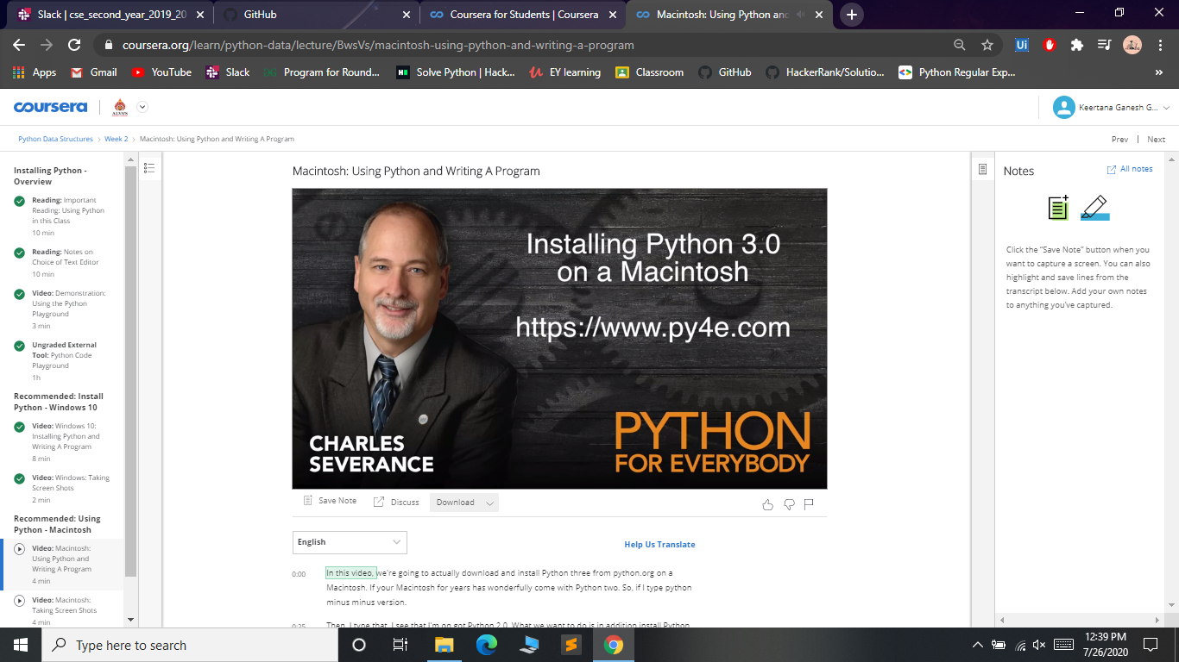

**Online coding:  
Today in python class python exsercise was given for practice.**

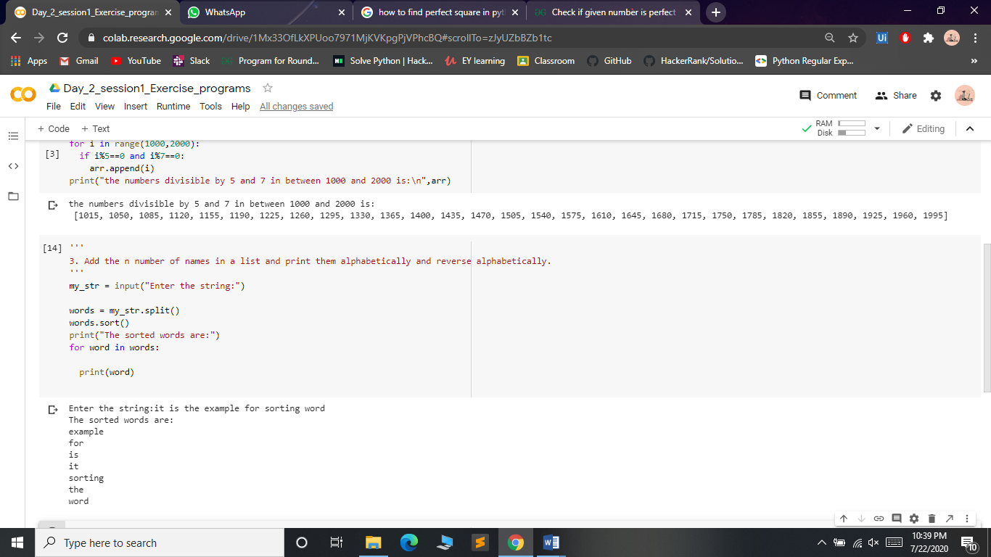

LINK I mentioned below:

<https://github.com/keertanaganiga/Python_Workshop>