**DAILY ONLINE ACTIVITIES SUMMARY**

|  |  |  |  |  |  |  |  |  |
| --- | --- | --- | --- | --- | --- | --- | --- | --- |
| **Date:** | **28 June 2020** | | | | | **Name:** | **Keertana Ganesh Ganiga** | |
| **Sem & Sec** | **4th sem, 2nd year** | | | | | **USN:** | **4al18cs036** | |
| **Online Test Summary** | | | | | | | | |
| **Subject** | | **-----** | | | | | | |
| **Max. Marks** | | **----** | | **Score** | | | **-----** | |
| **Certification Course Summary** | | | | | | | | |
| **Course** | **Machine learning with python** | | | | | | | |
| **Certificate Provider** | | | **GreatLearning** | | **Duration** | | | **10.5 hours** |
| **Coding Challenges** | | | | | | | | |
| **Problem Statement:2 program** | | | | | | | | |
| **Status: Executed** | | | | | | | | |
| **Uploaded the report in Github** | | | | | **Yes** | | | |
| **If yes Repository name** | | | | | <https://github.com/keertanaganiga/Lockdown_coding>  <https://github.com/keertanaganiga/Lockdown_certification>  <https://github.com/keertanaganiga/lockdown_reports> | | | |
| **Uploaded the report in slack** | | | | | **Yes** | | | |

#### *Certification Course Summary:*

#### Today I started new Machine learning with python in Great Learning which is of 10.5 hrs. After the completion of course, certificate will be provided.

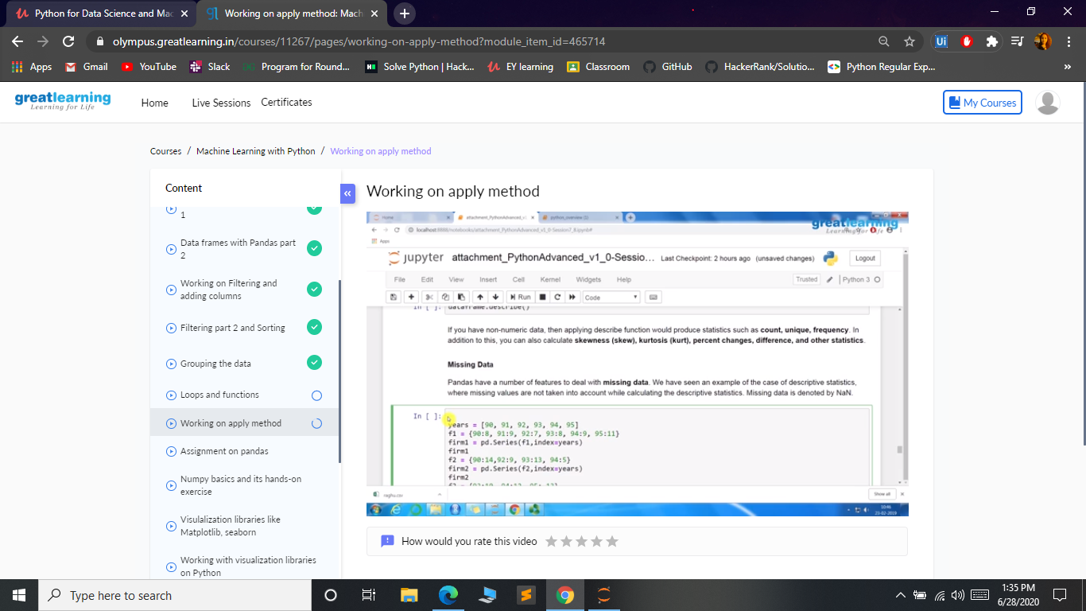

***Coding Challenges:***

Today I solved 2 coding challenge,

1. **Write a C++ program to find the sum of 2 integers using Pointers**

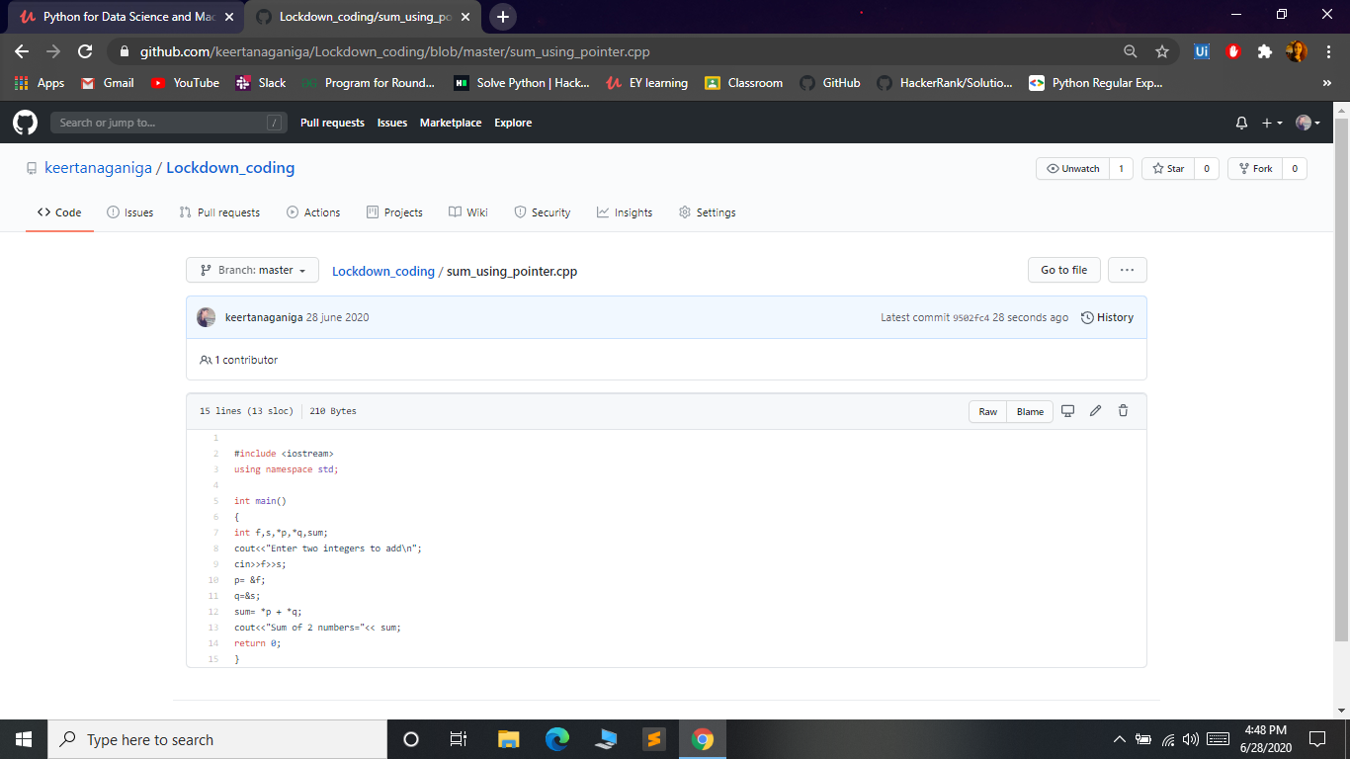

**2. Write a C++ program to enter the details of students and display them using class and object. The details should be private in nature and use public members function to access the private members. (Define the member function outside the class).**

