**DAILY ONLINE ACTIVITIES SUMMARY**

|  |  |  |  |  |  |  |  |  |
| --- | --- | --- | --- | --- | --- | --- | --- | --- |
| **Date:** | **28 may 2020** | | | | | **Name:** | **Keertana Ganiga** | |
| **Sem & Sec** | **4th sem, 2nd year** | | | | | **USN:** | **4AL18CS036** | |
| **Online Test Summary** | | | | | | | | |
| **Subject** | | **MICROCONTROLLER AND EMBEDDED SYSTEMS (18cs44)**  **And Adalitha Kannada** | | | | | | |
| **Max. Marks** | | **20(mes), 50(kannada)** | | **Score** | | | **17(mes) 33(kannada)** | |
| **Certification Course Summary** | | | | | | | | |
| **Course** | **Introduction to deep learning** | | | | | | | |
| **Certificate Provider** | | | **DataCamp** | | **Duration** | | | **4 HOURS** |
| **Coding Challenges** | | | | | | | | |
| **Problem:**  **1 program executed** | | | | | | | | |
| **Status: executed** | | | | | | | | |
| **Uploaded the report in GitHub** | | | | | **YES** | | | |
| **If yes Repository name** | | | | | <https://github.com/keertanaganiga/Lockdown_coding>  <https://github.com/keertanaganiga/Lockdown_certification>  <https://github.com/keertanaganiga/lockdown_reports> | | | |
| **Uploaded the report in slack** | | | | | **YES** | | | |

Online Test Summary:

**MICROCONTROLLER AND EMBEDDED SYSTEMS (18cs44) the test was from 2nd module of 20 marks at 11:30 Am.**

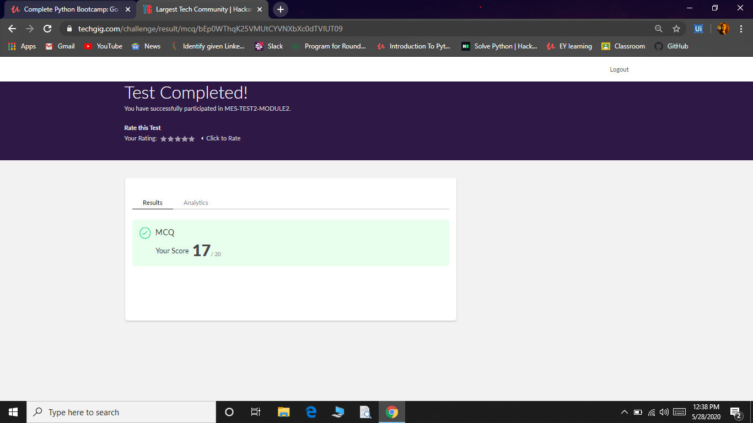

Today Adalitha kannada test was conducted for 50 marks at 2:00Pm for 50 minutes.

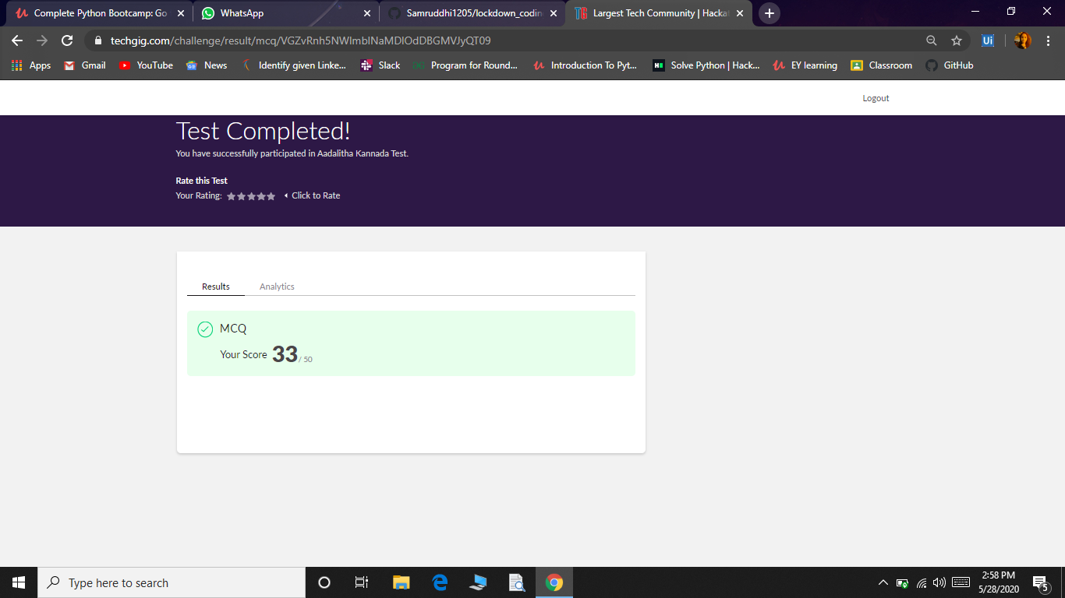

Online Certification course:

Today I started new course Introduction to Deep Learning in Python ,in DataCamp which is of $hours course.

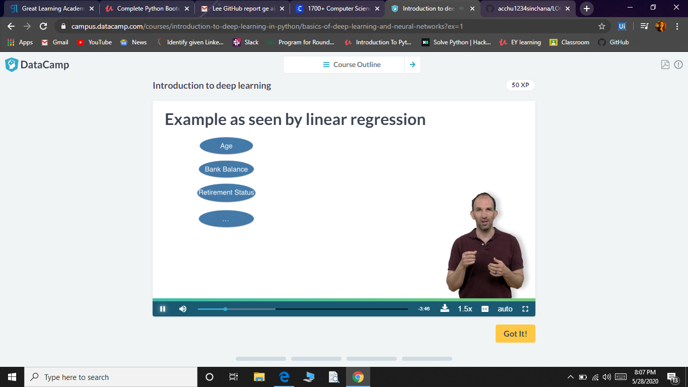

Online Coding summary:

**C program to find digital root of a number**.

1. Description:  
   A digital root is the recursive sum of all the digits in a number. Given n, take the sum of the digits of n. If that value has more than one digit, continue reducing in this way until a single-digit number is produced. This is only applicable to the natural numbers.  
   digit root (0) = 0
2. digital root (16)  
   => 1 + 6  
   => 7
3. digital root (132189)  
   => 1 + 3 + 2 + 1 + 8 + 9  
   => 24 ...  
   => 2 + 4  
   => 6

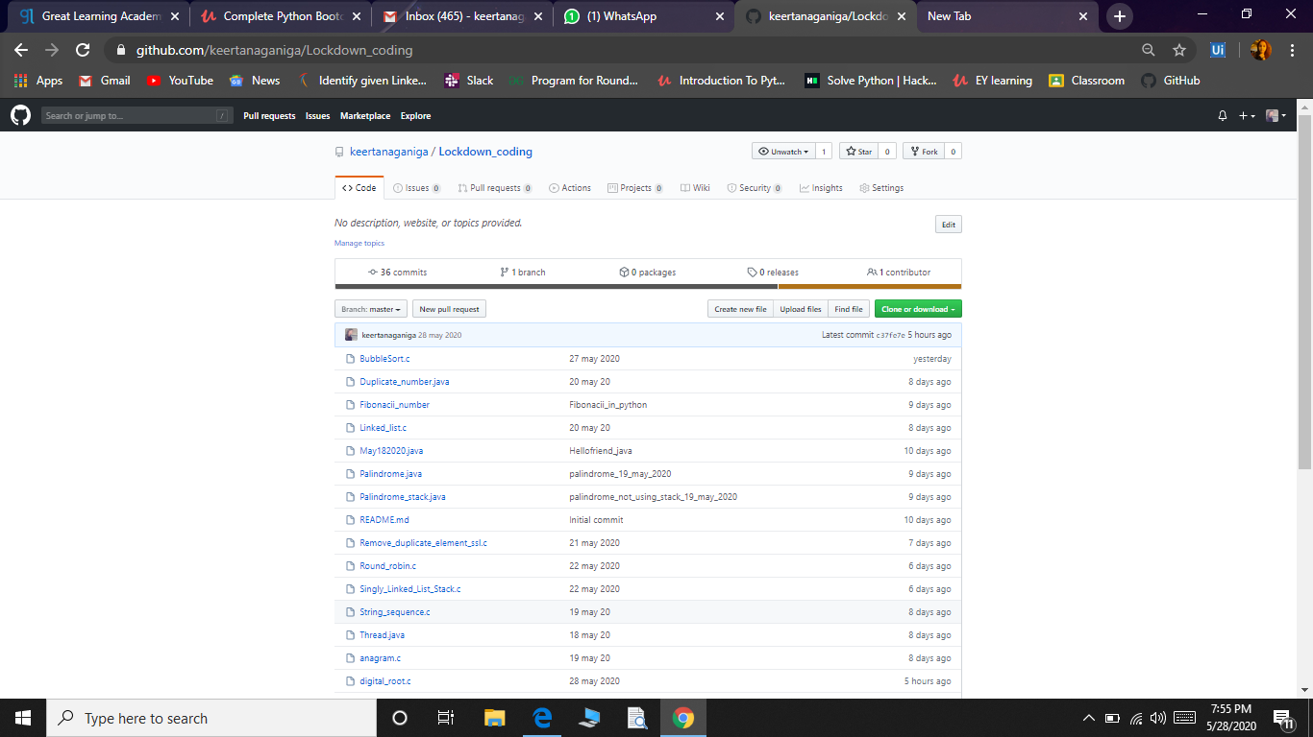

**Coding challenges:**

**I attended coding challenge in Hacker Rank today’s was day 9 program.**

