**DAILY ONLINE ACTIVITIES SUMMARY**

|  |  |  |  |  |  |  |  |  |
| --- | --- | --- | --- | --- | --- | --- | --- | --- |
| **Date:** | **29 July 2020** | | | | | **Name:** | **Keertana Ganesh Ganiga** | |
| **Sem & Sec** | **4th sem, 2nd year** | | | | | **USN:** | **4al18cs036** | |
| **Online Test Summary** | | | | | | | | |
| **Subject** | | **OPERATING SYSTEM** | | | | | | |
| **Max. Marks** | | **30** | | **Score** | | | **---** | |
| **Certification Course Summary** | | | | | | | | |
| **Course** | Python Data Structure | | | | | | | |
| **Certificate Provider** | | | **Coursera** | | **Duration** | | | **19 hrs** |
| **Coding Challenges** | | | | | | | | |
| **Problem Statement: python program** | | | | | | | | |
| **Status: executed** | | | | | | | | |
| **Uploaded the report in Github** | | | | | **Yes** | | | |
| **If yes Repository name** | | | | | <https://github.com/keertanaganiga/Lockdown_coding>  <https://github.com/keertanaganiga/Lockdown_certification>  <https://github.com/keertanaganiga/lockdown_reports> | | | |
| **Uploaded the report in slack** | | | | | **Yes** | | | |

#### Online Test: Today OPERATING SYSTEM was conducted for 30 marks from 9:30-10:20 AM.

#### Certification Course Summary:

#### Today I continued new course in Coursera, Python Data Structure which is of 19 Hrs course.

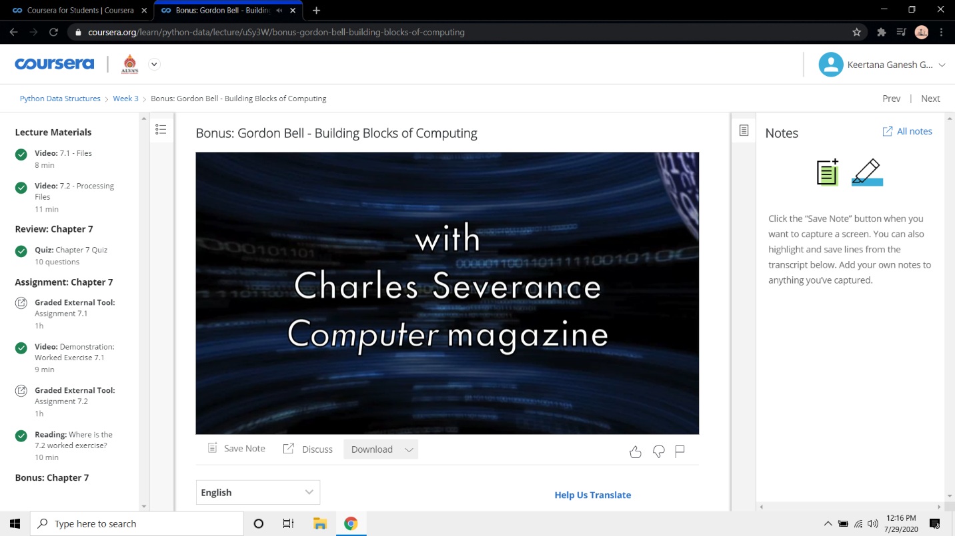

**Online coding:***In this challenge, the user enters a string and a substring. You have to print the number of times that the substring occurs in the given string. String traversal will take place from left to right, not from right to left.*

*NOTE: String letters are case-sensitive.*

*Input Format:*

*The first line of input contains the original string. The next line contains the substring.*

*Output Format:*

*Output the integer number indicating the total number of occurrences of the substring in the original string.*

*Sample Input:*

*ABCDCDC*

*CDC*

*Sample Output:*

*2*

