**DAILY ONLINE ACTIVITIES SUMMARY**

|  |  |  |  |  |  |  |  |  |
| --- | --- | --- | --- | --- | --- | --- | --- | --- |
| **Date:** | **29 June 2020** | | | | | **Name:** | **Keertana Ganesh Ganiga** | |
| **Sem & Sec** | **4th sem, 2nd year** | | | | | **USN:** | **4al18cs036** | |
| **Online Test Summary** | | | | | | | | |
| **Subject** | | **-----** | | | | | | |
| **Max. Marks** | | **----** | | **Score** | | | **-----** | |
| **Certification Course Summary** | | | | | | | | |
| **Course** | **Machine learning with python** | | | | | | | |
| **Certificate Provider** | | | **GreatLearning** | | **Duration** | | | **10.5 hours** |
| **Coding Challenges** | | | | | | | | |
| **Problem Statement:1 program** | | | | | | | | |
| **Status: Executed** | | | | | | | | |
| **Uploaded the report in Github** | | | | | **Yes** | | | |
| **If yes Repository name** | | | | | <https://github.com/keertanaganiga/Lockdown_coding>  <https://github.com/keertanaganiga/Lockdown_certification>  <https://github.com/keertanaganiga/lockdown_reports> | | | |
| **Uploaded the report in slack** | | | | | **Yes** | | | |

#### *Certification Course Summary:*

#### Today I started new Machine learning with python in Great Learning which is of 10.5 hrs. After the completion of course, certificate will be provided.

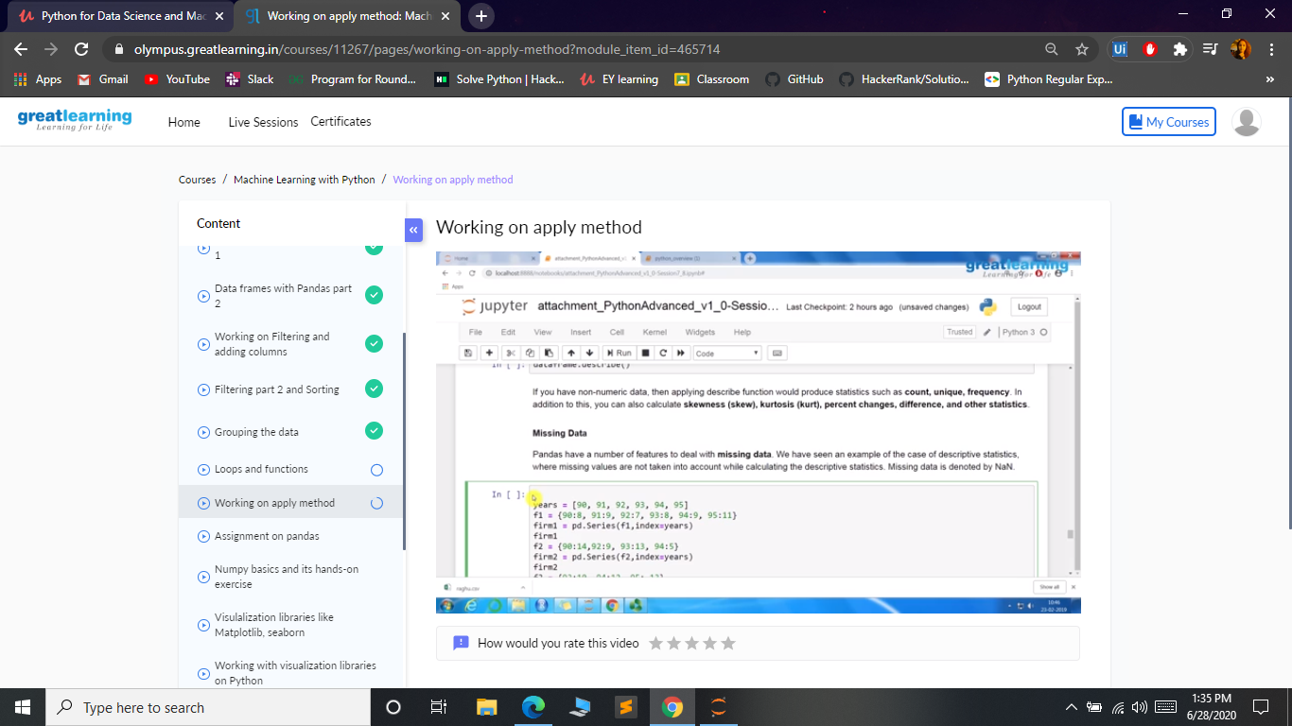

***Coding Challenges:***

Today I solved 1 coding challenge,

1. **Given a list of numbers, write a Python program to count Even and Odd numbers in a List.**

**Example:**

Input: list1 = [2, 7, 5, 64, 14] Output: Even = 3, odd = 2 Input: list2 = [12, 14, 95, 3] Output: Even = 2, odd = 2 Example 1: count Even and Odd numbers from given list using for loop Iterate each element in the list using for loop and check if num % 2 == 0, the condition to check even numbers. If the condition satisfies, then increase even count else increase odd count.

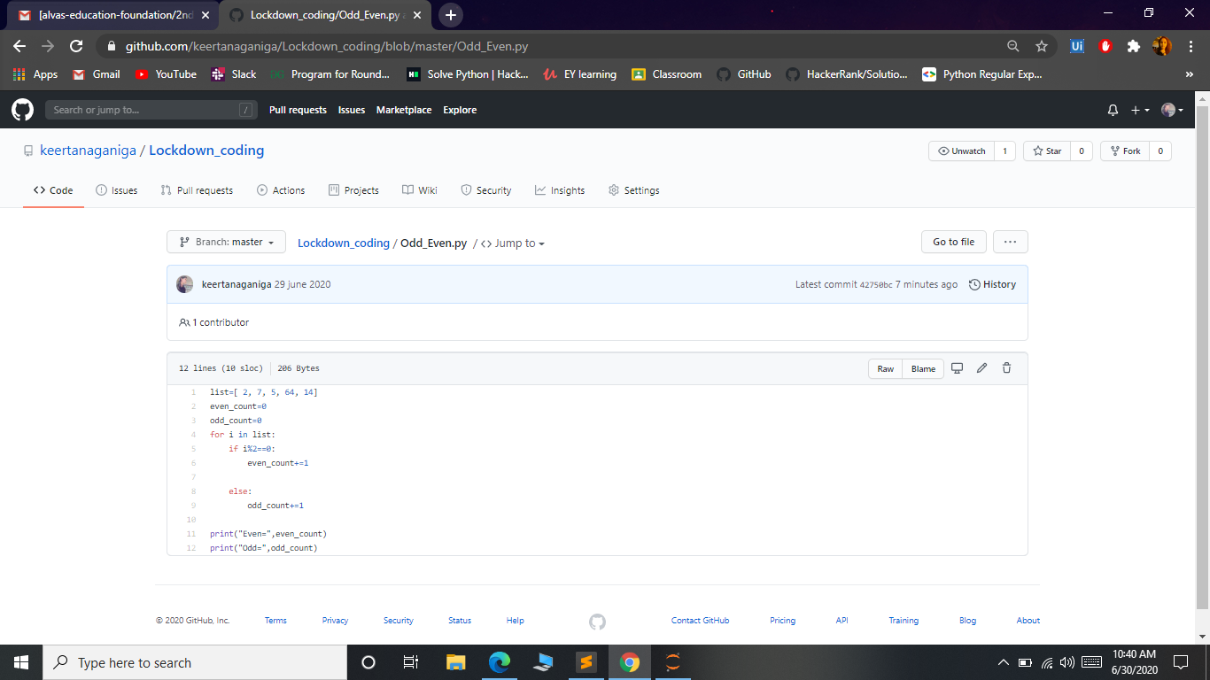

**Online class:**

Class not attended due to personal problem and informed to class coordinator.