**DAILY ONLINE ACTIVITIES SUMMARY**

|  |  |  |  |  |  |  |  |  |
| --- | --- | --- | --- | --- | --- | --- | --- | --- |
| **Date:** | **29 may 2020** | | | | | **Name:** | **Keertana Ganesh Ganiga** | |
| **Sem & Sec** | **4th sem, 2nd year** | | | | | **USN:** | **4al18cs036** | |
| **Online Test Summary** | | | | | | | | |
| **Subject** | | **OPERATING SYSTEMS (18cs43)** | | | | | | |
| **Max. Marks** | | **30** | | **Score** | | | **26** | |
| **Certification Course Summary** | | | | | | | | |
| **Course** | **Front end Development-HTML** | | | | | | | |
| **Certificate Provider** | | | **Great Learning** | | **Duration** | | | **3.5 hours** |
| **Coding Challenges** | | | | | | | | |
| **Problem Statement:2 program** | | | | | | | | |
| **Status: Executed** | | | | | | | | |
| **Uploaded the report in Github** | | | | | **Yes** | | | |
| **If yes Repository name** | | | | | <https://github.com/keertanaganiga/Lockdown_coding>  <https://github.com/keertanaganiga/Lockdown_certification>  <https://github.com/keertanaganiga/lockdown_reports> | | | |
| **Uploaded the report in slack** | | | | | **Yes** | | | |

**Online Test Summary:**

Today **OPERATING SYSTEMS (18cs43)** was conducted of first module. Total marks for the test was 30.

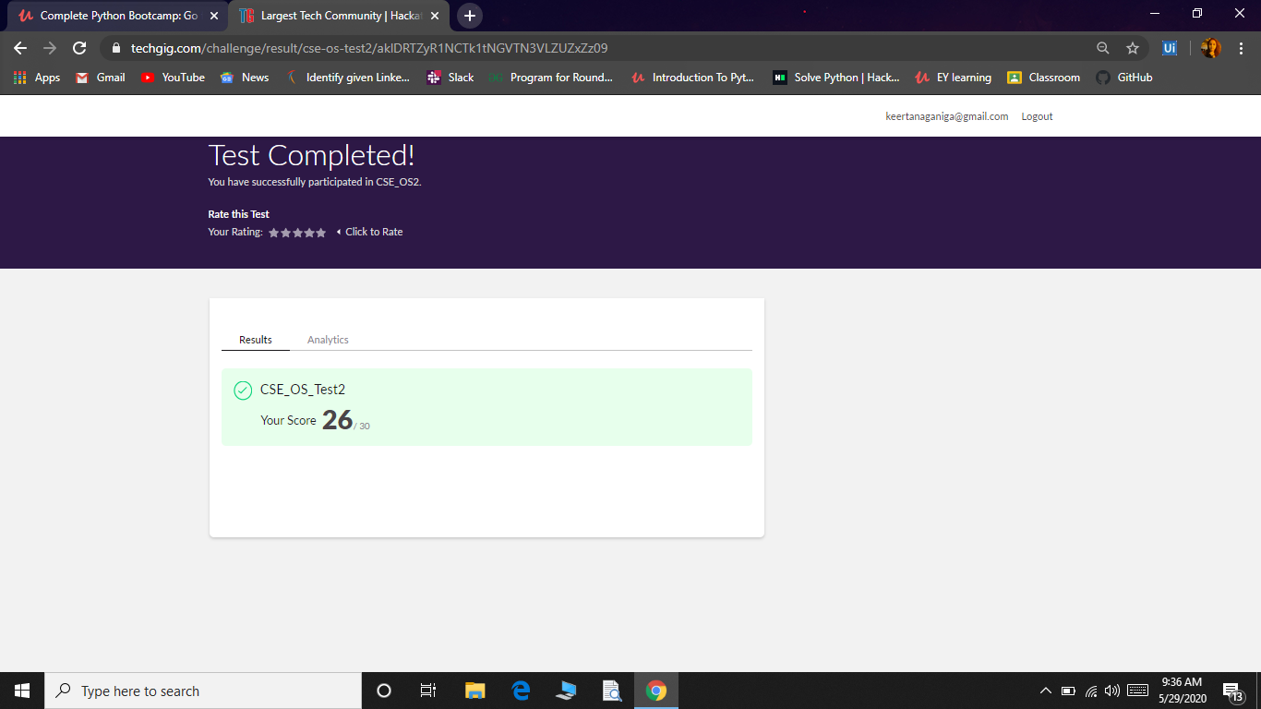

**Certification Course Summary:** **Today I started new certificate course through Great Learning I selected Front end Development-HTML ,Todays concept was Introduction to Front end, Creating HTML file, HTML structure, Paragraph tags, More details on Head tags, Heading Tags and each concept related quiz.**

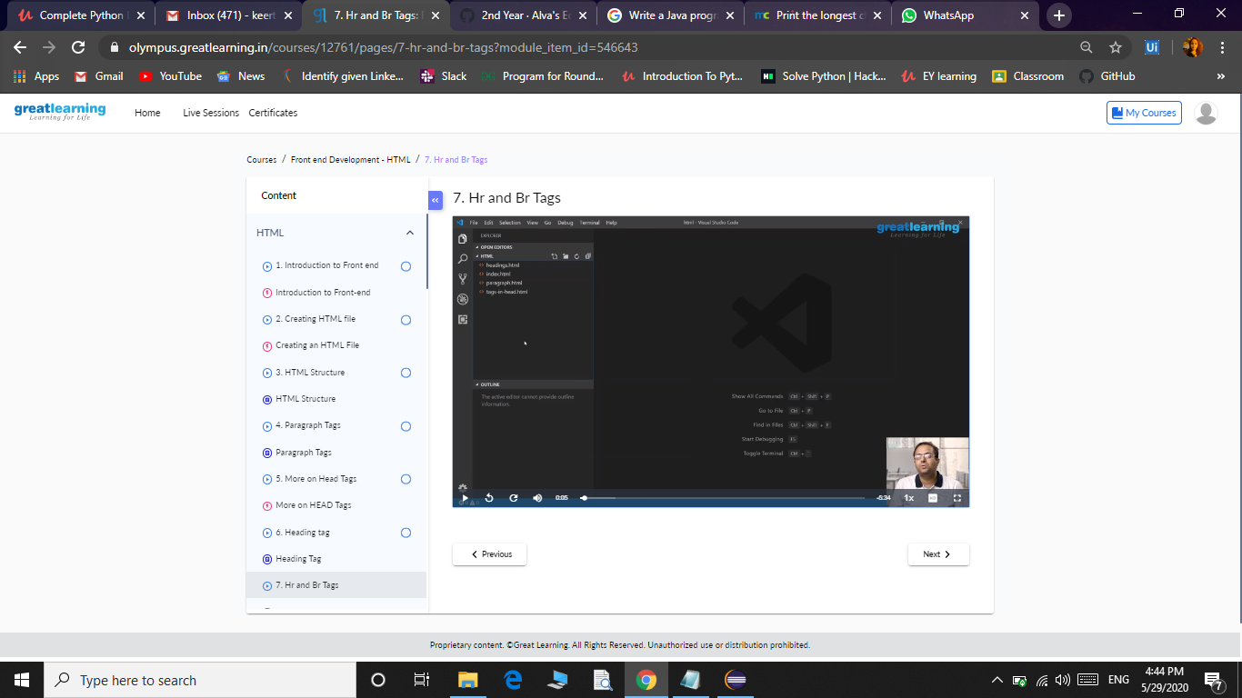

**Coding Challenges:**

Today I solved 2 coding challenge,

1. [Write a C Program to generate first N Armstrong Numbers](https://github.com/orgs/alvas-education-foundation/teams/2nd-year/discussions/87)
2. [Write a Java program to Find size of the largest ‘+’ formed by all ones in a binary matrix](https://github.com/orgs/alvas-education-foundation/teams/2nd-year/discussions/86)

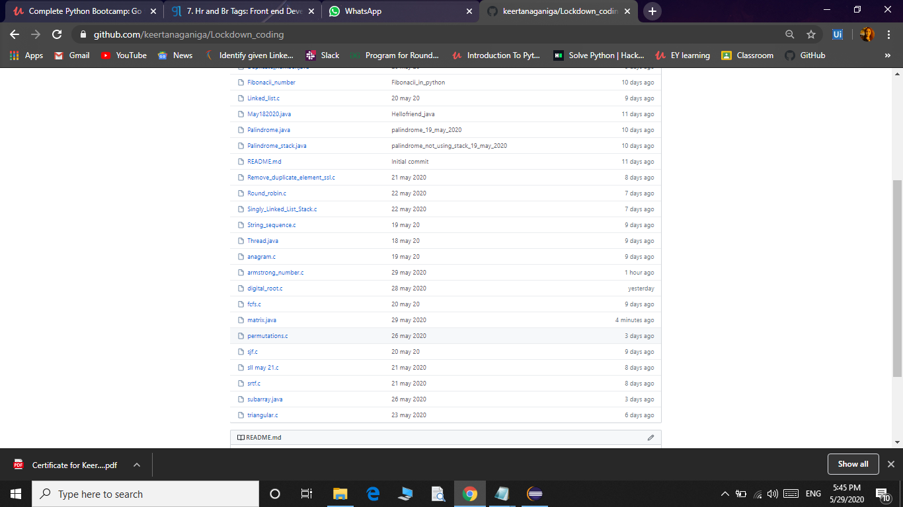

Coding challenge:

Today I attended coding challenge through Hacker rank which is 10th day coding challenge. The coding related to python language.

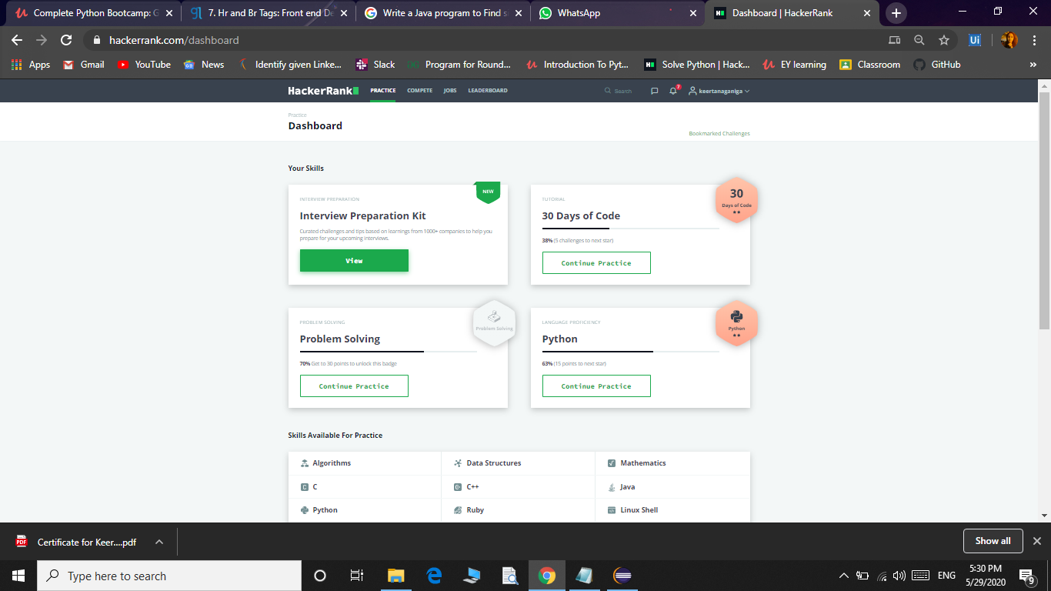

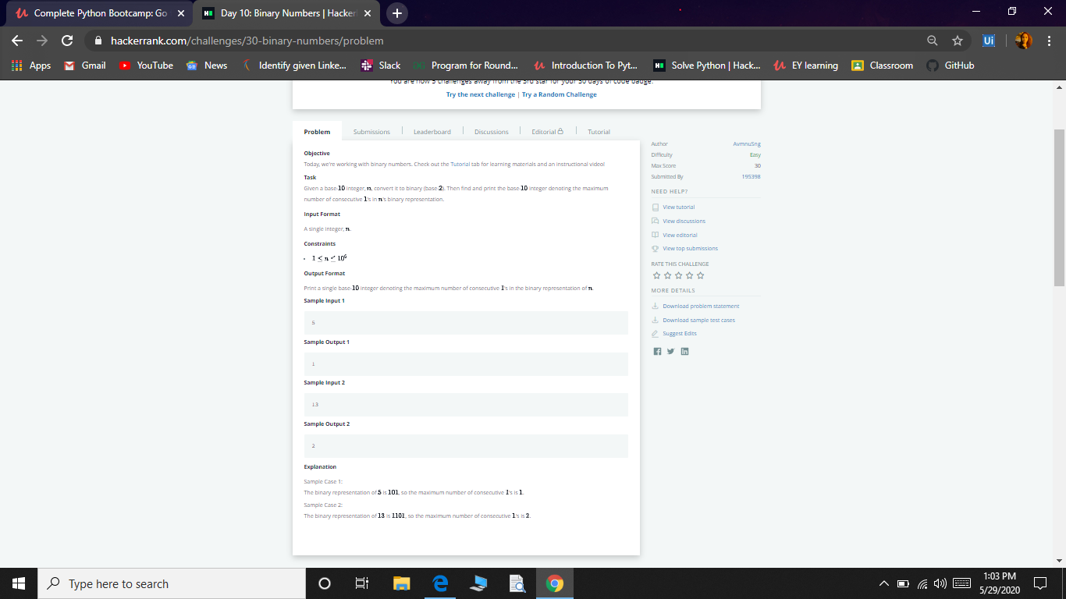

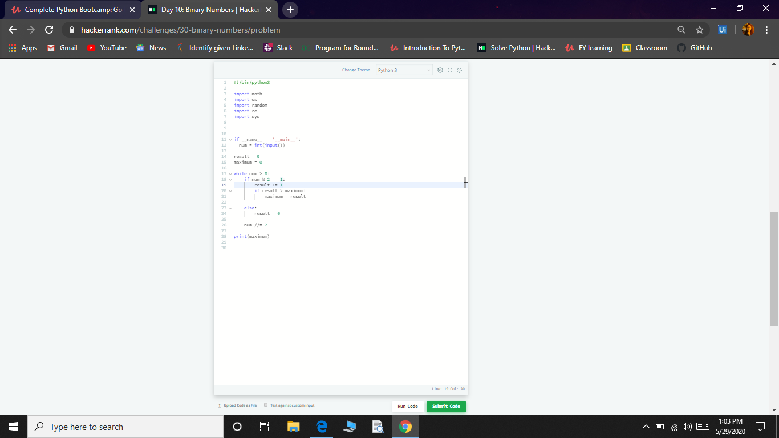

Extra Activity:

Today I attended one Quiz which is **ONLINE QUIZ ON DATA & COMPUTER COMMUNICATION NETWORK and I got 85% with certificate.**

