**DAILY ONLINE ACTIVITIES SUMMARY**

|  |  |  |  |  |  |  |  |  |
| --- | --- | --- | --- | --- | --- | --- | --- | --- |
| **Date:** | **30 may 2020** | | | | | **Name:** | **Keertana Ganesh Ganiga** | |
| **Sem & Sec** | **4th sem, 2nd year** | | | | | **USN:** | **4al18cs036** | |
| **Online Test Summary** | | | | | | | | |
| **Subject** | | **DATA COMMUNICATION (18cs46), COMPLEX ANALYSIS, PROBABILITY AND STATISTICAMETHODS (18mat41)** | | | | | | |
| **Max. Marks** | | **DC-30**  **Maths-30** | | **Score** | | | **dc-25**  **maths-30** | |
| **Certification Course Summary** | | | | | | | | |
| **Course** | **Front end Development-HTML** | | | | | | | |
| **Certificate Provider** | | | **Great Learning** | | **Duration** | | | **3.5 hours** |
| **Coding Challenges** | | | | | | | | |
| **Problem Statement:1 program** | | | | | | | | |
| **Status: Executed** | | | | | | | | |
| **Uploaded the report in Github** | | | | | **Yes** | | | |
| **If yes Repository name** | | | | | <https://github.com/keertanaganiga/Lockdown_coding>  <https://github.com/keertanaganiga/Lockdown_certification>  <https://github.com/keertanaganiga/lockdown_reports> | | | |
| **Uploaded the report in slack** | | | | | **Yes** | | | |

**Online Test Summary:**

Today **DATA COMMUNICATION (18cs46)** was conducted of first module. Total marks for the test was 30.

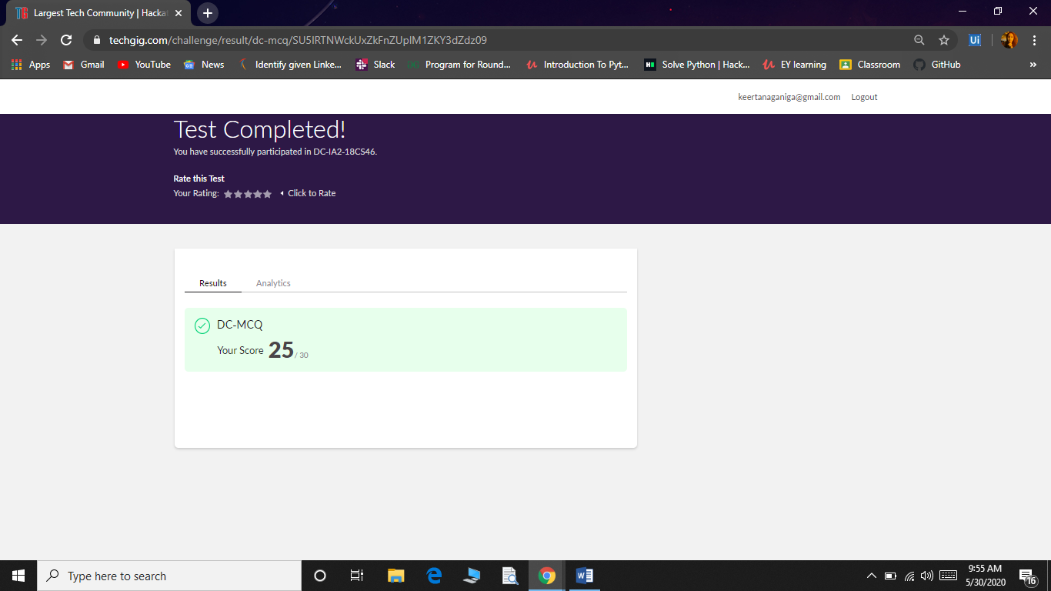

Today 18MAT41 also conducted for 30 marks which is divided into two parts 10 questions of 1 mark and 10 questions of 2 marks at 3:00 Pm.

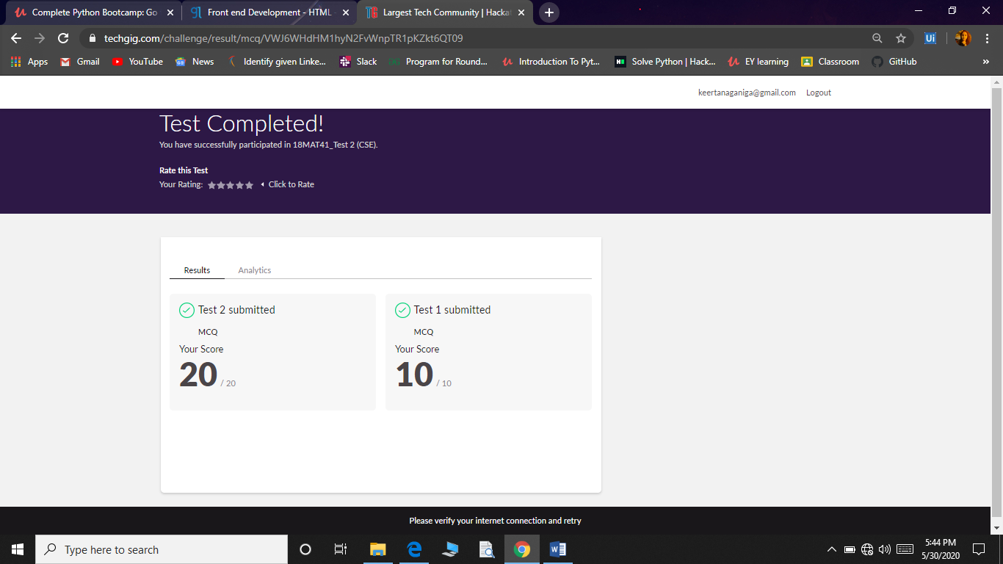

**Certification Course Summary:** **Today I started new certificate course through Great Learning I selected Front end Development-HTML, Todays I learnt about Hr and Br tags, Anchor Tag, Absolute and relative paths, Link it online and Image Tags, Alt attribute and each concept related quiz.**

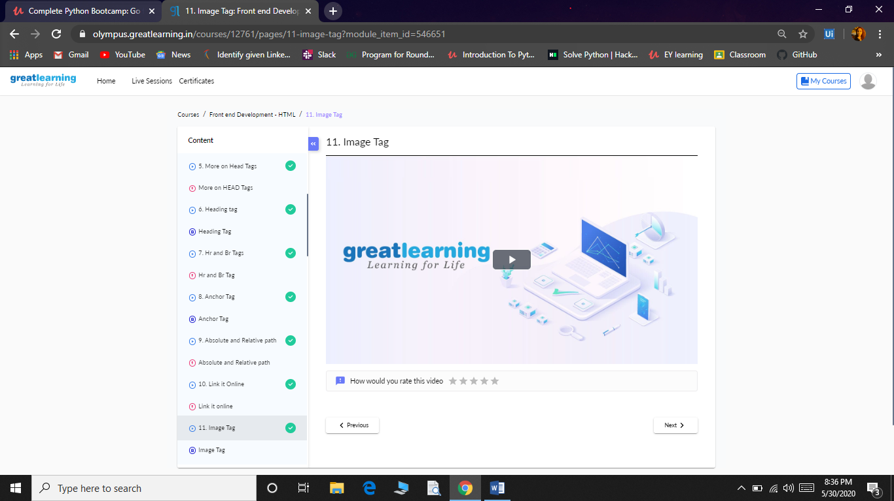

**Coding Challenges:**

Today I solved 1 coding challenge,

**Write a C Program to count Uppercase, Lowercase, special character and numeric values for a given String**

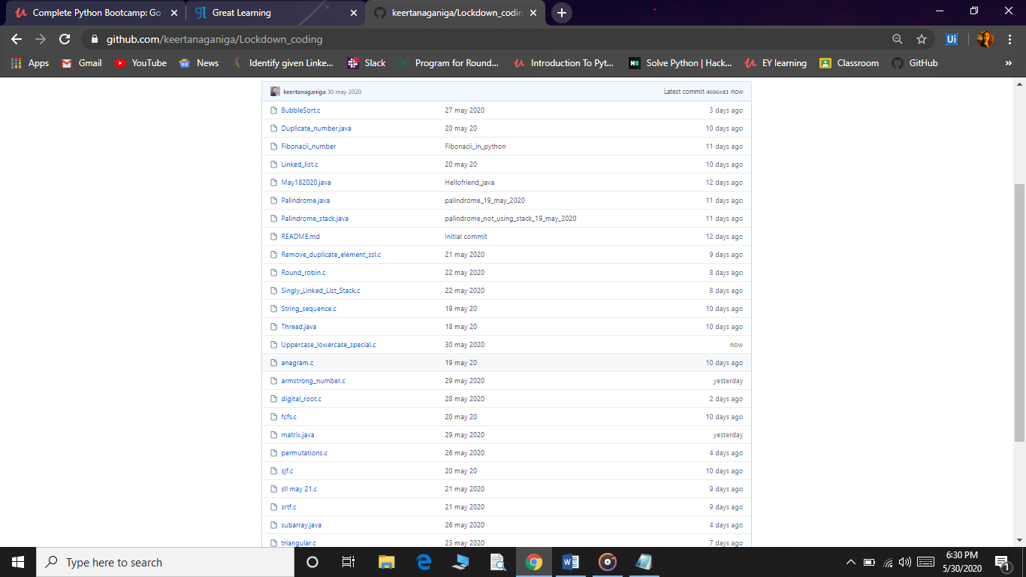

Coding challenge:

Today I attended coding challenge through Hacker rank which is 11th day coding challenge. The coding related to python language.

