**DAILY ONLINE ACTIVITIES SUMMARY**

|  |  |  |  |  |  |  |  |  |
| --- | --- | --- | --- | --- | --- | --- | --- | --- |
| **Date:** | **31 may 2020** | | | | | **Name:** | **Keertana Ganesh Ganiga** | |
| **Sem & Sec** | **4th sem, 2nd year** | | | | | **USN:** | **4al18cs036** | |
| **Online Test Summary** | | | | | | | | |
| **Subject** | | **---------** | | | | | | |
| **Max. Marks** | | **---------------** | | **Score** | | | **-----------** | |
| **Certification Course Summary** | | | | | | | | |
| **Course** | **Front end Development-HTML** | | | | | | | |
| **Certificate Provider** | | | **Great Learning** | | **Duration** | | | **3.5 hours** |
| **Coding Challenges** | | | | | | | | |
| **Problem Statement:1 program** | | | | | | | | |
| **Status: Executed** | | | | | | | | |
| **Uploaded the report in Github** | | | | | **Yes** | | | |
| **If yes Repository name** | | | | | <https://github.com/keertanaganiga/Lockdown_coding>  <https://github.com/keertanaganiga/Lockdown_certification>  <https://github.com/keertanaganiga/lockdown_reports> | | | |
| **Uploaded the report in slack** | | | | | **Yes** | | | |

**Certification Course Summary:** **Today I started new certificate course through Great Learning I selected Front end Development-HTML, Todays I learnt about HR and Br tags deeply, image attribute, Alt attribute, Clickable images, ordered list and unordered list, Table creating.**

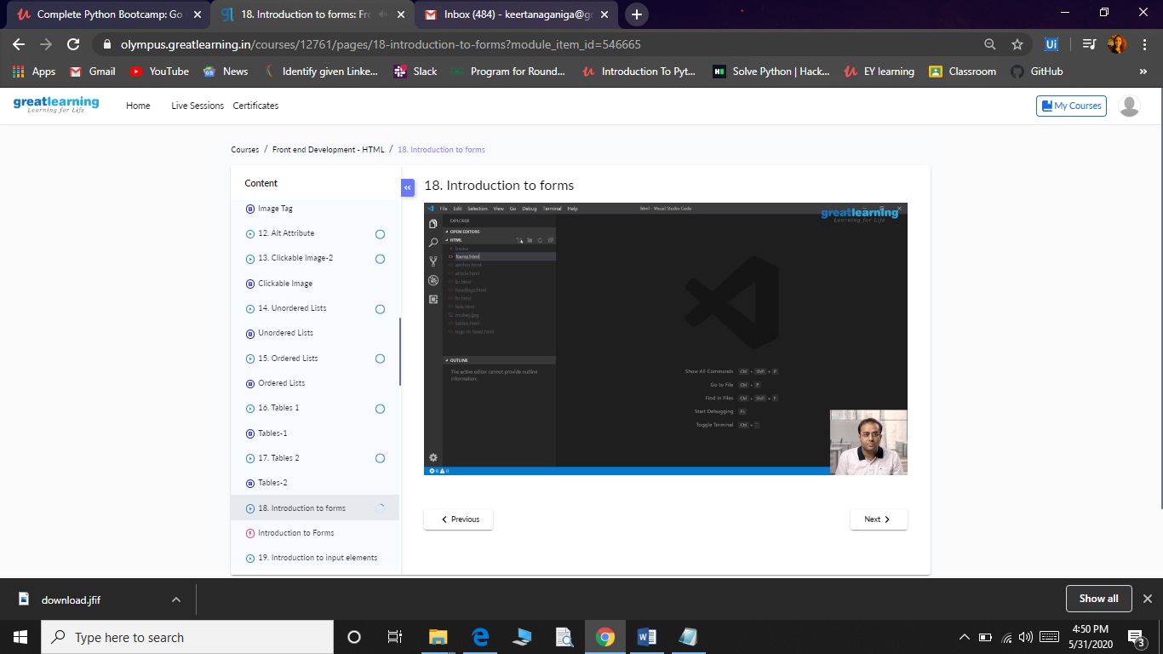

**Coding Challenges:**

Today I solved 1 coding challenge,

 Write a Java program to calculate nPr.

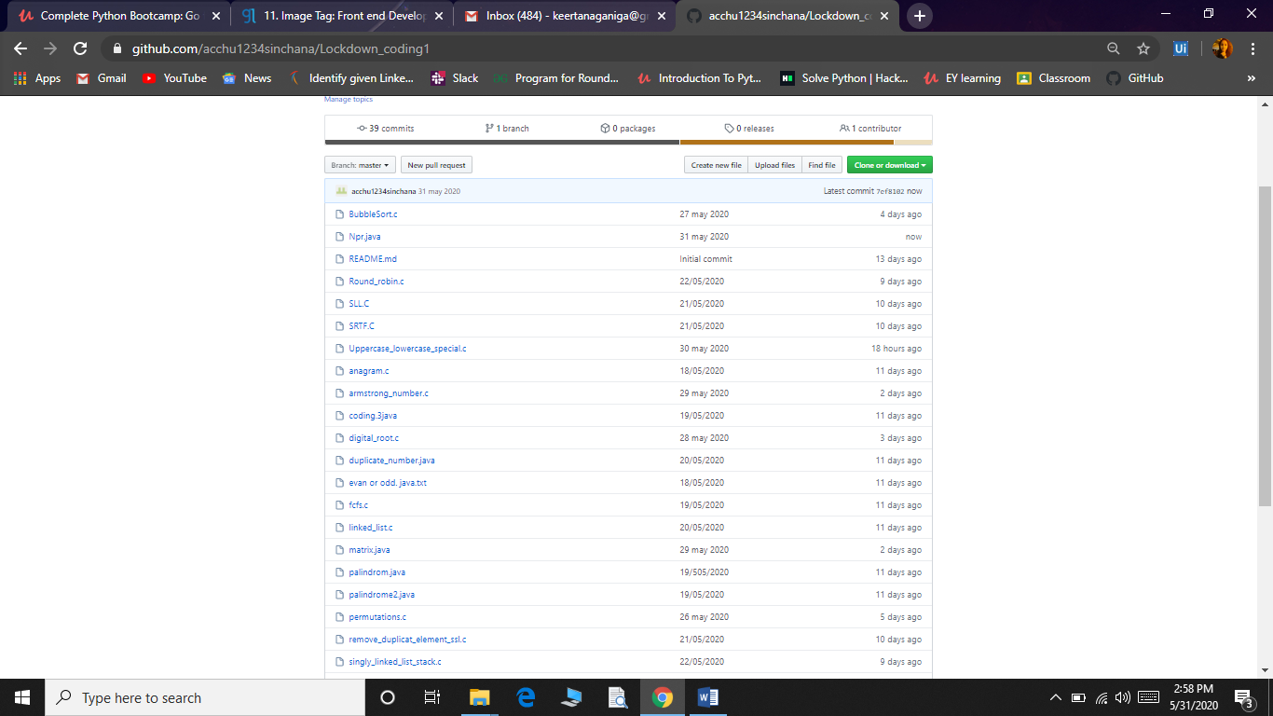

Coding challenge:

Today I attended coding challenge through Hacker rank which is 12th day coding challenge. The coding related to python language.

