**DAILY ONLINE ACTIVITIES SUMMARY**

|  |  |  |  |  |  |  |  |  |
| --- | --- | --- | --- | --- | --- | --- | --- | --- |
| **Date:** | **04 June 2020** | | | | | **Name:** | **Keertana Ganesh Ganiga** | |
| **Sem & Sec** | **4th sem, 2nd year** | | | | | **USN:** | **4al18cs036** | |
| **Online Test Summary** | | | | | | | | |
| **Subject** | | **MICROCONTROLLER AND EMBEDDED SYSTEM (18cs44)** | | | | | | |
| **Max. Marks** | | **20** | | **Score** | | | **17** | |
| **Certification Course Summary** | | | | | | | | |
| **Course** | **Front end Development-HTML** | | | | | | | |
| **Certificate Provider** | | | **Great Learning** | | **Duration** | | | **3.5 hours** |
| **Coding Challenges** | | | | | | | | |
| **Problem Statement:2 program** | | | | | | | | |
| **Status: Executed** | | | | | | | | |
| **Uploaded the report in Github** | | | | | **Yes** | | | |
| **If yes Repository name** | | | | | <https://github.com/keertanaganiga/Lockdown_coding>  <https://github.com/keertanaganiga/Lockdown_certification>  <https://github.com/keertanaganiga/lockdown_reports> | | | |
| **Uploaded the report in slack** | | | | | **Yes** | | | |

**Online Test Summary:**

Today **MICROCONTROLLER AND EMBEDDED SYSTEM (18cs44)** was conducted of first module. Total marks for the test was 20.

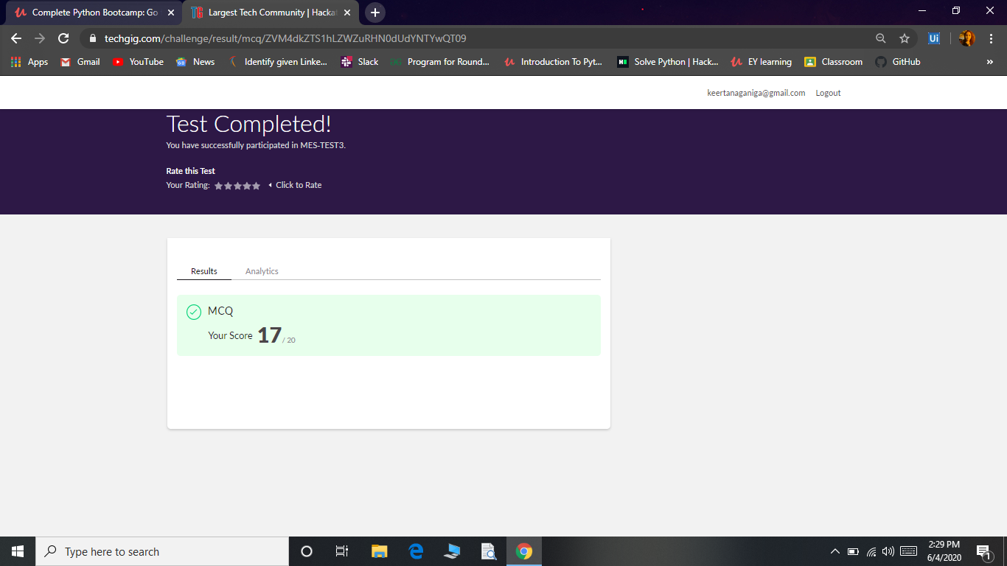

**Certification Course Summary:** **Today I started new certificate course through Great Learning I selected Front end Development of-CSS. Today I learnt about Introduction to CSS, Inline styling, Internal styling with class, External styling, Types, ID and class Selector, Attribute selector, Attribute Value selector.**

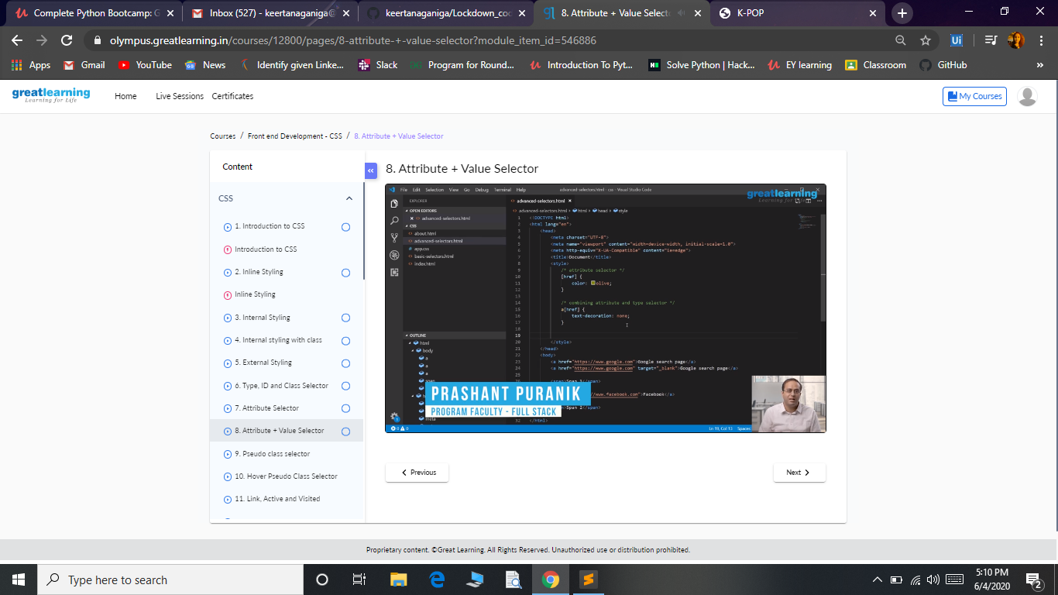

**Coding Challenges:**

Today I solved 2 coding challenge,

**1.** **write a java program to read three integer values from the keyboard and find the sum of the values. Declare a variable "sum" of type int and store the result in it.**

**2. Write a C++ program to find the missing number in array**

