**DAILY ONLINE ACTIVITIES SUMMARY**

|  |  |  |  |  |  |  |  |  |
| --- | --- | --- | --- | --- | --- | --- | --- | --- |
| **Date:** | **08 June 2020** | | | | | **Name:** | **Keertana Ganesh Ganiga** | |
| **Sem & Sec** | **4th sem, 2nd year** | | | | | **USN:** | **4al18cs036** | |
| **Online Test Summary** | | | | | | | | |
| **Subject** | | **COMPLEX ANALYSIS, PROBABILITY AND STATISTICAL METHODS (18MAT41)** | | | | | | |
| **Max. Marks** | | **30** | | **Score** | | | **18** | |
| **Certification Course Summary** | | | | | | | | |
| **Course** | **Front end Development-CSS** | | | | | | | |
| **Certificate Provider** | | | **Great Learning** | | **Duration** | | | **5 hours** |
| **Coding Challenges** | | | | | | | | |
| **Problem Statement:1 program** | | | | | | | | |
| **Status: Executed** | | | | | | | | |
| **Uploaded the report in Github** | | | | | **Yes** | | | |
| **If yes Repository name** | | | | | <https://github.com/keertanaganiga/Lockdown_coding>  <https://github.com/keertanaganiga/Lockdown_certification>  <https://github.com/keertanaganiga/lockdown_reports> | | | |
| **Uploaded the report in slack** | | | | | **Yes** | | | |

**Online Test Summary:**

Today **COMPLEX ANALYSIS, PROBABILITY AND STATISTICAL METHODS (18MAT41)** was conducted. Total marks for the test was 30.

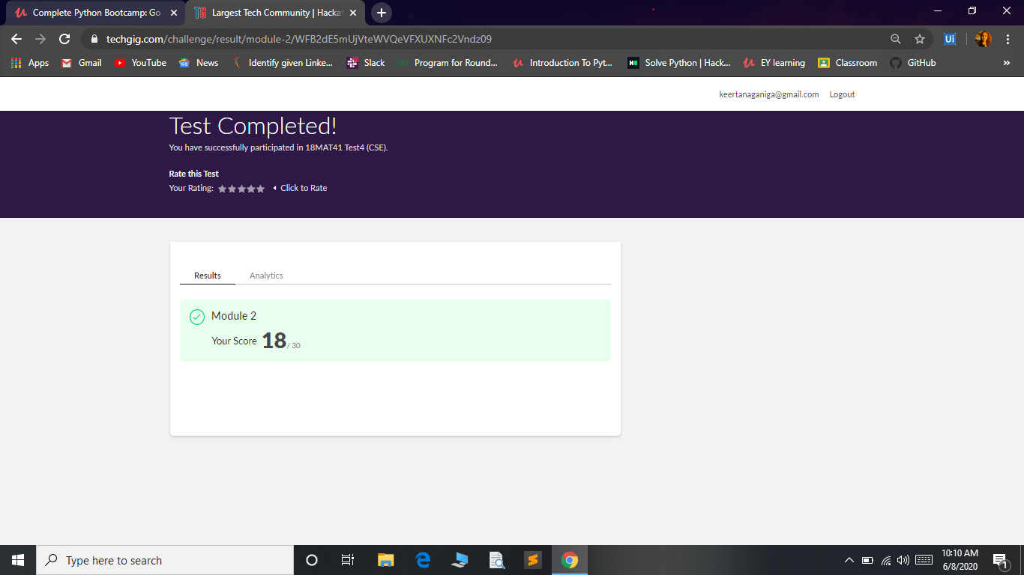

**Certification Course Summary:** **Today I started new certificate course through Great Learning I selected Front end Development of CSS, Todays concept was Combination of Selector, Specificity of combination of Selector, Specificity Values, Colors RGB and Hexadecimals, Opacity, Introduction to box model, Width, Height, Min and Max Width.**

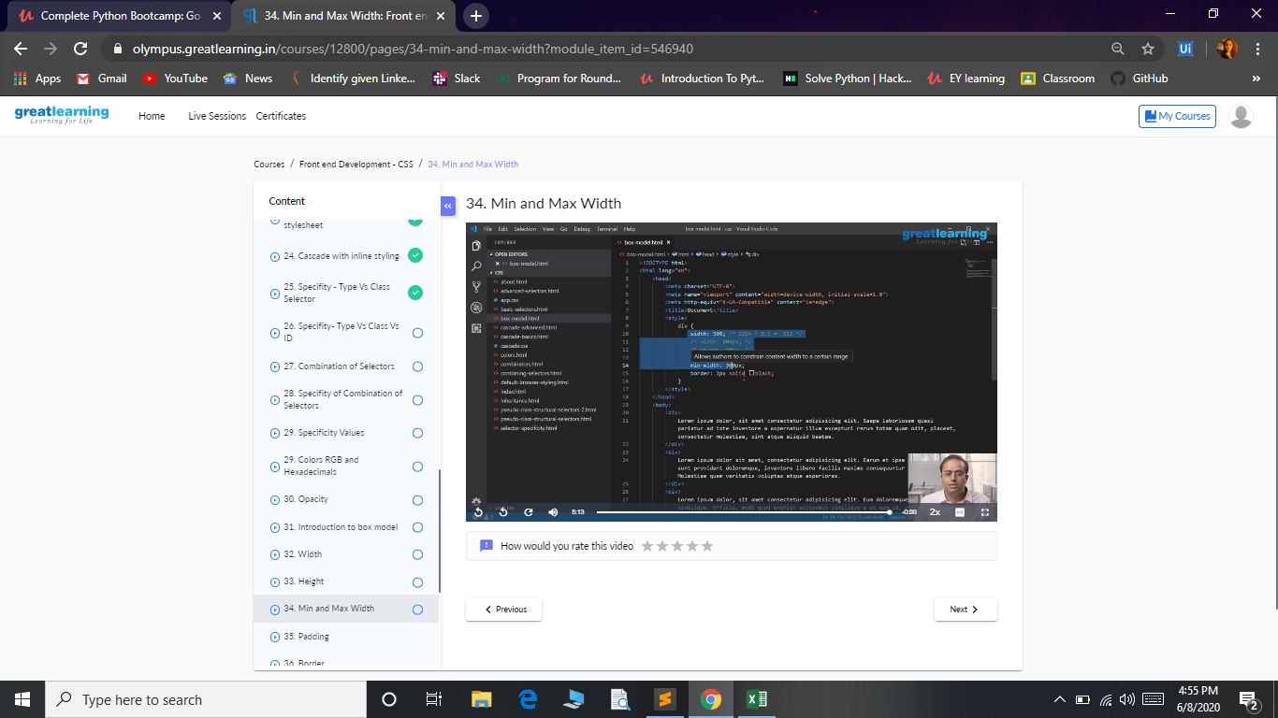

**Coding Challenges:**

Today I solved 1 coding challenge,

**1. Write a Java Program to check whether the given matrix is magic square or not**

