**DAILY ONLINE ACTIVITIES SUMMARY**

|  |  |  |  |  |  |  |  |  |
| --- | --- | --- | --- | --- | --- | --- | --- | --- |
| **Date:** | **09 June 2020** | | | | | **Name:** | **Keertana Ganesh Ganiga** | |
| **Sem & Sec** | **4th sem, 2nd year** | | | | | **USN:** | **4al18cs036** | |
| **Online Test Summary** | | | | | | | | |
| **Subject** | | **--------** | | | | | | |
| **Max. Marks** | | **-----** | | **Score** | | | **-----** | |
| **Certification Course Summary** | | | | | | | | |
| **Course** | **Front end Development-CSS** | | | | | | | |
| **Certificate Provider** | | | **Great Learning** | | **Duration** | | | **5 hours** |
| **Coding Challenges** | | | | | | | | |
| **Problem Statement:1 program** | | | | | | | | |
| **Status: Executed** | | | | | | | | |
| **Uploaded the report in Github** | | | | | **Yes** | | | |
| **If yes Repository name** | | | | | <https://github.com/keertanaganiga/Lockdown_coding>  <https://github.com/keertanaganiga/Lockdown_certification>  <https://github.com/keertanaganiga/lockdown_reports> | | | |
| **Uploaded the report in slack** | | | | | **Yes** | | | |

**Certification Course Summary:** **Today I started new certificate course through Great Learning I selected Front end Development of CSS, Todays concept was Padding, border, Margin, Insertion of background, Styling the background images, Moving the background image, Font styling, Other text styling, about Advances CSS. Today I completed the front-end development of CSS with certificate.**

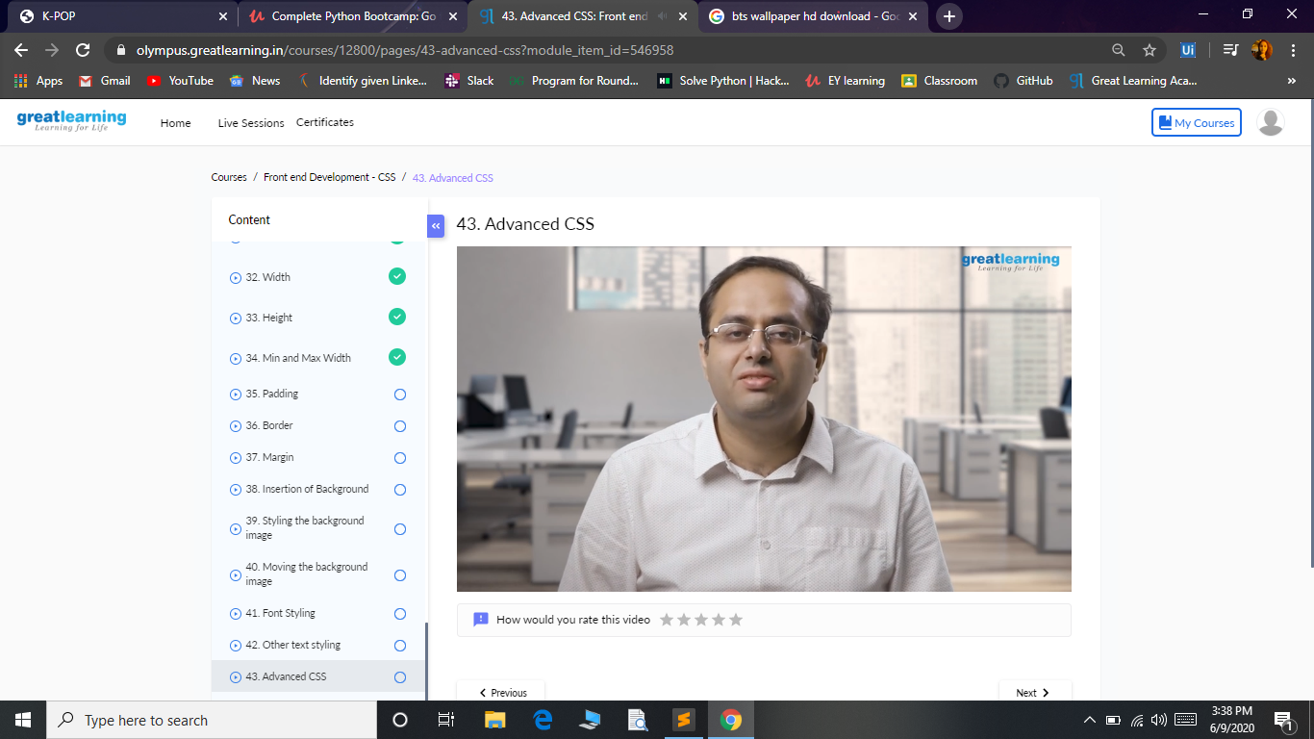

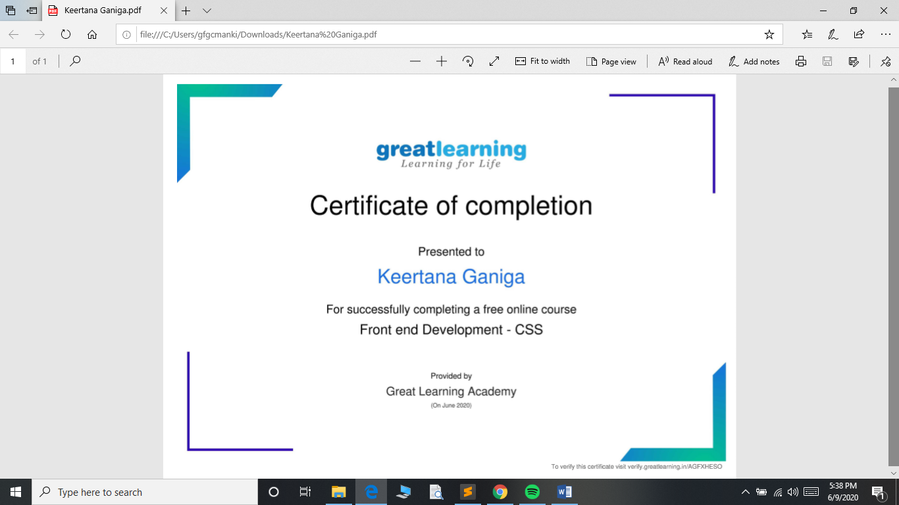

**Coding Challenges:**

Today I solved 1 coding challenge,

**1.**  **Write a C++ Program to rotate the matrix by K times Program in C**

