**DAILY ONLINE ACTIVITIES SUMMARY**

|  |  |  |  |  |  |  |  |  |
| --- | --- | --- | --- | --- | --- | --- | --- | --- |
| **Date:** | **22 may 2020** | | | | | **Name:** | **Keertana Ganesh Ganiga** | |
| **Sem & Sec** | **4th sem, 2nd year** | | | | | **USN:** | **4al18cs036** | |
| **Online Test Summary** | | | | | | | | |
| **Subject** | | **OPERATING SYSTEMS (18cs43)** | | | | | | |
| **Max. Marks** | | **30** | | **Score** | | | **20** | |
| **Certification Course Summary** | | | | | | | | |
| **Course** | **Introduction to Python Programming** | | | | | | | |
| **Certificate Provider** | | | **Udemy** | | **Duration** | | | **5 hours** |
| **Coding Challenges** | | | | | | | | |
| **Problem Statement:2 program** | | | | | | | | |
| **Status: Executed** | | | | | | | | |
| **Uploaded the report in Github** | | | | | **Yes** | | | |
| **If yes Repository name** | | | | | <https://github.com/keertanaganiga/Lockdown_coding> | | | |
| **Uploaded the report in slack** | | | | | **Yes** | | | |

**Online Test Summary:**

Today **OPERATING SYSTEMS (18cs43)** was conducted of first module. Total marks for the test was 30.

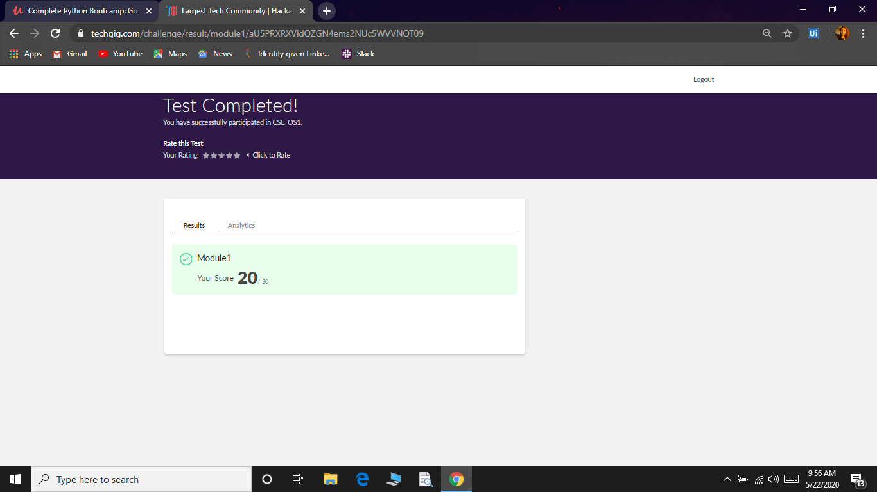

**Certification Course Summary:** **Today I started new certificate course through Udemy. I choose the concept of Introduction to Python Programming. I learnt about Up and Running with Python, All the basics(new)**

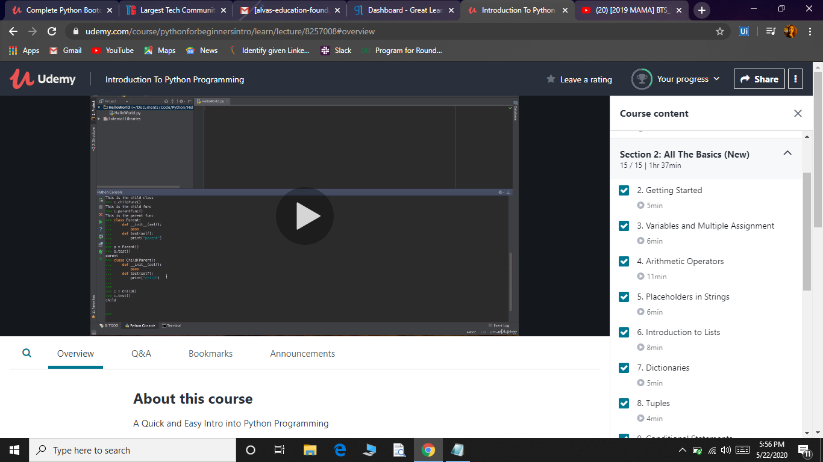

**Coding Challenges:**

Today I solved 3 coding challenge,

1. **First Create a Singly Linked List Stack with the node corresponding to First Element is the base of the stack; and its link field must be always Null.  
   When you push First Element, it is the First and it is Base of the stack. Its Link must be Null. top pointer pointing to First. (top = First)  
   When you push any element, (No need of checking Stack full case because SLL is dynamic) Create a new node called temp using malloc function and insert a number into Data field, and Link field must be pointing to top; and move the pointer top to point to temp.  
   When you pop, First check for stack Empty. if First == NULL, then Stack Empty. If it is not empty, the pointer temp must be pointing to top. Move the pointer top to top->link. delete temp.  
   When you display the stack element, First Check for Stack Empty as in pop operation. If it is not empty, display all the elements of current stack starting from top to First.**
2. **Write a C or Java program to implement round robin type of process scheduling.  
   Input: Process with burst time, arrival time and specify the time quantum  
   Output: Processes scheduled based on the round robin type of scheduling, with its average waiting time.**

