**DAILY ONLINE ACTIVITIES SUMMARY**

|  |  |  |  |  |  |  |  |  |
| --- | --- | --- | --- | --- | --- | --- | --- | --- |
| **Date:** | **23 may 2020** | | | | | **Name:** | **Keertana Ganesh Ganiga** | |
| **Sem & Sec** | **4th sem, 2nd year** | | | | | **USN:** | **4al18cs036** | |
| **Online Test Summary** | | | | | | | | |
| **Subject** | | **DATA COMMUNICATION (18cs46)** | | | | | | |
| **Max. Marks** | | **30** | | **Score** | | | **25** | |
| **Certification Course Summary** | | | | | | | | |
| **Course** | **Introduction to Python Programming** | | | | | | | |
| **Certificate Provider** | | | **Udemy** | | **Duration** | | | **5 hours** |
| **Coding Challenges** | | | | | | | | |
| **Problem Statement:1 program** | | | | | | | | |
| **Status: Executed** | | | | | | | | |
| **Uploaded the report in Github** | | | | | **Yes** | | | |
| **If yes Repository name** | | | | | <https://github.com/keertanaganiga/Lockdown_coding> | | | |
| **Uploaded the report in slack** | | | | | **Yes** | | | |

**Online Test Summary:**

Today **DATA COMMUNICATION (18cs46)** was conducted of first module. Total marks for the test was 30.

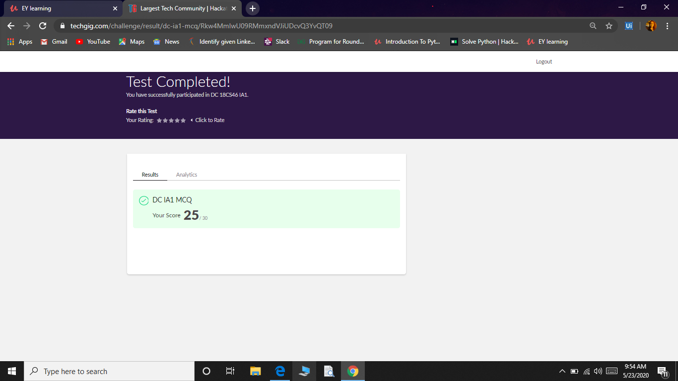

**Certification Course Summary:** **Today I started new certificate course through Udemy. I choose the concept of Introduction to Python Programming. I learnt about loop conditions, variables, All the basics(old).**

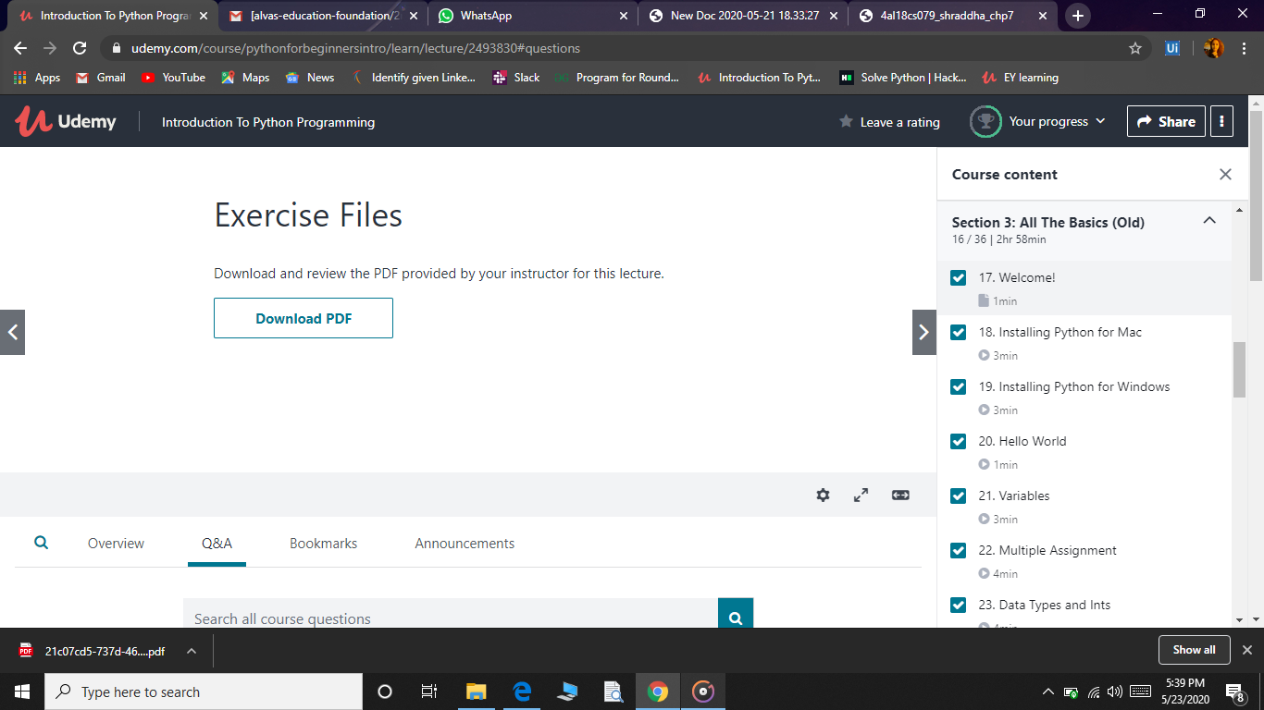

**Coding Challenges:**

Today I solved 1 coding challenge:

1. **Write a C Program to generate first N Triangular Numbers (Where N is Read from the Key board).**

