Training Report on
EL encashment and CGEIS Funds Management System
AT
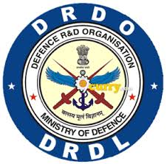

Defence Research and Development Laboratory (DRDL)
Kanchanbagh, Hyderabad.

In Partial Fulfillment of the
B.Tech In

Computer Science and Engineering
INDIAN INSTITUTE OF INFORMATION TECHNOLOGY, NAGPUR
(An Institution of National Importance by Act of Parliament)
Survey No.140,141/1 behind Br. Sheshrao Wankade Shetkari Sahkari Soot Girni, Nagpur, 441108

Submitted By
Anumalasetty Keerthan – BT22CSE172

Under The Guidance
Shri B. V. Hari krishna Nanda (Scientist ‘G’)
Technology Director, DIT, DRDL
DECLARATION

I, Anumalasetty Keerthan, hereby declare that this report is being submitted for partial fulfilment of the requirements of my internship at Defence Research and Development Laboratory (DRDL).
This report is original work carried out by me during my internship and have been completed under the guidance of Shri B.V. Hari Krishna Nanda, Scientist ‘G’ and Smt. G.M.V. Lakshmi, To ‘C’. This internship was undertaken as a part of the academic curriculum of Indian Institute of Information Technology Nagpur.

Anumalasetty Keerthan
BT22CSE172

Smt. G.M.V. Lakshmi, TO ‘C’

B.V. Hari Krishna Nanda, Scientist ‘G’
Technology Director, DIT, DRDL

ACKNOWLEDGEMENT

I wish to express my sincere gratitude to the Defence Research and Development Laboratory (DRDL), Kanchanbagh for providing a highly professional environment to undertake this work.
I am deeply indebted to Shri B.V. Hari Krishna Nanda, Sc ‘G’ for granting me the invaluable opportunity to work on this project and for his continuous guidance. I extend my heartfelt thanks to Smt. G.M.V. Lakshmi, TO ’C’ for her unwavering support and technical insights throughout the project duration.
My gratitude also goes to the entire Department team for their cooperative spirit and constant encouragement.
Additionally, I am thankful to the library and other administrative staff at DRDL for providing seamless access to essential resources and facilities.

Anumalasetty Keerthan
BT22CSE172

ABOUT DRDL

The Defence Research and Development Laboratory (DRDL) is one of the India's most important missile development laboratories under the Defence Research and Development Organization (DRDO). It is located in Kanchan Bagh, Hyderabad, and plays a central role in Indian missile technology development.

The Formation and Amalgamation (1958)
Before its formal establishment in Hyderabad, the genesis of the laboratory began in 1958. It originated from the amalgamation of the Technical Development Establishment (TDEs) of the Indian Army and the Directorate of Technical Development and Production (DTDP) with the Defence Science Organisation.
This merger was part of a larger national initiative to create a dedicated, self-supporting defence research entity. Established in 1961, the laboratory playes a foundational role in India's strategic defence infrastructure and aerospace technologies.
Today, the laboratory is globally recognized for designing, developing and successfully evaluating critical weapon platforms, including the Agni, Prithvi, Akash, Trishul and other key missile families. It has also contributed to the development of the supersonic Brahmos cruise missile, helping ensure the nation's self-reliance in tactical and missile systems.

HISTORY

The Defence Research and Development Laboratory (DRDL) was established in June 1961 in New Delhi as a small, specialized unit operating within the Defence Science Laboratory. Recognizing the urgent need for vast, isolated testing grounds and dedicated engineering facilities, the Ministry of Defence relocated the laboratory to Hyderabad in 1962.
DRDL initially occupied the historic, repurposed Naizams army barracks in Phool Bagh, an area now known as Kanchan Bagh. This move provided the physical foot print required to lay down the permanent structural infrastructure for India's indigenous missile design.
Early Experimental Programs (1960s–1970s)
During its first two decades, DRDL undertook highly ambitious classified projects that laid the foundational expertise for Indian aerospace engineering. In the 1960s, the laboratory launched Project Indigo, an early attempt to engineer a surface-to-air missile (SAM). However, the project was ultimately halted due to strict international technology embargoes.
In the 1970s, DRDL initiated Project Devil and Project Valiant. These projects focused on reverse-engineering the soviet SA-2 liquid-propellant missile and long-range ballistic system. While Government formally shelved both programs before mass production, they served as critical learning crucibles, training a generation of DRDL scientists in liquid rocket propulsion, telemetry, and advanced fabrication technologies.
The IGMDP Golden Era (1983–2008), The true turning point for the laboratory came in 1982 when Dr. A. P. J. Abdul Kalam assumed charge as Director, radically restructuring the laboratory into a unified, mission driven powerhouse.
In 1983, the Government of India officially sanctioned the Integrated Guided Missile Development Program (IGMDP), appointing DRDL as the lead design architecture house.

ABSTRACT

The internship work carried out at Defence Research and Development Laboratory (DRDL), Hyderabad, focused on the development and modernization of enterprise-level web applications used for administrative and financial workflow management. The primary objective was to improve existing systems by replacing traditional technologies with modern web development frameworks that provide better performance, scalability, maintainability, and user experience.
During the internship, I worked on three major projects namely the EL Encashment System, CGEIS Funds Management System, and Admin & Finance Package. The EL Encashment System automates the earned leave encashment process by managing employee records, leave calculations, bill preparation, and financial workflow processing. The CGEIS Funds Management System facilitates employee fund and insurance-related operations, including fund calculations, bill generation, and workflow automation. The Admin & Finance Package was developed to manage administrative and financial operations efficiently through employee data management and financial record maintenance.
The applications were developed using a modern full-stack architecture consisting of React.js for frontend development, Spring Boot for backend services, and Oracle Database for data storage and management. REST APIs were used for communication between frontend and backend modules. The systems were designed with responsive user interfaces, modular architecture, form validation mechanisms, and workflow automation capabilities.
Through these projects, practical knowledge of full-stack development, frontend engineering, backend API development, database integration, software testing, debugging, and enterprise application development was gained. The internship provided valuable exposure to real-world software development practices and enhanced technical, analytical, and problem-solving skills.
Keywords: React.js, Spring Boot, Oracle Database, Full Stack Development, Enterprise Applications, EL Encashment System, CGEIS Funds Management System, Admin & Finance Package, REST APIs, Workflow Automation.

TABLE OF CONTENTS

S.No | Section Title | Page No
1 | Declaration | 2
2 | Acknowledgement | 3
3 | About DRDL | 4
4 | History | 5
5 | Abstract | 6
6 | Table of Contents | 7
7 | List of Figures | 8
8 | Introduction | 9
9 | Project Objectives | 10
10 | Technology Stack | 11
11 | Database Design | 13
12 | Technical Details of the projects or modules completed | 17
13 | Results and Discussion | 28
14 | Challenges and Learnings from the internship | 29
15 | References | 30

LIST OF FIGURES

S.No | Name of Figure | Page No
1 | Admin and Finance Package | 19
2 | Prepare bill | 22
3 | Add Bill Number | 22
4 | Add DV Number | 23
5 | Add MRO Details | 23
6 | Show MRO Details | 24
7 | CGEIS Funds | 26
8 | CGEIS Funds Reports | 27

INTRODUCTION

Modern organizations require efficient software systems to manage administrative, financial, and employee-related operations. Traditional applications often suffer from performance limitations, outdated interfaces, and maintenance challenges. To address these issues, organizations are increasingly adopting modern web technologies that provide enhanced performance, scalability, and user experience.
During the internship at DRDL, I worked on enterprise applications designed to automate critical organizational workflows. These applications were developed using React.js, Spring Boot, and Oracle Database, following a modular and scalable architecture.
The major projects undertaken during the internship include:
Admin & Finance Package
A web-based administrative and financial management system designed to streamline organizational operations. The system facilitates employee data management, financial record handling, administrative workflow processing, and information management through a user-friendly interface. My contribution primarily involved designing and developing responsive frontend pages using React.js.
EL Encashment System
A web-based application developed to automate the earned leave encashment process of employees. The system manages employee information, leave calculations, bill generation, validation, and workflow processing while reducing manual effort and improving operational efficiency.
CGEIS Funds Management System
A financial management application developed for handling employee insurance and fund-related activities. The system supports employee search, fund calculations, bill preparation, DV management, record maintenance, and workflow automation.
The internship provided hands-on experience in frontend development, backend integration, database management, API development, debugging, testing, and software maintenance while working on real-world enterprise applications.

PROJECT OBJECTIVES

The primary objectives of the internship projects were:
General Objectives
• To modernize existing enterprise applications using contemporary web technologies.
• To automate administrative and financial workflows.
• To improve system performance, responsiveness, and maintainability.
• To reduce manual processing efforts through workflow automation.
• To enhance user experience through intuitive and responsive interfaces.
EL Encashment System Objectives
• Automate leave encashment processing.
• Simplify bill preparation and approval workflows.
• Reduce paperwork and manual calculations.
• Improve accuracy in financial processing.
• Provide efficient employee search and data retrieval mechanisms.
CGEIS Funds Management System Objectives
• Manage employee insurance and fund records digitally.
• Automate fund calculations and bill generation.
• Improve workflow processing efficiency.
• Reduce operational complexity and manual intervention.
Admin & Finance Package Objectives
• Centralize employee information management.
• Manage financial records efficiently.
• Improve administrative workflow processing.
• Provide user-friendly interfaces for data management.
• Enhance accessibility and maintainability through modern frontend technologies.
TECHNOLOGY STACK

Frontend Technologies
React.js
React.js was used for building dynamic and responsive user interfaces. Its component-based architecture improved code reusability, maintainability, and application performance.
JavaScript
JavaScript was used for implementing business logic, event handling, API interactions, and dynamic user interface behavior.
HTML5
HTML5 provided the structural foundation for application pages and forms.
CSS3
CSS3 was used to create responsive layouts and improve the visual appearance of the applications.

Backend Technologies
Java
Java was used for implementing backend services and business logic.
Spring Boot
Spring Boot was utilized for developing REST APIs, handling requests, validations, workflow processing, and database communication.
REST APIs
RESTful APIs enabled seamless communication between frontend and backend modules.

Database Technologies
Oracle Database
Oracle Database was used for secure storage and management of employee records, financial data, leave information, and transaction details.

Development Tools
Visual Studio Code
Used for frontend and backend development.
Postman
Used for API testing and validation.
Git & GitHub
Used for version control and project management.
Maven
Used for dependency management and project build automation.

DATABASE DESIGN

The applications developed during the internship use Oracle Database for storing and managing employee information, financial records, leave encashment data, and CGEIS fund details. The database was designed to support the operational requirements of the EL Encashment System and CGEIS Funds Management System while maintaining data integrity and efficient retrieval of records.
The database consists of the following major tables:
PERSONNEL TABLE
The PERSONNEL table stores employee master information used across the application.
The table contains:
• Employee Code
• Employee Name
• Division
• Date of Birth
• Employee Category
This table serves as the primary source for employee-related information and is used during employee search and record retrieval operations.
FINANCE_DATA TABLE
The FINANCE_DATA table stores financial information associated with employees.
The table contains:
• Basic Pay
• Special Pay
• GPF Account Number
• PAN Number
• Other Financial Details
This information is used during leave encashment calculations and financial processing activities.
EL_ENCASHMENT TABLE
The EL_ENCASHMENT table is the main transaction table used in the EL Encashment System.
The table stores:
• Employee Information
• Encashment Purpose
• Event Date
• Block Period
• EL Days
• HPL Days
• Encashment Amount
• Income Tax Details
• Recovery Amounts
• Grand Total Amount
• Bill Number
• DV Details
• MRO Details
• Processing Status
The table supports the complete workflow from bill preparation to final settlement.
SALARY TABLE
The SALARY table stores employee-wise monthly CGEIS contribution details.
The table contains:
• Employee Information
• Contribution Month
• CGEIS Contribution Amount
• Value Amount
These records are used for CGEIS fund calculations and settlement processing.
CGEIS_BILL TABLE
The CGEIS_BILL table stores fund settlement information generated for employees.
The table contains:
• Employee Information
• Settlement Reason
• Bill Information
• Tax Details
• Insurance Coverage
• Recovery Information
• Net Payable Amount
• Processing Status
CGEIS_BILL_ITEM TABLE
The CGEIS_BILL_ITEM table stores detailed calculation records associated with CGEIS bills.
The table maintains contribution periods, calculation values, multipliers, and settlement amounts required during bill generation.
DATABASE RELATIONSHIPS
The database follows a relational structure where employee records stored in the PERSONNEL table are linked with financial information stored in the FINANCE_DATA table.
The EL_ENCASHMENT table references employee information for leave encashment processing, while the SALARY table maintains monthly contribution records used for CGEIS calculations.
The CGEIS_BILL and CGEIS_BILL_ITEM tables store settlement details and calculation records for employee fund management.
DATABASE FEATURES
The database design provides:
• Centralized employee information management
• Efficient financial record storage
• Leave encashment workflow support
• CGEIS fund management support
• Fast employee search functionality
• Secure and reliable data storage
• Reduced data redundancy
• Easy maintenance and scalability
The Oracle Database implementation enabled efficient management of employee records, financial transactions, leave encashment processing, and CGEIS fund operations within the enterprise applications developed during the internship.

TECHNICAL DETAILS OF THE PROJECTS OR MODULES COMPLETED

Project 1: Admin & Finance Package
1. Project Overview
The Admin & Finance Package is a centralized portal used for accessing various administrative and financial applications within the organization. The package serves as a navigation hub that provides users with quick access to multiple modules such as EL Encashment System, CGEIS Funds Management System, and other administrative applications.
The primary objective of the project was to modernize the existing JSP-based interface and provide a more responsive, user-friendly, and visually appealing experience using React.js.
2. Existing System and Problems
The existing Admin & Finance Package was developed using JSP technology and contained numerous navigation options for accessing different organizational modules.
The system had several limitations:
• Outdated user interface
• Limited responsiveness
• Poor visual appearance
• Difficult maintenance of frontend pages
• Inconsistent user experience
• Slow adaptation to modern web standards
These limitations reduced usability and affected the overall user experience.
3. Proposed System
To overcome the limitations of the existing interface, the Admin & Finance Package was redesigned using React.js.
The new interface provides a modern and responsive dashboard that allows users to easily access different applications through organized navigation components. The redesigned page improves usability, accessibility, and maintainability while preserving the existing functionality of the system.
4. System Architecture
• Frontend Layer
The frontend was developed using React.js. It manages page rendering, navigation, user interactions, and responsive layouts.
• Backend Layer
Existing backend services remain responsible for handling the functionality of individual modules accessed through the portal.
5. Features Implemented
The following features were implemented in the Admin & Finance Package:
• Modern React-based User Interface
• Responsive Design
• Navigation Dashboard
• Multiple Module Access Links
• Improved User Experience
• Organized Layout Structure
• Reusable React Components
• Enhanced Visual Design
6. My Contributions
My contributions in this project include:
• Redesigned the existing JSP-based interface using React.js
• Developed the complete frontend page for the Admin & Finance Package
• Created a modern dashboard-style layout
• Implemented navigation functionality for various modules and packages
• Developed reusable React components
• Improved application responsiveness and user experience
• Performed UI testing and debugging
• Enhanced the visual appearance and maintainability of the application
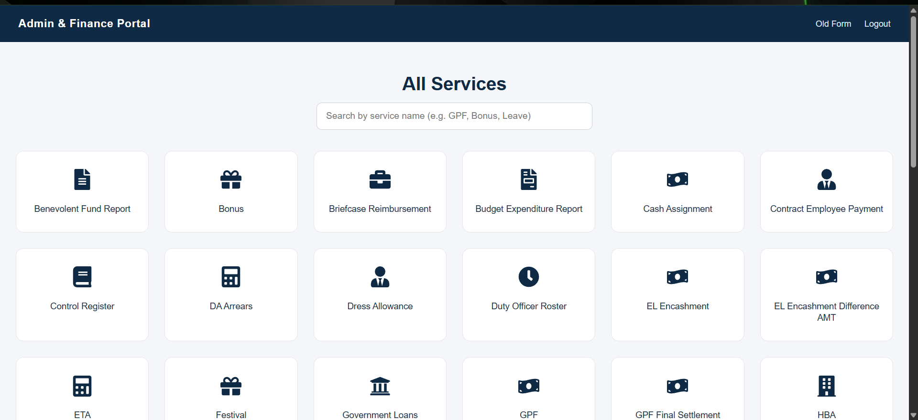
Figure-1 Admin and Finance Package

Project 2: EL Encashment System

Project Overview
The EL Encashment System was developed to automate the earned leave encashment workflow for employees. The primary objective of the project was to replace the existing JSP-based legacy application with a modern web application using ReactJS and Spring Boot.
The system was designed to improve application speed, responsiveness, maintainability, and overall user experience while simplifying administrative operations.
The application allows users to manage employee leave encashment workflows digitally through automated calculations, bill generation, and validation-based processing

Existing System and Problems
The earlier application was developed using JSP technology and had several limitations:
•Slow page loading and response time
• Outdated user interface
• Difficult maintenance and scalability
• Limited responsiveness and usability
• Complex workflow handling
• Increased manual effort during processing
The legacy architecture also made frontend modifications difficult and affected user experience significantly.

Proposed System
To overcome the limitations of the previous system, a completely new application was developed using ReactJS and Spring Boot architecture.
The frontend was developed using ReactJS with reusable components and responsive UI design. The backend APIs were developed using Spring Boot and connected to Oracle Database for secure data handling and processing.
The proposed system improved speed, modularity, maintainability, and user interaction.

System Architecture
The application follows a three-layer architecture:
    - Frontend Layer
The frontend was developed using ReactJS. It handles user interactions, form handling, validations, page rendering, and API integration.
    - Backend Layer
The backend was developed using Spring Boot. REST APIs were created for employee search, leave calculations, bill generation, and database operations.
    - Database Layer
Oracle Database was used for storing employee records, leave balances, bill details, and transaction-related data.

Features Implemented
The following features were implemented in the EL Encashment System:
• Employee Search Functionality
• Employee Details Retrieval
• Leave Balance Calculation
• Encashment Calculation
• Bill Preparation Module
• Add DV Functionality
• Validation Handling
• Error Handling
• Responsive User Interface
• Backend API Integration
• Oracle Database Connectivity
- My Contributions
My contributions in the project include:
• Designed and developed the complete frontend using ReactJS
• Developed backend APIs using Spring Boot
• Created database connectivity with Oracle Database
• Implemented employee search and bill preparation workflows
• Developed Add DV functionality
• Handled form validations and error handling
• Improved UI responsiveness and application performance
• Integrated frontend and backend modules
• Tested application workflows and fixed issues
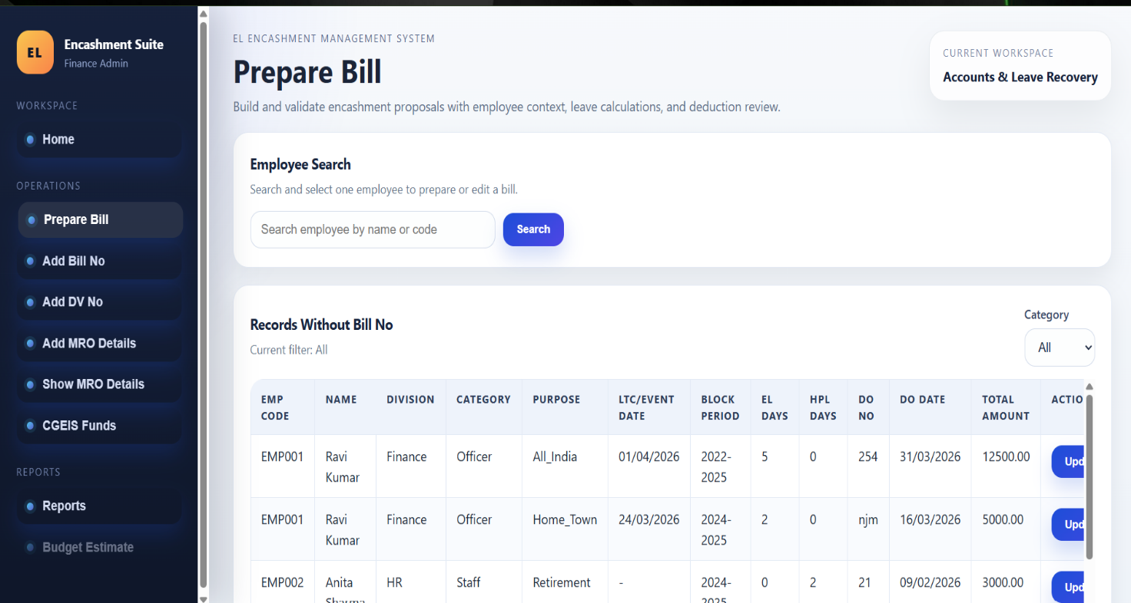
Fig-2 Prepare bill

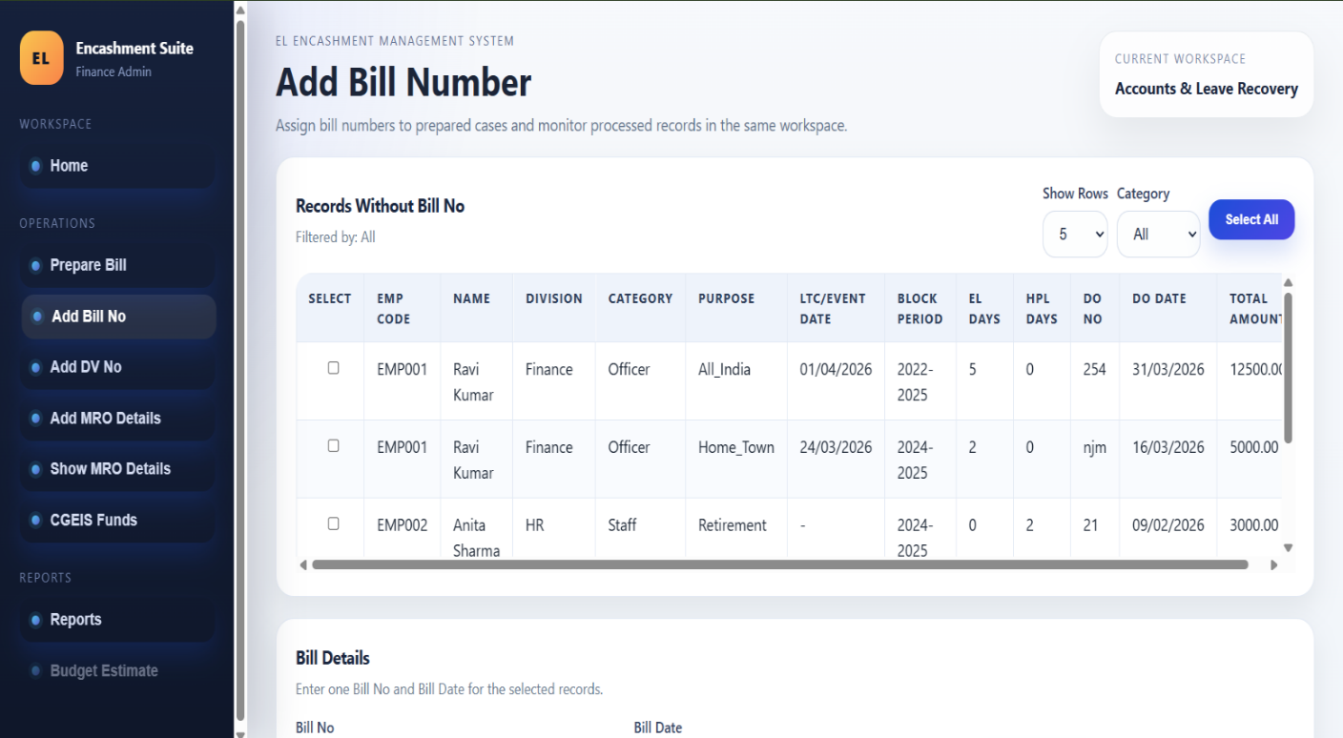
Fig-3 Add Bill Number
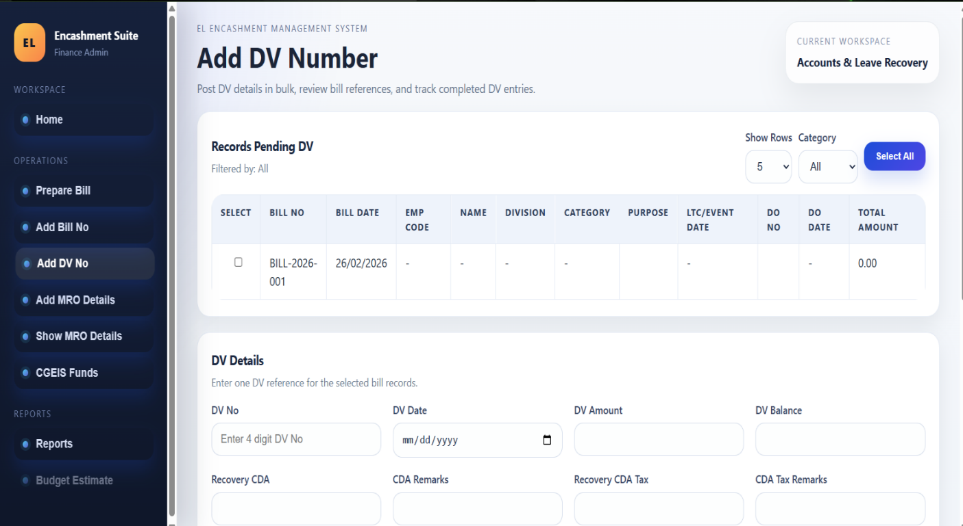
Fig-4 Add DV Number

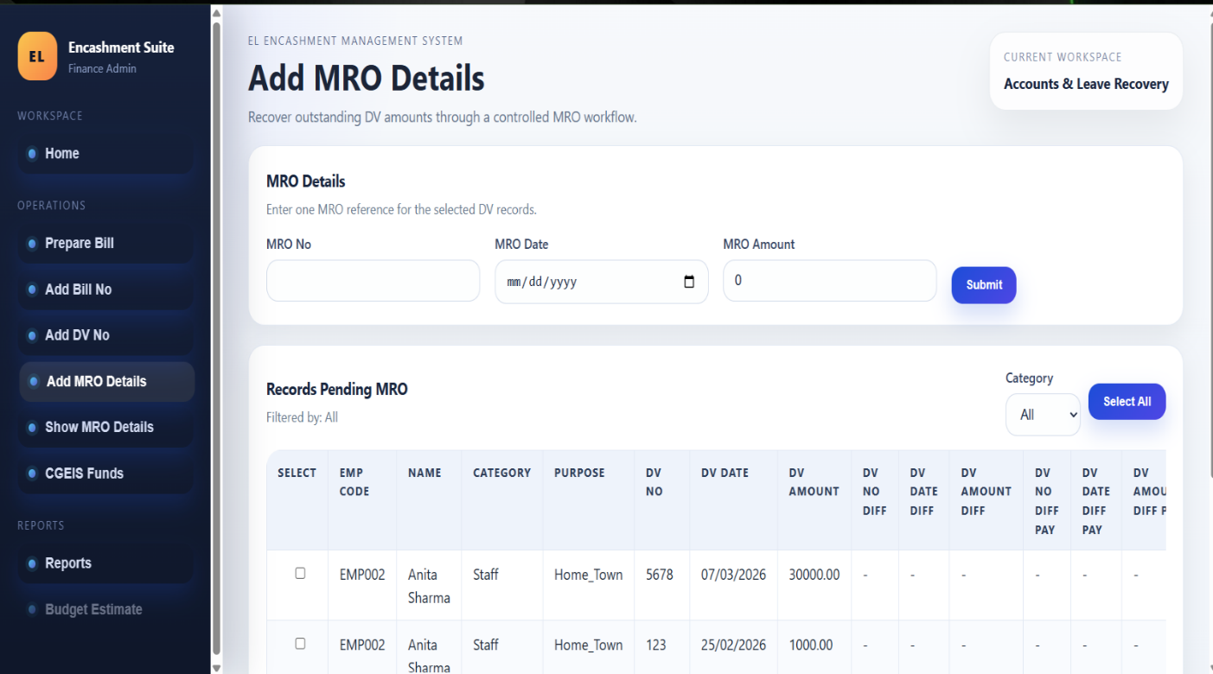
Fig-5 Add MRO Details
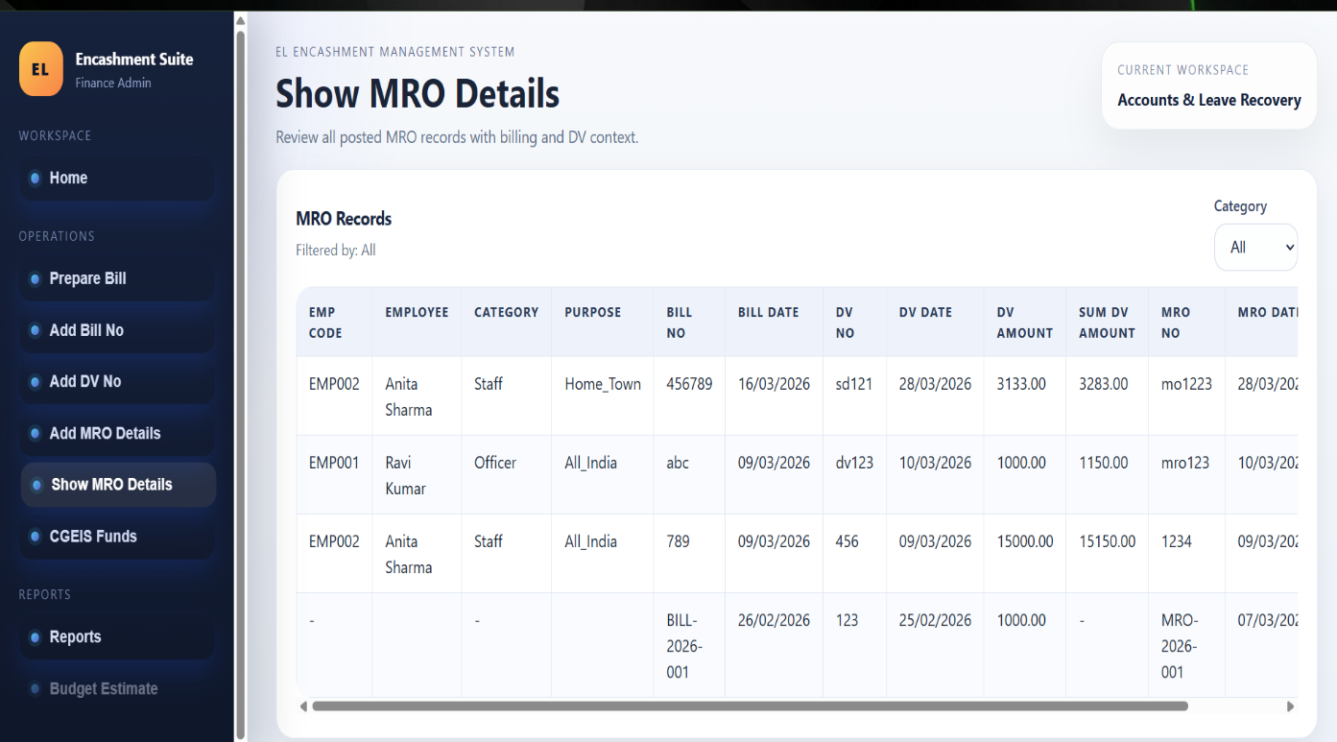
Fig-6 Show MRO Details

Project 3: CGEIS Funds Management System

- Project Overview
The CGEIS Funds Management System was developed to manage employee fund and insurance-related processes digitally. The project aimed to modernize the previous JSP-based application by rebuilding the system using ReactJS and Spring Boot technologies.
The new application provides better performance, improved user experience, and efficient workflow management.
- Existing System and Problems
The previous JSP-based system faced multiple challenges:
• Slow processing and navigation
• Outdated interface design
• Difficult frontend maintenance
• Limited scalability
• Manual workflow dependencies
• Complex data handling
The application required modernization to improve usability and system performance.
- Proposed System
The new CGEIS system was developed using ReactJS for frontend development and Spring Boot for backend services.
REST APIs were developed for handling employee fund details, calculations, bill preparation, and workflow processing. Oracle Database was integrated for secure data storage and retrieval.
The redesigned system provides a faster and more user-friendly experience.
- System Architecture

Frontend Layer
Developed using ReactJS with reusable UI components and responsive layouts.

Backend Layer
Spring Boot APIs were created for business logic implementation, validations, and database communication.

Database Layer
Oracle Database was used for employee records, fund information, and bill management.
- Features Implemented
The following functionalities were implemented in the CGEIS module:
• Employee Search Functionality
• Fund Calculation Module
• Bill Preparation Workflow
• Add DV Functionality
• Data Validation
• API Integration
• Responsive UI Design
• Oracle Database Connectivity
• Error Handling and Workflow Processing
- My Contributions
My contributions in the project include:
• Developed complete frontend interfaces using ReactJS
• Built backend APIs using Spring Boot
• Integrated Oracle Database with backend services
• Implemented employee search and workflow processing
• Developed bill preparation and DV modules
• Improved frontend design and responsiveness
• Performed testing and debugging of application workflows
• Fixed validation and integration issues
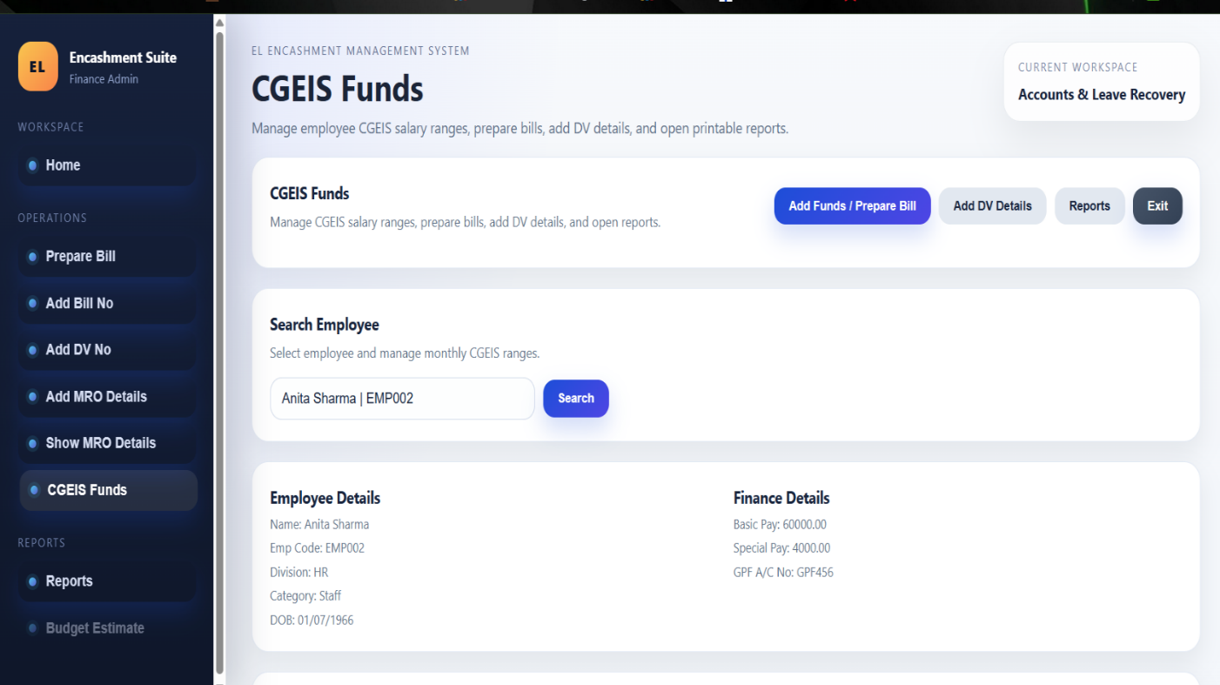
Fig-7 CGEIS Funds

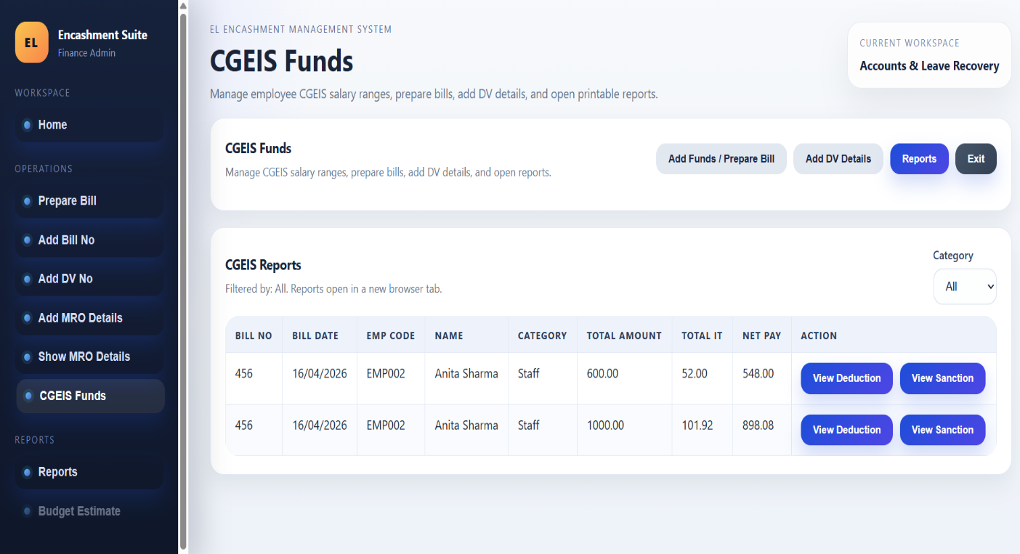
Fig-8 CGEIS Funds Reports

RESULTS AND DISCUSSION

The internship provided practical exposure to enterprise-level software development and modernization of legacy applications.
The developed EL Encashment System and CGEIS Funds Management System successfully improved the performance and usability of the existing applications by replacing traditional JSP-based architecture with ReactJS and Spring Boot.
The major outcomes of the internship are as follows:
• Improved application speed and responsiveness
• Modern and user-friendly interface design
• Better frontend maintainability through component-based architecture
• Efficient backend processing using Spring Boot APIs
• Improved workflow automation and reduced manual effort
• Better database interaction using Oracle Database
• Enhanced debugging and problem-solving skills
• Practical exposure to full stack development
The internship also helped in understanding real-world enterprise workflows, frontend-backend integration, and software development practices.

CHALLENGES AND LEARNINGS FROM THE INTERNSHIP

The internship provided excellent opportunities to learn modern technologies and real-time software development practices while working on enterprise applications.
1. Understanding Legacy Systems
One of the major challenges was understanding the existing JSP-based legacy applications and their workflows before redesigning the system using modern technologies.
This helped in understanding enterprise application structures and workflow analysis.
2. Frontend Migration Challenges
Migrating old JSP pages into ReactJS-based components required redesigning UI flows and improving user interaction while maintaining the original functionality.
This improved knowledge of component-based frontend development and state handling.
3. Backend API Development
Developing backend APIs using Spring Boot and integrating them with Oracle Database required careful handling of request processing, validations, and database communication.
This improved backend development and API integration skills.
4. Database Handling
Working with Oracle Database for employee records, bill processing, and workflow management improved practical knowledge of SQL queries and database operations.
5. Debugging and Testing
Handling integration issues, validation problems, and workflow errors helped improve debugging and troubleshooting skills.
6. Full Stack Development Experience
The internship provided complete exposure to frontend development, backend API creation, database integration, and workflow implementation.
This improved understanding of full stack web application development.
REFERENCES

- Getting Started with Java | Oracle Java Documentation
https://docs.oracle.com/en/java/

- Maven Documentation
https://maven.apache.org/

- Spring Boot Reference Documentation
https://docs.spring.io/spring-boot/docs/current/reference/html/

- React: A JavaScript library for building user interfaces
https://reactjs.org/docs/

- Git Documentation
https://git-scm.com/doc

- REST API Tutorial - RESTful Architecture
https://restfulapi.net/

- Bootstrap Documentation
https://getbootstrap.com/

- Oracle Database Documentation
https://docs.oracle.com/en/database/

