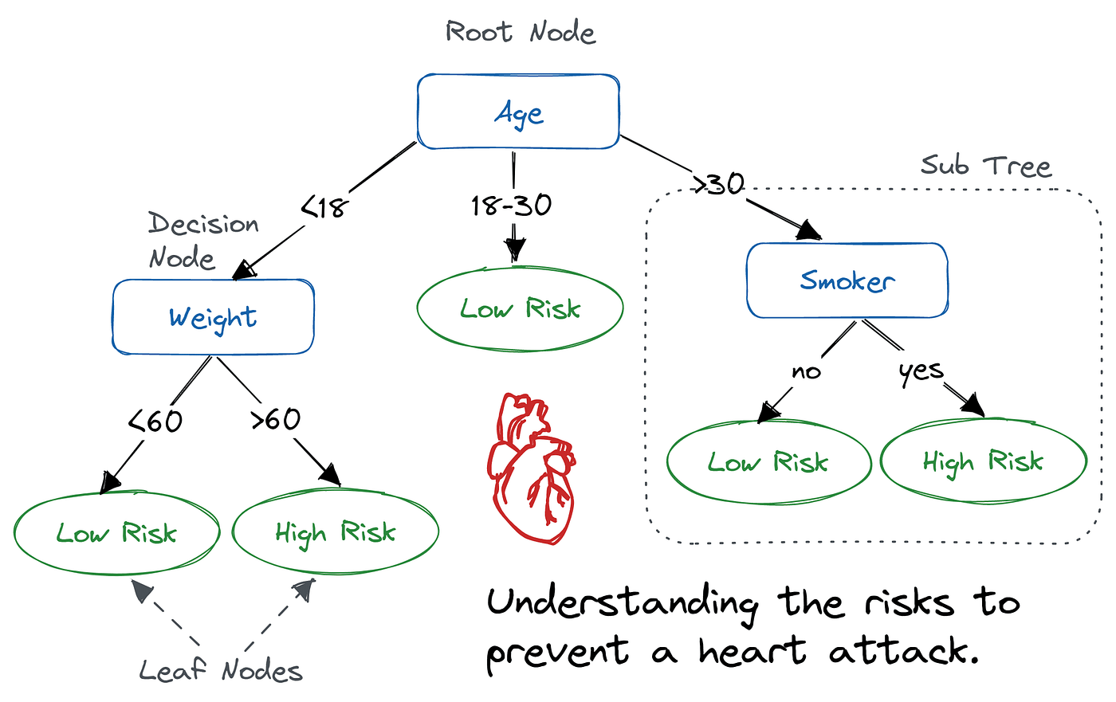

**create a user input python prog for above image**

age = int(input("Enter your age: "))

weight = float(input("Enter your weight (in kg): "))

smoker = input("Are you a smoker? (yes/no): ").strip().lower()

# Decision Tree Logic

if age < 18:

if weight < 60:

risk = "Low Risk"

else:

risk = "High Risk"

elif 18 <= age <= 30:

risk = "Low Risk"

else: # age > 30

if smoker == "yes":

risk = "High Risk"

else:

risk = "Low Risk"

# Output result

print("\n--- Heart Attack Risk Analysis ---")

print(f"Age: {age}")

print(f"Weight: {weight} kg")

print(f"Smoker: {smoker.capitalize()}")

print(f"Predicted Risk: {risk}")