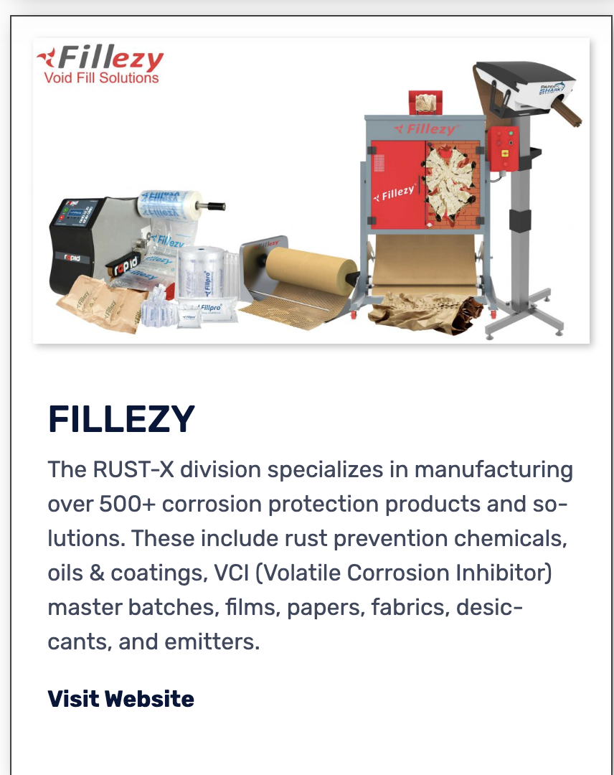

**Product**

**Fillezy**

**Fillezy** is a leading manufacturer of a complete range of paper,hexapaper,void fill, and cushioning solutions that have proven to prevent damages up to 100%.

**Our Products**

**https://www.fillezy.com/shop/**