SIMATS ENGINEERING
ASSESSMENT TOOL 2: Scenario-Based

COURSE NAME: | Cloud Computing and Big Data Analytics | COURSE CODE: | CSA1522

Name | KEERTHANA.L
Register Number | 192521062

COURSE OUTCOME COVERED
CO2: Analyze virtualization architectures to identify performance and security issues in cloud computing environments. (BL3)

Dave's Taxonomy: Manipulation (Level 2)  Question Count: 5 | Total Marks: 25

Code of Conduct
I KEERTHANA.l-(192521062)(Name / Reg No) certify that this submission is my original work and that I have adhered to the guidelines specified for this assessment.
I understand that any violation of academic integrity rules will result in disciplinary action.
Signature of the student: ____________________

Assessment Tasks
Scenario-Based Questions

- A media company wants to migrate its video streaming platform to the cloud.
The system must handle millions of concurrent users with minimal buffering.
Design a cloud architecture using scalability and caching techniques.
Explain how load balancing and auto-scaling can ensure smooth streaming.
Discuss cost optimization strategies for such high-demand workloads.

- A fintech startup is deploying applications using containers across multiple cloud providers.
They face challenges in maintaining consistency and managing deployments.
Propose a solution using container orchestration and multi-cloud strategies.
Explain how service discovery and scaling can be handled efficiently.
Highlight the benefits and risks of a multi-cloud deployment model.

- An e-learning platform experiences data loss due to accidental deletion in the cloud.
The organization needs a robust backup and disaster recovery strategy.
Design a solution using cloud-native backup, replication, and versioning.
Explain how recovery time objective (RTO) and recovery point objective (RPO) are achieved.
Provide steps to ensure business continuity during failures.

- A government agency is adopting a hybrid cloud model for sensitive and non-sensitive data.
Some applications must remain on-premises due to compliance requirements.
Design a hybrid architecture that ensures secure communication between environments.
Explain how identity management and encryption should be implemented.
Discuss challenges in managing hybrid cloud environments.
- A SaaS provider needs to ensure high availability and fault tolerance for its application.
The system must continue operating even if one region goes down.
Propose a multi-region deployment strategy in the cloud.
Explain how data replication and failover mechanisms should be configured.
Discuss monitoring and alerting strategies for proactive issue detection.

Scenario-Based Rubric

Criteria | Weightage | Level 4 - Exemplary | Level 3 - Proficient | Level 2 - Developing | Level 1 - Beginning
Understanding of Scenario | 20% | Demonstrates complete understanding of the scenario context | Good understanding with minor gaps | Partial understanding | Fails to understand the scenario
Identification of Risks / Issues | 20% | Identifies all major issues correctly | Identifies most issues | Limited issue identification | Misses major issues
Application of Concepts | 25% | Applies virtualization concepts effectively | Applies concepts with minor mistakes | Partially correct application | Weak application
Decision Justification | 20% | Decisions are well justified and technically strong | Reasonable justification | Weak justification | No useful justification
Clarity | 15% | Clear and well-organized response | Generally clear | Somewhat unclear | Poorly presented
1. A media company wants to migrate its video streaming platform to the cloud. The system must handle millions of concurrent users with minimal buffering. Design a cloud architecture using scalability and caching techniques. Explain how load balancing and auto-scaling can ensure smooth streaming. Discuss cost optimization strategies for such high-demand workloads.
ANSWER:
Video Streaming Platform in Cloud
A video streaming platform may have millions of users watching videos at the same time. If all requests are handled by one server, it can become overloaded and users may face buffering. A cloud-based architecture can solve this problem.
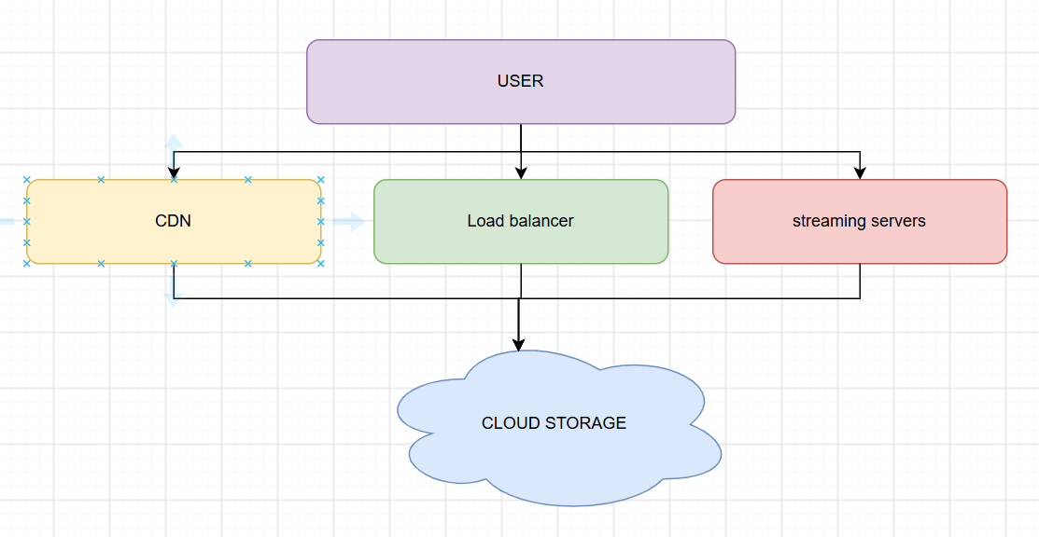
- Videos are stored in cloud storage.
- A CDN keeps popular videos closer to users.
- A load balancer distributes requests between servers.
- Multiple streaming servers can work at the same time.
- Auto-scaling adds or removes servers depending on traffic.
TYPES:
- CDN caching: Frequently watched videos are served from nearby CDN locations.
- Load balancing: User requests are divided between different servers.
- Auto-scaling: More servers are started when the number of users increases.
- Horizontal scaling: New servers can be added instead of depending on one large server.
- Caching: Repeated requests for the same content do not always have to reach the main storage.
For example, if a new movie becomes popular and millions of users start watching it, the CDN can serve most of the video requests. At the same time, auto-scaling can start additional servers to handle the increased application traffic.
The company can control the cost by:
- Removing unused servers when traffic becomes low.
- Using auto-scaling instead of keeping maximum servers running all the time.
- Moving old or rarely watched videos to cheaper storage.
- Using CDN caching to reduce repeated access to storage.
- Monitoring resource usage regularly.
Therefore, CDN, caching, load balancing and auto-scaling together can provide smooth streaming and also prevent unnecessary cloud spending.

2. A fintech startup is deploying applications using containers across multiple cloud providers.They face challenges in maintaining consistency and managing deployments.Propose a solution using container orchestration and multi-cloud strategies.Explain how service discovery and scaling can be handled efficiently. Highlight the benefits and risks of a multi-cloud deployment model.
ANSWER:
Container Deployment Across Multiple Clouds
The fintech startup is using containers on different cloud platforms. Managing these containers separately can cause differences in configuration and deployment. A common orchestration system can make the process easier.

The company can use Kubernetes to manage the container

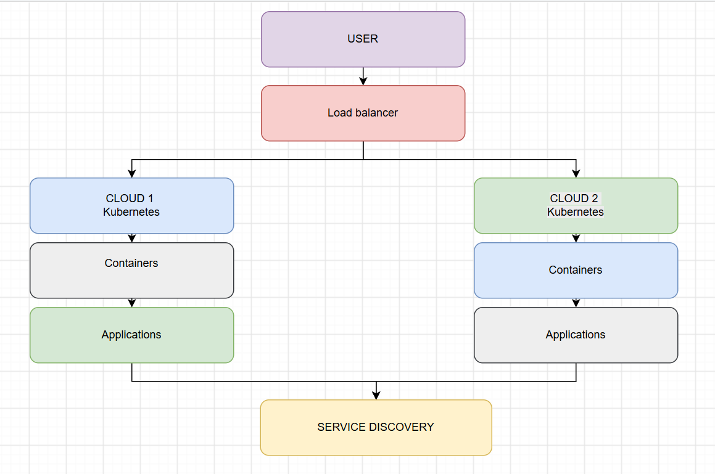
- The application is packaged into containers.
- The same container image can be deployed on different cloud providers.
- Kubernetes manages the containers automatically.
- Deployment configurations can be kept consistent across clouds.
Kubernetes can handle tasks such as:
- Starting and stopping containers.
- Restarting failed containers.
- Deploying new application versions.
- Increasing or decreasing the number of containers.
- Checking whether containers are working properly.
Containers may be created or removed frequently, so their IP addresses can change. Kubernetes services provide a stable way for one application component to find another.
For scaling:
- Low traffic → fewer containers
- High traffic → more containers
- Failed containers can be automatically replaced.
This means the company does not need to manually manage every container.
Advantages:
- Less dependency on one cloud provider.
- Application can continue using another cloud if one provider has problems.
- Different cloud services can be used according to the requirement.
- Provides better flexibility.
Disadvantages:
- Managing multiple clouds is more difficult.
- Monitoring becomes more complicated.
- Data transfer between clouds can increase cost.
- Security settings need to be maintained properly in all environments.
Thus, Kubernetes with a multi-cloud approach can provide consistency and flexibility, but the company must carefully manage security, monitoring and cost.

3.An e-learning platform experiences data loss due to accidental deletion in the cloud. The organization needs a robust backup and disaster recovery strategy. Design a solution using cloud-native backup, replication, and versioning. Explain how recovery time objective (RTO) and recovery point objective (RPO) are achieved. Provide steps to ensure business continuity during failures.
ANSWER:
Backup and Disaster Recovery for E-Learning Platform
The e-learning platform stores important data such as student records, assignments, course materials and exam information. Accidental deletion can cause serious problems, so the organization needs a proper backup and recovery system.

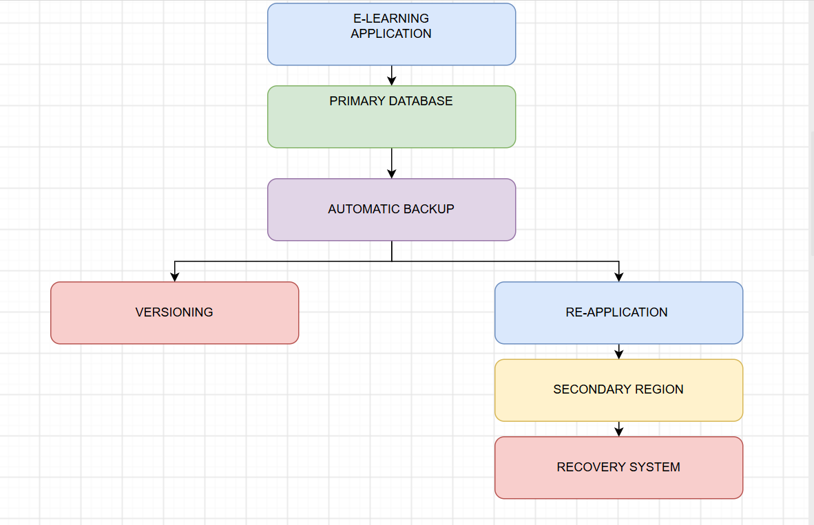
- Important data should be backed up automatically.
- Backups can be scheduled hourly or daily depending on the data.
- Copies should be kept in a different location or region.
- Backup data should also be protected from unauthorized access.
Versioning and replication Comparison:
Versioning :
keeps previous versions of files.
For example, if an assignment file is accidentally deleted, the previous version can be restored instead of creating the file again.

Replication :
keeps a copy of data in another region.
- Primary region → Secondary region
- Data is copied regularly.
- If the primary region fails, the secondary copy can be used.
RTO and RPO
Two important recovery requirements are:
Term | Meaning | Example
RTO | - Maximum acceptable time to restore the service | 30 minutes
RPO | - Maximum acceptable amount of recent data loss | 15 minutes
To achieve a low RPO, backups or replication should happen frequently.
To achieve a low RTO, the recovery process should be automated as much as possible.

- Detect the failure.
- Stop depending on the damaged system.
- Use the latest available backup or replica.
- Start the application in the backup environment.
- Redirect users to the working system.
- Check whether the recovered data is correct.
- Restore the original environment after fixing the problem.
Backup recovery should also be tested regularly because simply having a backup does not guarantee that it can be restored successfully.
Therefore, backup, versioning and replication can reduce data loss and help the e-learning platform continue its service during failures.

4.A government agency is adopting a hybrid cloud model for sensitive and non-sensitive data. Some applications must remain on-premises due to compliance requirements. Design a hybrid architecture that ensures secure communication between environments. Explain how identity management and encryption should be implemented. Discuss challenges in managing hybrid cloud environments.
ANSWER:
Hybrid Cloud for Government Agency
The government agency has both sensitive and non-sensitive information. Since some information has to remain within the organization's premises, a hybrid cloud is suitable.
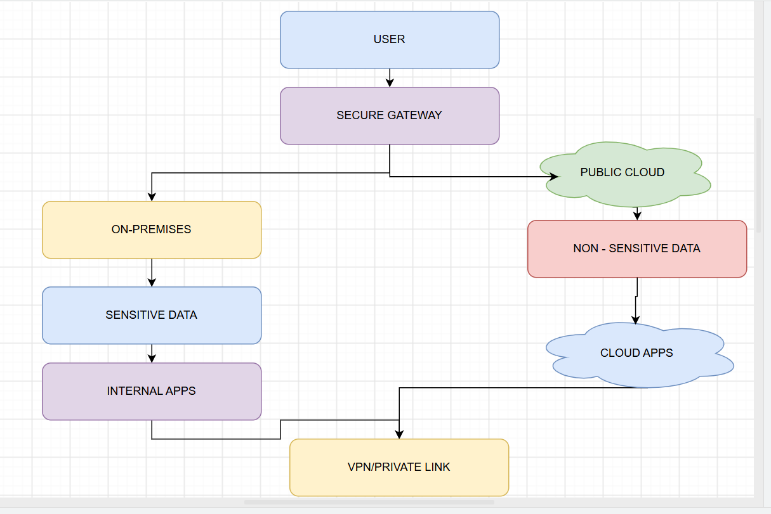
- Sensitive government data
- Applications covered by compliance rules
- Internal systems

Through VPN :
- Non-sensitive applications
- Public websites
- Workloads that need extra computing resources
Both environments can communicate through a VPN or private connection.
The connection between the two environments should be protected using:
- VPN or private network connection
- Firewalls
- Secure communication protocols
- Network segmentation
- Access rules
Only required systems should be allowed to communicate. For example, a cloud application should not automatically get access to the complete government network.
Identity and access
Identity management is important because many employees may use both environments.
- Give each user a separate account.
- Use role-based access control (RBAC).
- Give only the permissions required for the user's job.
- Use multi-factor authentication for important accounts.
- Remove access when an employee no longer needs it.

Data should be encrypted:
- At rest: while stored in databases or cloud storage.
- In transit: while moving between the cloud and on-premises systems.
- Encryption keys should also be stored and managed securely.
Some common challenges are:
- Managing two different environments.
- Maintaining the same security policies.
- Monitoring both cloud and on-premises systems.
- Network configuration problems.
- Higher management complexity.
- Meeting government compliance requirements.
Therefore, hybrid cloud gives the agency the advantage of keeping sensitive data on-premises while still using cloud resources for other applications.

5. A SaaS provider needs to ensure high availability and fault tolerance for its application. The system must continue operating even if one region goes down. Propose a multi-region deployment strategy in the cloud. Explain how data replication and failover mechanisms should be configured. Discuss monitoring and alerting strategies for proactive issue detection.
ANSWER:
Multi-Region SaaS Application
A SaaS application should remain available even if one cloud region fails. If everything is hosted in one region, a regional failure can make the application unavailable. A multi-region setup can reduce this risk.

Users → Global Load Balancer → Region 1 / Region 2 → Application Servers → Database
- The application is deployed in more than one region.
- Each region has multiple application servers.
- A global load balancer sends users to a healthy region.
- Auto-scaling can add servers when traffic increases.
The database also needs a copy in another region:
- Data from the main database is replicated to another region.
- Replication keeps the second region updated.
- The choice between synchronous and asynchronous replication depends on the application's requirements.
If the main region fails, the second region can use its available database copy.
For example,
if Region 1 fails:
- Health checks detect the failure.
- The load balancer stops sending traffic to Region 1.
- User requests are redirected to Region 2.
- Region 2 uses the replicated data.
- Application servers in Region 2 handle the users.
- After Region 1 is repaired, it can be brought back into the system.
This process is called failover.

The provider should continuously monitor:
- Server health
- Application errors
- Response time
- CPU and memory usage
- Database health
- Network traffic
- Replication status
Alerts can be sent to the technical team when a serious problem is detected.
Advantages:
- Less downtime
- Better availability
- Protection from regional failures
- Users can be redirected automatically
- Application can handle traffic from different locations
Therefore, deploying the SaaS application across multiple regions with replication, monitoring and automatic failover provides better availability and fault tolerance.

