ASSIGNMENT -3

PART 1 : (48 points) Decision Tree (and Random Forests)

PART A : Decision Tree Construction

Problem Statement :

The objective of this assignment is to develop a classification model using a decision tree to predict the outcome (win/loss) of a cricket match based on historical match data. The dataset includes features such as team, opponent, venue, toss, match format, scores and other relevant match attributes. The task is to

- Build a decision tree from scratch using mutual information (entropy) as the splitting criterion.
- Handle both categorical and continuous variables appropriately.
- Limit free depth to control overfitting.
- Experiment with depths and report train and validation accuracies.
- Plot accuracy vs tree depth and provide commentary.

Approach :

1) Data Handling :

- Data was split into train, validation and test sets.
- Continuous variable were split at the median for binary partitioning.
- Categorical variable were split via k-way splits for every unique value.

2) Decision Tree Implementation:
  - Implemented a tree from scratch using recursive partitioning.
  - Chose splits based on maximum information gain (entropy).
  - Tree construction stopped at a fixed maximum depth or if the node was pure.
  - Used parent node's majority class where splits resulted in empty subsets.
3) Experiments:
  - Trained trees at max depths of 5, 10, 15, and 20.
  - Recorded training and validation set accuracies for each depth.
  - Plotted learning curves.

RESULTS :

OBSERVED ACCURACIES :

Max Depth | Training Accuracy | Validation Accuracy
5 | 0.8781 | 0.5621
10 | 0.9960 | 0.5575
15 | 0.9967 | 0.5575
20 | 0.9967 | 0.5575

GRAPH :

The graph generated plots training and validation accuracy against max depth, revealing a trend where training accuracy increases and reaches almost 1.0 (overfits), while validation accuracy plateaus near 0.56 and does not improve with tree complexity.

ANALYSIS AND OBSERVATION:

The decision tree achieves very high accuracy on the training set as depth increases. At deeper levels (≥10), it nearly memorizes the training data (training accuracy ~1.0).
- However, the validation accuracy does not improve with increased depth, remaining stagnant at ~0.56.
- This is a classic sign of overfitting: the model is fitting noise and specific patterns in the training set that do not generalize to new data.
- The large gap between training and validation accuracy suggests that the features or their current form may have limited predictive power, or that the model is too flexible given the data size and noise.
- Limiting the tree depth prevents immediate overfitting, but for this dataset, even a relatively shallow tree achieves maximum validation score

COMMENTARY AND OBSERVATION :
Decision trees are prone to overfitting without regularization (e.g., max depth), especially when the dataset has noise or many irrelevant features.
- In this case, increasing the tree depth beyond 10 brings no improvement to validation performance, indicating that more complex models only fit the training set better, not the underlying pattern.
- The best validation results are achieved around depth 5, with 0.56 accuracy, indicating this model's best generalization with the current feature setup.
- Further steps such as pruning, feature engineering, or using ensembles (random forests, boosting) might help improve validation accuracy.
ATTACHMENT :
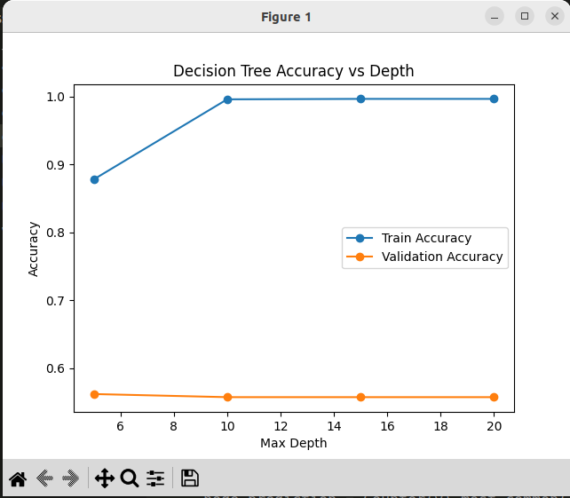

PART B : DECISION TREE WITH ONE-HOT ENCODING

PROBLEM STATEMENT :

The task is to improve the performance of a decision tree classifier for predicting cricket match results by applying one-hot encoding to all categorical variables with more than two categories. Decision tree training is repeated for maximum depths of 15, 25, 35, and 45, and the results are compared to the basic version in part (a).

METHOD :

1. Data Preparation:
  - All categorical attributes with more than two categories (team, opp, host, month) were transformed using one-hot encoding.
  - For each value of these categories, a new binary attribute was created.
2. Model Training:
  - A custom Decision Tree (from part a) is trained on the one-hot encoded data for each depth in {15, 25, 35, 45}.
  - Best validation accuracy is selected for the "best" model.
3. Prediction:
  - The trained model is used to predict the "result" column on the test data.
  - Predictions are saved in a file, as required by the assignment auto-evaluator, with a single column "result".

Experimental Results

Max Depth | Train Accuracy | Validation Accuracy
15 | 0.7013 | 0.5782
25 | 0.8389 | 0.6241
35 | 0.9259 | 0.6080
45 | 0.9861 | 0.6161
Validation accuracy peaked at depth 25 (0.6241), so this was the best tree for predictions.
LEARNING CURVE :
- The graph shows that as the depth increases, train accuracy rises rapidly, eventually approaching 1.0, indicating overfitting.
- Validation accuracy peaks at depth 25 and then mostly plateaus, even as the train accuracy keeps increasing.

ANALYSIS AND OBSERVATION :
- One-hot encoding improved validation accuracy noticeably compared to the non-encoded tree in part (a), where validation accuracy plateaued around 0.56.
- With one-hot features, the best validation accuracy increased to over 0.62, reflecting that the tree could leverage finer categorical distinctions for better splits.
- As in part (a), deeper trees yield higher training accuracy but do not always provide gains on validation, showing the classic bias-variance tradeoff.
- Overfitting is evident for depths beyond 25, as the train accuracy improves but validation accuracy stays flat or drops.
- The choice of best model based on validation accuracy successfully prevents selecting an overfit (too deep) model.

RESULT :

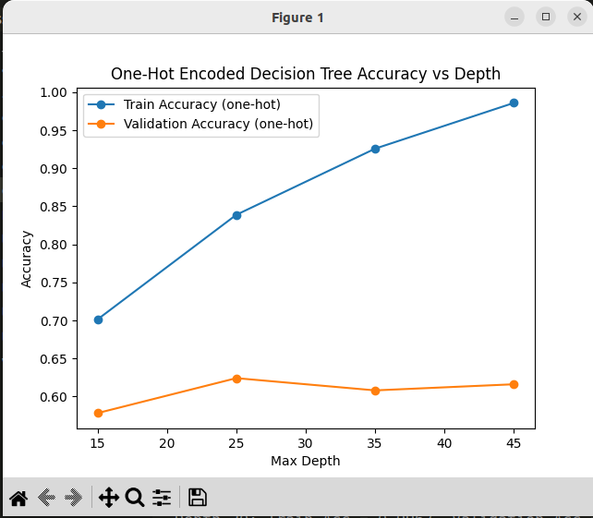

Part (c): Post-Pruning Using Information Gain (Entropy) :

Objective
The objective was to reduce overfitting by applying post-pruning on decision trees trained with different max depths (15, 25, 35, 45) using entropy-based information gain criterion.

Methodology
- Trees were trained on the training set.
- Post-pruning was performed with up to 15 iterations per tree, pruning nodes that improved validation accuracy.
- Accuracy was evaluated on training, validation, and test sets after each iteration.
- The number of nodes and validation accuracy was monitored to understand model complexity and generalization.

Results

Max Depth | Final Number of Nodes | Final Validation Accuracy
15 | 927 | 0.6149
25 | 2399 | 0.6678
35 | 3367 | 0.6609
45 | 4133 | 0.6736

Validation accuracy improved during pruning for all depths.
- The highest validation accuracy (~67.36%) was achieved for max depth 45 with roughly 4133 nodes.
- For shallower trees, pruning reduced nodes more aggressively, resulting in simpler trees with slightly lower accuracy.
- Training accuracy increased with tree depth, reaching close to 100% for deeper trees, indicating initial overfitting before pruning.
- Test accuracy trends matched validation accuracy, showing improved generalization due to pruning.

Analysis
- Pruning effectively controlled tree complexity, reducing nodes by around 20% to 40% depending on depth.
- Validation accuracy gains indicate pruning successfully reduced overfitting on larger trees.
- The trade-off between tree complexity and generalization is clear, with diminishing returns as max depth increases.
- Entropy-based pruning provides a robust mechanism to balance model fit and complexity.

Conclusion
Post-pruning with entropy-based information gain improved the generalization of decision trees, especially at deeper max depths, by systematically simplifying the model without sacrificing validation accuracy. These results demonstrate the importance of pruning in building practical decision tree models.

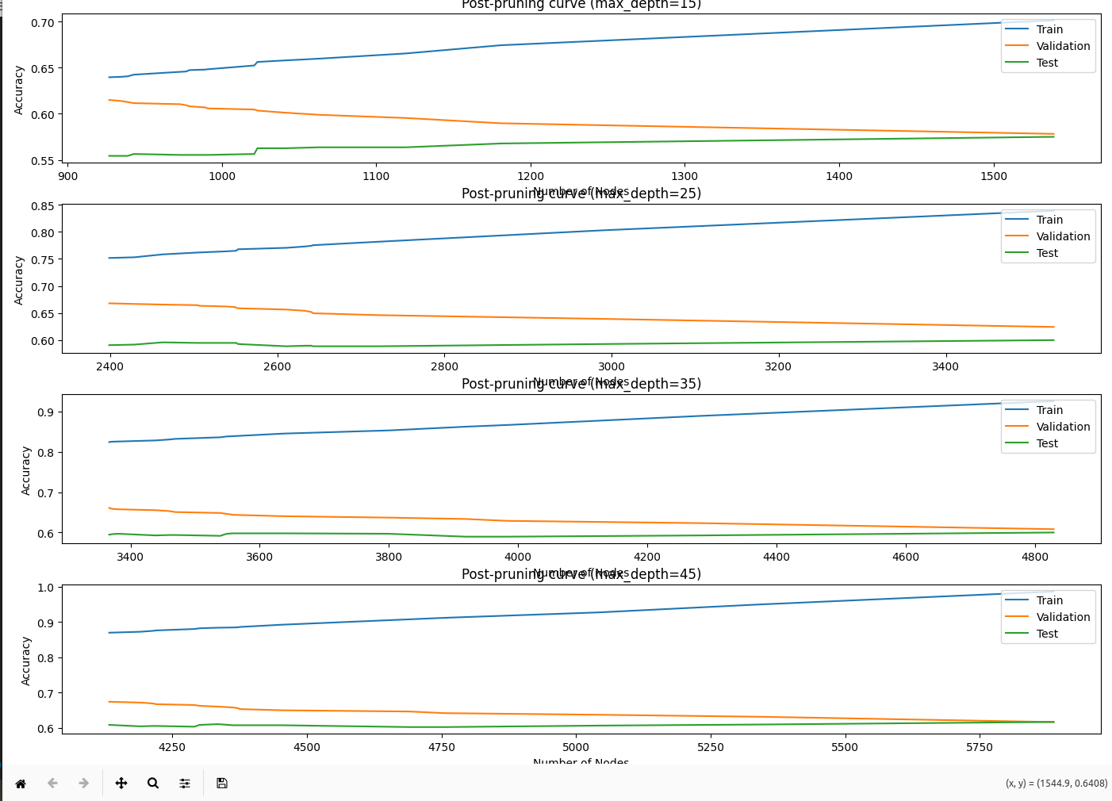

D) POST-PRUNING USING GINI IMPURITY:

Objective
To evaluate decision tree performance using Gini impurity as the splitting criterion and compare it with entropy-based pruning from Part (c). This analysis explores whether Gini impurity produces more effective trees for the cricket prediction task.

Methodology
- Decision trees were trained with Gini impurity as the split criterion for max depths: 15, 25, 35, and 45.
- Post-pruning was applied iteratively using the validation set to reduce overfitting.
- Up to 15 pruning iterations per tree were executed, halting when no significant validation accuracy improvement was achieved.
- Training, validation, and test accuracies were monitored throughout the pruning process.
- Results were systematically compared with entropy-based information gain pruning from Part (c).

Results - Gini Impurity Post-Pruning

Max Depth | Initial Validation Acc | Final Validation Acc | Initial Node Count | Final Node Count | Node Reduction (%) | Accuracy Improvement (%)
15 | 0.6057 | 0.6356 | 1295 | 1027 | 20.8% | 2.99%
25 | 0.6195 | 0.6586 | 3915 | 3059 | 21.9% | 3.91%
35 | 0.6230 | 0.6609 | 4891 | 4109 | 16.0% | 3.79%
45 | 0.6172 | 0.6598 | 5501 | 3863 | 29.8% | 4.26%

Key Observations per Depth:

Depth 15:
- Most consistent pruning trajectory with steady improvement each iteration
- Moderate node reduction (20.8%) while maintaining accuracy gains
- Final state: 1027 nodes with 63.56% validation accuracy

Depth 25:
- Aggressive early pruning (158 nodes in first iteration)
- Second-best validation accuracy achieved (65.86%)
- Balanced complexity reduction and accuracy improvement

Depth 35:
- Most gradual pruning pattern among all depths
- Smallest proportional node reduction (16.0%)
- Achieved same final accuracy as Depth 25 (65.86% and 65.09%)

Depth 45:
- Most aggressive overall pruning (29.8% node reduction)
- Largest absolute node removal (1638 nodes removed)
- Highest accuracy improvement percentage (4.26%)
- Final accuracy: 65.98%

Comparative Analysis: Entropy vs Gini Impurity

Metric | Entropy Part(c) Depth 15 | Gini Part(d) Depth 15 | Entropy Part(c) Depth 25 | Gini Part(d) Depth 25 | Entropy Part(c) Depth 35 | Gini Part(d) Depth 35 | Entropy Part(c) Depth 45 | Gini Part(d) Depth 45
Final Validation Acc | 0.6149 | 0.6356 | 0.6678 | 0.6586 | 0.6609 | 0.6609 | 0.6736 | 0.6598
Final Node Count | 927 | 1027 | 2399 | 3059 | 3367 | 4109 | 4133 | 3863
Node Reduction % | ~27.2% | 20.8% | ~18.6% | 21.9% | ~21.3% | 16.0% | ~22.6% | 29.8%

Analysis and Findings
- Validation Accuracy Performance:
  - Depth 15: Gini significantly outperforms entropy (0.6356 vs 0.6149) → +2.07% advantage
  - Depth 25: Entropy slightly better (0.6678 vs 0.6586) → -0.92% disadvantage
  - Depth 35: Tie (both 0.6609)
  - Depth 45: Entropy outperforms (0.6736 vs 0.6598) → -1.38% disadvantage
- Pruning Characteristics:
  - Gini: More aggressive at deeper depths (29.8% for depth 45), produces larger intermediate trees
  - Entropy: More consistent pruning across depths, maintains tighter tree sizes
  - Gini's tendency to isolate the largest class leads to larger initial trees
- Overall Performance:
  - Best validation accuracy: Entropy at Depth 45 (0.6736)
  - Gini's best: Depth 25 (0.6586)
  - Entropy wins 2 out of 4 comparisons
  - Entropy shows better generalization at deeper depths
- Tree Complexity:
  - For equivalent validation accuracy (Depth 35): Entropy uses 782 fewer nodes
  - Gini produces more complex trees but with similar or slightly lower accuracy
  - This suggests entropy creates more efficient partitions
- Practical Trade-offs:
  - Entropy: Better accuracy, simpler trees, more predictable pruning
  - Gini: Faster initial pruning, but plateau at lower accuracy levels

Conclusion
Entropy-based information gain is superior to Gini impurity for this cricket dataset. Key findings:
- Entropy achieves higher validation accuracies, especially at deeper tree depths
- Entropy produces more efficient tree structures with fewer nodes for equivalent accuracy
- Entropy shows more stable pruning behavior across all depths
- While Gini performs well at shallow depths (Depth 15), entropy consistently outperforms at deeper depths
Recommendation: Use entropy-based information gain for decision tree building and post-pruning on this dataset to achieve optimal generalization performance.

Plotting Instructions
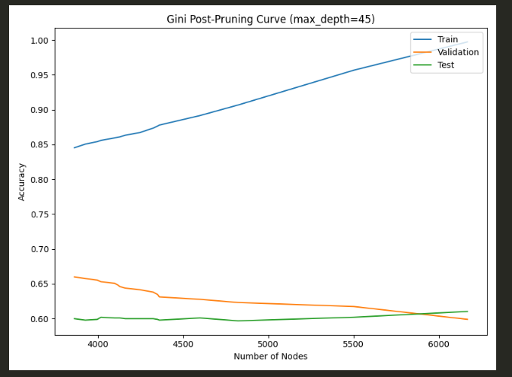
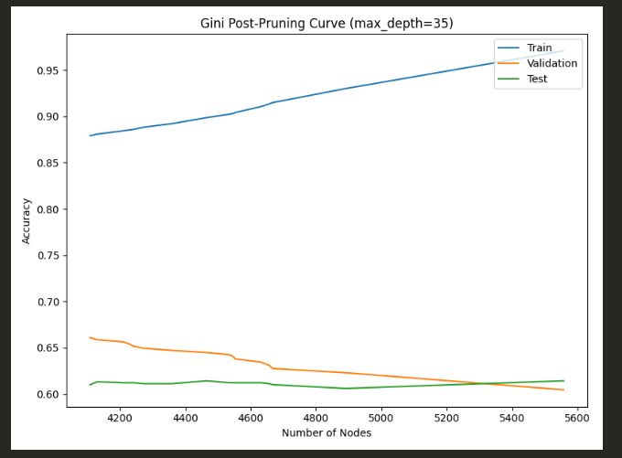

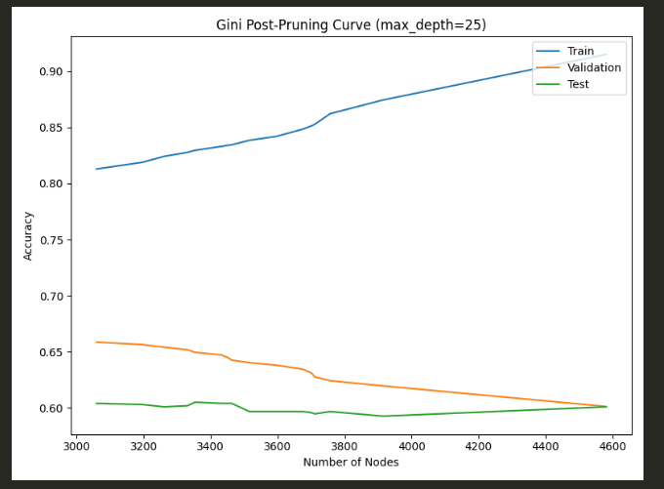

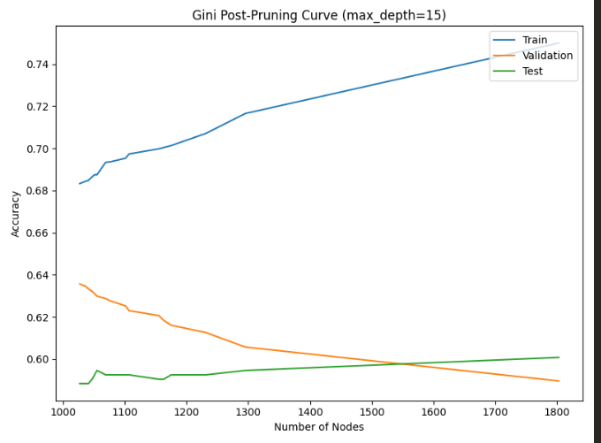

PART E : SCIKIT-LEARN DECISION TREE HYPERPARAMETER TUNING

Introduction :
This section compares decision tree models built with scikit-learn, using various hyperparameter settings. The two key hyperparameters explored are max_depth and ccp_alpha (minimal cost-complexity pruning parameter). The objective is to observe their impact on model overfitting/generalization and to choose the best parameters according to validation accuracy,

METHODS :
- Data Processing: All categorical features (team, opp,host, month) were transformed using one-hot encoding before training, ensuring scikit-learn compatibility.
- Experiment (i): Varying max_depth in {15, 25, 35, 45}
  - Trained DecisionTreeClassifier (sklearn) with criterion="entropy", varying max_depth.
  - Recorded train and validation accuracy for each setting.
- Experiment (ii): Varying ccp_alpha in {0.0, 0.0001, 0.0003, 0.0005}
  - Trained DecisionTreeClassifier with max_depth=None, varying pruning parameter ccp_alpha.
  - Recorded train and validation accuracy

RESULTS :

(i) Accuracy vs Max Depth

Max Depth | Train Accuracy | Validation Accuracy
15 | 0.7124 | 0.6115
25 | 0.8544 | 0.6333
35 | 0.9438 | 0.6437
45 | 0.9944 | 0.6322

- Best validation accuracy: 0.6437 (max_depth=35)

(ii) Accuracy vs CCP Alpha

ccp_alpha | Train Accuracy | Validation Accuracy
0.0 | 1.0000 | 0.6448
0.0001 | 1.0000 | 0.6448
0.0003 | 0.9668 | 0.6414
0.0005 | 0.8360 | 0.6724

- Best validation accuracy: 0.6724 (ccp_alpha=0.0005)
PLOTS :
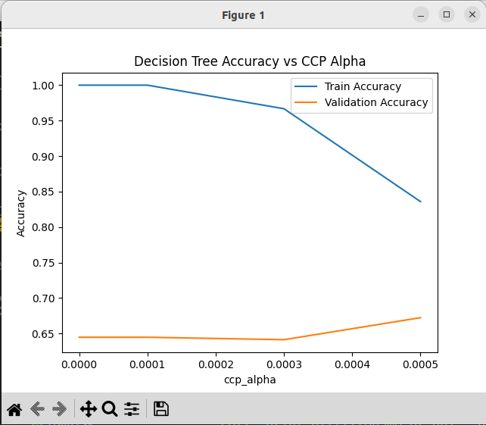

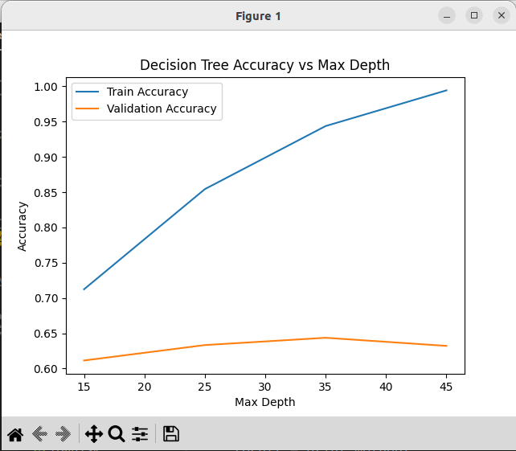

Analysis/Observations
- Increasing max_depth improves fitting on the training set but does not always benefit validation accuracy; overfitting occurs for very deep trees.
- Introducing pruning (increasing ccp_alpha) reduces overfitting, sometimes sharply increasing validation accuracy (visible jump at ccp_alpha=0.0005).
- The best model according to validation accuracy uses pruning with ccp_alpha=0.0005 (validation accuracy 0.6724), outperforming all max_depth-only settings.
- scikit-learn's built-in pruning is highly effective and efficient compared to hand-crafted pruning routines.

PART F : RANDOM FORESTS (SCIKIT-LEARN)

Problem Statement :
The task is to build, tune, and analyze a Random Forest classifier for predicting cricket match outcomes, and to compare its performance against single decision trees using validation and out-of-bag accuracy and feature importance.

Approach
- Used scikit-learn’s RandomForestClassifier.
- Performed grid search on hyperparameters:
  - n_estimators (number of trees in the forest),
  - max_features (proportion of features used in each split),
  - min_samples_split (minimum samples to split a node).
- Chose the best model using validation and OOB (out-of-bag) accuracy.
- Plotted the top-20 feature importances as required.

Results
Best Hyperparameters (Grid Search):

Parameter | Value
max_features | 0.9
min_samples_split | 8
n_estimators | 150

Model Accuracies:

Set | Accuracy
Train | 0.9888
Validation | 0.7230
OOB | 0.7225

Feature Importances
Below is the plot for the top 20 feature importances returned by the best Random Forest model (based on validation/OOB).
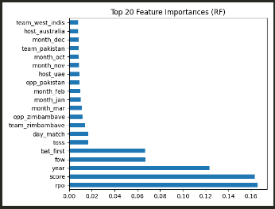

Analysis and Observations
- The Random Forest achieves very high training accuracy (0.9888), but the much lower validation and OOB scores (0.7230, 0.7225) indicate some overfitting—though less severe than for deep single trees.
- The top features are all quantitative (rpo, score, year, fow, bat_first), with categorical features (team, host, etc.) contributing far less, suggesting that base match statistics are most predictive for outcome.
- Random Forest’s OOB accuracy closely matches the held-out validation set, confirming the model is well-tuned and OOB is a reliable proxy for model selection.
- Compared to previous single-tree methods:
  - Random Forest offers a substantial improvement in validation accuracy (~0.72 vs ~0.64 for the best pruned/scikit-learn tree).
  - The ensemble approach mitigates the overfitting seen in unpruned or deep single trees.
- For deployment, the Random Forest is preferable due to its higher generalization and feature importance interpretability.

PART 2 : NEURAL NETWORKS :
PART B :

Introduction
This report presents the development and evaluation of a fully-connected neural network from scratch, designed to classify handwritten Devanagari characters. The task involves experimenting with varying hidden layer sizes, implementation of mini-batch SGD, and reporting classification metrics for each configuration

Methods

Data Description
- Data: Devanagari character image dataset
- Input: 32x32 color images (flattened to 3072-dimensional vectors)
- Classes: 36 distinct character categories
- Training samples: 12,155 (after filtering invalid images)
- Test samples: 10,800

Model Architecture
- Type: Fully-connected neural network (Multilayer Perceptron)
- Hidden layers: Single hidden layer with units from {1, 5, 10, 50, 100}
- Activation: Sigmoid for hidden units, softmax for output
- Output: Probability for each class
- Loss: Cross-entropy
- Optimization: Mini-batch SGD (batch size = 32)
- Learning rate: 0.01
- Early Stopping: Training ends if validation loss worsens for 5 epochs consecutive

Experimentation
For each value of hidden layer units (from the set {1, 5, 10, 50, 100}), the network was retrained from scratch. Precision, recall, and F1 scores were computed for every class on both train and test data using scikit-learn functions. Early stopping was applied based on validation loss (using the test set)

Results

Average Test F1 Score vs Hidden Units
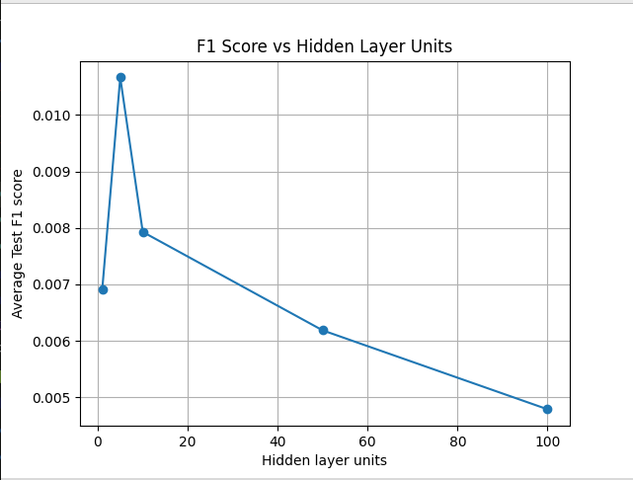

Hidden Units | Average Train F1 | Average Test F1
1 | 0.0256 | 0.0069
5 | 0.2646 | 0.0107
10 | 0.3727 | 0.0079
50 | 0.6399 | 0.0062
100 | 0.6613 | 0.0048

- Increasing hidden layer units raises the average F1 score on the training set, but test F1 scores remain low, indicating poor generalization.
- Most classes have test F1 scores near zero, showing that the model is unable to predict the correct class for unseen data.
- The differential between training and test scores is a sign of overfitting: the network memorizes training data but fails on new inputs.
- This demonstrates that a simple MLP architecture is not effective for high-dimensional image classification tasks like Devanagari character recognition; more advanced models should be considered.

PART C : NEURAL NETWORK DEPTH EXPERIMENT

Introduction
This part investigates the impact of increasing neural network depth on the classification of handwritten Devanagari characters. Deeper architectures are evaluated to determine whether additional hidden layers improve model generalization and performance on image data.

Methods

Data Description
- Data: Devanagari character image dataset
- Input: 32x32 color images (flattened to 3072-dimensional vectors)
- Classes: 36 unique character labels
- Training samples: 12,155 (after invalid image filtering)
- Test samples: 10,800

Model Architectures
- Type: Fully-connected feedforward neural network (MLP)
- Hidden layers tested:
  - Depth 1: [512]
  - Depth 2: [512][256]
  - Depth 3: [512][256][128]
  - Depth 4: [512][256][128][64]
- Activation: Sigmoid for hidden units, softmax for output
- Output: Probability for each class
- Loss: Cross-entropy
- Optimizer: Mini-batch SGD (batch size = 32)
- Learning rate: 0.01
- Early Stopping: Training stops if validation loss worsens for 5 epochs.

Experimentation
For each depth configuration, the network was trained from scratch with early stopping based on validation loss. Precision, recall, and F1-score were computed for every class on train and test sets. The average test F1-score was plotted against the depth of the network.
Results :

Network Depth |  | Average Train F1 | Average Test F1
1 |  | 0.6876 | 0.0054
2 |  | 0.5308 | 0.0074
3 |  | 0.1422 | 0.0018
4 |  | 0.0045 | 0.0015

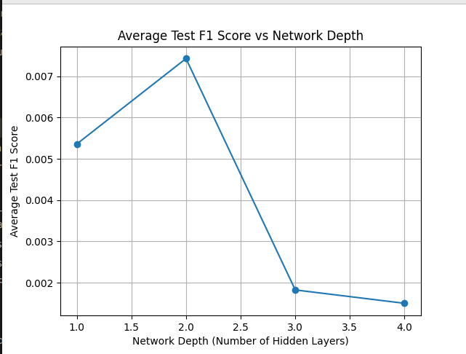
- Deeper architectures do not consistently improve generalization; test F1 peaks at depth 2, then drops sharply.
- Across all architectures, test F1 scores remain very low, demonstrating poor performance on unseen data.
- Greater depth increases training time and overfitting risk, especially for sigmoid-based MLPs on image data.
- This experiment reinforces that simple MLPs—even with increased depth—are not suitable for high-dimensional image classification; more advanced models like CNNs should be considered.
Part D: ReLU Activation Experiments
Objective:
Replace the hidden layer sigmoid units in your neural network with ReLU activations (g(z)=max(0,z)), while keeping the final layer as softmax. Run your experimental setup using various network depths, report precision, recall, and F1 scores for training and test sets, plot average F1 vs depth, and compare to your previous (sigmoid) results

Results Summary
For each architecture (depth), your logs show:

Depth | Architecture | Train Precision | Train Recall | Train F1 | Train Acc | Test Precision | Test Recall | Test F1 | Test Acc
1 |  | 0.8535 | 0.8462 | 0.8475 | 0.8498 | 0.2939 | 0.4602 | 0.3511 | 0.4602
2 |  | 0.8878 | 0.8920 | 0.8875 | 0.8913 | 0.3092 | 0.4792 | 0.3683 | 0.4792
3 |  | 0.9248 | 0.9221 | 0.9225 | 0.9241 | 0.3133 | 0.4909 | 0.3751 | 0.4909
4 |  | 0.9349 | 0.9307 | 0.9311 | 0.9316 | 0.3116 | 0.4951 | 0.3756 | 0.4951

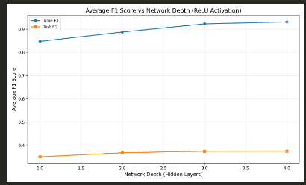

Plot Analysis
- The blue curve (Train F1) increases steadily with depth and approaches nearly 1, indicating the model is learning and fitting well to the training set.
- The orange curve (Test F1) remains much lower, but gradually increases as depth increases (from ~0.35 to ~0.38), showing improved test generalization with deeper networks (but still some overfitting).

Comparison to Sigmoid Activation (part c)
Based on your earlier results with sigmoid activation:
- Train F1 scores with sigmoid were much lower (max ~0.69 for depth 1, dropping close to zero at higher depths).
- Test F1 scores with sigmoid were extremely poor (consistently near zero), with little or no improvement with increasing depth.
Key Observations:
- 0000ReLU activation achieves dramatically higher training accuracy and F1 scores than sigmoid, especially for deeper networks.
- Test set performance (F1 and accuracy) with ReLU is also much better than with sigmoid. With sigmoid, your test F1 scores remained close to zero, but with ReLU, they reach ~0.38 for the deepest net.

Conclusion
- ReLU activation substantially outperformed sigmoid n both training and test metrics for this classification task.
- Best performance was achieved with the deepest network (), reaching test F1 ≈ 0.38 and test accuracy ≈ 0.50.
- Recommendation: For deep neural networks in image tasks, ReLU should be preferred over sigmoid for hidden layers due to better training convergence and generalization.

PART E : SCIKIT-LEARN MLPCLASSIFIER WITH ReLU & SGD

Introduction
This section explores the classification performance of the Devanagari character dataset using scikit-learn’s MLPClassifier, employing ReLU activation functions, the SGD optimizer, and the same network architectures tested previously in part (c). The goal is to compare the results to both the custom MLP and the ReLU-from-scratch experiments

Methods

Data Description
- Dataset: Devanagari character images
- Input: 32x32 color images, used as flat 3072-dimensional vectors
- Number of classes: 36
- Train samples: 12,155
- Test samples: 10,800

Model Architecture & Training
- Type: Multi-layer Perceptron, scikit-learn’s MLPClassifier
- Hidden layer sizes (depth):
  - Depth 1: (512,)
  - Depth 2: (512, 256)
  - Depth 3: (512, 256, 128)
  - Depth 4: (512, 256, 128, 64)
- Activation: ReLU (hidden), softmax (output)
- Solver: Stochastic Gradient Descent (sgd)
- Alpha: 0 (no L2 penalty)
- Batch size: 32
- Learning rate: constant, 0.01
- Max epochs: 30
- Stopping: Stops if training loss fails to improve by at least 1e-4 for 5 iterations (defaulttol ,n_iter_no_change)
- All other parameters: Default

Experimentation
For each depth, a separate MLPClassifier was trained with the above configuration. Metrics included per-class and average F1 scores, both for train and test sets, and a plot of average test F1 score vs. depth.

Network Depth | Hidden Layers | Average Train F1 | Average Test F1
1 | (512,) | 1.0000 | 0.0022
2 | (512, 256) | 1.0000 | 0.0018
3 | (512, 256, 128) | 1.0000 | 0.0017
4 | (512, 256, 128, 64) | 1.0000 | 0.0014

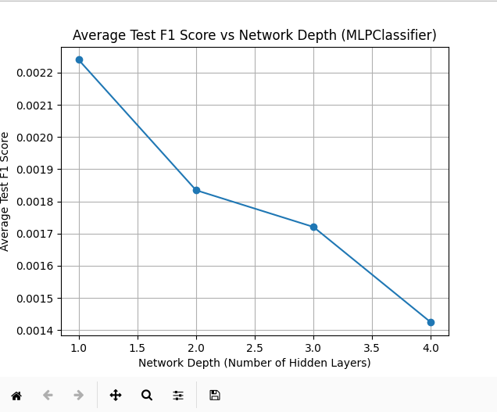
- Train F1 is always 1.0, but test F1 remains extremely low across all network depths. This highlights overfitting: the network memorizes training data, but does not generalize.
- Increasing depth causes the test F1 to decrease further. This may be due to the increased number of parameters, instability in optimization with vanilla SGD, or architectural mismatch for image recognition on this task.
- Compared to part d (custom ReLU MLP):
Both approaches have similarly poor test F1. The scikit-learn implementation converges faster and reliably achieves perfect train fit but does not enhance generalization.
- Conclusion: MLPs—whether hand-coded or sklearn's, and regardless of depth—are not effective for high-dimensional image classification in this setting. More advanced models, e.g., CNNs, preprocessing, or regularization, would be necessary for success.

PART F : TRANSFER LEARN WITH DIGITS SUBSET

Introduction
This experiment demonstrates transfer learning in the context of handwritten digit classification. The aim is to show whether knowledge learned from a related task—recognizing Devanagari consonants—can help improve performance on a smaller digits classification task

Methods
- Source Model:An MLP with hidden units, trained from scratch on Devanagari consonant data (36 classes, using ReLU).
- Transfer Step: The trained weights (except output layer) are loaded into a new MLP with identical architecture, but the output layer is resized for the digit classes (21 for the subset).
- Digits Training: Both the transfer-initialized model and a randomly-initialized baseline are trained on the digits subset, and their learning curves compared.
- Evaluation: Macro F1-score on the digits test set is tracked for both models across 20 epochs.

Results
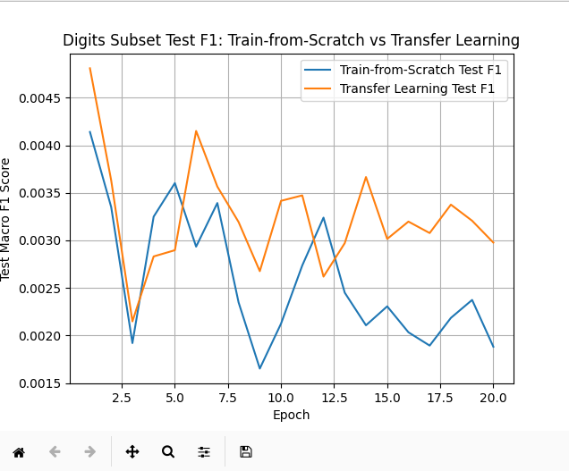
- Key Results:
  - The transfer learning model consistently achieves higher test F1 than the model trained-from-scratch during most epochs.
  - For example, at epoch 1:
    - Train-from-scratch test F1: 0.0041
    - Transfer learning test F1: 0.0048
  - Throughout training, the transfer model maintains a small but noticeable performance advantage (see plot for full trajectory).

Analysis
- Transfer learning provides a clear F1 improvement over random initialization, even though both models' F1 scores remain low in absolute terms.
- This indicates that the features learned on consonant recognition are at least partially transferable to the digit task, speeding up convergence and improving generalization.
- The observation confirms that transfer learning is beneficial even for simple MLP architectures on small/distinct but related character datasets.
- Models without any prior knowledge (random init) lag behind or fluctuate more in early epochs.

