**Git Basics**

Contents

Add existing project to GitHub using the command line 1

Fetch or pull a repository and after making changes push it in the same remote repository 3

Git Branch Commands 6

Collaboration 8

# Add existing project to GitHub using the command line

Download git bash from <https://git-scm.com/downloads> - Git Bash

Open **Git Bash ,** Create a directory and change the path.

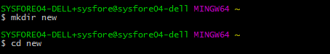

Initialize the local directory as a Git repository.



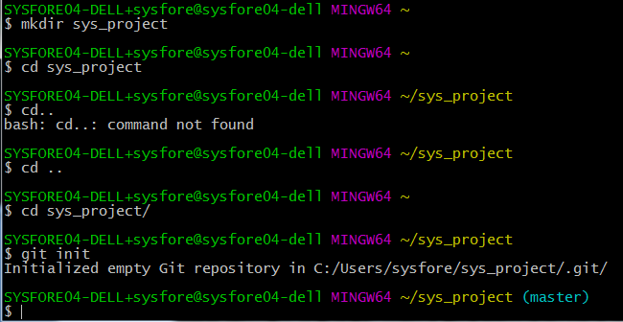

4. Add the files in your new local repository. This stages them for the first commit.

Here you add your HTML files

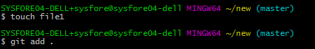

5. Commit the files that you've staged in your local repository.

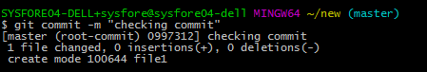

6. At the top of your GitHub repository's Quick Setup page, click  to copy the remote repository URL.

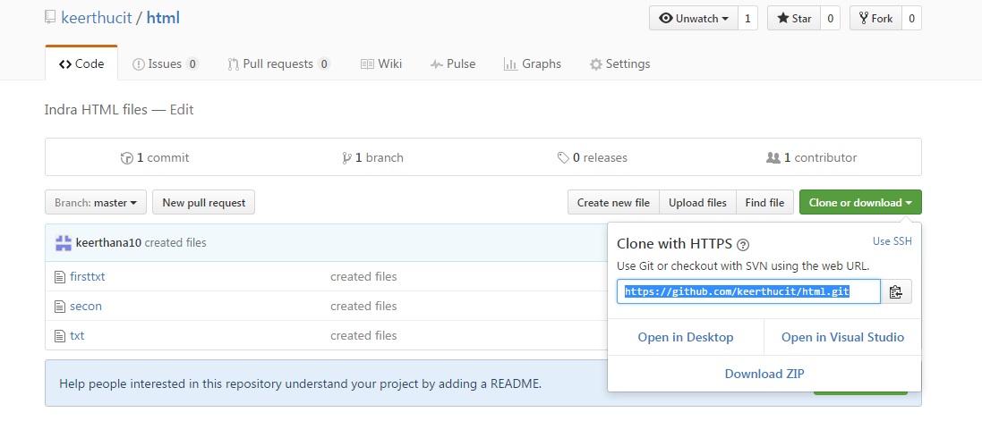7. In the Command prompt, [add the URL for the remote repository](https://help.github.com/articles/adding-a-remote) where your local repository will be pushed.



8.Verify the remote URL

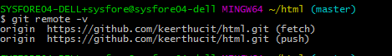

9. [Push the changes](https://help.github.com/articles/pushing-to-a-remote) in your local repository to GitHub.

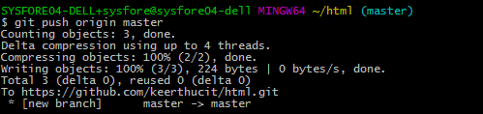

# Fetch or pull a repository and after making changes push it in the same remote repository

1.Clone the repository in Git bash

2. You will find the folder or local repository in the same name of remote repository

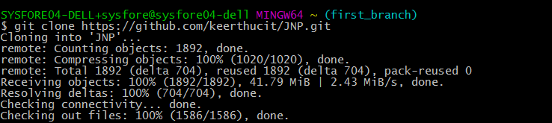

3. Make the changes to files ,add or remove files in the local repository.

4.change the directory to repository name.

5.Add the new files to staging area using git add as usual.

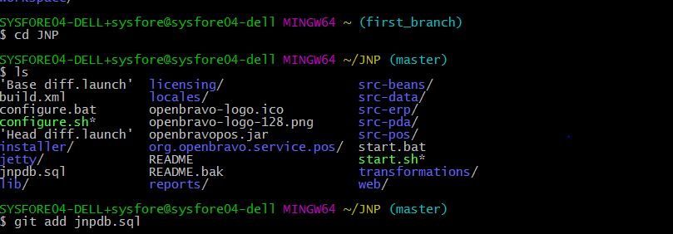

6.perform git commit with relevant message

7.check the remote url with git remote –v

8.Then push the changes in the remote repository using Git push

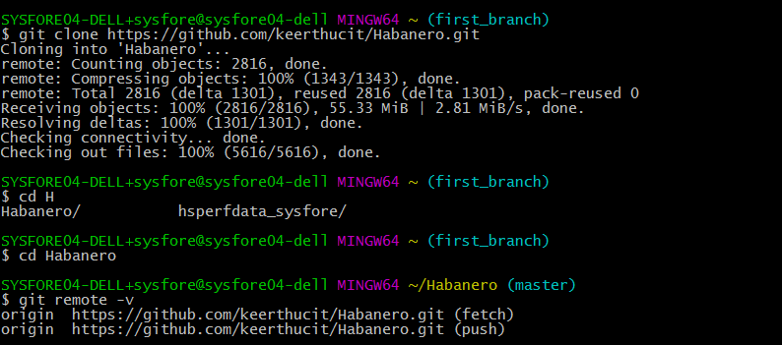

Next example

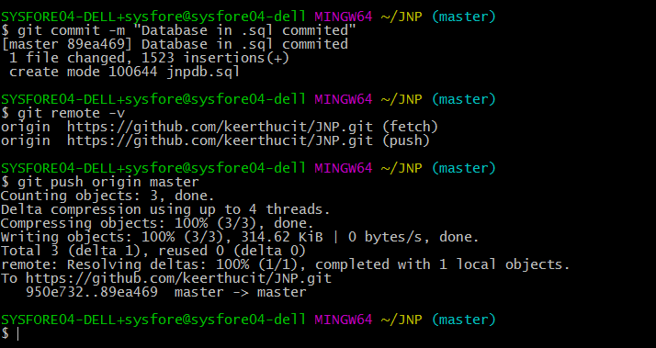

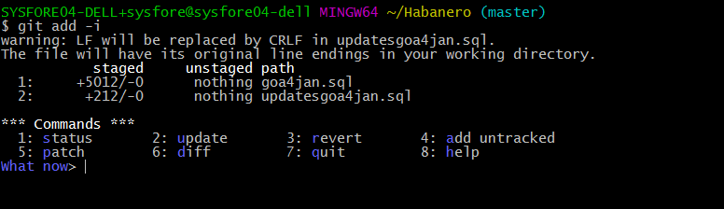

Type the files to be staged say 1 or 2 or 1,2

https://git-scm.com/book/en/v2/Git-Tools-Interactive-Staging

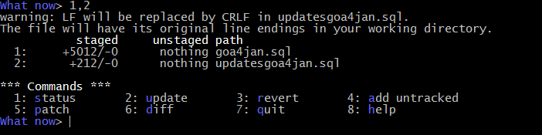

Type 7 to quit

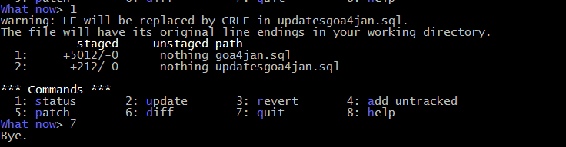

Perform git commit

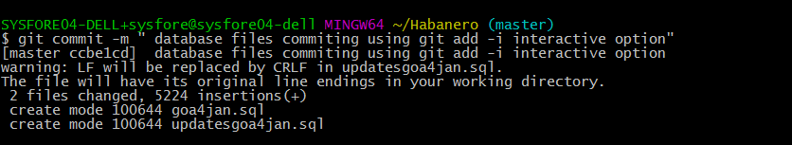

Perform git push

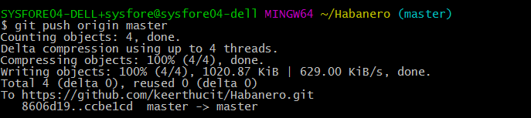

After creating local repository with gint init and files created and commited after git add

Create remote repository using same name as local repo and copy the url and append it to git remote



**Then push the files to remote as**

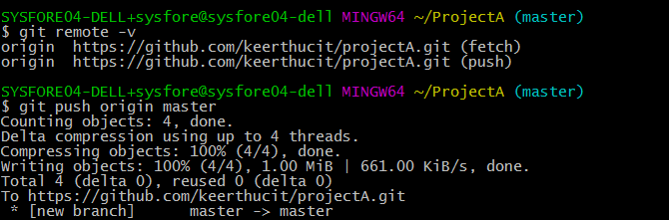

# Git Branch Commands

**1.Create the branch on your local machine and switch in this branch :**

$ git checkout -b [name_of_your_new_branch]

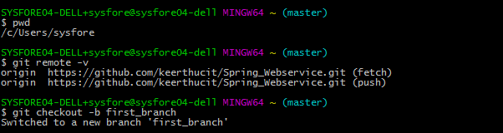

**2.To know all the branches**

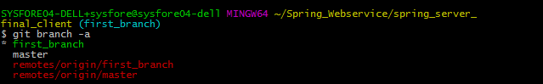

**3.Push the branch on github :** $ git push origin [branch]

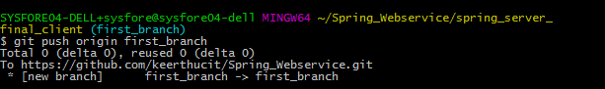

**4.Do some changes to your branch and commit and push to origin**

|  |
| --- |
| * **Git add** * **Git commit** * **Git push** |
|  |  |

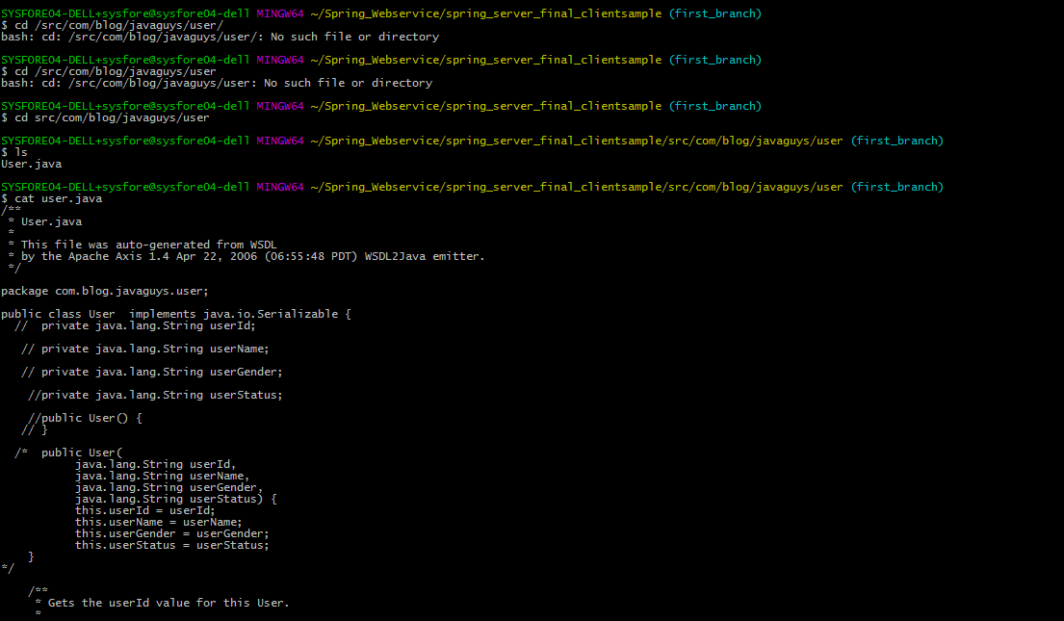

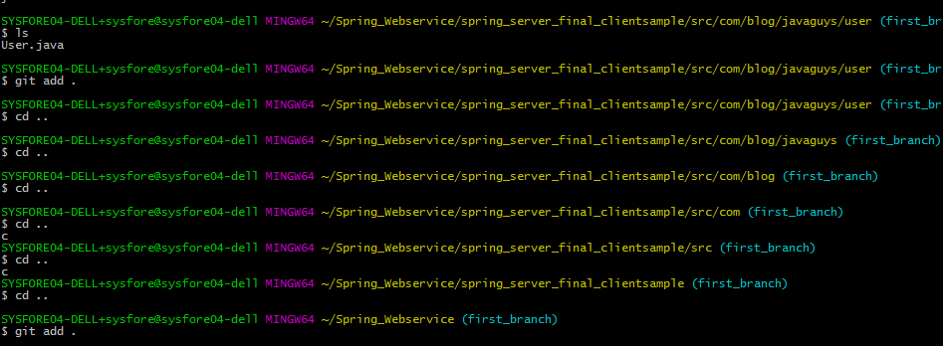

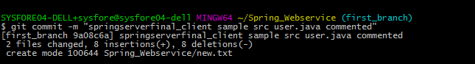

**5.Check remote and branches again**

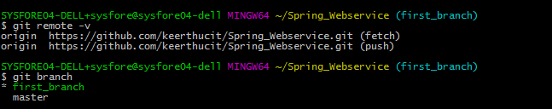

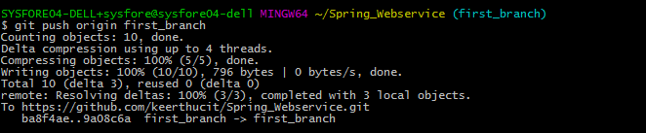

**----------------------------------------------------------------------------End--------------------------------------------------------------------**

# Collaboration

Team members must create branch and push code

1.Clone the new repository you have created in your github account

git clone <https://github.com/keerthucit/HTML.git>

2.i.Check list and find the repository you have created in GitHub with ls command,

Move to the repository you have created in github

cd HTML

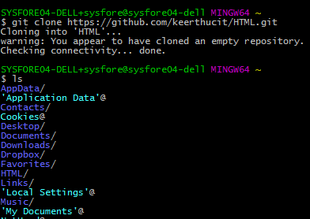



ii.If you want to create branch under master branch ,check with command

git remote



Add branch with command

Git checkout –b *branch name*





3.create files or copy files to be staged in this location

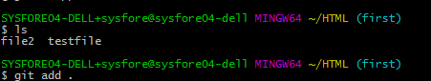

4.git config user.name “keerthana”

5.git config user.email [keerthucit@gmail.com](mailto:keerthucit@gmail.com)

git remote add origin <https://github.com/keerthucit/HTML.git>

Staging area

6.git add .

Keeping staged files ready

7.git commit –m “changes done”

Pushing work tree / commited files in GitHub

8.git push origin master

Account creation

* Sign up github using your mail ID
* Notify me the mail ID
* I will add you as a collaborator for the weather project

Code Collaboration

* First pull from repo – git pull
* Push your changes – git add . ; git commit –m “changes”; git push origin master

