Analysis, Design and Verification of an X-Band Rectangular Waveguide Feed Line for a UAV Weather Radar
ECA13 – Microwave Engineering: CO1 Application-Based Assessment (AY 2027–28)
Maximum Marks: 100 | Bloom's Levels: K4 – K6
Name: Keerthana S Register No.: 192412045

EXECUTIVE SUMMARY
The report follows the chain APPLICATION → STRUCTURE EVALUATION → MODE MODEL AND DESIGN → LOSS EVALUATION → NETWORK / S-PARAMETER MODEL → VALIDATION → ENGINEERING DECISION. The selected application is the feed line between the transmit/receive (T/R) module and the antenna of an X-band weather and obstacle-avoidance radar on a civil UAV, operating from 9.0 to 10.0 GHz over a 0.30 m run. Coaxial, rectangular waveguide, stripline and microstrip were compared; WR-90 waveguide scored highest (3.70 against 3.50 for coax). The TE₁₀ mode has a cutoff of 6.557 GHz and a single-mode range of 6.557 to 13.114 GHz. The initial design (bare aluminium guide, standard adapters, unmatched antenna with VSWR 1.80) has 0.744 dB insertion loss and 10.9 dB return loss, so it fails. Mismatch (49.7 %) and adapter loss (40.3 %) dominate, not conductor loss (9.9 %). The final design adds a two-section reduced-height transformer, silver-plated walls and low-loss adapters, giving 0.206 dB worst-case insertion loss and at least 31.9 dB return loss for ±0.05 mm machining tolerance. The final design is accepted; the initial design is not.
Assumptions used throughout: f₀ = 9.5 GHz, c = 2.998 × 10⁸ m/s, η₀ = 376.73 Ω, copper σ = 5.8 × 10⁷ S/m unless stated, air-filled guide, the antenna port equivalent to a reduced-height guide of impedance Z_{c}/1.8, and negligible susceptance of the height steps (examined in Stage 6).

STAGE 1 – FORMULATION OF THE APPLICATION AND OPERATING REQUIREMENT
1.1 Application and importance. A civil UAV flying beyond visual line of sight needs a weather and obstacle-avoidance radar that fits in a payload bay of a few hundred grams. The transmission structure between the T/R module and the antenna decides how much of the radar's power reaches the air and how much of the weak echo reaches the receiver, because every dB lost in the feed is lost twice in the radar range equation. The same feed topology is used in military airborne radar; in the EMI/EMC domain it matters because a UAV carries GNSS, telemetry and video links within centimetres of a radiator of 20 W average power, so the feed must not leak.
Historical development. Maxwell's equations (1865) predicted electromagnetic waves and Hertz (1887) produced and detected them at metre wavelengths. Hollow metal-pipe guiding was demonstrated by Southworth and by Barrow at Bell Laboratories and MIT in 1936. The cavity magnetron (Randall and Boot, Birmingham, 1940) delivered kilowatts at centimetre wavelengths and made airborne radar possible. Satellite links followed (Telstar, 1962), then planar circuits and MMICs from the 1970s, and today 5G/6G millimetre-wave systems. Each step moved designers from bulky waveguide towards integrated planar lines, and this assignment sits at the point where both are still competitive.
1.2 Frequency-band comparison. The bands were compared for a 20 dBi antenna (effective area A_{e} = Gλ²/4π) and a 1 GHz sweep (range resolution c/2B = 0.15 m).
Band | Centre | λ₀ | A_{e} for 20 dBi | Rain loss (25 mm/h, approx.) | Remark
C | 5.6 GHz | 53.5 mm | 228 cm² | 0.12 dB/km | Large antenna; weak rain echo
X | 9.5 GHz | 31.6 mm | 79 cm² | 0.70 dB/km | Compact antenna, good rain echo
Ku | 15.5 GHz | 19.3 mm | 29 cm² | 1.8 dB/km | Short range in rain; higher feed loss

X-band was selected: its aperture of about 9 cm × 9 cm fits the airframe, its rain attenuation is acceptable over the few-kilometre range needed, and 9.0–10.0 GHz gives a fractional bandwidth of 10.5 % and 0.15 m range resolution. C-band needs an antenna about 2.9 times larger in area; Ku-band raises both rain loss and feed loss (conductor loss rises as √f).
1.3 Quantified requirement specification.
Parameter | Requirement
Application and category | UAV weather/obstacle radar feed; civil
Operating band | 9.0–10.0 GHz, f₀ = 9.5 GHz
Characteristic impedance | 50 Ω at the coaxial interfaces; waveguide referenced to Z_{PV}
Maximum insertion loss | 0.40 dB over the 0.30 m run, including adapters and mismatch
Input return loss / VSWR | ≥ 20 dB (VSWR ≤ 1.22) over 9.0–10.0 GHz
Isolation / EMI shielding | ≥ 80 dB
Power | 200 W peak, 20 W average
Size, weight, cost | Cross-section ≤ 30 × 15 mm, mass ≤ 150 g, cost ≤ ₹12,000

1.4 Constraints. (i) EMI/EMC: a closed metal guide gives more than 100 dB shielding, and WR-90 acts as a high-pass filter, attenuating a 1.575 GHz GNSS signal by (π/a)√(1−(f/f_{c})²) = 133.4 Np/m, i.e. about 1159 dB/m or 348 dB over 0.30 m. (ii) Safety: with 20 W average power and an assumed 20 dBi antenna the power density equals the 10 W/m² public limit (ICNIRP) at R = √(PG/4πS) = √(20 × 100/(4π × 10)) = 3.99 m, so a 4 m keep-out zone is required while transmitting. (iii) Environment: −40 °C to +70 °C and vibration; aluminium expands 23 × 10⁻⁶/K, so a 100 K swing changes a by about 0.05 mm and f_{c} by about 0.2 %.
Stage 1 deliverable: Application (UAV radar feed) → Category (civil) → Band (X, 9.0–10.0 GHz, justified above) → Transmission requirements (Section 1.3) → Constraints (Section 1.4) → Acceptance criteria (IL ≤ 0.40 dB, RL ≥ 20 dB, shielding ≥ 80 dB).
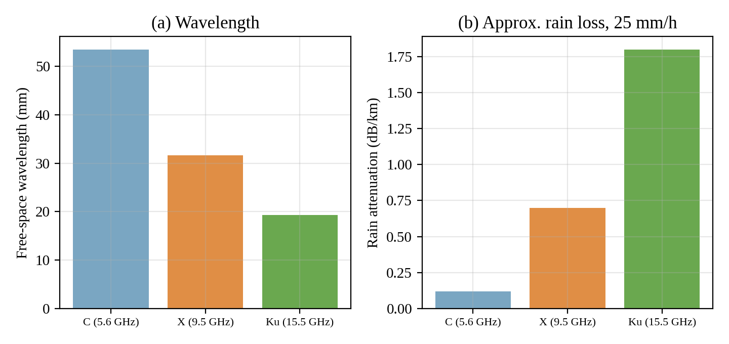
Figure 1: Wavelength and approximate rain attenuation of the candidate bands

STAGE 2 – EVALUATION AND SELECTION OF THE TRANSMISSION STRUCTURE
2.1 Modes and wave types at 9.5 GHz.
Structure | Dominant mode / wave type | Cutoff or upper single-mode limit | Higher-order mode
Coaxial (PTFE) | TEM, no cutoff | Upper limit 33.8 GHz | TE₁₁
WR-90 waveguide | TE₁₀ | Cutoff 6.557 GHz; TE₂₀ at 13.114 GHz | TE₂₀, TE₀₁, TE₁₁/TM₁₁
Stripline | TEM (single dielectric) | Parallel-plate mode near 41 GHz | TE₁/TM₁ plate modes
Microstrip | Quasi-TEM | f_{p} ≈ 39 GHz (dispersion, surface waves) | Surface-wave and hybrid modes

Why microstrip is quasi-TEM. The field lies partly in the substrate (phase velocity c/√ε_{r}) and partly in air (velocity c). A pure TEM wave needs one velocity in the whole cross-section, but the boundary conditions at the dielectric–air interface can only be met if small longitudinal components E_{z} and H_{z} exist. For the 0.508 mm substrate these are small compared with the transverse components, so the line is treated as TEM with an effective permittivity ε_{eff} = 1.873 (between 1 and 2.2); it rises with frequency to 1.892 at 9.5 GHz and about 2.0 at 30 GHz, so the line is dispersive (Figure 2).
Why a hollow waveguide cannot support TEM. A TEM wave has E_{z} = H_{z} = 0, so the transverse electric field is the gradient of a potential that satisfies Laplace's equation ∇_{t}²Φ = 0. With only one conductor, the wall is an equipotential boundary, so Φ is constant inside and E = 0. Equivalently, a transverse H loop would need a conduction or displacement current along z, which a TEM wave does not have.
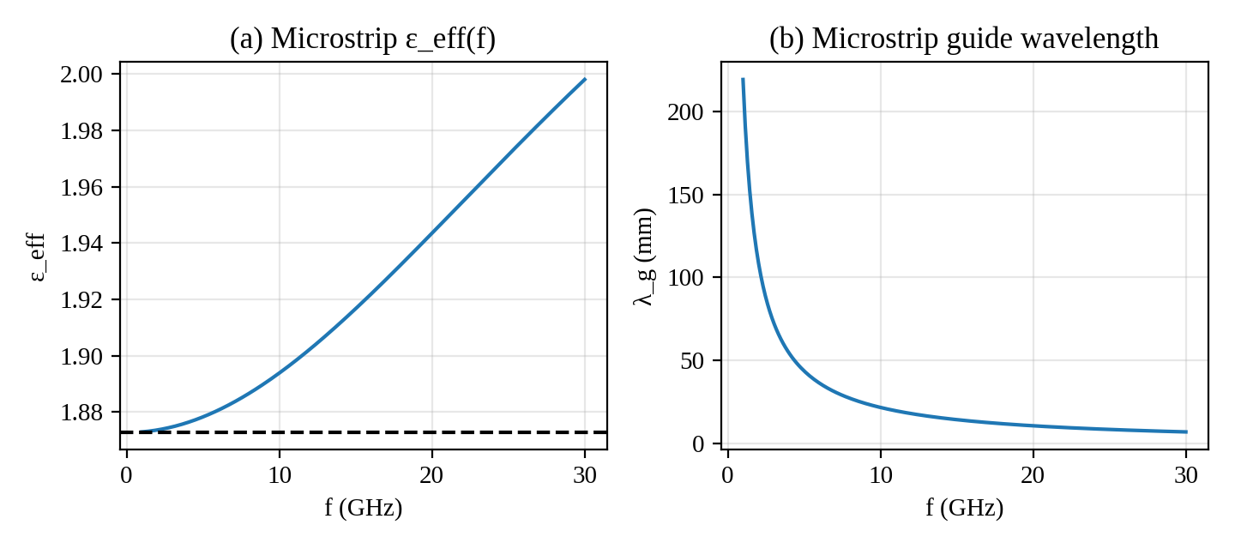
Figure 2: Microstrip effective permittivity and guide wavelength versus frequency
2.2 Weighted decision matrix. Scores (1–5) were assigned from the estimates in Table 2.2, and the weights reflect that loss and power are mission-critical, while size is secondary on a platform that already carries a 9 cm antenna.
Estimate at 9.5 GHz | WR-90 | Coax | Stripline | Microstrip
Attenuation (dB/m) | 0.114 | 1.27 | 3.17 | 3.81
Insertion loss over 0.30 m incl. adapters (dB) | 0.33 | 0.48 | 1.15 | 1.34
Upper single-mode limit (GHz) | 13.1 | 33.8 | 41 | ≈ 39
Mass of 0.30 m run (est.) | 0.13 kg | 0.03 kg | 0.05 kg | 0.03 kg

Criterion | Weight | WR-90 | Coax | Stripline | Microstrip
Insertion loss | 0.30 | 5 | 3 | 2 | 1
Power handling | 0.15 | 5 | 3 | 2 | 2
Shielding / EMI | 0.15 | 5 | 5 | 4 | 2
Size and weight | 0.10 | 1 | 3 | 4 | 5
Cost | 0.10 | 2 | 3 | 3 | 5
Frequency range / bandwidth | 0.10 | 3 | 5 | 4 | 4
Integration | 0.10 | 1 | 3 | 4 | 5
Weighted score | 1.00 | 3.70 | 3.50 | 3.00 | 2.80

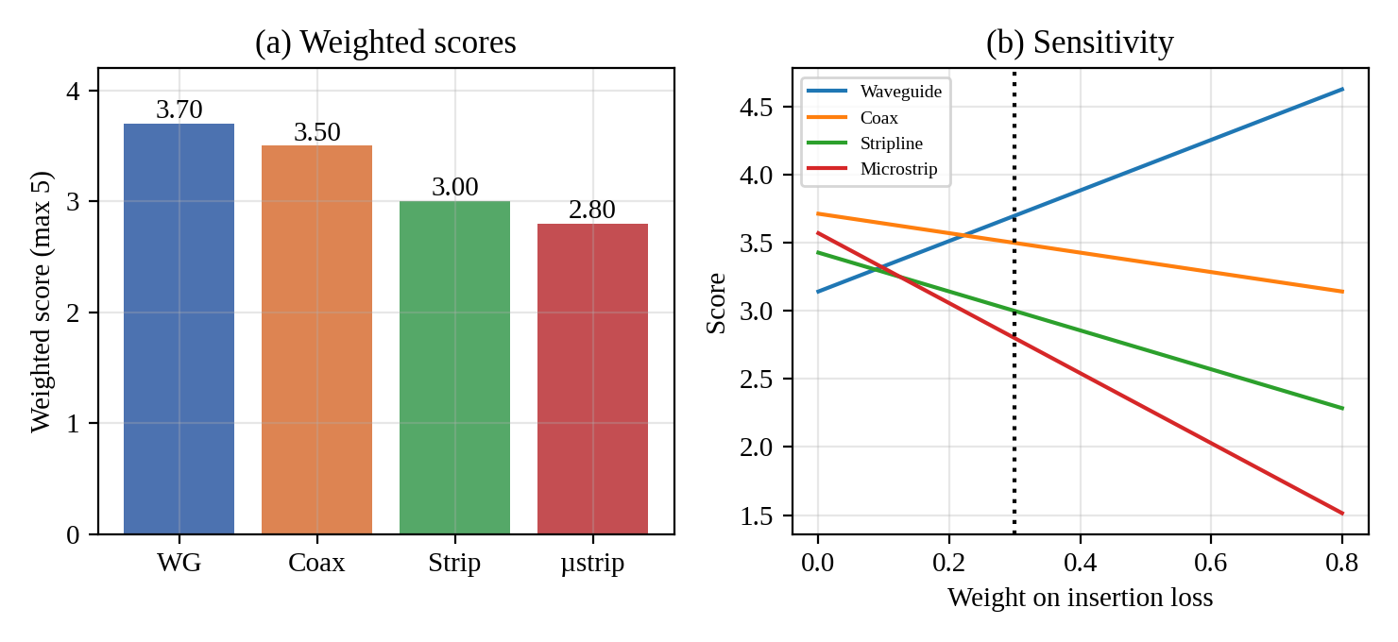
Figure 3: Weighted scores and sensitivity to the insertion-loss weight
2.3 Sensitivity. Waveguide stays first as long as the loss weight exceeds 0.222 (otherwise coax wins) and 0.096 (otherwise microstrip wins). Raising the weight on size and weight from 0.10 to above 0.182 puts coax first, and above 0.266 microstrip first. So the ranking reverses when size is valued about 1.8 times as much as now, or loss less than three-quarters as much. A frequency change also matters: at half the frequency (4.75 GHz) WR-90 is below cutoff and attenuates at 94.7 Np/m (823 dB/m), so a larger WR-187 guide (a = 47.55 mm) would be needed, which removes its size advantage; at twice the frequency (19 GHz) WR-90 becomes multimode (TE₁₀, TE₂₀, TE₀₁, TE₁₁/TM₁₁ all propagate), requiring WR-42, while coax conductor and dielectric losses rise to 1.44 and 0.50 dB/m (+53 %), which strengthens the case for waveguide.
2.4 Defence against the strongest alternative (coax). The PTFE semi-rigid line has 1.27 dB/m, so with two 0.05 dB connectors it gives 0.48 dB, which exceeds the 0.40 dB limit. A 7 mm air-spaced line (a = 1.52 mm, b = 3.5 mm) would give 0.33 dB/m and 0.20 dB in total, but at about 3.5 times the cross-section and mass, with bead supports and a TE₁₁ limit of 19 GHz; its cost and weight erase the advantage that made coax attractive.
Design Decision 1. For the specified application I select WR-90 rectangular waveguide over coaxial line because it meets the 0.40 dB loss budget with margin (0.33 dB against 0.48 dB), has more than 100 dB shielding, and handles far more power, at the cost of about 100 g extra mass. If the frequency were halved the guide would be cut off and the ranking would move to coax or microstrip; if doubled, WR-42 would be needed and waveguide would remain best.

STAGE 3 – MODE AND PROPAGATION MODEL, AND DIMENSION DESIGN
3.1 Transmission-line model. For a line section with per-unit-length R, L, G, C, the telegrapher's equations are
dV/dz = −(R + jωL) I dI/dz = −(G + jωC) V
Eliminating I gives d²V/dz² = γ²V with
γ = α + jβ = √[(R + jωL)(G + jωC)] Z₀ = √[(R + jωL)/(G + jωC)]
so V(z) = V⁺e^{−γz} + V⁻e^{+γz}. For low loss (R ≪ ωL, G ≪ ωC): α ≈ R/(2Z₀) + GZ₀/2 and β ≈ ω√(LC). The reflection coefficient at a load is Γ_{L} = (Z_{L} − Z₀)/(Z_{L} + Z₀) and the input impedance is Z_{in} = Z₀(Z_{L} + Z₀tanh γℓ)/(Z₀ + Z_{L}tanh γℓ).
3.2 Field solution for the rectangular guide. For a guide with 0 ≤ x ≤ a, 0 ≤ y ≤ b, assume fields ∝ e^{−jβz} and a lossless, air-filled interior with perfectly conducting walls. For TE modes (E_{z} = 0), H_{z}(x,y) satisfies (∇_{t}² + k_{c}²)H_{z} = 0 with k_{c}² = k² − β². Separation of variables and the wall condition ∂H_{z}/∂n = 0 give
H_{z} = H₀ cos(mπx/a) cos(nπy/b) e^{−jβz} k_{c} = √[(mπ/a)² + (nπ/b)²]
and f_{c} = (c/2)√[(m/a)² + (n/b)²]. For TE₁₀: H_{z} = H₀cos(πx/a), E_{y} = −j(ωμa/π)H₀sin(πx/a), H_{x} = j(βa/π)H₀sin(πx/a), and the wave impedance is Z_{TE} = E_{y}/(−H_{x}) = ωμ/β = η/√(1 − (f_{c}/f)²). For TM modes (H_{z} = 0), E_{z} = E₀sin(mπx/a)sin(nπy/b), both m, n ≥ 1, and Z_{TM} = ηβ/k. Assumptions: perfect conductor, uniform air fill, straight uniform guide, time dependence e^{jωt}; loss is added afterwards as a perturbation, which is valid because α ≪ β.
3.3 Mode comparison.
Property | TEM | TE | TM
Field components | E_{z} = H_{z} = 0 | H_{z} ≠ 0, E_{z} = 0 | E_{z} ≠ 0, H_{z} = 0
Cutoff | None (f_{c} = 0) | f_{c} > 0 | f_{c} > 0 (m, n ≥ 1)
Dispersion | None, v_{p} = c/√ε_{r} | v_{p} > c, v_{g} < c | v_{p} > c, v_{g} < c
Wave impedance | η/√ε_{r} | η/√(1 − (f_{c}/f)²) > η | η√(1 − (f_{c}/f)²) < η
Needs | Two conductors | One closed conductor | One closed conductor

TE₁₀ is best for this application because it has the lowest cutoff, the widest single-mode range (an octave), a purely polarised E-field along y, and the lowest conductor loss; no TM mode exists below 16.145 GHz.
3.4 Dimension design. The guide is the standard WR-90: a = 22.86 mm, b = 10.16 mm (b ≈ a/2 so that TE₀₁ cuts off at 14.754 GHz, above TE₂₀ at 13.114 GHz). The operating band 9–10 GHz lies between 1.37 f_{c} and 0.76 of the TE₂₀ cutoff, giving margins of 37 % above TE₁₀ cutoff and 31 % below TE₂₀.
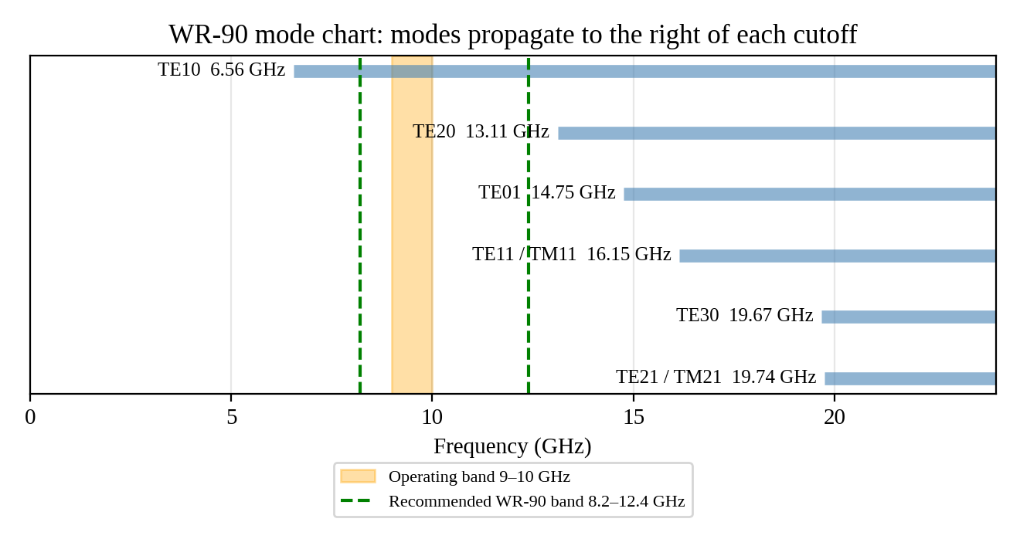
Figure 4: WR-90 cutoff chart with the operating band marked
Quantity | Value at 9.5 GHz
a × b | 22.86 mm × 10.16 mm
f_{c,10} / f_{c,20} / f_{c,01} / f_{c,11} | 6.557 / 13.114 / 14.754 / 16.145 GHz
Single-mode range / recommended band | 6.557–13.114 GHz / 8.2–12.4 GHz
Phase constant β | 144.1 rad/m
Guide wavelength λ_{g} | 43.6 mm
Phase velocity v_{p} | 4.143 × 10⁸ m/s (1.382c)
Group velocity v_{g} | 2.169 × 10⁸ m/s (0.724c)
Group delay over 0.30 m | 1.383 ns (1.461 ns at 9 GHz, 1.325 ns at 10 GHz)
Wave impedance Z_{TE} | 520.6 Ω
Equivalent impedance Z_{PV} | 462.8 Ω

Worked calculation (with units). f_{c} = c/(2a) = 2.998 × 10⁸ m/s ÷ (2 × 0.02286 m) = 6.557 GHz. k = 2πf/c = 2π × 9.5 × 10⁹/2.998 × 10⁸ = 199.1 rad/m. √(1 − (6.557/9.5)²) = √(1 − 0.4764) = 0.7236. β = 199.1 × 0.7236 = 144.1 rad/m. λ_{g} = 2π/β = 43.6 mm. v_{p} = c/0.7236 = 4.143 × 10⁸ m/s, v_{g} = 0.7236c = 2.169 × 10⁸ m/s, and v_{p}v_{g} = 8.99 × 10¹⁶ = c² (check). Z_{TE} = 376.73/0.7236 = 520.6 Ω.
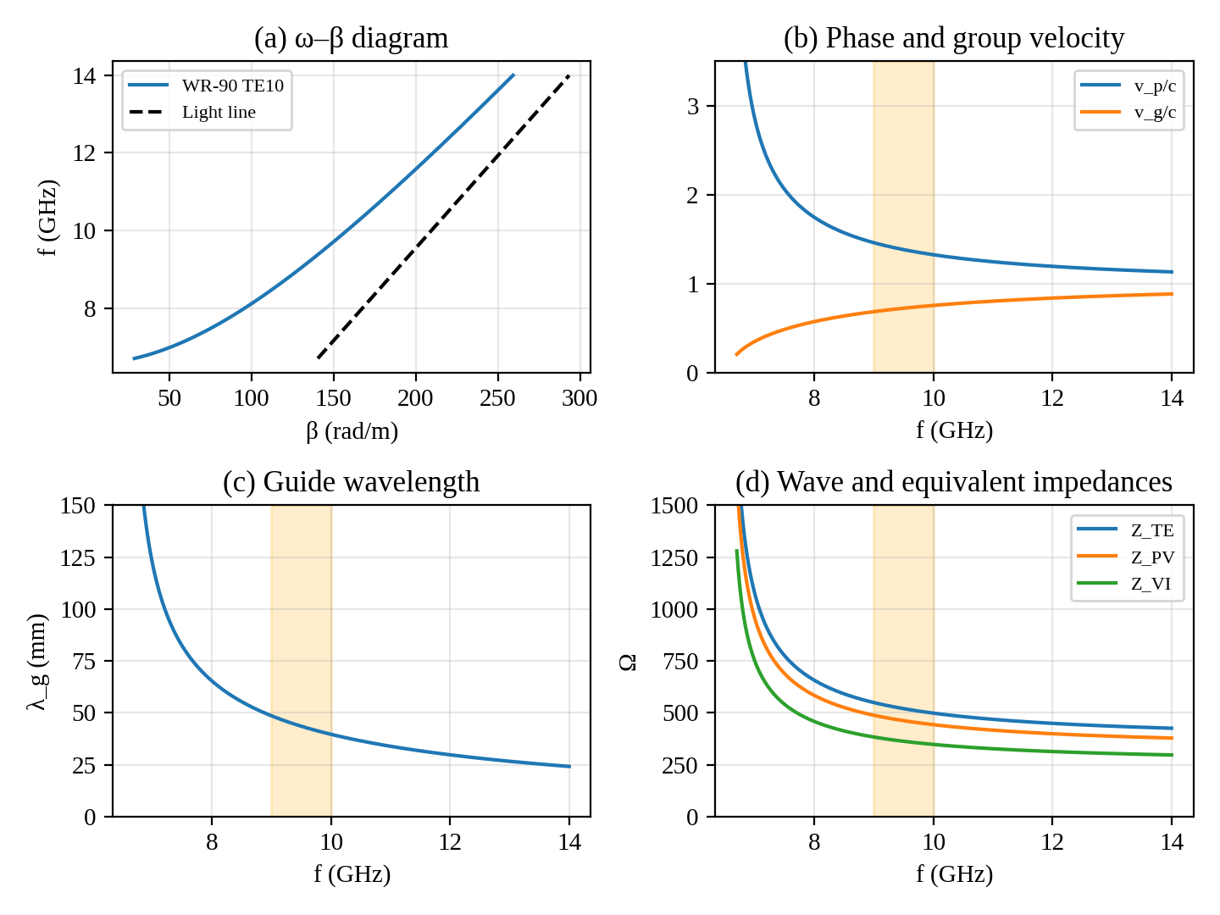
Figure 5: Dispersion, velocities, guide wavelength and impedances of the TE10 mode
3.5 Higher-order modes. The first unwanted mode is TE₂₀ (13.114 GHz), but it is odd in x, so a probe or iris placed at x = a/2 does not excite it. The dangerous pair is TE₁₁ and TM₁₁: they are degenerate at 16.145 GHz and are excited by any asymmetric discontinuity, but they lie 6 GHz above the band. The second harmonic of the transmitter (19 GHz) is above all of these cutoffs, so a harmonic filter (or the T/R module's own filtering) is needed to keep it out of the guide. The design change adopted is to centre the coax–waveguide probe at x = a/2 and use symmetric height steps.
Design Decision 2. The dominant mode is TE₁₀ with cutoff 6.557 GHz; the single-mode range is 6.557 GHz to 13.114 GHz; therefore the chosen dimensions are acceptable because the 9–10 GHz band has 37 % margin above cutoff and 31 % margin below TE₂₀, and group-delay spread across the band is only 0.136 ns.

STAGE 4 – LOSS EVALUATION AND LOSS-REDUCTION DESIGN
4.1 Loss mechanisms and formulas. Conductor loss of the TE₁₀ mode is
α_{c} = R_{s}/[bη√(1 − (f_{c}/f)²)] · [1 + (2b/a)(f_{c}/f)²] (Np/m), R_{s} = √(πfμ₀/σ) = 1/(σδ_{s})
with the surface-roughness factor K = 1 + (2/π)arctan[1.4(Δ/δ_{s})²] multiplying R_{s}. Dielectric loss is α_{d} = πf√ε_{r} tan δ/c (zero in an air guide). For comparison, coax has α_{c} = R′/(2Z₀) with R′ = (R_{s}/2π)(1/a + 1/b); stripline and microstrip use the standard Pozar/Hammerstad expressions listed in Program 5. At 9.5 GHz the copper skin depth is δ_{s} = 1/√(πfμ₀σ) = 0.678 µm and R_{s} = 0.02543 Ω.
4.2 Loss budget (0.30 m). Initial design: aluminium (σ = 3.5 × 10⁷ S/m, δ_{s} = 0.873 µm) with 1.0 µm rms roughness, two adapters of 0.15 dB, and the antenna reflection Γ = 0.2857. Final design: silver-plated walls (σ = 6.1 × 10⁷ S/m, δ_{s} = 0.661 µm, 0.4 µm rms), two adapters of 0.08 dB, and the two-section transformer.
Loss component | Initial (dB/m) | Improved (dB/m) | Initial (dB, 0.30 m) | Improved (dB, 0.30 m) | % of total (initial → final) | Trade-off
Conductor | 0.246 | 0.144 | 0.074 | 0.043 | 9.9 → 21.2 | Plating cost; tarnish control
Dielectric (air) | 0 | 0 | 0 | 0 | 0 → 0 | None
Radiation / flange leakage | ≈ 0 | ≈ 0 | < 0.001 | < 0.001 | 0 → 0 | Needs flange gasket
Connector / transition | 1.00 | 0.53 | 0.300 | 0.160 | 40.3 → 78.6 | Better adapters cost more
Mismatch | 1.233 | 0.001 | 0.370 | 0.0003 | 49.7 → 0.1 | Adds 21.8 mm of guide
Total | 2.48 | 0.68 | 0.744 | 0.204 | 100 | Meets 0.40 dB

4.3 Dominant loss. Mismatch is the dominant mechanism in the initial design: 0.370 dB is 49.7 % of 0.744 dB, ahead of the adapters (40.3 %) and well ahead of conductor loss (9.9 %). After redesign the adapters dominate (78.6 %), which identifies the next improvement (a waveguide-output T/R module would remove them).
4.4 Parametric study. (a) Material: at 9.5 GHz α_{c} is 0.114 dB/m (Cu), 0.111 (Ag), 0.147 (Al) and 0.223 (brass), scaling as 1/√σ. (b) Frequency: α_{c} of the guide falls from 0.34 dB/m near 6.8 GHz to 0.09 dB/m at 14 GHz, because the (f_{c}/f)² terms shrink, unlike coax whose loss rises as √f. (c) Roughness: for Al, rms 1 µm raises the loss by K = 1.68 (0.146 → 0.246 dB/m); the effect saturates at K = 2 when roughness exceeds about 2δ_{s}. (d) Dielectric: in the coax and microstrip, each 0.5 × 10⁻³ increase in tan δ adds about 0.63 dB/m and 0.51 dB/m, respectively, so low-loss laminates are essential for planar lines.
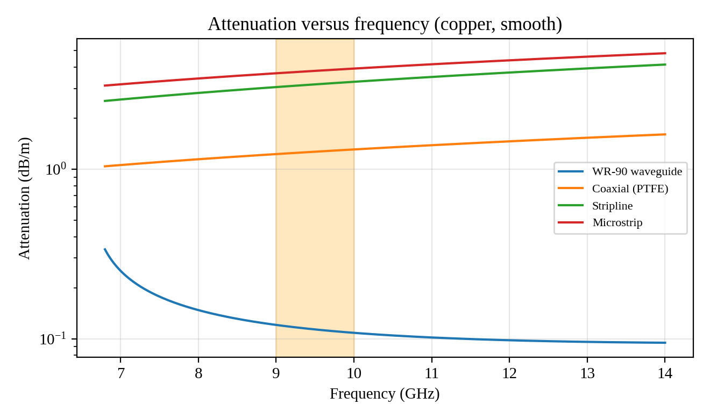
Figure 6: Attenuation versus frequency for the four structures
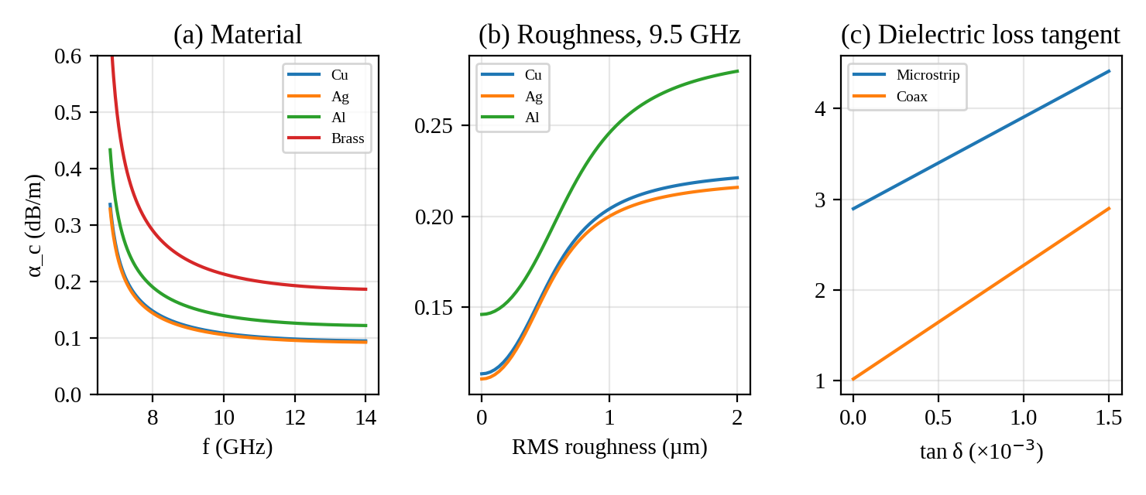
Figure 7: Effect of material, roughness and loss tangent on attenuation
4.5 Redesign and judgement. The loss-reduction measures adopted are (i) a two-section matching transformer (−0.370 dB), (ii) low-loss adapters (−0.140 dB) and (iii) silver plating of at least 3δ_{s} (about 2 µm; 5 µm specified) over a smoothed surface (−0.031 dB), a total improvement of 0.540 dB (0.744 → 0.204 dB). The improved design meets the 0.40 dB requirement with 49 % margin. Trade-offs: plating adds cost and needs sulphide protection, the transformer adds 21.8 mm of length and tightens tolerances, and better adapters are costlier.
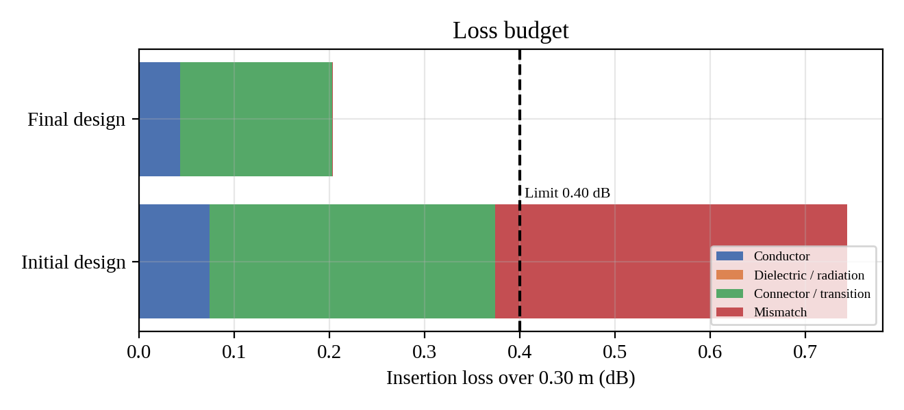
Figure 8: Loss budget of the initial and final designs
Worked calculation. Initial design: K = 1 + (2/π)arctan[1.4(1.0/0.873)²] = 1 + (2/π)arctan(1.837) = 1.683. R_{s,eff} = 1.683 × √(π × 9.5 × 10⁹ × 4π × 10⁻⁷/3.5 × 10⁷) = 1.683 × 0.03274 = 0.05509 Ω. α_{c} = 0.05509/(0.01016 × 376.73 × 0.7236) × (1 + 0.8889 × 0.4764) = (0.05509/2.7697) × 1.4235 = 0.02831 Np/m = 0.2459 dB/m, i.e. 0.0738 dB over 0.30 m. For comparison the coax dielectric loss is α_{d} = π × 9.5 × 10⁹ × √2.1 × 2 × 10⁻⁴/2.998 × 10⁸ = 0.02885 Np/m = 0.2506 dB/m and its conductor loss is 1.018 dB/m.
Design Decision 3. The dominant loss mechanism is mismatch contributing 49.7 % of the total; the loss-reduction measure I adopt is a two-section transformer with silver plating and low-loss adapters, which reduces the attenuation from 0.744 to 0.204 dB.

STAGE 5 – NETWORK MODEL, MATCHING AND S-PARAMETERS
5.1 Equivalent voltage and current. In a non-TEM guide the voltage depends on the integration path and the current on the contour, so V and I are not unique. For TE₁₀ take V = ∫E_{y}dy = E₀b at x = a/2 and I = ∫H_{x}dx = (E₀/Z_{TE})(2a/π). Then Z_{VI} = V/I = (πb/2a)Z_{TE} = 363.5 Ω. The alternative power-voltage definition P = |V|²/(2Z) with P = E₀²ab/(4Z_{TE}) gives Z_{PV} = 2bZ_{TE}/a = 462.8 Ω; the two differ by π/4. Because the S-parameters are ratios of normalised waves, either choice gives the same S-parameters if used consistently; Z_{PV} is used here. All heights scale Z_{PV} linearly with b (Z ∝ b).
5.2 Wave variables. With reference impedance Z₀, a = (V + Z₀I)/(2√Z₀) and b = (V − Z₀I)/(2√Z₀), so that P_{avg} = ½(|a|² − |b|²). The S-matrix is b = Sa.
5.3 Two-port and cascade. A line of impedance Z and electrical length θ = γℓ has ABCD matrix [cosh γℓ, Z sinh γℓ; sinh γℓ/Z, cosh γℓ], and sections are cascaded by matrix multiplication. With normalised port references z₁ = 1 and z₂:
S₁₁ = (Az₂ + B − Cz₁z₂ − Dz₁)/Δ, S₂₁ = 2√(z₁z₂)/Δ, Δ = Az₂ + B + Cz₁z₂ + Dz₁
S₁₂ = 2(AD − BC)√(z₁z₂)/Δ and S₂₂ = (−Az₂ + B − Cz₁z₂ + Dz₁)/Δ. Because det[ABCD] = 1 for a reciprocal network, S₁₂ = S₂₁.
5.4 Impedance of the realistic load. The antenna port is taken as a reduced-height guide with Z_{L} = Z_{c}/1.8, i.e. b_{L} = 5.644 mm (Z_{PV} = 257.1 Ω). Then Γ_{L} = (0.5556 − 1)/(0.5556 + 1) = −0.2857, VSWR = 1.80, RL = 20 log(1/0.2857) = 10.88 dB, and the mismatch loss is −10 log(1 − 0.2857²) = 0.370 dB. This fails the 20 dB requirement.
5.5 Matching design. A quarter-wave transformer of impedance Z_{t} = √(Z_{c}Z_{L}) is needed. Single section: z_{t} = √0.5556 = 0.7454, so Z_{PV,t} = 344.9 Ω, b_{t} = 0.7454 × 10.16 = 7.573 mm, length λ_{g0}/4 = 43.61/4 = 10.90 mm. Two-section binomial: z₁ = z_{L}^{1/4} = 0.8633 (b = 8.772 mm, 399.5 Ω) and z₂ = z_{L}^{3/4} = 0.6435 (b = 6.538 mm, 297.8 Ω), each 10.90 mm long.
Hand calculation (single section at 9.0 GHz). At 9.0 GHz, β = 129.2 rad/m so θ = βℓ_{t} = 80.7°. The two junction coefficients are Γ₁ = (z_{t} − 1)/(z_{t} + 1) = −0.1459 and Γ₂ = (z_{L} − z_{t})/(z_{L} + z_{t}) = −0.1459. Then Γ_{in} = Γ₁(1 + e^{−2jθ})/(1 + Γ₁²e^{−2jθ}) with e^{−2jθ} = −0.948 − j0.319 gives |Γ_{in}| = 0.0481, i.e. RL = 26.4 dB, which agrees with the numerical value (26.36 dB). At 9.5 GHz, θ = 90°, so A = D = 0, B = jz_{t}, C = j/z_{t} and S₁₁ = (z_{t}² − z_{L})/(z_{t}² + z_{L}) = 0.
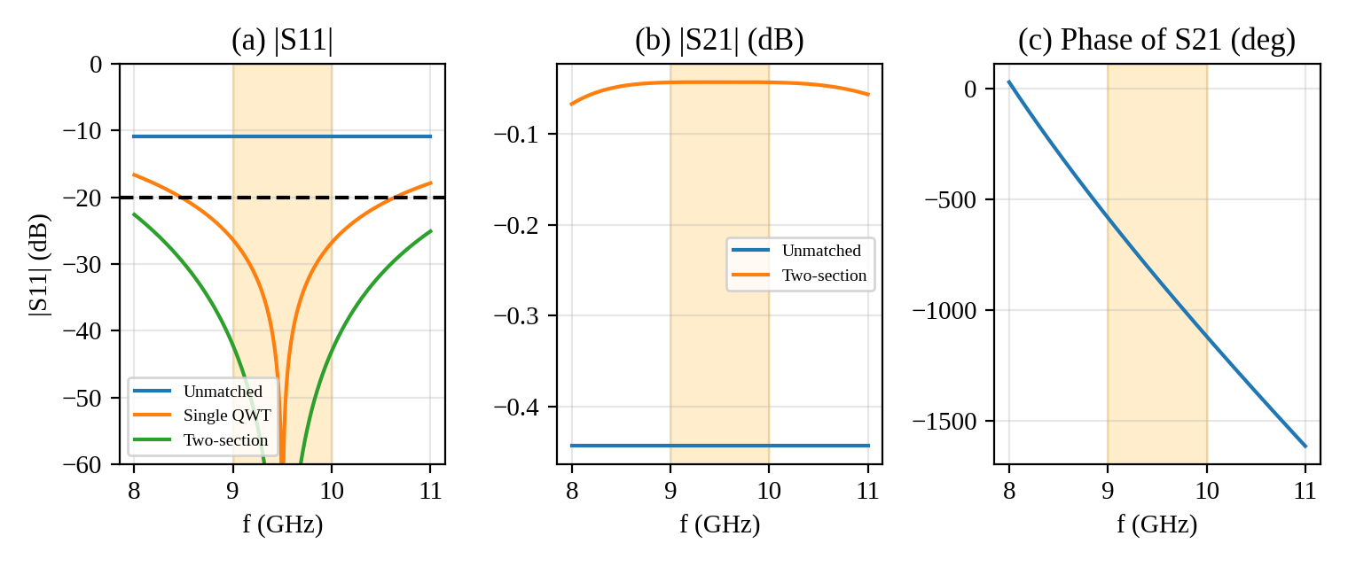
Figure 9: S-parameters (magnitude and phase) of the unmatched and matched networks
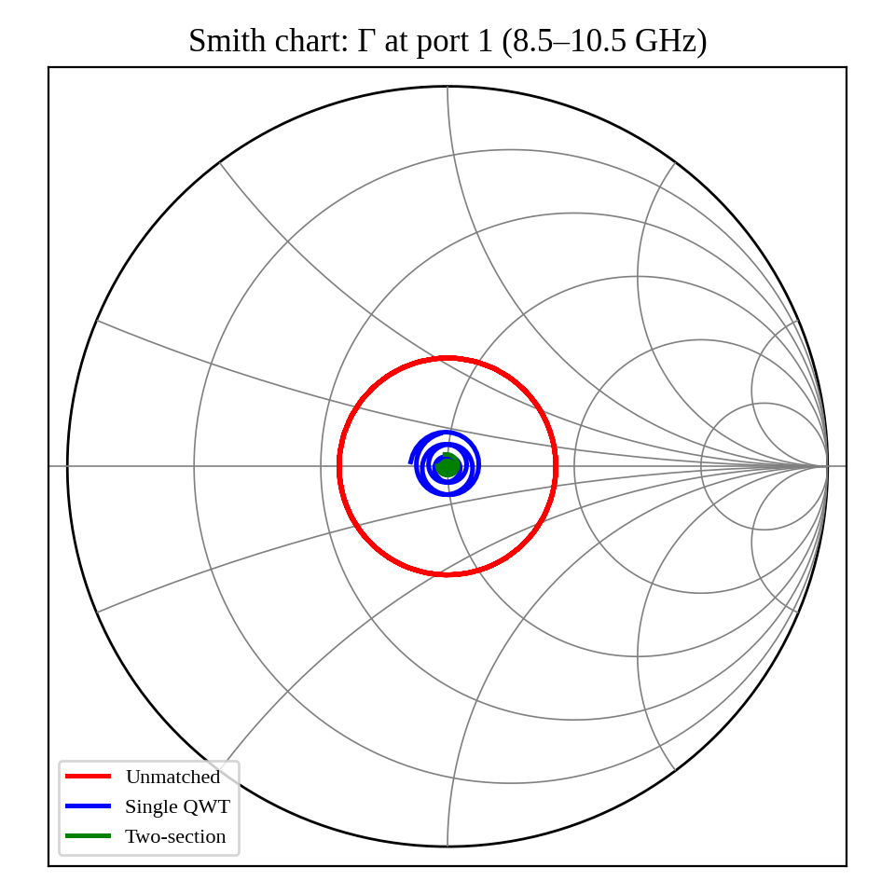
Figure 10: Smith chart of the input reflection coefficient
Parameter | Before matching | After matching (two-section) | Target | Interpretation
Characteristic impedance Z₀ | Z_{PV} = 462.8 Ω; load 257.1 Ω | Same reference; steps 399.5 → 297.8 → 257.1 Ω | — | Impedance is stepped down gradually
Reflection coefficient / VSWR | 0.286 / 1.80 | ≤ 0.0078 / ≤ 1.016 in band | VSWR ≤ 1.22 | Pass
Return loss (from S₁₁) | 10.88 dB | ≥ 42.2 dB (9–10 GHz) | ≥ 20 dB | Pass with 22 dB margin
Insertion loss (from S₂₁, line only) | 0.444 dB (Al, rough) | 0.043 dB (Ag) | ≤ 0.40 dB incl. adapters | Pass; adapters add 0.16 dB
Reciprocity / lossless check | S₁₂ = S₂₁ to 10⁻¹⁶; |S₁₁|² + |S₂₁|² = 1 lossless, 0.982 lossy | S₁₂ = S₂₁; 1 lossless, 0.990 lossy | Reciprocal | Passive reciprocal network

f (GHz) | |S₁₁| (dB) | |S₂₁| (dB, lossless) | |S₂₂| (dB)
9.0 | −42.2 | −0.0003 | −42.2
9.5 | < −200 (ideal match) | 0.0000 | < −200
10.0 | −43.0 | −0.0002 | −43.0

5.6 Relation of S to IL and RL. RL = −20 log|S₁₁| and IL = −20 log|S₂₁|; for a lossless network |S₂₁|² = 1 − |S₁₁|², so IL is entirely mismatch loss, while for a lossy line the deficit 1 − |S₁₁|² − |S₂₁|² equals the dissipated fraction (1.8 % before, 1.0 % after). Verification: the same results were obtained independently with the MATLAB script (Program 9), a NumPy implementation, the closed-form reflection expression above and the Smith chart (Figure 10).

STAGE 6 – VALIDATION, CRITIQUE AND DEFENCE OF THE FINAL DESIGN
6.1 Validation by independent methods. Loss: standard formula (Section 4.1) and the ABCD model agree (0.043 dB conductor, S₂₁ 0.0432 dB). Return loss: ABCD model, closed-form Γ_{in} and Smith chart agree to 0.05 dB. Modes: cutoff formula and the cutoff chart agree. Shielding: a continuous metal guide with gasketed flanges exceeds 100 dB, which is a datasheet-type value for WR-90 hardware. Power: with a conservative breakdown field of 1 MV/m (one-third of air's 3 MV/m) the TE₁₀ peak power limit is P = abE²/(4Z_{TE}) = 0.02286 × 0.01016 × 10¹²/(4 × 520.6) ≈ 112 kW, far above 200 W.
6.2 Critique of assumptions. (i) Ideal conductor: replaced by surface resistance and roughness; the result (0.144 dB/m) is 27 % above smooth copper. (ii) Uniform dielectric: air, so no loss and no ε_{r}(f) dependence. (iii) Neglected step discontinuities: an E-plane height step has a small shunt susceptance; if each of the three steps contributed |Γ| ≈ 0.01, the worst-case sum would be 0.03 (RL ≈ 30 dB), still above 20 dB, but this must be checked by full-wave simulation. (iv) The antenna load was modelled as a purely resistive step; a real slot array has reactance that must be measured. (v) The adapter loss (0.08 dB) is a datasheet assumption.
6.3 Tolerance and frequency sensitivity. A Monte Carlo study (800 trials, uniform errors on a, b, both transformer heights and all lengths, with the worst RL over 9–10 GHz recorded) gave:
Tolerance | Single section: min RL / P(RL ≥ 20 dB) | Two-section: min RL / P(RL ≥ 20 dB) | TE₁₀ cutoff range
±5 % | 14.65 dB / 64 % | 13.39 dB / 77 % | 6.245–6.902 GHz
±1 % | 22.65 dB / 100 % | 27.06 dB / 100 % | 6.492–6.623 GHz
±0.05 mm | 25.16 dB / 100 % | 31.95 dB / 100 % | 6.543–6.572 GHz

A ±5 % error is far looser than machined waveguide and cannot guarantee 20 dB, so the drawing must call for ±0.05 mm (≤ 0.5 % of the smallest dimension). The TE₁₀ cutoff stays below 6.9 GHz and TE₂₀ above 12.49 GHz for ±5 %, so single-mode operation is robust. At the worst machining case (RL = 31.95 dB, |Γ| = 0.0253) the mismatch loss is 0.003 dB, so the insertion loss is 0.043 + 0.160 + 0.003 = 0.206 dB. A 100 K temperature rise changes f_{c} by only 0.2 %.
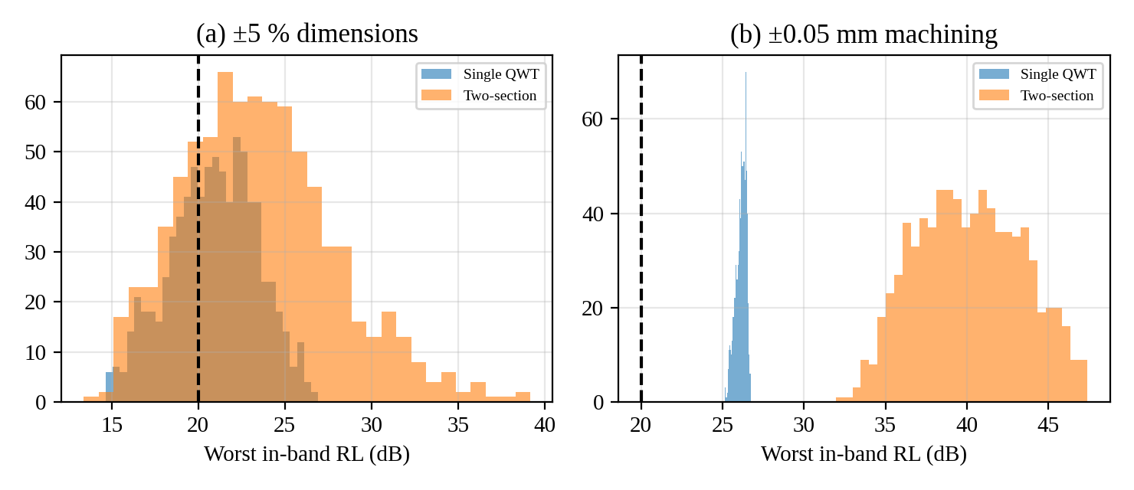
Figure 11: Monte Carlo distribution of worst-case in-band return loss
6.4 EMC and safety. Shielding comes from the continuous guide; leakage is limited by gasketed or choke flanges and by bonding the guide to the airframe with a low-impedance (< 2.5 mΩ) path to avoid ground loops. Connector choice matters: 3.5 mm or SMA adapters must be torqued and mated with the guide's centred probe. The guide rejects 1.575 GHz GNSS by more than 300 dB and the telemetry bands below 6.5 GHz similarly. Test plan: (1) calibrated VNA measurement of S₁₁ and S₂₁ from 8 to 12 GHz, comparing with Figure 9; (2) shielding and flange leakage measurement with a near-field probe at full power (guided by IEEE Std 299); (3) high-power burn-in at 200 W peak; (4) thermal cycling −40 to +70 °C and vibration (RTCA DO-160); (5) a field-strength survey to confirm the 4 m keep-out distance.
6.5 Improved alternative. The remaining limitation is adapter loss (78.6 % of the final loss). The proposed improvement is a T/R module with a native WR-90 output flange, removing both adapters and reducing total loss to about 0.05 dB, plus a full-wave (CST or HFSS) check of the height steps.

SPECIFICATION VERIFICATION TABLE
Requirement | Specified | Initial design | Final design (worst case) | Satisfied?
Operating frequency / single-mode range | 9–10 GHz | 6.557–13.114 GHz | 6.557–13.114 GHz (6.25–12.49 GHz at ±5 %) | Yes
Dominant mode and cutoff | TE₁₀ | TE₁₀, 6.557 GHz | TE₁₀, 6.557 GHz | Yes
Insertion loss / attenuation | ≤ 0.40 dB | 0.744 dB | 0.206 dB | Initial: No; Final: Yes
Impedance / VSWR | ≤ 1.22 | 1.80 | ≤ 1.05 | Initial: No; Final: Yes
Return loss (S₁₁) | ≥ 20 dB | 10.88 dB | ≥ 31.95 dB | Initial: No; Final: Yes
EMI shielding / isolation | ≥ 80 dB | > 100 dB | > 100 dB | Yes
Power handling / size | 200 W peak; ≤ 150 g; ≤ 30 × 15 mm | ≈ 112 kW limit; 0.13 kg; 25.4 × 12.7 mm | Same plus 21.8 mm length | Yes

FINAL ENGINEERING DECISION
SHOULD THIS STRUCTURE AND MODE BE ADOPTED FOR THE APPLICATION?
(i) Initial design: NO. The bare aluminium WR-90 with standard adapters and no matching has an insertion loss of 0.744 dB (limit 0.40 dB) and a return loss of 10.88 dB (limit 20 dB), although the mode and shielding requirements are satisfied.
(ii) Final design: YES. The TE₁₀ WR-90 guide with a two-section transformer, silver plating and low-loss adapters meets every specification: single-mode margin of 37 % and 31 %, insertion loss 0.206 dB, return loss at least 31.95 dB at ±0.05 mm, shielding above 100 dB, and 112 kW power capacity. The decision is conditional on machining to ±0.05 mm and on confirmation by measurement and full-wave simulation of the step discontinuities. The decision is defended against coax (0.48 dB, fails loss) and the planar lines (1.15 and 1.34 dB). The most important sensitivity is the dimensional tolerance; the most important remaining loss is the adapters.
If an exception arises: should the full-wave check show reflection above −20 dB, replace the single height steps by a smooth taper of length 2λ_{g} (about 87 mm), which trades length for a lower reflection, and keep the WR-90 guide and TE₁₀ mode.

PROGRAM 1 – BAND COMPARISON
Aim: to quantify wavelength, effective antenna area and rain loss for the candidate bands.
% Program 1: band comparison for the radar feed (C, X, Ku)
c = 2.998e8;
fb = [5.6e9 9.5e9 15.5e9]; % band centre frequencies (Hz)
names = {'C','X','Ku'};
lam = c./fb*1e3; % free-space wavelength (mm)
rain = [0.12 0.70 1.8]; % approx. rain loss, dB/km at 25 mm/h
subplot(1,2,1); bar(lam); set(gca,'XTickLabel',names); ylabel('\lambda_0 (mm)');
subplot(1,2,2); bar(rain); set(gca,'XTickLabel',names); ylabel('dB/km');
Aeff = 100*lam.^2*1e-6/(4*pi) % effective area (m^2) for a 20 dBi antenna
Figure 12: Output of Program 1
The wavelength falls from 53.5 mm at C-band to 19.3 mm at Ku-band, and the effective area for a 20 dBi antenna from 22.8 × 10⁻³ m² to 2.9 × 10⁻³ m². X-band gives the best compromise of antenna size and rain loss.

PROGRAM 2 – WR-90 MODE CHART
Aim: to list the cutoff frequencies of the first modes and show where the band lies.
% Program 2: WR-90 mode (cutoff) chart
c = 2.998e8; a = 22.86e-3; b = 10.16e-3;
fc = @(m,n) 0.5*c*sqrt((m/a)^2 + (n/b)^2);
modes = [1 0; 2 0; 0 1; 1 1; 3 0; 2 1];
for k = 1:size(modes,1)
fcm(k) = fc(modes(k,1), modes(k,2))/1e9;
fprintf('m=%d n=%d fc = %.3f GHz\n', modes(k,:), fcm(k));
end
barh(1:numel(fcm), fcm); hold on; xline(9,'--'); xline(10,'--');
xlabel('Cutoff frequency (GHz)'); grid on;
Figure 13: Output of Program 2
Mode | TE₁₀ | TE₂₀ | TE₀₁ | TE₁₁/TM₁₁ | TE₃₀ | TE₂₁/TM₂₁
f_{c} (GHz) | 6.557 | 13.114 | 14.754 | 16.145 | 19.671 | 19.740

The program reproduces the cutoff chart used in Stage 3 and shows TE₁₀ alone in the 6.557–13.114 GHz window.

PROGRAM 3 – DISPERSION, VELOCITIES AND IMPEDANCES
Aim: to compute β, λ_{g}, v_{p}, v_{g}, Z_{TE}, Z_{PV} and Z_{VI}.
% Program 3: dispersion, velocities and impedances of the TE10 mode
c = 2.998e8; a = 22.86e-3; b = 10.16e-3; eta0 = 376.73;
fcut = 0.5*c/a;
f = linspace(6.7e9, 14e9, 300);
s = sqrt(1 - (fcut./f).^2); k0 = 2*pi*f/c;
beta = k0.*s; lamg = 2*pi./beta;
vp = c./s; vg = c*s;
ZTE = eta0./s; ZPV = 2*b/a*ZTE; ZVI = pi*b/(2*a)*ZTE;
i0 = find(f >= 9.5e9, 1);
fprintf('beta=%.1f rad/m, lamg=%.2f mm, vp=%.3e, vg=%.3e m/s\n', beta(i0), lamg(i0)*1e3, vp(i0), vg(i0));
fprintf('ZTE=%.1f, ZPV=%.1f, ZVI=%.1f ohm\n', ZTE(i0), ZPV(i0), ZVI(i0));
subplot(2,2,1); plot(beta, f/1e9); hold on; plot(k0, f/1e9,'--');
subplot(2,2,2); plot(f/1e9, vp/c, f/1e9, vg/c);
subplot(2,2,3); plot(f/1e9, lamg*1e3);
subplot(2,2,4); plot(f/1e9, [ZTE; ZPV; ZVI]);
Figure 14: Output of Program 3
Quantity at 9.5 GHz | Value
β / λ_{g} | 144.1 rad/m / 43.6 mm
v_{p} / v_{g} | 4.143 × 10⁸ / 2.169 × 10⁸ m/s
Z_{TE} / Z_{PV} / Z_{VI} | 520.6 / 462.8 / 363.5 Ω

Phase velocity exceeds c and group velocity is below c, with v_{p}v_{g} = c². Dispersion is strongest near cutoff, which is why the band is placed well above 6.557 GHz.

PROGRAM 4 – MICROSTRIP DESIGN AND DISPERSION
Aim: to design a 50 Ω microstrip and quantify its dispersion for the comparison in Stage 2.
% Program 4: microstrip design and dispersion (Getsinger model)
c = 2.998e8; eta0 = 376.73; er = 2.2; h = 0.508e-3; Z0 = 50;
A = Z0/60*sqrt((er+1)/2) + (er-1)/(er+1)*(0.23 + 0.11/er);
wh = 8*exp(A)/(exp(2*A) - 2); W = wh*h; % W/h and width
ee0 = (er+1)/2 + (er-1)/2/sqrt(1 + 12*h/W); % static eps_eff
Zchk = eta0/(sqrt(ee0)*(wh + 1.393 + 0.667*log(wh + 1.444)));
mu0 = 4e-7*pi; fp = Zchk/(2*mu0*h); G = 0.6 + 0.009*Zchk;
f = linspace(1e9, 30e9, 200);
ee = er - (er - ee0)./(1 + G*(f/fp).^2); % dispersive eps_eff
subplot(1,2,1); plot(f/1e9, ee); ylabel('\epsilon_{eff}');
subplot(1,2,2); plot(f/1e9, c./(sqrt(ee).*f)*1e3); ylabel('\lambda_g (mm)');
fprintf('W = %.3f mm, ee0 = %.3f, Z0 = %.1f ohm\n', W*1e3, ee0, Zchk);
Figure 15: Output of Program 4
The 50 Ω line has W = 1.588 mm (W/h = 3.126), ε_{eff} = 1.873 and Z₀ = 49.8 Ω. ε_{eff} rises to 1.892 at 9.5 GHz (+1 %), which confirms its quasi-TEM, mildly dispersive character.

PROGRAM 5 – ATTENUATION OF THE FOUR STRUCTURES
Aim: to compare conductor and dielectric attenuation versus frequency.
% Program 5: attenuation of the four structures versus frequency
c = 2.998e8; mu0 = 4e-7*pi; eta0 = 376.73; sig = 5.8e7;
Rs = @(f) sqrt(pi*f*mu0/sig);
a = 22.86e-3; b = 10.16e-3; fcut = 0.5*c/a;
awg = @(f) 8.686*Rs(f)./(b*eta0*sqrt(1-(fcut./f).^2)).*(1+(2*b/a)*(fcut./f).^2);
% coaxial line (PTFE)
er = 2.1; tdc = 2e-4; bc = 1.5e-3; Z0 = 50; ac = bc/exp(Z0*sqrt(er)/60);
acx = @(f) 8.686*(Rs(f)/(2*pi)*(1/ac + 1/bc)/(2*Z0) + pi*f*sqrt(er)*tdc/c);
% stripline
es = 2.2; tds = 9e-4; bs = 1.524e-3; ts = 17.5e-6;
Ws = (30*pi/(sqrt(es)*Z0) - 0.441)*bs;
As = 1 + 2*Ws/(bs-ts) + (1/pi)*((bs+ts)/(bs-ts))*log((2*bs-ts)/ts);
ast = @(f) 8.686*(2.7e-3*Rs(f)*es*Z0*As/(30*pi*(bs-ts)) + pi*f*sqrt(es)*tds/c);
% microstrip (h = 0.508 mm, W = 1.588 mm, eps_eff = 1.873, Z0 = 49.8 ohm)
h = 0.508e-3; Wm = 1.588e-3; ee = 1.873; Z0m = 49.8;
ams = @(f) 8.686*(Rs(f)/(Z0m*Wm) + (2*pi*f/c)*es*(ee-1)*tds/(2*sqrt(ee)*(es-1))) + 0.10;
f = linspace(6.8e9, 14e9, 300);
semilogy(f/1e9, awg(f), f/1e9, acx(f), f/1e9, ast(f), f/1e9, ams(f)); grid on;
legend('WR-90','Coax','Stripline','Microstrip'); xlabel('f (GHz)'); ylabel('dB/m');
fprintf('at 9.5 GHz: %.4f %.4f %.4f %.4f dB/m\n', awg(9.5e9), acx(9.5e9), ast(9.5e9), ams(9.5e9));
Figure 16: Output of Program 5
Structure | α at 9.5 GHz (dB/m) | Loss over 0.30 m (dB)
WR-90 | 0.114 | 0.034
Coax | 1.269 | 0.381
Stripline | 3.168 | 0.950
Microstrip | 3.805 | 1.142

Waveguide loss is about 11 times lower than coax and 33 times lower than microstrip at 9.5 GHz, and it decreases with frequency while the others increase.

PROGRAM 6 – PARAMETRIC STUDY OF CONDUCTOR LOSS
Aim: to study the effect of material, frequency and roughness on waveguide loss.
% Program 6: parametric study of waveguide conductor loss
c = 2.998e8; mu0 = 4e-7*pi; eta0 = 376.73;
a = 22.86e-3; b = 10.16e-3; fcut = 0.5*c/a;
sigs = [5.8e7 6.1e7 3.5e7 1.5e7]; names = {'Cu','Ag','Al','Brass'};
f = linspace(6.8e9, 14e9, 300); r = fcut./f;
subplot(1,3,1); hold on;
for k = 1:4
R = sqrt(pi*f*mu0/sigs(k));
plot(f/1e9, 8.686*R./(b*eta0*sqrt(1-r.^2)).*(1+(2*b/a)*r.^2));
end
legend(names);
% roughness factor (Hammerstad) at 9.5 GHz
f0 = 9.5e9; rms = linspace(0, 2e-6, 60); r0 = fcut/f0;
subplot(1,3,2); hold on;
for k = [1 2 3]
d = 1/sqrt(pi*f0*mu0*sigs(k)); K = 1 + (2/pi)*atan(1.4*(rms/d).^2);
R = K*sqrt(pi*f0*mu0/sigs(k));
plot(rms*1e6, 8.686*R/(b*eta0*sqrt(1-r0^2))*(1+(2*b/a)*r0^2));
end
legend('Cu','Ag','Al');
Figure 17: Output of Program 6
Material (smooth, 9.5 GHz) | Cu | Ag | Al | Brass
α_{c} (dB/m) | 0.114 | 0.111 | 0.147 | 0.223

Loss scales as 1/√σ and roughness can raise it by up to a factor of two. Surface finish therefore matters as much as material choice, which justifies plating plus smoothing.

PROGRAM 7 – LOSS BUDGET
Aim: to reproduce the budget of Section 4.2 and the share of each mechanism.
% Program 7: loss budget, initial versus final design (L = 0.30 m)
c = 2.998e8; mu0 = 4e-7*pi; eta0 = 376.73; L = 0.30;
a = 22.86e-3; b = 10.16e-3; f0 = 9.5e9; r = (0.5*c/a)/f0;
alpha = @(sig,rms) 8.686*(1+(2/pi)*atan(1.4*(rms*sqrt(pi*f0*mu0*sig))^2)) ...
*sqrt(pi*f0*mu0/sig)/(b*eta0*sqrt(1-r^2))*(1+(2*b/a)*r^2);
cond = L*[alpha(3.5e7,1e-6) alpha(6.1e7,0.4e-6)]; % dB: Al rough, Ag plated
trans = [0.30 0.16]; % two adapters (dB)
G0 = (1/1.8 - 1)/(1/1.8 + 1); % unmatched reflection
mis = [-10*log10(1-G0^2) -10*log10(1-0.00776^2)]; % dB
tot = cond + trans + mis;
bar([cond; trans; mis]', 'stacked'); set(gca,'XTickLabel',{'Initial','Final'});
fprintf('Initial %.4f dB, Final %.4f dB\n', tot(1), tot(2));
fprintf('Share (initial): cond %.1f%%, trans %.1f%%, mismatch %.1f%%\n', 100*[cond(1) trans(1) mis(1)]/tot(1));
Figure 18: Output of Program 7
Design | Conductor | Adapters | Mismatch | Total (dB)
Initial | 0.0738 | 0.30 | 0.3698 | 0.7436
Final | 0.0432 | 0.16 | 0.0003 | 0.2035

The program returns 0.7436 dB and 0.2035 dB and shares of 9.9 %, 40.3 % and 49.7 % for the initial design, matching the hand calculation.

PROGRAM 8 – WEIGHTED DECISION MATRIX AND SENSITIVITY
Aim: to compute the weighted scores and the weight at which the ranking reverses.
% Program 8: weighted decision matrix and sensitivity
w = [0.30 0.15 0.15 0.10 0.10 0.10 0.10]; % IL, power, shielding, size, cost, band, integration
S = [5 5 5 1 2 3 1; % waveguide
3 3 5 3 3 5 3; % coax
2 2 4 4 3 4 4; % stripline
1 2 2 5 5 4 5]; % microstrip
score = S*w' % 3.70 3.50 3.00 2.80
x = linspace(0, 0.8, 801); sc = zeros(numel(x), 4);
for i = 1:numel(x)
ww = w; ww(1) = x(i);
ww(2:end) = w(2:end)*(1 - x(i))/(1 - w(1)); % renormalise the others
sc(i,:) = (S*ww')';
end
plot(x, sc); xlabel('Weight on insertion loss');
xc = x(find(sc(:,1) < sc(:,2), 1, 'last')) % WG overtaken by coax below this weight
Figure 19: Output of Program 8
Scores are 3.70, 3.50, 3.00 and 2.80. Waveguide is overtaken by coax when the loss weight drops below 0.222, which shows the choice is robust to moderate changes in weights.

PROGRAM 9 – ABCD CASCADE, S-PARAMETERS AND MATCHING
Aim: to build the networks, compute S₁₁ and S₂₁, and compare matching options.
% Program 9: ABCD cascade, S-parameters and matching (reference z1 = 1, z2 = zL)
a = 22.86e-3; c = 2.998e8; L = 0.30; zL = 1/1.8;
fcut = 0.5*c/a; f0 = 9.5e9;
lg0 = c/(f0*sqrt(1-(fcut/f0)^2)); lt = lg0/4; % quarter guide wavelength
zt = sqrt(zL); z1 = zL^0.25; z2 = zL^0.75; % transformer impedances
alpha_np = 0; % use 0.1441/8.686 to include loss
f = linspace(8e9, 11e9, 601);
S11 = zeros(3,numel(f)); S21 = S11;
for i = 1:numel(f)
beta = 2*pi*f(i)/c*sqrt(1-(fcut/f(i))^2);
M0 = line_abcd(1, beta*L, alpha_np*L);
Ms = {M0, M0*line_abcd(zt,beta*lt,0), M0*line_abcd(z1,beta*lt,0)*line_abcd(z2,beta*lt,0)};
for k = 1:3
[S11(k,i), S21(k,i)] = abcd2s(Ms{k}, 1, zL);
end
end
plot(f/1e9, 20*log10(abs(S11))); ylim([-60 0]); grid on;
legend('Unmatched','Single QWT','Two-section');
function M = line_abcd(z, th, al)
g = al + 1i*th;
M = [cosh(g) z*sinh(g); sinh(g)/z cosh(g)];
end
function [S11, S21] = abcd2s(M, z1, z2)
A = M(1,1); B = M(1,2); C = M(2,1); D = M(2,2);
den = A*z2 + B + C*z1*z2 + D*z1;
S11 = (A*z2 + B - C*z1*z2 - D*z1)/den;
S21 = 2*sqrt(z1*z2)/den;
end
Figure 20: Output of Program 9
Network | RL min in 9–10 GHz | RL ≥ 20 dB range
Unmatched | 10.88 dB | none
Single QWT | 26.36 dB | 8.48–10.64 GHz
Two-section | 42.20 dB | 8.0–11.0 GHz (whole sweep)

The single section already satisfies the requirement, with 6 dB of margin; the two-section transformer widens the 20 dB band to the whole 8–11 GHz sweep and gives 42 dB across 9–10 GHz, which is why it is chosen for robustness against tolerance.

PROGRAM 10 – SMITH CHART
Aim: to display the input reflection coefficient of the three networks.
% Program 10: Smith chart of the input reflection coefficient
% (run after Program 9)
th = linspace(0, 2*pi, 400); plot(cos(th), sin(th), 'k'); hold on;
for rr = [0.2 0.5 1 2 5] % constant-resistance circles
plot(rr/(1+rr) + cos(th)/(1+rr), sin(th)/(1+rr), 'Color', [.6 .6 .6]);
end
plot(real(S11(1,:)), imag(S11(1,:)), 'r', real(S11(2,:)), imag(S11(2,:)), 'b', ...
real(S11(3,:)), imag(S11(3,:)), 'g', 'LineWidth', 1.5);
axis equal; axis([-1.05 1.05 -1.05 1.05]); legend('','','','','','','Unmatched','Single','Two-section');
% With the RF Toolbox: smithplot(f, S11(3,:).')
Figure 21: Output of Program 10
The unmatched locus is a circle of radius 0.286 around the origin (a constant VSWR circle of 1.80), while both matched loci collapse to a small region near the centre.

PROGRAM 11 – MONTE CARLO TOLERANCE STUDY
Aim: to estimate the effect of dimensional error on the worst-case in-band return loss.
% Program 11: Monte Carlo tolerance study of the two-section transformer
a = 22.86e-3; b = 10.16e-3; c = 2.998e8; L = 0.30; zL = 1/1.8;
fcut = 0.5*c/a; f0 = 9.5e9; lt = c/(f0*sqrt(1-(fcut/f0)^2))/4;
b1 = zL^0.25*b; b2 = zL^0.75*b;
N = 800; tol = 0.05; fg = linspace(9e9, 10e9, 21); rl = zeros(N,1);
for n = 1:N
u = @() 1 + tol*(2*rand - 1);
a_ = a*u(); b_ = b*u(); bb1 = b1*u(); bb2 = b2*u();
l1 = lt*u(); l2 = lt*u(); lm = L*u(); worst = 0;
for f = fg
s = sqrt(1-(0.5*c/a_/f)^2); beta = 2*pi*f/c*s;
Z0n = 2*b*376.73/sqrt(1-(fcut/f)^2)/a; % nominal reference
zz = @(h) 2*h*376.73/s/a_/Z0n;
M = line_abcd(zz(b_),beta*lm,0)*line_abcd(zz(bb1),beta*l1,0)*line_abcd(zz(bb2),beta*l2,0);
S11 = abcd2s(M, 1, zL); worst = max(worst, abs(S11));
end
rl(n) = -20*log10(worst);
end
histogram(rl); fprintf('min RL = %.1f dB, P(RL>=20) = %.2f\n', min(rl), mean(rl>=20));
% line_abcd and abcd2s as defined in Program 9
Figure 22: Output of Program 11
At ±5 % the probability of meeting 20 dB is 64 % (single) and 77 % (two-section); at ±0.05 mm it is 100 % for both and the minimum return loss is 25.2 dB and 31.9 dB respectively.

PROGRAM 12 – TE10 FIELD PATTERN
Aim: to visualise the dominant-mode field that defines the equivalent V–I model.
% Program 12: TE10 field pattern
a = 22.86e-3; c = 2.998e8; f0 = 9.5e9; fcut = 0.5*c/a;
lg0 = c/(f0*sqrt(1-(fcut/f0)^2)); beta0 = 2*pi/lg0;
x = linspace(0, a, 100); z = linspace(0, 3*lg0, 200);
[X, Z] = meshgrid(x, z);
Ey = sin(pi*X/a).*cos(beta0*Z); % E_y(x,z) at t = 0
subplot(1,2,1); plot(x*1e3, sin(pi*x/a), x*1e3, (fcut/f0)*cos(pi*x/a));
subplot(1,2,2); contourf(Z*1e3, X*1e3, Ey, 15); colorbar;
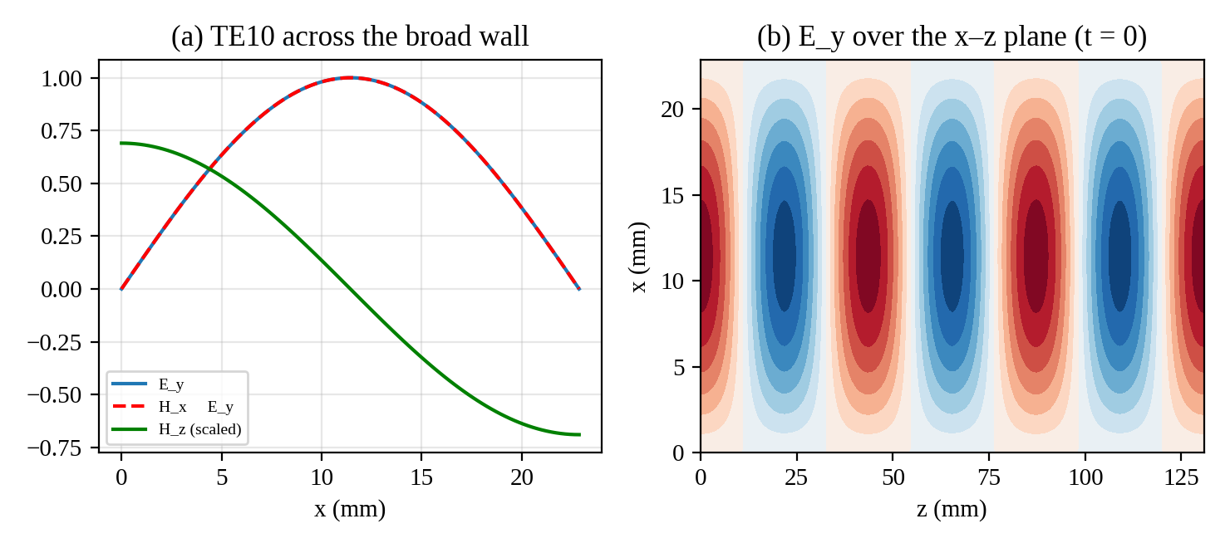
Figure 23: Output of Program 12
E_{y} is zero at the side walls and maximum at x = a/2, with a period of one guide wavelength (43.6 mm) along z. The sinusoidal profile justifies placing the feed probe at the centre and integrating E_{y} over y at x = a/2 to define the equivalent voltage.

REFERENCES
1. D. M. Pozar, Microwave Engineering, 4th ed., Wiley.
2. R. E. Collin, Foundations for Microwave Engineering, 2nd ed., Wiley-IEEE Press.
3. N. Marcuvitz, Waveguide Handbook, IEE.
4. E. O. Hammerstad and O. Jensen, Accurate models for microstrip computer-aided design, IEEE MTT-S Digest, 1980.
5. W. J. Getsinger, Microstrip dispersion model, IEEE Trans. MTT, 1973.
6. ICNIRP, Guidelines for limiting exposure to electromagnetic fields (100 kHz to 300 GHz), Health Physics, 2020.
7. IEEE Std 299, Measuring the Effectiveness of Electromagnetic Shielding Enclosures.

