Design Doc SMART DRIVE

*Author(s):*

*R. Nikitha*

*N. Lakshmi Vyshnavi*

*B. Sai Tulasi*

*K. Keerthana*

*N. Lakshmi Manasa*

*G. Sridevi*

*M. Gnaneshwari*

*Date: 10/06/2019*

Revision: 1

Document Status: Draft [Draft, Completed, Submitted, Reviewed, Final]

Project Status: In-Progress [In Review, Approved, In-Progress, Completed]

Revision History

|  |  |  |  |
| --- | --- | --- | --- |
| Date | Revision | Description | Author |
| 22/05/2019 | 0 | Initial draft of the design doc template | Team |
| 10/06/2019 | 1 | Changes related to prototype | Team |
|  |  |  |  |
|  |  |  |  |
|  |  |  |  |
|  |  |  |  |
|  |  |  |  |
|  |  |  |  |
|  |  |  |  |
|  |  |  |  |

Table of Contents

Introduction4

Summary4

Background4

Design Overview5

Requirements5

Documentation5

Minimum Viable Product5

Stretch goals5

Future work5

Architectural Diagrams6

System Diagrams6

Application Programming Interface6

Recommendations6

Project Overview6

Communication and Tracking6

Risks7

Milestones7

Project Phases7

Cost7

Frequently Asked Question7

References7

**Introduction**

## Summary

Driving car in heavy pollution and unpleasant situations may lead to collisions of vehicles. Using this device it will be helpful for the driver to drive safe to destination.

## Background

During unpleasant weather conditions like foggy days, heavy rains, there may be a possibility of vehicle collision due to lack of proper vision. There are also situations where vehicle collision occurs due to high speed in traffic. The solution is, driver is alerted with the intensity of the LED and the app which converts the text to speech and tell the driver about the obstacles which are behind and front. And this can be achieved by, embedding sensors along the corners of the car to detect the obstacle distance (ultra sonic sensor) and notify if any limitation of distance is violated. The application and the navigation screen in the car allow driver to check if the driver is in the safe zone. The application notifies using audio by connecting the Bluetooth to the speakers. The sensors activate the LED's to catch the attention of fellow drivers. The sensor will activate the horn and with increasing volume to notify other users. The application will disable or hang the mobile phone in case if the driver is using. It notifies to the nearest police station or ambulance at emergency times. All the above process is done with respect to speed of the car which is achieved by using accelerometer.

Forbes:

Rear-view cameras: It has two main purposes; firstly to give the driver a clear view of what’s behind the vehicle when reversing and, secondly, to protect children and animals from being accidentally hit or run over. These cameras typically use wide-angle lenses to give up to 180-degree backward views.

Overlaps:

On normal roads, it could be difficult as in India we find people driving bumper to bumper.

Gains:

It is very useful on highways.

# Design Overview

## Requirements

### Hardware Requirements:

* Ultrasonic sensor
* Arduino UNO
* LED
* Buzzer

Software Requirements:

* Arduino Software
* MIT APP Inventor 2

### Documentation

Documents, Code related to the project is available in the drive.

<http://bit.ly/2I6Al4P>

## Minimum Viable Product

Alerting driver with intensity of light and through app, depending on the distance of vehicles which are behind and front of the vehicle.

## Stretch goals

If the vehicle meets with an accident then an alert can be sent to nearby hospitals and family members.

## Future work

We can integrate it with smart parking solutions, wherein it will be able to tell whether the slot is available or not.

# Architectural Diagrams

# System Diagrams

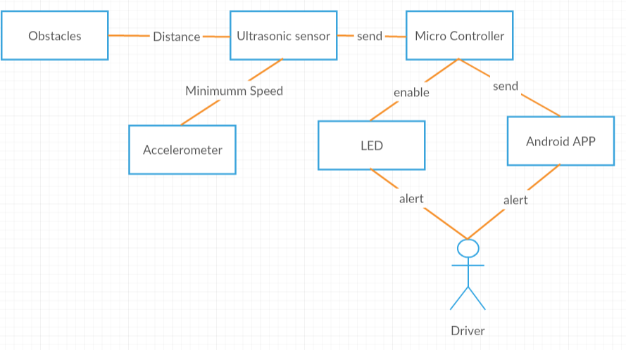

Via Bluetooth

# Application Programming Interface

An LED embedded near steering.

## Recommendations

Using a versioned endpoint simplifies the process of making future backwards incompatible API changes;

/api/v0

# Project Overview

## Communication and Tracking

The device performance should be known from the customer.

## Risks

Assumptions:

If LED’s won’t work properly.

If Bluetooth is not on in mobile phone.

If App won’t receive values in time via Bluetooth.

## Milestones

Connecting the prototype with accelerometer.

## Project Phases

Market research

Development

Testing

Deployment

## Cost

Price – 2000/-

Cost – 3000/-

# Frequently Asked Question

# References

<https://blog.nationwide.com/winter-car-safety-features/>

<https://www.roadandtrack.com/new-cars/car-technology/g6926/buying-new-car-top-features/>