# ****Sales and Profit Insights Dashboard – Detailed Report****

## ****1. Introduction****

This report presents a detailed review of the company’s performance based on the Sales and Profit Insights Dashboard. It covers key performance indicators, sales trends over time, regional performance, category-wise contributions, and strategic recommendations. The dataset used for this analysis contains transaction-level information, including order values, profit figures, quantities sold, product categories, payment modes, customer locations. By combining these data points, the dashboard delivers actionable insights for decision-making and performance improvement.

## ****2. Key Metrics Overview****

The dashboard highlights four primary performance indicators that summarize overall business health:

* **Total Quantity Sold:** 12,745 units
* **Total Sales:** ₹61,82,639
* **Total Profit:** ₹16,10,697
* **Profit Margin:** 26.05%

These metrics show that the company generates significant sales revenue with a healthy profit margin, reflecting strong cost control and pricing strategies. A profit margin above 25% suggests that the company is managing operational costs effectively while maintaining competitive selling prices.

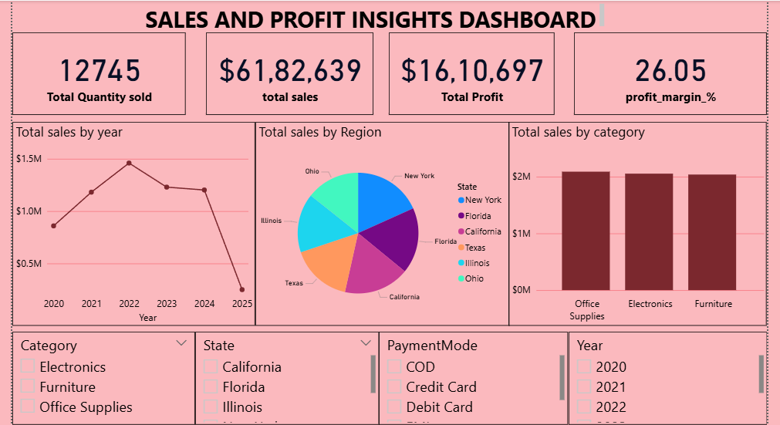

## ****3. Yearly Sales Trend Analysis****

The sales trend over time provides valuable insight into market performance and demand fluctuations. Between 2020 and 2022, sales showed steady growth, peaking in 2022. This period likely benefited from strong market demand, effective promotional campaigns, and possibly the introduction of high-performing products.

However, after 2022, sales performance began to decline. In 2023 and 2024, the drop was moderate, but in 2025, sales fell sharply to their lowest level in five years. This sharp downturn could be linked to economic challenges, reduced consumer spending, competitive market pressures, or shifts in customer preferences. Understanding the root causes of this drop should be a priority for management.

## ****4. Regional Performance Insights****

Regional sales analysis shows a clear distribution pattern across different states. **New York, Florida, and California** are the top-performing regions, contributing the largest share of total sales. These states likely benefit from a strong customer base, higher average incomes, and better distribution networks.

Meanwhile, **Texas, Illinois, and Ohio** generate lower sales volumes. This indicates untapped potential, and with targeted marketing and improved distribution channels, these markets could contribute more significantly to overall revenue.

## ****5. Category Performance Analysis****

The company’s products are categorized into **Office Supplies, Electronics, and Furniture**. The data reveals a balanced performance among these categories, with **Office Supplies** slightly leading the sales charts, followed closely by Electronics and Furniture.

This distribution is a positive sign, as it indicates that the company is not overly dependent on a single category, reducing overall business risk. Still, further growth can be achieved by leveraging top-performing product lines and running targeted campaigns for slower-moving items.

## ****6. Strategic Recommendations****

Based on the insights from the dashboard, the following strategies are recommended:

1. **Investigate Post-2022 Decline:** Conduct a deeper analysis into the reasons behind the sales drop after 2022, considering factors like competitor activity, pricing strategy, and market trends.
2. **Expand in Underperforming Regions:** Focus marketing efforts and promotional campaigns in states like Ohio and Illinois to unlock additional sales potential.
3. **Leverage High-Performing States:** Introduce premium product lines or exclusive offers in New York, Florida, and California to further boost revenue in these strong markets.
4. **Enhance Category Performance:** Continue strengthening Office Supplies sales while introducing innovations in Electronics and Furniture to encourage repeat purchases.
5. **Optimize Customer Engagement:** Expand payment options, improve the online shopping experience, and offer loyalty programs to retain and grow the customer base.

## ****7. Conclusion****

The Sales and Profit Insights Dashboard gives a comprehensive view of the company’s operational and financial performance. The healthy profit margin and balanced product category sales demonstrate a solid business foundation. However, the declining sales trend since 2022 is a cause for concern and requires prompt attention.

By focusing on regional expansion, leveraging strong markets, innovating product offerings, and enhancing customer engagement, the company can address the decline and position itself for sustainable growth in the coming years.