**MANUAL TESTING PROJECT**

**TYPES OF TESTING DONE:** Functional testing, Integration testing, System Testing,   
Compatibility Testing, Performance Testing, Usability Testing

**NAME OF APPLICARION BEING TESTED:**

SWIGGY

**BROWSERS USED FOR TESTING:**

Chrome, Firefox

**FUNCTIONAL TESTING:**

**APPLICATION NAME:** SWIGGY

**DEFECT FOUND:** The Swiggy website does not provide a visible or accessible logout button, preventing users from logging out of their accounts easily.

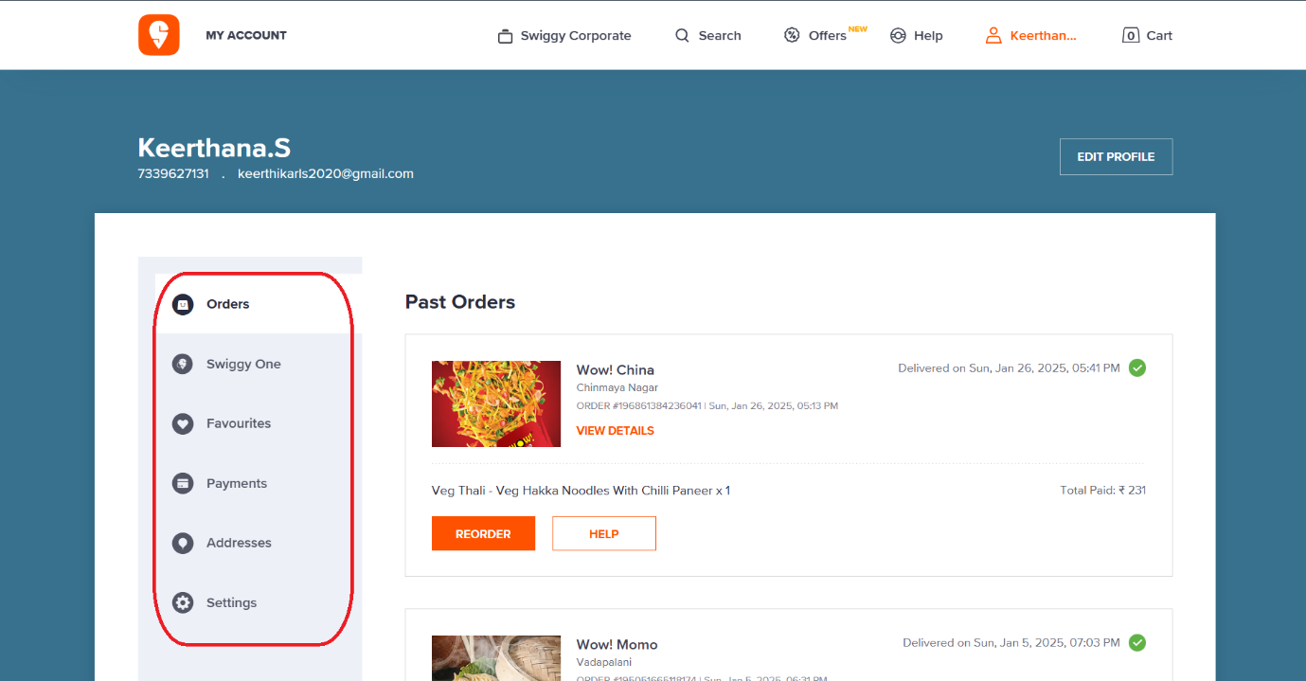

**DEFECT FOUND:** The 50% discount should apply when the purchase amount exceeds ₹200, but the discount is not being applied as expected, even when the conditions are met. This indicates that the discount logic is malfunctioning.

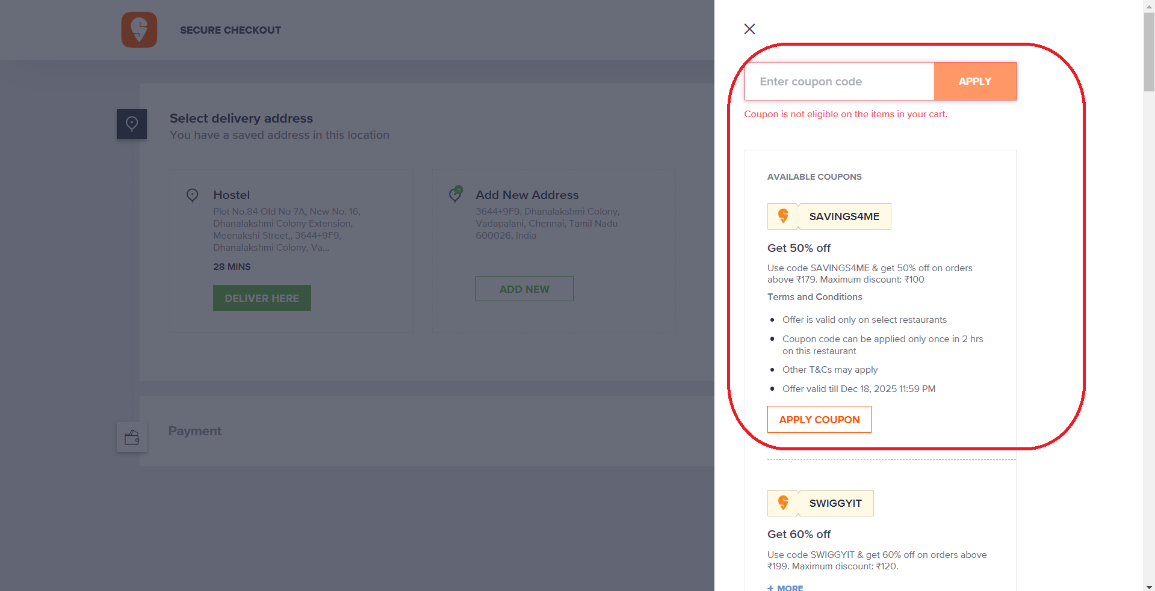

**INTEGRATION TESTING:**

**DEFECT FOUND**: The Twitter logo (old design) is still displayed instead of the new X logo. However, clicking on it correctly redirects users to the X platform.

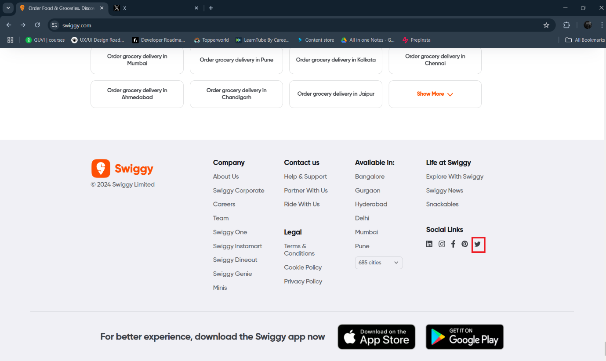

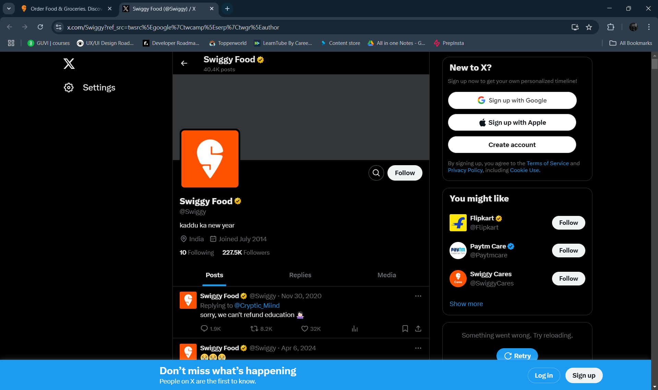

**DEFECT FOUND**: The copyright year displayed in the footer of the Swiggy website is inconsistent across different pages. While some pages show "© 2024 Swiggy Limited", others display "© 2025 Swiggy".

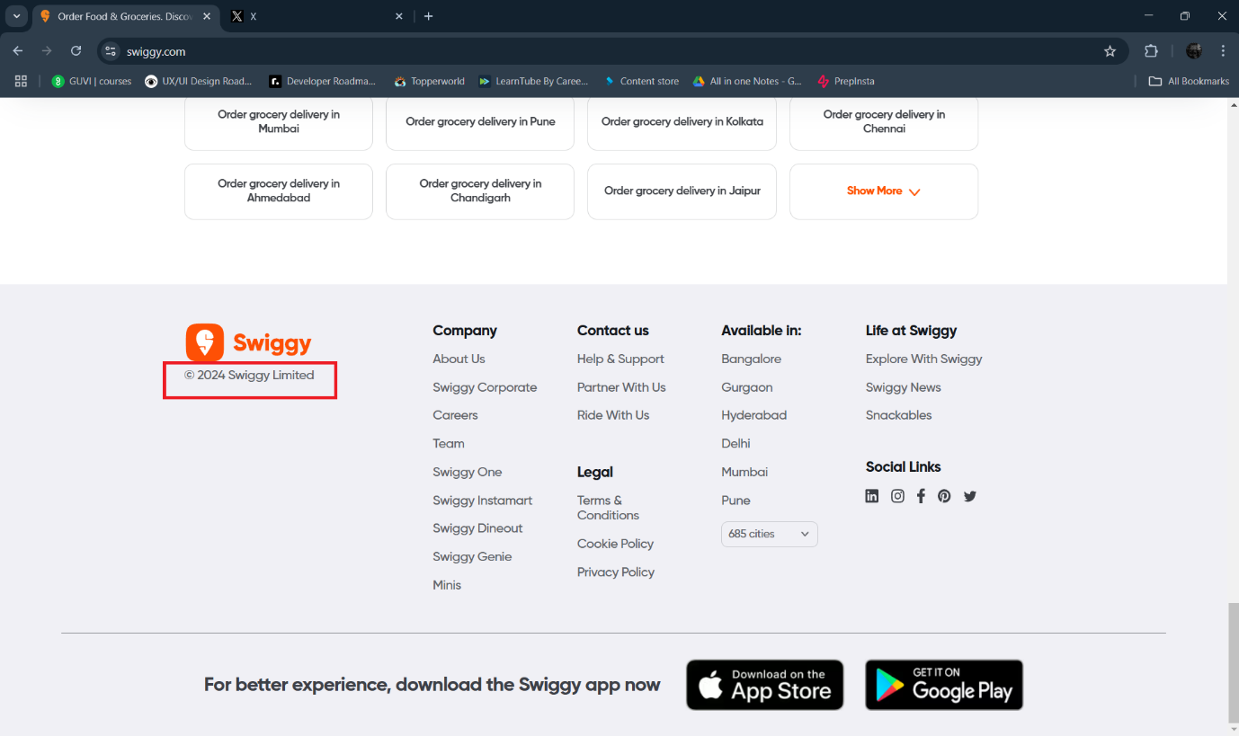

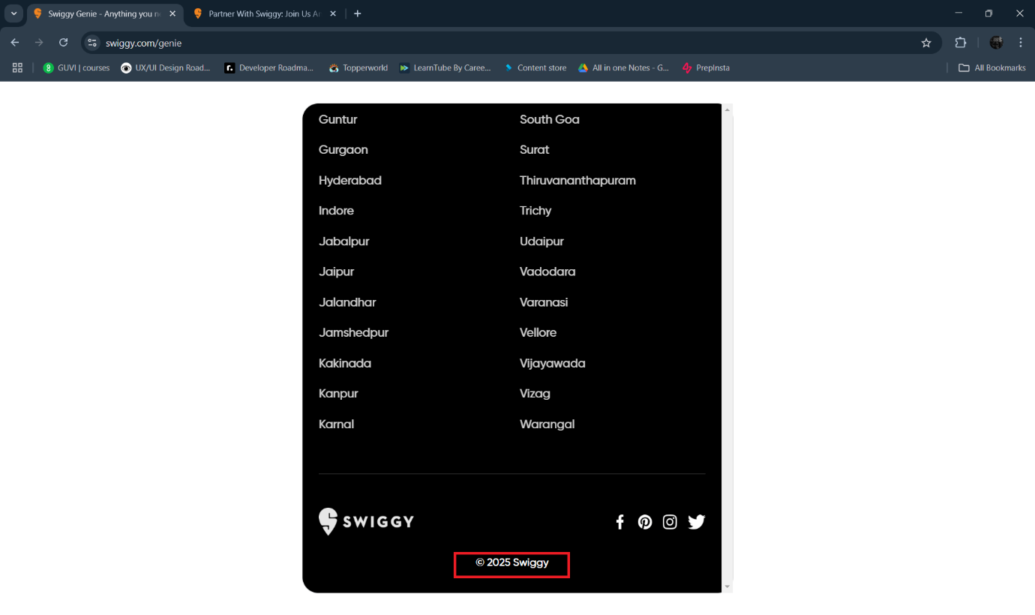

**USABILITY TESTING:**

**DEFECT FOUND:** The Live Order Tracking page of Swiggy displays a Google Maps section, but the delivery icon is misaligned on the map.

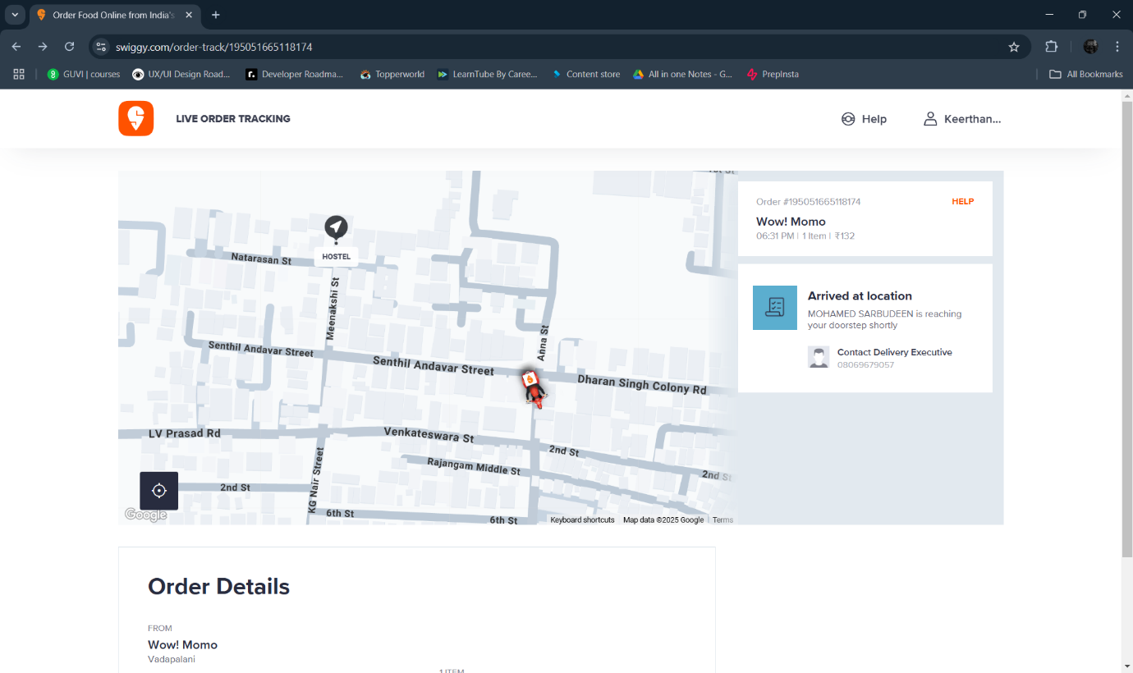

**PERFORMANCE TESTING:**

**DEFECT FOUND:** To assess how the system performs under different conditions, particularly focusing on how fast or slow certain operations (like delivery time calculation and updating) occur.

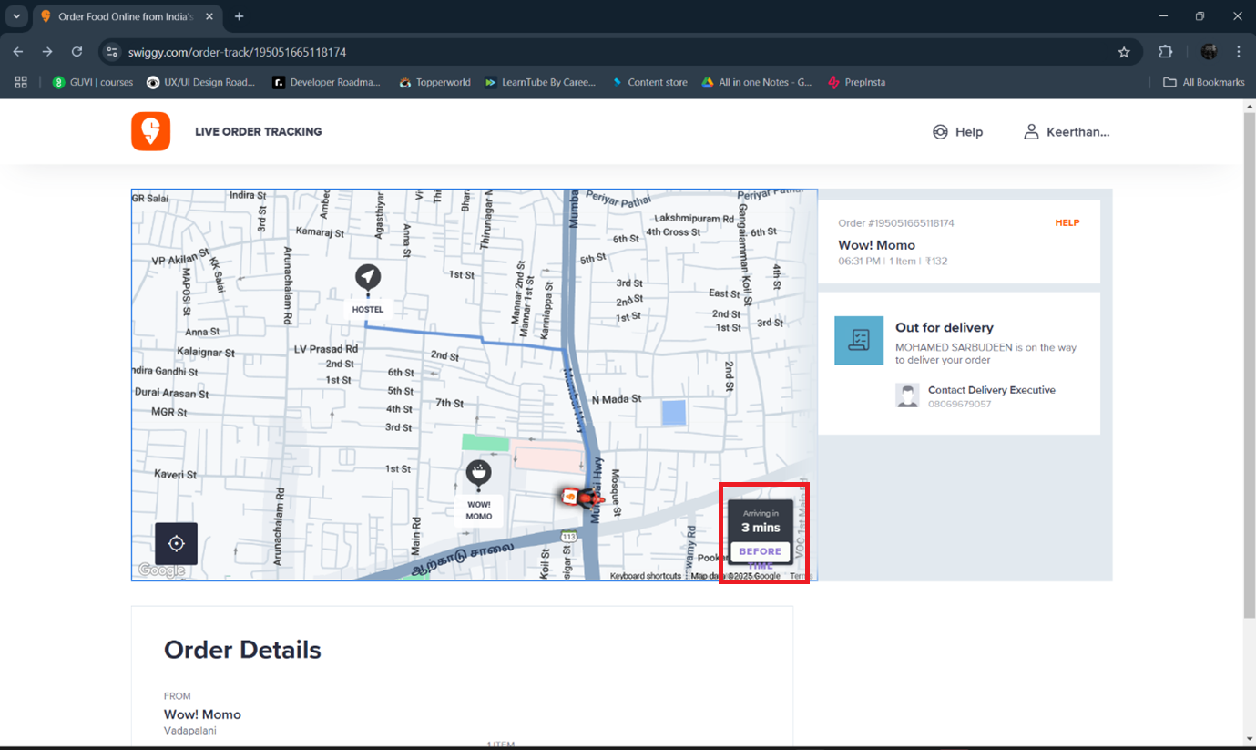

**SMOKE TESTING:**

**DEFECT FOUND:** The "Non-Veg" filter is not functioning correctly. It is displaying vegetarian food items (like Papaya Juice) when it should only be showing non-vegetarian options.

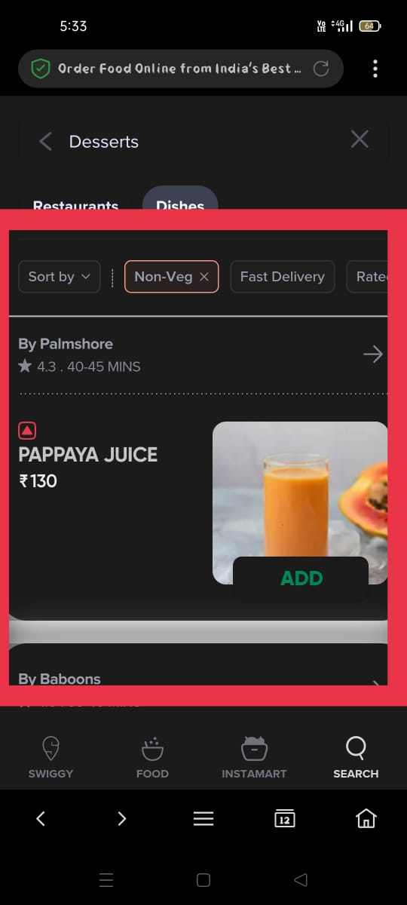

**GLOBALIZATION TESTING:**

**DEFECT FOUND:** The issue, where a machine translation gives an incorrect or inaccurate translation (such as "Lite" being translated as "Lite" in Tamil instead of the appropriate term), falls under **Localization Testing** within **Globalization Testing**.

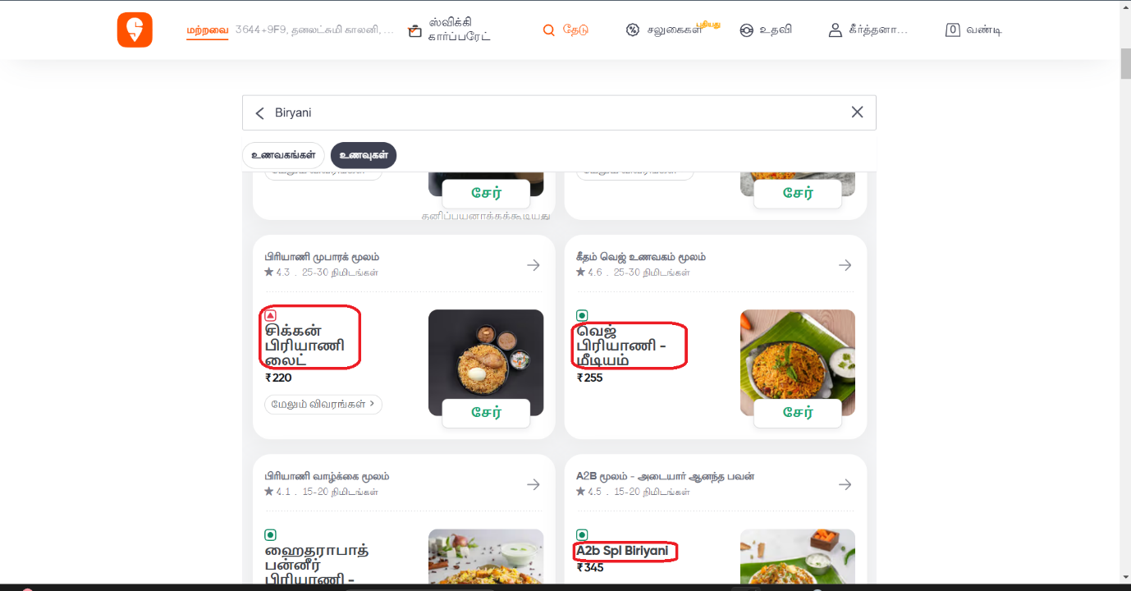

**DEFECT FOUND:** "Kathal" in Hindi refers to **Jackfruit**, but if the translation to Tamil (from the Hindi version) doesn’t accurately convey **Jackfruit Biryani** in Tamil, it’s a translation error.

