***DATA VISUALIZATION***

***POWER BI***

***Name: Keerthana K M Roll No: 231057007***

1. **List the tasks performed in data analysis and demonstrate five core components of analytics.**

* Establish a goal, for which the data collection is required
* Determine the type of data analytics to use, in order choose the right data
* Determine a plan to take factors like budget, time, resources into consideration, that is involved in the process of preparing data
* Collection of data
* Cleaning of data
* Evaluation of data
* Visualization of data

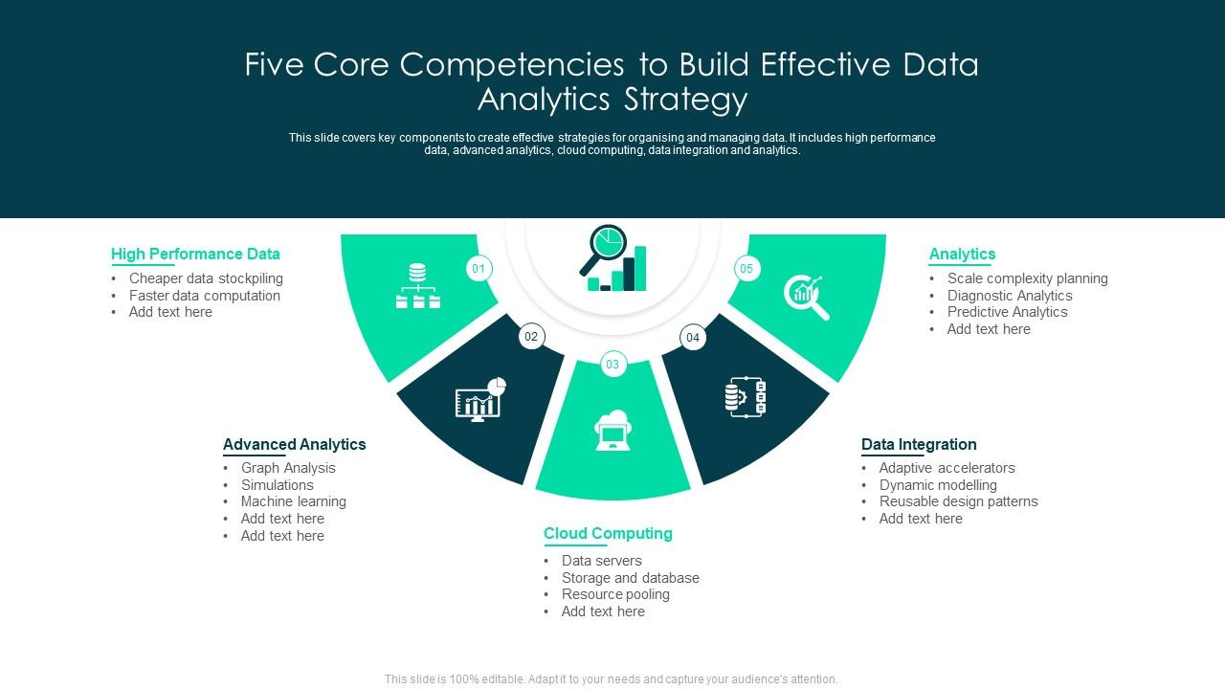

*Fig 1.1 – Five Core Competencies of Data Analytics*

***The five core components of Data Analytics involve collecting data, analysing data, reporting results, improving processes, building a data-driven culture.***

1. **Describe five job roles in the overall spectrum of data discovery and understanding.**
2. Data Liaison
3. Data Architect
4. Platform Architect
5. Data Analyst
6. Data Scientist

***Data Liaison***

* Acts as the point of contact for the Open Data Unit in terms of organising meetings with one’s organisation
* Provides short progress updates to the Open Data Unit in relation to open data activities within one’s organisation on a quarterly basis
* Acts as the point of contact for any queries that the Open Data Unit receive in respect of data from one’s organisation and work with policy areas that manage data to encourage its release
* Promotes and encourages the publication and use of open data within one’s organisation as well as encouraging all such data to be linked to the national open data portal data.gov.ie – acts as an Open Data champion or encourage others to do so
* Promotes the availability of the framework for open data training and the framework for open data technical support within one’s organisations
* Work with the Open Data Unit in ensuring that datasets on the national portal relevant to one’s organisation are compliant with the Open Data technical framework

***Data Architect***

* Develops database solutions to store and retrieve company information
* Installs and configures information systems to ensure functionality
* Analyses structural requirements for new software and applications
* Migrates data from legacy systems to new solutions
* Designs conceptual and logical data models and flowcharts
* Improves system performance by conducting tests, troubleshooting and integrating new elements
* Optimizes new and current database systems
* Defines security and backup procedures
* Coordinates with the Data Science department to identify future needs and requirements
* Provides operational support for Management Information Systems (MIS)

***Platform Architect***

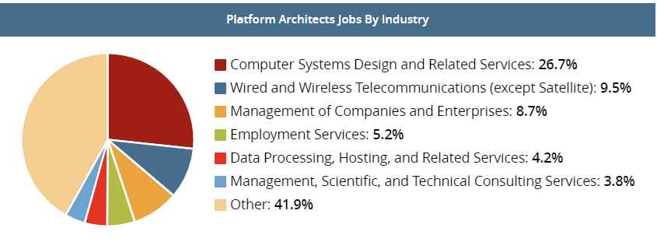

*Fig 2.1 – Platform architects’ jobs across industries*

* Architect partners with strategic planning and engineering teams to take ideas from concepts to fruition
* Interacts with external customers and partners in the industry
* Participates in the design, build and deployment of a new Open Source DB service and platform including service request, provisioning process, configuration, monitoring definition, backup and recovery strategy, and security
* Is capable of developing conceptual and detailed design documentation
* Articulates and presents different points-of-views on various technologies with key stakeholders of infrastructure programs via workshop, web conference and PowerPoint presentation
* Mentors team members in technology, architecture and delivery of new solutions
* Participates in POC's with applications and projects interested in using new DB platform capabilities
* Works closely with company’s Operations Service Delivery partner to perform knowledge transfer (KT) training to Level2 and Level3 staff, support and optimize DB infrastructure
* Identifies, investigates, evaluates and quickly becomes proficient in new technologies and technical disciplines that are of significance to HealthTrust
* Provides technical leadership and sets architectural direction for all the business services in the domain by bringing both technical vision and business objectives together

***Data Analyst***

* Data mining: Data Analysts extract data from multiple sources that can be primary or secondary. After that, they organize the data in a proper format that can be easily understood.
* Maintaining databases: Data Analysts help design and maintain database systems. This includes creating, updating, reading, and deleting a database.
* Data preparation: Data collected from multiple sources would always have errors, redundancy, missing values, and many more, which means that the data is in a raw format. After the extraction of the data, therefore, Data Analysts have to convert the raw data into structured data by resolving the errors in the data, removing irrelevant data, and identifying the potential data. They apply many data cleaning techniques to make it ready for manipulation and visualization by Data Scientists.
* Quality assurance: Most organizations rely on their data for their day-to-day pursuits. Therefore, it becomes necessary to get quality data for enhancing the productivity of the organization. Data Analysts make sure that the data collected from multiple sources is relevant to the business.
* Collaborating with other teams: Data Analysts prepare data for Data Scientists, ML Engineers, and other software development teams. They use the data for building ML-based automated software. Data Analysts coordinate with development teams to convey the necessary information related to the data.
* Preparing reports: Data Analysts prepare reports that represent crucial information. These reports consist of graphs and charts to represent factors associated with the business. They help monitor the direction of business growth by analysing factors such as profitability, market analysis, internal activities, etc.
* Troubleshooting: Data Analysts help troubleshoot issues related to information, reports, and databases.

***Data Scientist***

* Performs Data mining or extracting usable data from valuable data sources
* Uses machine learning tools to select features, create and optimize classifiers
* Carries out pre-processing of structured and unstructured data
* Enhances data collection procedures to include all relevant information for developing analytic systems
* Processes, cleans, and validates the integrity of data to be used for analysis
* Analyses large amounts of information to find patterns and solutions
* Develops prediction systems and machine learning algorithms
* Presents results in a clear manner
* Proposes solutions and strategies to tackle business challenges
* Collaborates with Business and IT teams

1. **Describe five key areas in the data analysis process.**

* ***Collection of data*** involves g[athering all of the data that your business produces](https://www.domo.com/data-integration), both internally and externally. The data can come from a variety of sources, including operational systems, transactional data, web and social media data and machine data. Depending on the data source, collection of data may vary. For an example, operational data can be manually extracted from systems, or automatically using Extract, Transform and Load (ETL) tools.
* ***Analysis of data*** is the process of using statistical techniques to examine the data and extract useful information. It can successfully be used to identify patterns and trends, predict future trends, also to detect anomalies in series of data.
* ***Results are reported*** so that one can [share the insights with others](https://www.domo.com/learn/article/sharing-dashboards-and-insights-through-business-intelligence/) and make decisions based on the findings. One can present findings on a dashboard, or generate a report, or create infographics, based on the type of audience and business requirements.
* ***Improving processes*** involves making changes to the way data is collected, processed, and analysed. It may also involve changing the way decisions are made based on the data. By constantly improving the process, you can ensure that data analytics is having a positive impact on the business.
* To be ***truly data-driven***, one needs to [build a culture](https://www.domo.com/blog/building-a-data-driven-culture-the-people-aspect/) in which everyone uses data to make decisions. This includes training employees on how to use data analytics and giving them access to the tools they need. Some steps towards a data-driven culture would be making the data accessible, train employees on how to use data, encourage a data-driven environment and create a culture of accountability.

1. **Describe Building blocks of Power BI.**

***The major building blocks of Power BI are visualizations, datasets, reports, dashboards and tiles.***

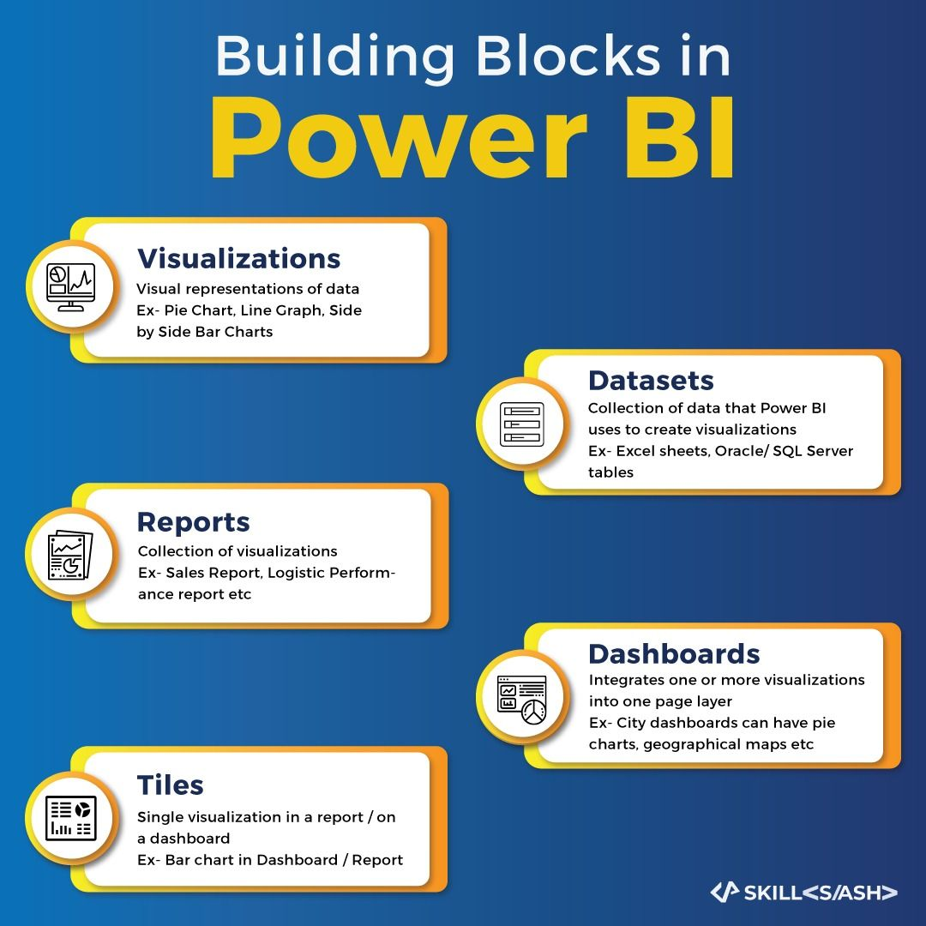

*Fig 4.1 – Building Blocks of Power BI*

**Visualization**, also know as a perception is a visual portrayal of information. For example, a diagram, chart, shading coded outline, other intriguing things you can make to speak to your information outwardly. Power BI has a wide range of various perception writes, and additionally coming constantly. The objective of a visual is to introduce information in a way that gives setting and experiences, both of which would almost certainly hard to perceive from a crude table of numbers or content.

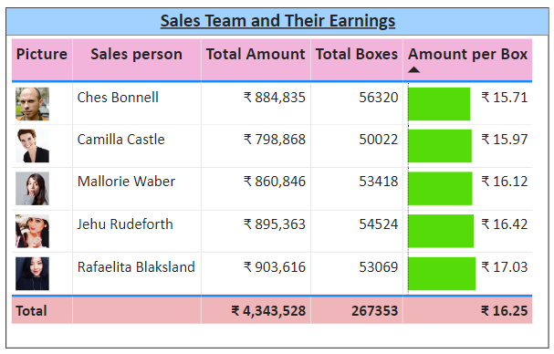

*Fig 4.2 – An example for Visualization*

A **dataset** is a collection of data that Power BI uses to create its visualizations. Dataset can also be a combination of many different sources, which can be filtered using Power BI and combined into one to use. An important feature of Power BI is the ability to connect to various data sources using its connectors. Whether the data one wants is in Excel or a Microsoft SQL Server database, in Azure or Oracle, or in a service like Facebook, Salesforce, or MailChimp, Power BI has built-in data connectors that let you easily connect to that data, filter it if necessary, and bring it into your dataset.

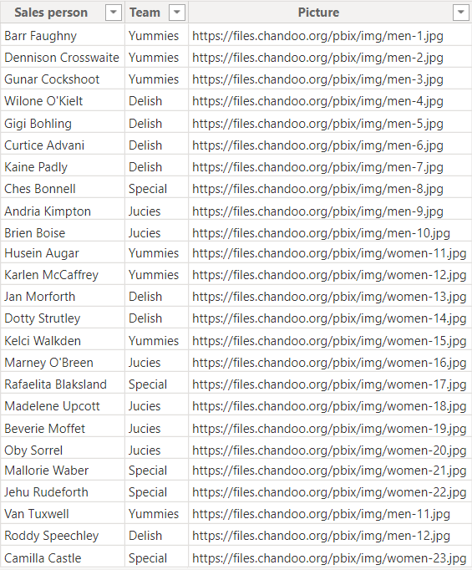

*Fig 4.3 – An example for Dataset*

**Report** is a collection of visualizations that appear together on one or more pages. A report in Power BI is a collection of items that are related to each other. A report takes place in a single workspace. A report can be associated with multiple dashboards within the workspace. Tiles pinned from that report may appear in more than one dashboard. Power BI Desktop can combine multiple datasets into a single report and this report can be exported to Power BI.

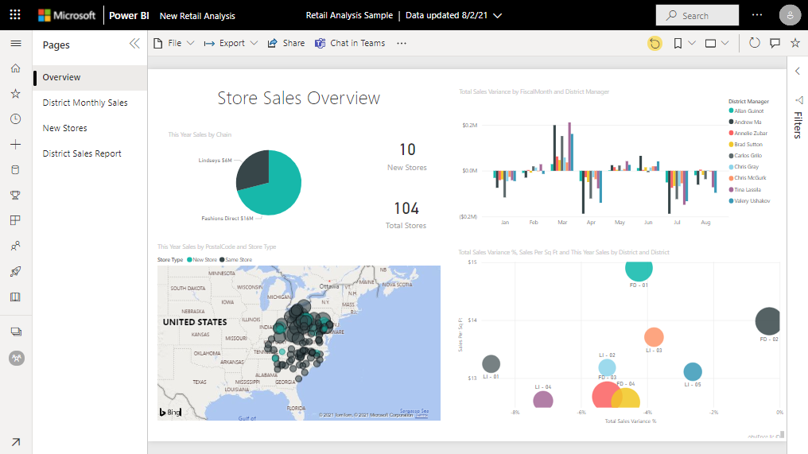

*Fig 4.4 – An example for Report*

A **Power BI** **dashboard** is a collection of visuals from a single page that you can share with others. Often it is a selected group of visuals that provide quick insight into the data or story you are trying to present. One can share dashboards with other users or groups, who can then interact with created dashboards when they’re in the Power BI service or on their mobile device. It is a workspace where one creates, combine, and rework interesting and compelling visuals.

Each visual data stored in the dashboards is referred to as a **Tile**.

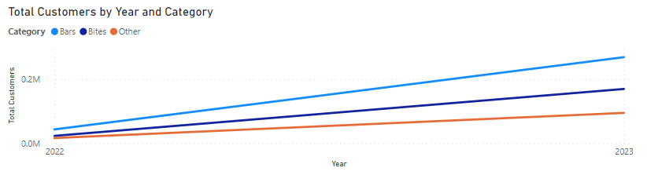

*Fig 4.5 – An example for a Tile*

1. **Demonstrate fact and dimension table with an example and list their characteristics.**

***Fact tables*** and dimension tables are key components of a schema in a data warehouse. A fact table contains records that combine attributes from different dimension tables. These records allow users to analyse different aspects of their business, which can aid in decision-making and improving the business.

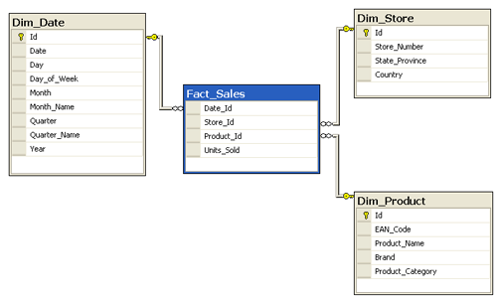

*Fig 5.1 – An example for Fact table wrt Dimension table*

***Dimension tables***, on the other hand, provide the context and background information for the measures recorded in the fact table. One of the main differences between fact tables and dimension tables is that dimension tables contain the attributes that the measures in the fact table are based on.

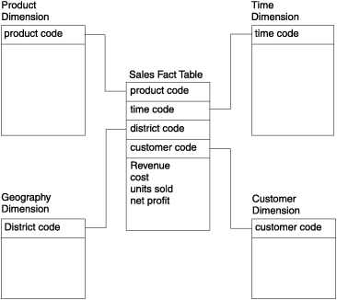

*Fig 5.2 – An example for Dimension table wrt Fact table*

***Characteristics of Fact Table***

* ***Outrigger Dimensions***: Outrigger dimensions are dimensions that refer to any other dimension table.
* ***Keys***: Each fact table has a key that is made up of the primary keys from all of the dimension tables connected to that fact table. A concatenated key is one such key that specifically identifies the row of the fact table.
* ***Additive Measures***: The fact table's attributes may be entirely, partially, or not at all additive. Measures that are applied to all dimensions are referred to as fully addition or additive measures. Quasi-measures are those that store the fundamental unit of measurement for any business process, whereas semi-additive measures add measures to some dimensions but not to all.
* ***Fact Table Grain***: The level of detail or depth of the information recorded in a fact table is referred to as the table's grain. A successful fact table must be designed at the highest level.
* ***Degenerated Dimensions***: A degenerated dimension is any dimension or attribute that is available in the fact table but cannot be added to or is non-additive.
* ***Sparse Data***: Some records in the fact table have characteristics with null values or measurements, which means that the information they contain is not given or provided.
* ***Shrunken Rollup Dimensions***: The dimensions that are created by subdividing the base dimension's columns and rows are known as shrunken rollup dimensions.

***Characteristics of Dimension Table***

* ***Relationship Between Attributes***: Although they are all included in the same dimension table, the attributes in it typically do not have a direct relationship with one another.
* ***Records***: The dimension table contains more characteristics than records.
* ***Keys***: The main key is required for every dimension table in order to help uniquely identify each entry.
* ***Normalization***: The dimension table is not normalized because doing so splits the data into different tables and makes it more difficult for queries to execute quickly because they must go through these extra tables to retrieve measurements from the fact table for each corresponding attribute in the dimension table.
* ***Attributes***: Because the dimension table has so many attributes, it looks to be expanding horizontally.
* ***Drilling Down, Rolling Up***: The presence of attributes in a dimension table enables the extraction of information by drilling down from a higher level to a lower level or by rolling up from a lower level to a higher level of the attributes.
* ***Attribute Values***: The majority of the values in the dimension table are expressed as text rather than numbers.

1. **Discuss ten differences between fact and dimension table.**

|  |  |  |
| --- | --- | --- |
| **Basis of Distinction** | **Fact Table** | **Dimension Table** |
| Definition | Facts about a business process, such as measurements or metrics. | Descriptive characteristics in the companion table to the fact table can be utilized as query constraints. |
| Characteristics | Positioned in the middle of a snowflake or star schema, surrounded by dimensions. | The edges of the snowflake or star schema, attached to the fact table, |
| Design | Defined by their grain or at the atomic level. | It must be extensive, in-depth, and of the highest calibre. |
| Task | A fact table is a quantifiable event for which data from a dimension table is gathered and used for reporting and analysis. | Gathering of background data about a company. |
| Data Type | Facts tables may include data about sales in relation to a number of parameters, such as Product and Date. | Each dimension table has attributes that provide information about the specifics of the dimension. For instance, product dimensions may include the product ID, category, etc. |
| Key | The fact table's primary key is mapped as a foreign key to dimensions. | Each dimension in a dimension table contains a primary key column that uniquely identifies it. |
| Storage | Helps to save report labels and filter domain values in dimension tables. | Load dimensional structures with thorough atomic data. |
| Hierarchy | Contains no hierarchy. | Hierarchies are present. For instance, Location could include a country, state, city, zip code, and more. |

*Table 6.1 – Fact table vs Dimension table*

1. **Demonstrate star and snow flake schema with a use case and illustration in detail.**

***Star Schema***

**SALES** is a fact table having attributes i.e. (Product ID, Order ID, Customer ID, Employer ID, Total, Quantity, Discount) which references to the dimension tables. ***Employee dimension table*** contains the attributes: Emp ID, Emp Name, Title, Department and Region. ***Product dimension table*** contains the attributes: Product ID, Product Name, Product Category, Unit Price. ***Customer dimension table*** contains the attributes: Customer ID, Customer Name, Address, City, Zip. ***Time dimension table*** contains the attributes: Order ID, Order Date, Year, Quarter, Month.

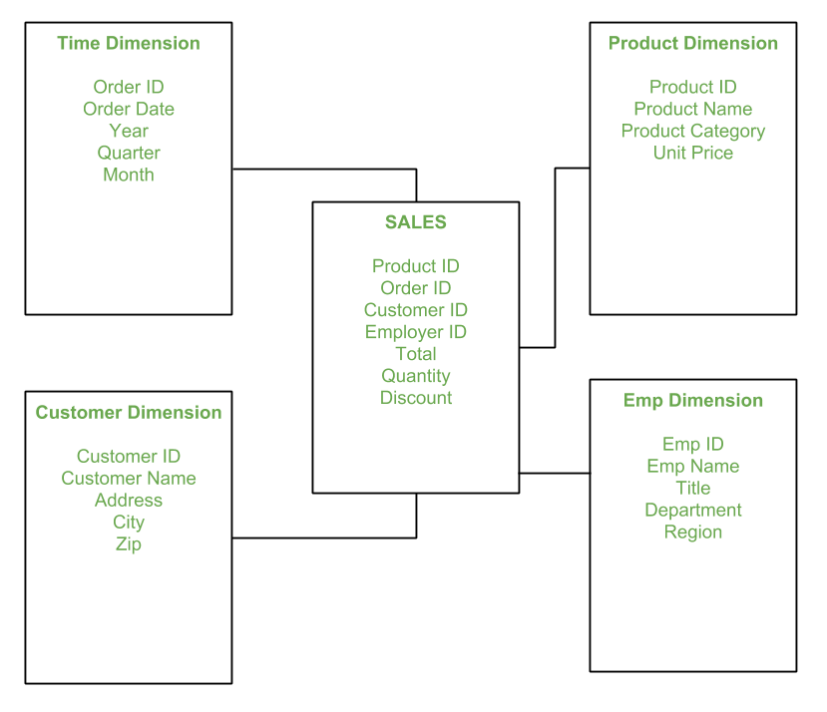

*Fig 7.1 – Star Schema*

In Star Schema, the Business process data that holds the quantitative data about a business is distributed in fact tables, and dimensions which are descriptive characteristics related to fact data. Sales price, sale quantity, distant, speed, weight, and weight measurements are few examples of fact data in star schema.   
Often, A Star Schema having multiple dimensions is termed as Centipede Schema. It is easy to handle a star schema which have dimensions of few attributes.

***Snow Flake Schema***

The ***Employee***dimension table now contains the attributes: EmployeeID, EmployeeName, DepartmentID, Region, and Territory.

The DepartmentID attribute links with the ***Employee***table with the ***Department***dimension table.

The ***Department***dimension is used to provide detail about each department, such as the Name and Location of the department.

The ***Customer***dimension table now contains the attributes: CustomerID, CustomerName, Address, and CityID.

The CityID attributes link the ***Customer***dimension table with the ***City***dimension table.

The ***City***dimension table has details about each city such as city name, Zipcode, State, and Country.

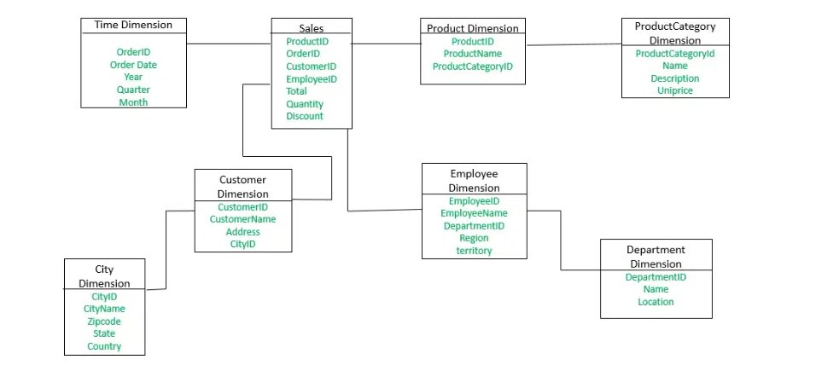

*Fig 7.2 – Snow Flake Schema*

The snowflake design is the result of further expansion and normalization of the dimension table. In other words, a dimension table is said to be snow flaked if the low-cardinality attribute of the dimensions has been divided into separate normalized tables. These tables are then joined to the original dimension table with referential constraints (foreign key constrain).   
Generally, snowflaking is not recommended in the dimension table, as it hampers the understandability and performance of the dimension model as more tables would be required to be joined to satisfy the queries.

1. **Demonstrate different types of relationship present between tables with an example.**

***One-to-One***

In a one-to-one relationship, a record in one table belongs to only one record in another table and vice versa.

For example, in the relationship between people and driver’s license numbers, a person can have only one driver’s license number, and a driver’s license number belongs to only person.

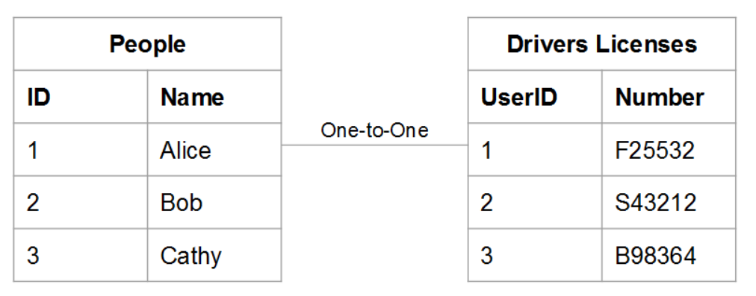

*Fig 8.1 – One-to-One relationship*

***One-to-Many***

In a one-to-many relationship, a record in one table can potentially belong to several records in another table. It is like the relationship between orders and items - an order can contain many items, but an item belongs to a single order. In this case, the orders table is the one side and the items table is the many sides.

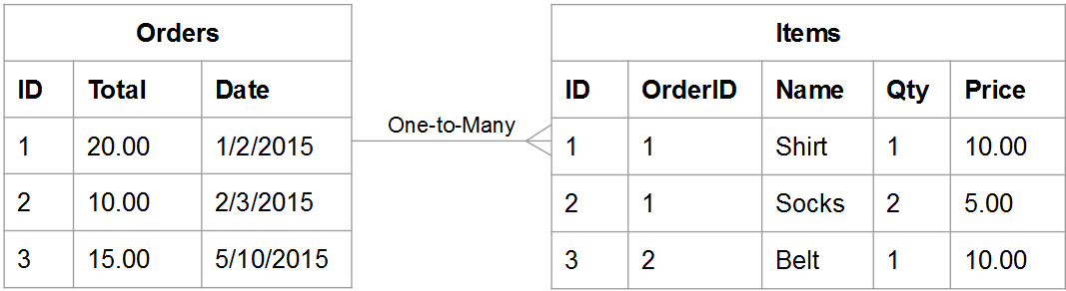

*Fig 8.2 – One-to-Many relationship*

### *Many-to-Many*

In a many-to-many relationship, a record in one table can potentially belong to several records in another table and vice versa.

Think about the relationship between **products** and **categories**: a product can belong to many categories, and a category can contain many products.

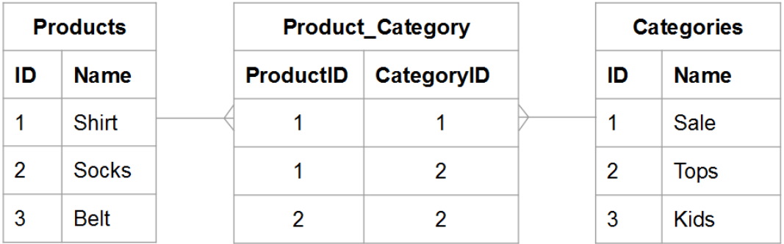

*Fig 8.3 – Many-to-Many relationship*

***Many-to-One***

In many-to-one relationship, more than one record in one table correspond to only one record in another table, but not vice versa. For example, if there is a ***Student table*** and a ***Courses table***, we can have many students taking up a single course, like BE, or BCA etc., but more than one course cannot have the same student details.

1. **Define DAX. Discuss the features of Power BI, how DAX formulas are written.**

***Data Analysis Expressions (DAX)*** is a large and comprehensive collection of functions and operators that are critical for utilizing many Power BI features. It helps in generating new data using the information that the Power BI model already possesses.

***Features of Power BI***

* ***Data Selection***: Power BI provides you with options to filter the datasets and create relevant small chunks of data. This will allow you to focus on individual datasets and perform more insightful Data Analysis.
* ***Responsiveness***: Power BI relies on highly responsive Navigation Trees and Dashboards on all platforms like Android, iOS, etc. This allows you to get a detailed insight into any Report or Graph without any glitches.
* ***Seamless Functionalities***: Power BI offers you simple drag-and-drop functionalities to create customized reports. This way, even if you have zero to no technical experience, you can easily analyse & visualize your data. Furthermore, Power BI’s platform works on Natural Language Queries. This safeguards you from putting time and resources into learning a complex query language.
* ***Data Connectivity***: Power BI contains a multitude of connectors that allows it to integrate with various external data sources. This way you can directly connect your preferred Data Sources to Power BI seamlessly and perform high-level Data Analytics and visualization.

***Steps involved in writing a DAX Formula***

* The name of the measure or calculated column
* The equal-to operator (“=”) indicates the start of the formula
* A DAX function
* Opening (and closing) parentheses (“()”)
* Column and/or table references
* Note that each subsequent parameter in a function is separated by a comma (“,”)

1. **Demonstrate the following DAX formulas with a context: COUNT, DISTINCTCOUNT, SUM, AVERAGE, MIN, MAX, SUMMARISE, CALCULATE, IF, IFERROR, ISBLANK, EOMONTH, DATEDIFF.**

**COUNT**

COUNT(<column>)

**DISTINCTCOUNT**

DISTINCTCOUNT ( table [column] )

**SUM**

SUM ( table[column] )

**AVERAGE**

AVERAGE ( table[column] )

**MIN**

MIN ( table[column] )

**MAX**

MAX ( table[column] )

**SUMMARIZE**

SUMMARIZE ( <Table> [, <GroupBy_Colname> [, [<Name>] [, [<Expression>] [, <GroupBy_Colname> [, [<Name>] [, [<Expression>] [, …] ] ] ] ])

**CALCULATE**

CALCULATE ( <Expression> [, <Filter> [, <Filter> [, …] ] ] ] )

**IF**

IF ( <LogicalTest>, <ResultIfTrue> [, <ResultIfFalse>] )

**IFERROR**

IFERROR ( <Value>, <ValueIfError> )

**ISBLANK**

ISBLANK ( <expression> )

**EOMONTH**

EOMONTH ( <StartDate>, <Months> )

**DATEDIFF**

DATEDIFF ( <Date1>, <Date2>, <Interval> )

1. **Describe the terminology used in Power BI with an example/use case**

***Table***: A table visual presents data in a tabular format, making it easy for end-users to interpret and analyse.

***Fact***: A fact table stores quantitative information for analysis and is often denormalized. A fact table works with dimension tables.

***Dimension***: Dimension tables provide context for the quantitative data in the fact table by describing the dimensions of the data, such as customers and products.

***Calendar***: It's used to set a date range. It returns a table containing a continuous collection of dates with a single column named “Date”. The dates in the range are from the start date to the finish date, inclusive of those two dates.

***Relationship***: Power BI Model Relationships shows how two or more tables are linked. They show how these tables are related to one another.

***One to Many***: In a one-to-many relationship, a record in one table can potentially belong to several records in another table.

***One to One***: In a one-to-one relationship, a record in one table belongs to only one record in another table and vice versa.

***Many to Many***: In a many-to-many relationship, a record in one table can potentially belong to several records in another table and vice versa.

***Primary Key***: A primary key is a unique identifier for a particular record in a dataset.

***Foreign Key***: A foreign key is a column or combination of columns that is used to establish and enforce a link between the data in two tables to control the data that can be stored in the foreign key table.

***Star Schema***: Star schema is a mature modelling approach widely adopted by relational data warehouses. A star schema enables faster data refreshes, reducing the processing time significantly.

***Snowflake Schema***: The snowflake schema is a “multi-dimensional” structure. At its core are fact tables that connect the information found in the dimension tables, which radiate outward like in the star schema.

***Measures***: Measures are named calculations that are used to aggregate data within a data model.

***Values***: The VALUES function (DAX) returns a one-column table that contains the distinct values from the specified table or column.

***Aggregation***: Aggregation functions calculate a (scalar) value such as count, sum, average, minimum, or maximum for all rows in a column or table as defined by the expression.

***Data Modelling***: A data model in Power BI is a logical representation of how data is structured and related within the tool.

***Slicer***: Slicers are another way of filtering. They're displayed on the report page, and narrow the portion of the dataset that's shown in the other report visualizations.

***Filter***: Filters in Power BI sort data and information based on some selected criteria. That is, one can select particular fields or values within fields and view only the information related to that.

***Query***: A query can give an answer to a simple question, perform calculations, combine data from different tables, add, change, or delete data from a database.

***ETL***: ETL is a process where data is extracted from a data source, then transformed, validated, standardized, corrected, quality checked and ultimately loaded into a data repository, where it is streamlined for analysis and reporting.

***Transformations***: Transformations involve converting a raw data source into a cleansed, validated and ready-to-use format. Data transformation is the process of converting data from one format into another.

***Batch***: Batch data is extracted once or in batches (for instance hourly or daily). It is then transformed, stored, and made available in a data environment.

***Data Pipeline***: Deployment Pipeline in Power BI is a component of the Power BI Service, which enables you to manage multiple environments, define each environment, assign workspaces to the environments, compare the contents of two environments, deploy the changes, have the history of deployment, rollback the change if needed, change the connections through the deployment process and more.

***Source***: Power BI supports large range of data sources. It allows one to connect to different flat files, SQL database, and Azure cloud or even web platforms such as Facebook, Google Analytics, and Salesforce objects.

***Refresh***: Refreshing data typically means importing data from the original data sources into a dataset, either based on a refresh schedule or on-demand.