**PROJECT REPORT**

**Project Title: Lease Management System**

**College Name: Nilgiri College of Arts and Science**

**College Code: Nilgiri College**

**Team ID: NM2025TMID26686**

**Team Members**

* **Team Leader:**
  + Name: Keerthana D
  + Email: ddivagar892@gmail.com
* **Team Member 1:**
  + Name: Lena B
  + Email: lenabasheerlena@gmail.com
* **Team Member 2:**
  + Name: Mohammed Basith
  + Email: pybasith7@gmail.com
* **Team Member 3:**
  + Name: Mohamed Ashif
  + Email: ashifkvl3377@gmail.com

**Table of Contents**

1. Introduction  
    1.1 Project Overview  
    1.2 Purpose
2. Functional and Performance Testing
3. Results
4. Advantages & Disadvantages
5. Conclusion
6. **INTRODUCTION**

**1.1 Project Overview**

The **Lease Management System (LMS)** is a Salesforce-based application designed to automate leasing processes. It manages **properties, tenants, leases, payments, and communication** with features such as flows, approval processes, and email alerts.

This project reduces manual work, improves efficiency, and ensures accurate record-keeping.

**1.2 Purpose**

* To automate tenant and lease management.
* To send **automatic rent reminders and approvals**.
* To prevent duplicate records with validations.
* To improve **landlord-tenant communication**.
* To ensure transparency and accuracy.

**SYSTEM ARCHITECTURE**

The Lease Management System is designed using Salesforce as the primary development platform. The system architecture follows a multi-layered approach to ensure scalability, reliability, and smooth operation.

**1. User Layer**

* The first layer consists of end-users, such as property managers, tenants, and administrators.
* Users interact with the system through the Lightning App interface.
* This layer ensures that both tenants and landlords have easy access to information like lease status, payment records, and notifications.

**2. Application Layer**

* This layer manages the business logic of the Lease Management System.
* It contains objects (Property, Tenant, Lease, Payment) and automation tools like:
  + Flows – for monthly rent reminders and payment processing.
  + Validation Rules – for ensuring accurate lease data.
  + Approval Processes – for handling lease requests, approvals, or rejections.

**3. Data Layer**

* All information is stored within Salesforce’s secure cloud database.
* The data layer manages relationships between:
  + Properties and Tenants
  + Leases and Payments
* It ensures data accuracy, integrity, and security at all times.

**4. Communication Layer**

* Automated emails and alerts are handled through Apex Classes and Triggers.
* Example: A monthly rent reminder email is sent automatically on the 1st of every month.
* This reduces manual communication and ensures tenants are always updated.

**DATA FLOW & PROCESS OVERVIEW**

The Lease Management System follows a clear and structured data flow to manage properties, tenants, leases, and payments. The data flow ensures that information moves efficiently between objects and processes, enabling automation and reducing errors.

Step 1: Tenant Registration

* - New tenants are added into the system through the Tenant object.
* - During registration, property assignment is checked to prevent duplicate occupancy.
* - Validation rules ensure all mandatory tenant information (name, contact, email) is filled.

Step 2: Lease Creation

* - Once a tenant is registered, a lease can be created and linked to the tenant and property.
* - Lease dates, rent amount, and contract terms are entered.
* - The system checks for overlapping leases on the same property to maintain data integrity.

Step 3: Payment Recording

* - Payment records are linked to the lease and tenant.
* - Rent due dates are automatically calculated based on lease start and end dates.
* - Payment status is updated automatically via Flows when a payment is marked as paid.

Step 4: Notifications & Reminders

* - Scheduled Apex classes trigger monthly rent reminder emails to tenants.
* - Leave or early termination requests trigger approval processes and email notifications.
* - Automated alerts reduce manual follow-ups and enhance communication between tenants and administrators.

Step 5: Reporting & Monitoring

* - Administrators can monitor occupancy status, payment records, and lease expiry dates.
* - Dashboards and list views provide a clear overview of all active leases, pending approvals, and overdue payments.
* - Reports can be generated for performance review, financial planning, or tenant management.

Step 6: Error Handling

* - Triggers and validation rules prevent incorrect assignments, duplicate tenants, and invalid lease dates.
* - Error messages guide users to correct issues before saving records.
* - System logs allow administrators to track and audit all data operations for accountability.

**2. FUNCTIONAL AND PERFORMANCE TESTING**

* **Validation Testing** – prevented duplicate tenant-property entries.
* **Flow Testing** – verified monthly rent reminder and payment success.
* **Approval Testing** – tested tenant leave approval and rejection.
* **Email Testing** – confirmed tenants received notifications.
* **Performance Testing** – ensured system ran without delays or errors

**LIMITATIONS & FUTURE ENHANCEMENTS**

4.1 Limitations

1. Internet Dependency

* The Lease Management System is cloud-based on Salesforce, so an active internet connection is required.
* Offline access is limited, which may affect users in areas with poor connectivity.

2. Limited Customization in Free Developer Edition

* Certain advanced Salesforce features are restricted in the free Developer Edition.
* Organizations may need paid plans to access full functionality for large-scale deployment.

3. Learning Curve for New Users

* Users unfamiliar with Salesforce may require training to navigate the system efficiently.
* Initial setup and understanding of Flows, Triggers, and Approval Processes may be challenging.

4. Manual Data Entry

* While the system automates many processes, some manual data input is still required, such as adding new tenants or updating property information.

5. Integration Limitations

* Integration with third-party payment gateways or external accounting software may require additional development and configuration.

4.2 Future Enhancements

1. Mobile Application Integration

* A mobile app version can be developed to allow tenants and administrators to access the system on smartphones.
* Push notifications can be used for payment reminders and lease updates.

2. Advanced Reporting & Analytics

* Implement dashboards with graphs and charts for rent collection trends, occupancy rates, and lease expirations.
* Enable predictive analysis to forecast vacancies and financial performance.

3. Payment Gateway Integration

* Integrate popular online payment options such as PayPal, Stripe, or local banking gateways for direct rent collection.

4. Multi-language Support

* Add multiple language options to cater to tenants from different regions.
* Improves accessibility and usability of the system.

5. Enhanced Security Features

* Implement two-factor authentication and role-based access for higher security.
* Regular security audits and monitoring for data protection.

6. AI-based Notifications & Suggestions

* Use AI to suggest lease renewal reminders, rent adjustments, or maintenance schedules.
* AI can also analyze tenant behavior patterns for better management decisions.

**FEATURES OF LEASE MANAGEMENT SYSTEM**

1. Tenant Management

* Stores detailed tenant information including personal details, contact information, and lease history.
* Prevents duplicate tenant registration and ensures data integrity through validation rules.
* Tracks tenant leave requests and automates approval workflows.

2. Property Management

* Maintains records of all properties including type, location, and occupancy status.
* Links properties with tenants and leases to avoid conflicts.
* Helps administrators quickly identify vacant or occupied properties.

3. Lease Management

* Automates lease creation, linking tenants to properties.
* Calculates lease start and end dates and tracks lease durations.
* Ensures compliance with rental terms using validation rules and triggers.

4. Payment Management

* Automates monthly rent calculation and payment reminders.
* Tracks payment status and generates alerts for overdue payments.
* Supports multiple payment records per lease while ensuring accuracy.

5. Automation & Notifications

* Sends automated emails for rent reminders, approvals, and rejections.
* Uses Flows and Apex classes to handle routine tasks efficiently.
* Reduces manual work for administrators and improves tenant communication.

6. Approval Processes

* Manages requests such as tenant leave or early lease termination.
* Ensures that each request goes through the correct workflow before final decision.
* Sends real-time notifications to both administrators and tenants regarding approvals or rejections.

7. Reporting & Dashboard

* Provides a clear overview of all leases, tenants, payments, and property status.
* Generates reports for financial planning, occupancy analysis, and administrative decision-making.
* Enables administrators to monitor performance and identify potential issues proactively.

8. Security & Data Integrity

* Implements validation rules and triggers to prevent incorrect data entry.
* Maintains a secure cloud environment for all sensitive tenant and property information.
* Allows only authorized users to access specific objects and records.

**3. RESULTS**

* Tabs created for **Property, Tenant, Lease, and Payment**.
* Automatic **email alerts** worked correctly.
* **Approval process** functioned as expected.

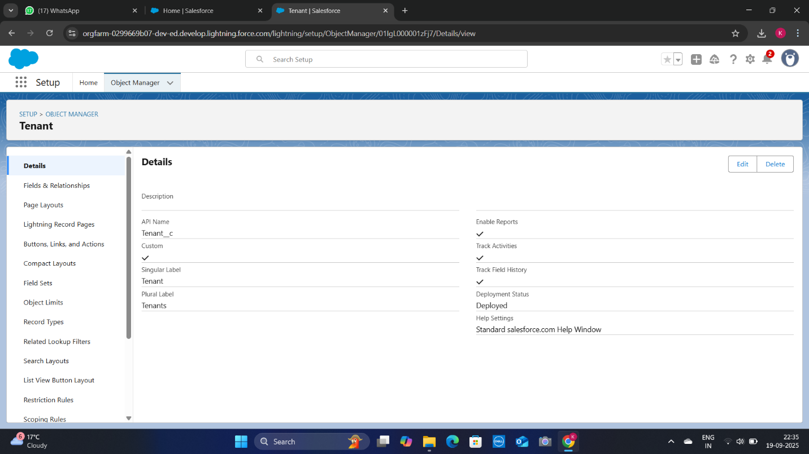

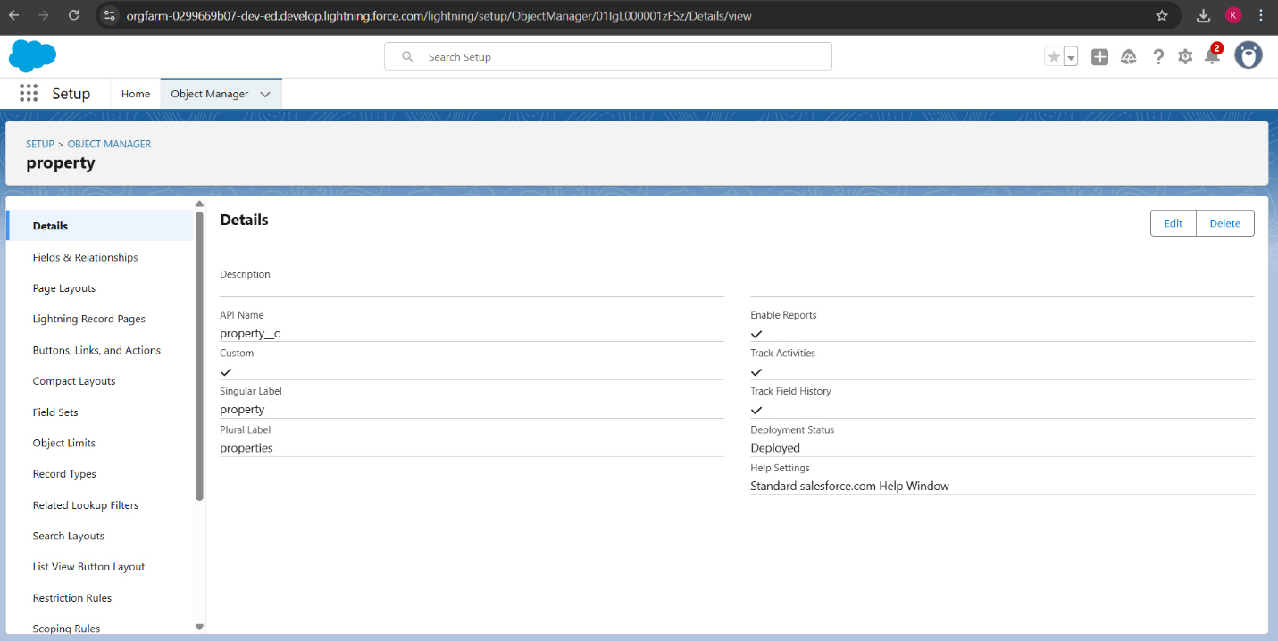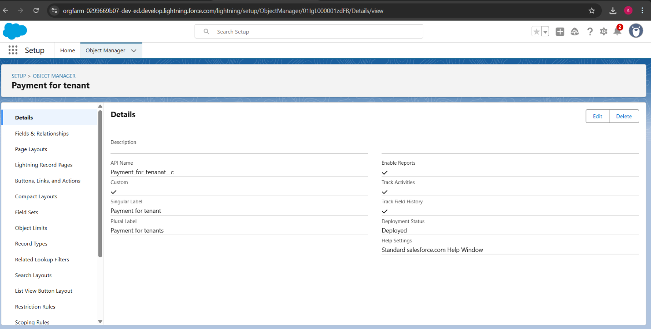

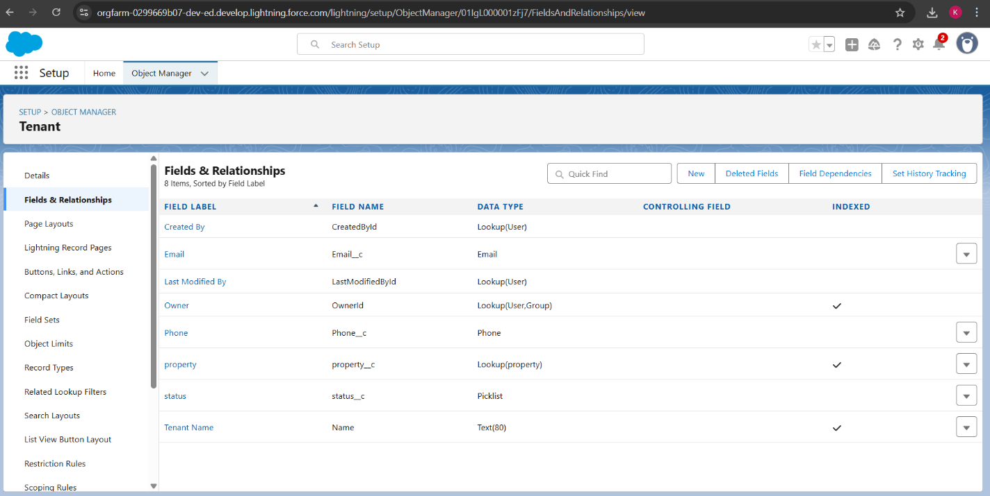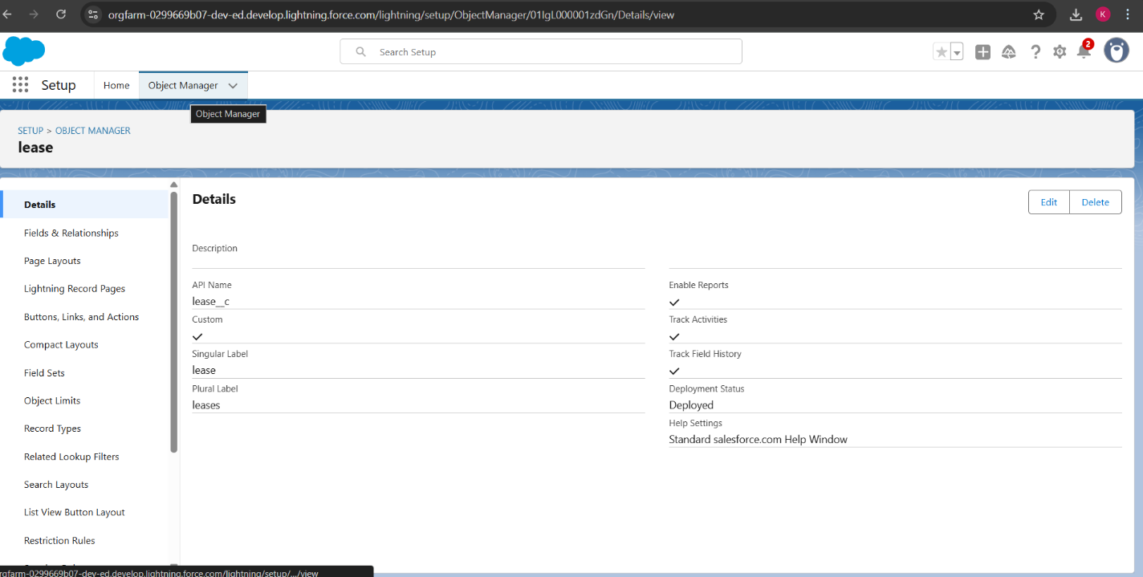

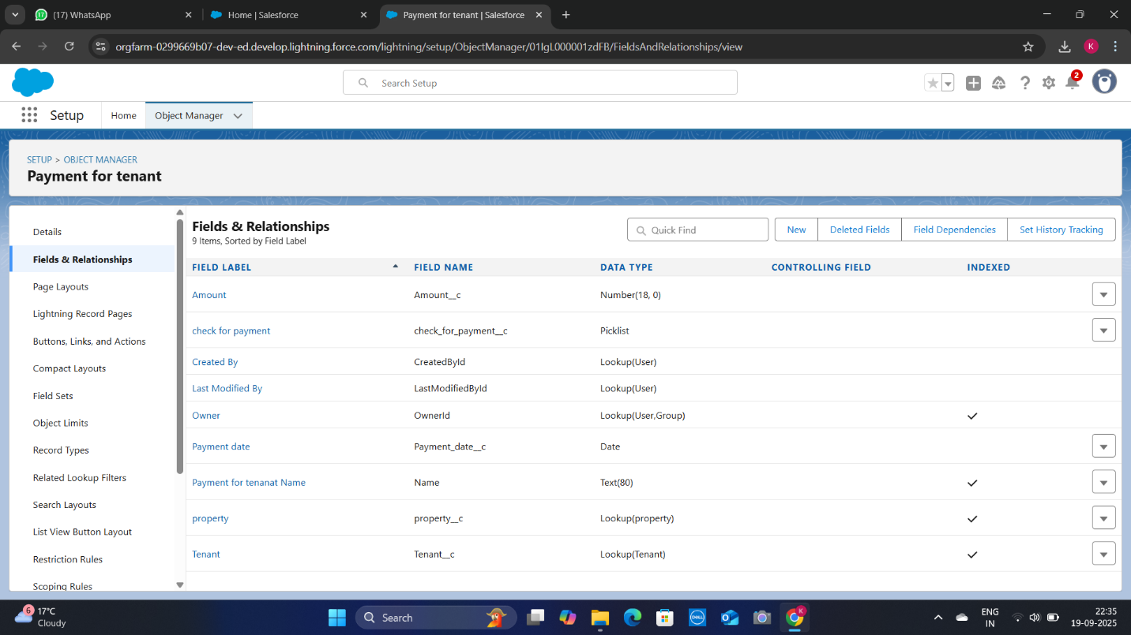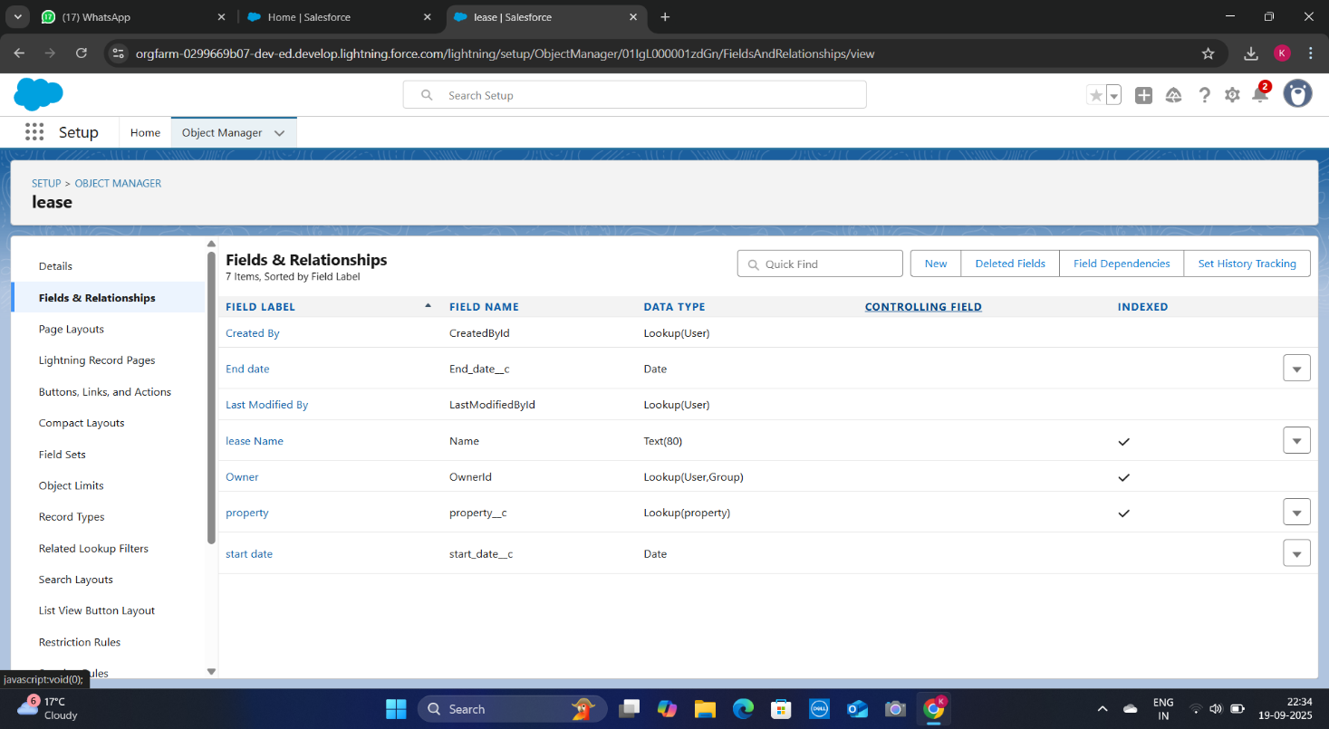

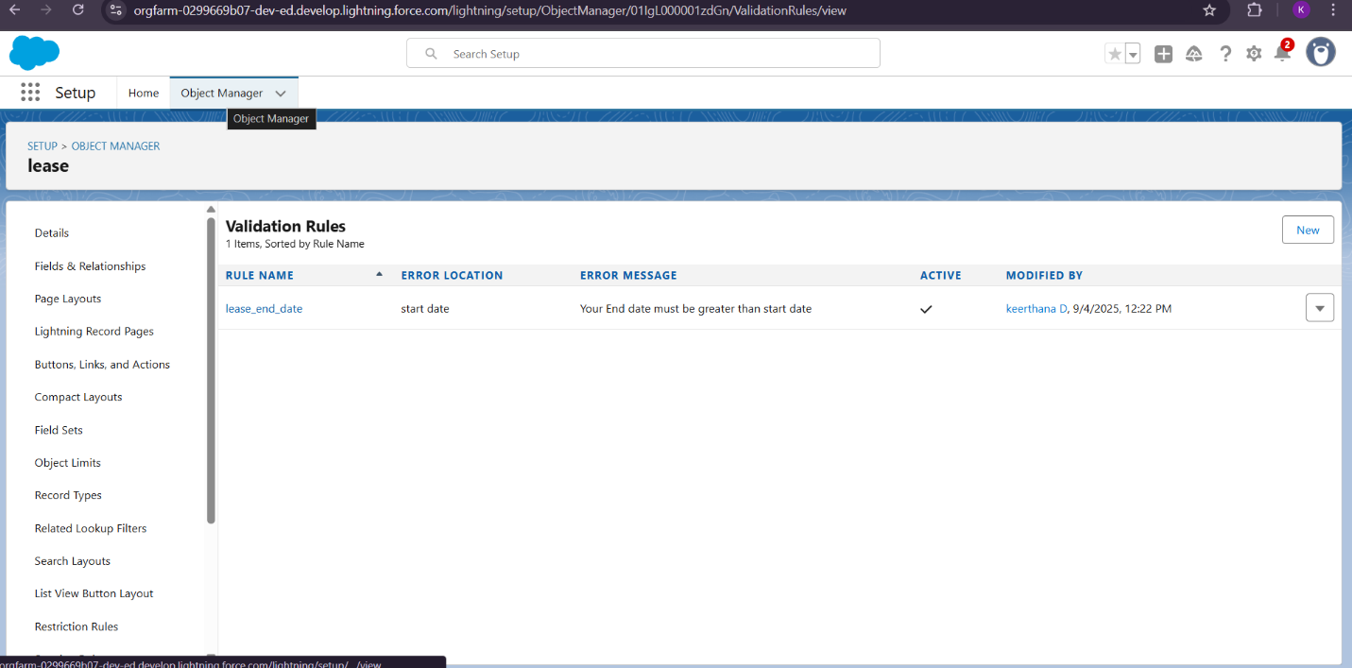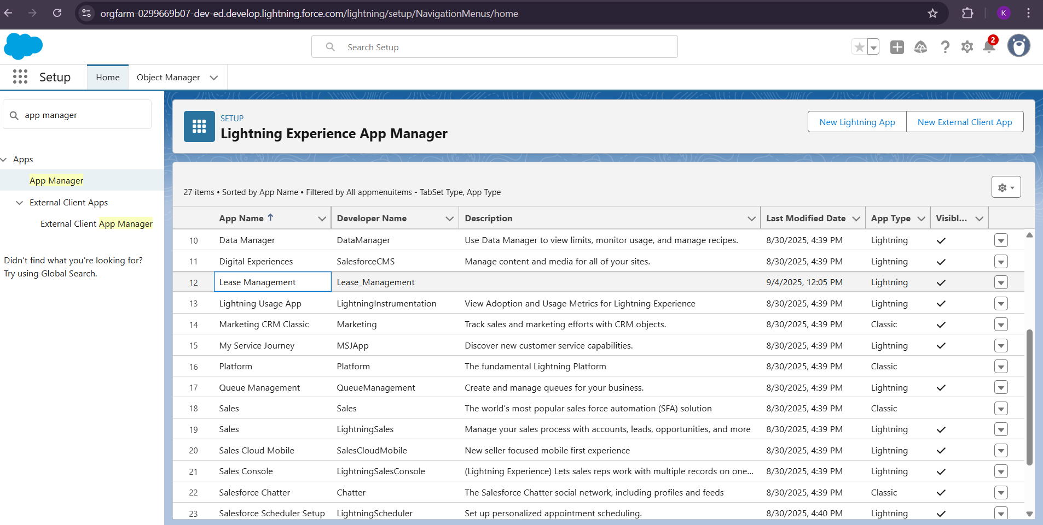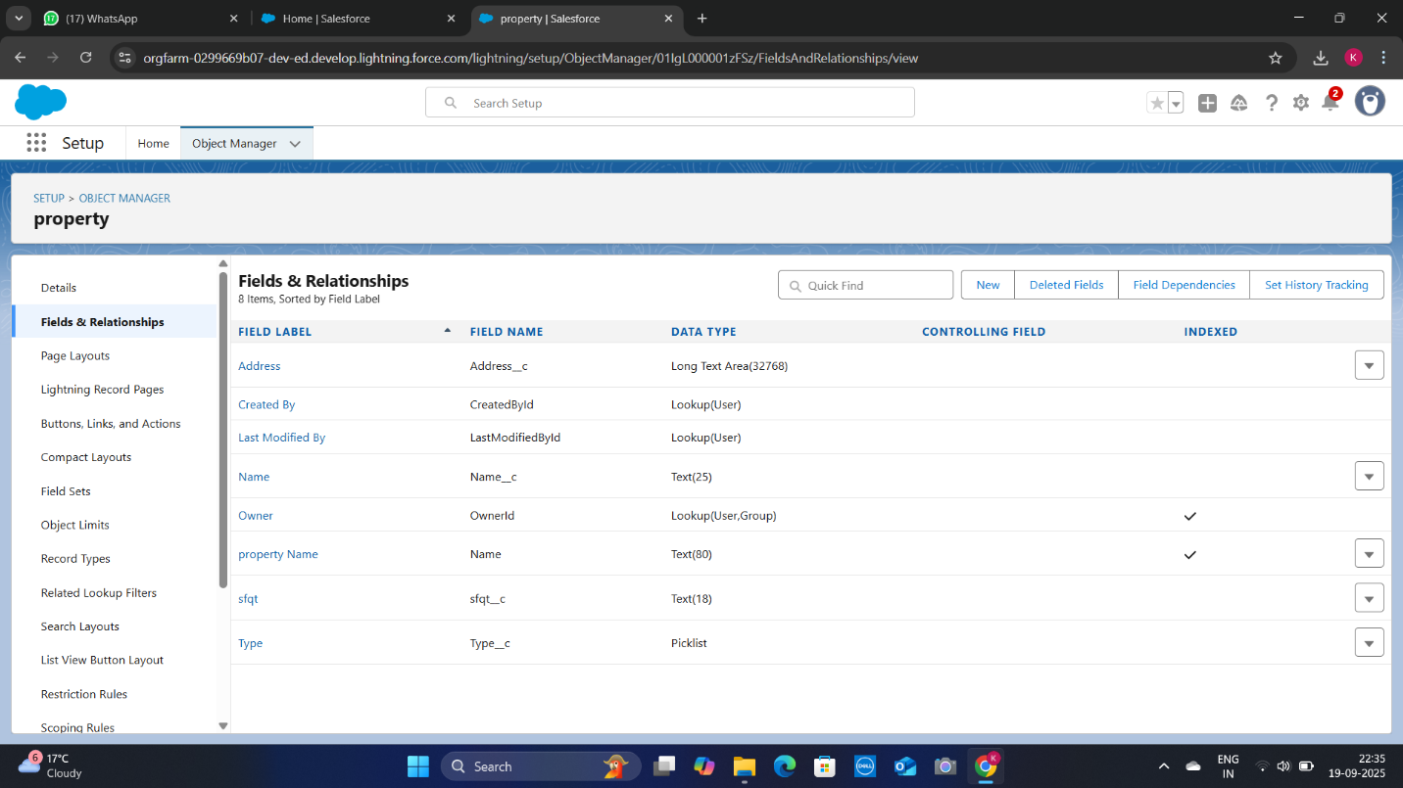

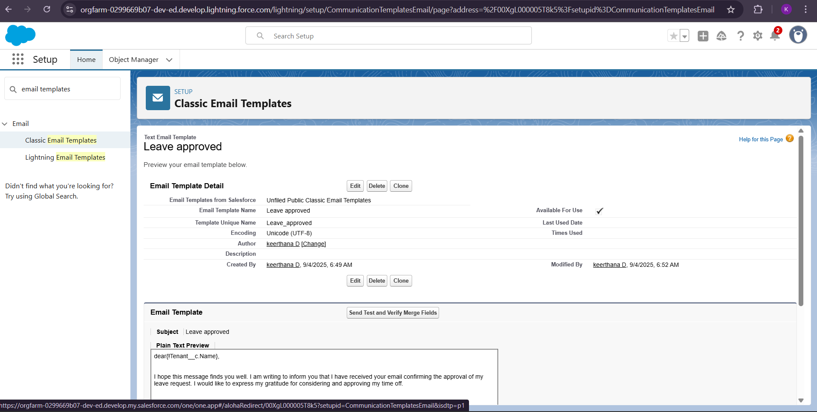

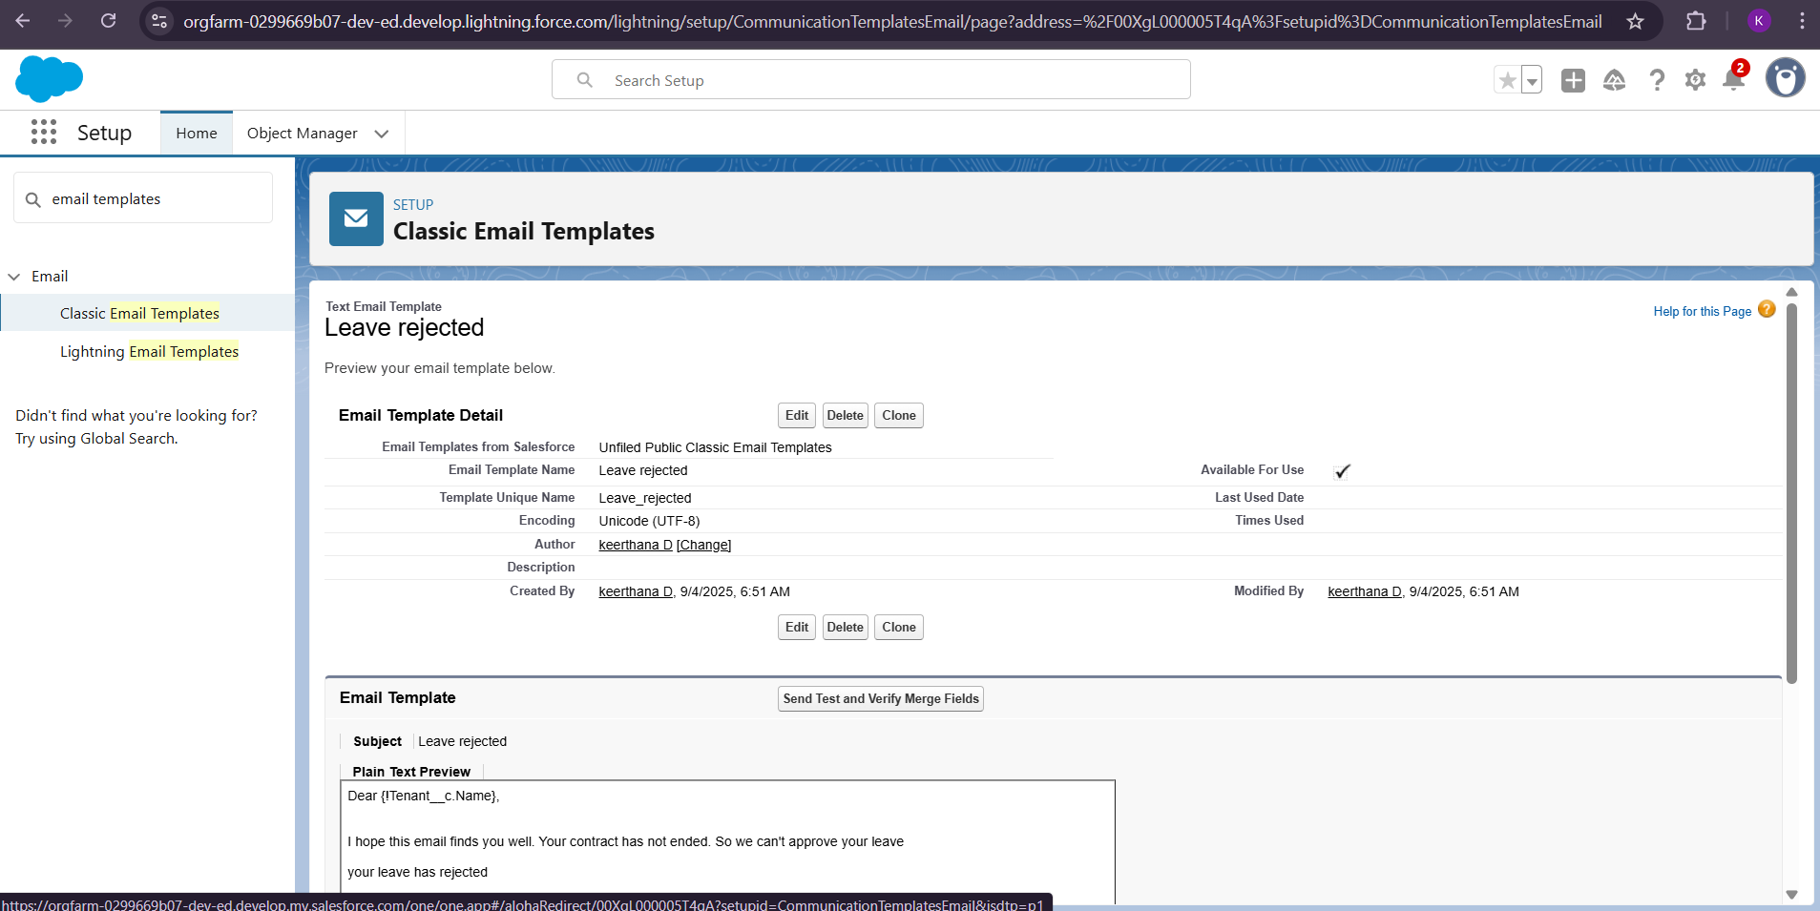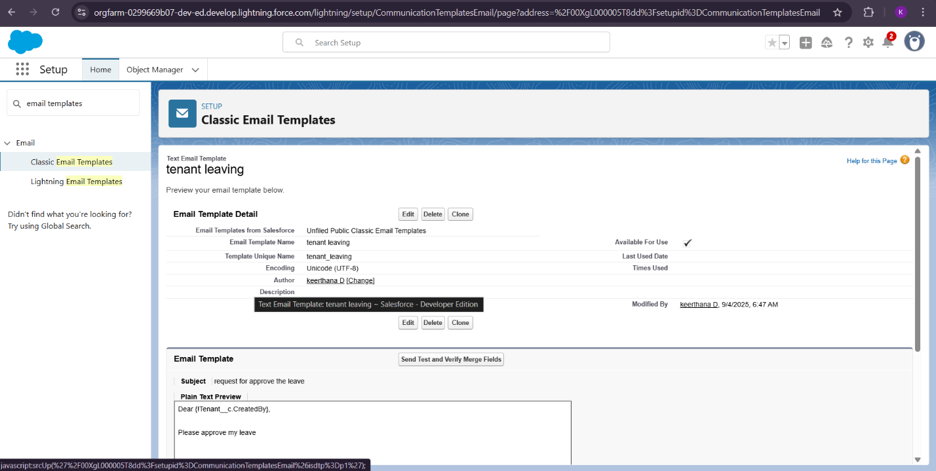

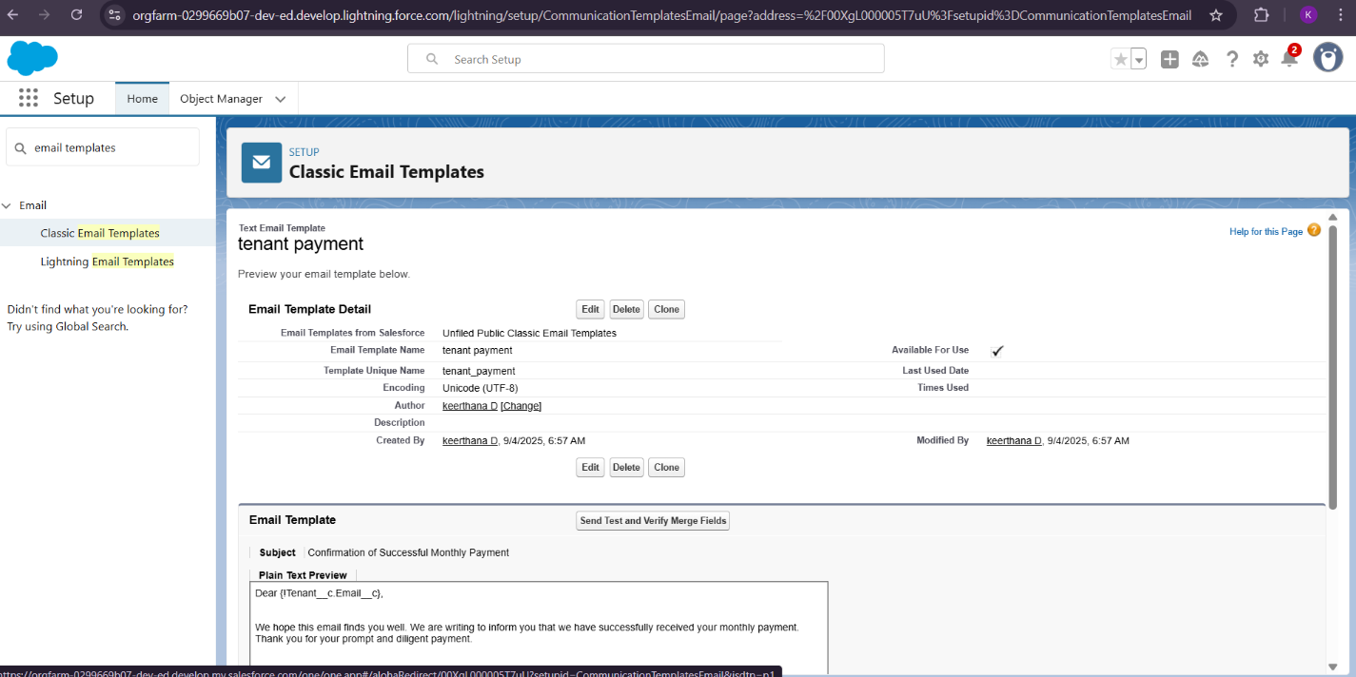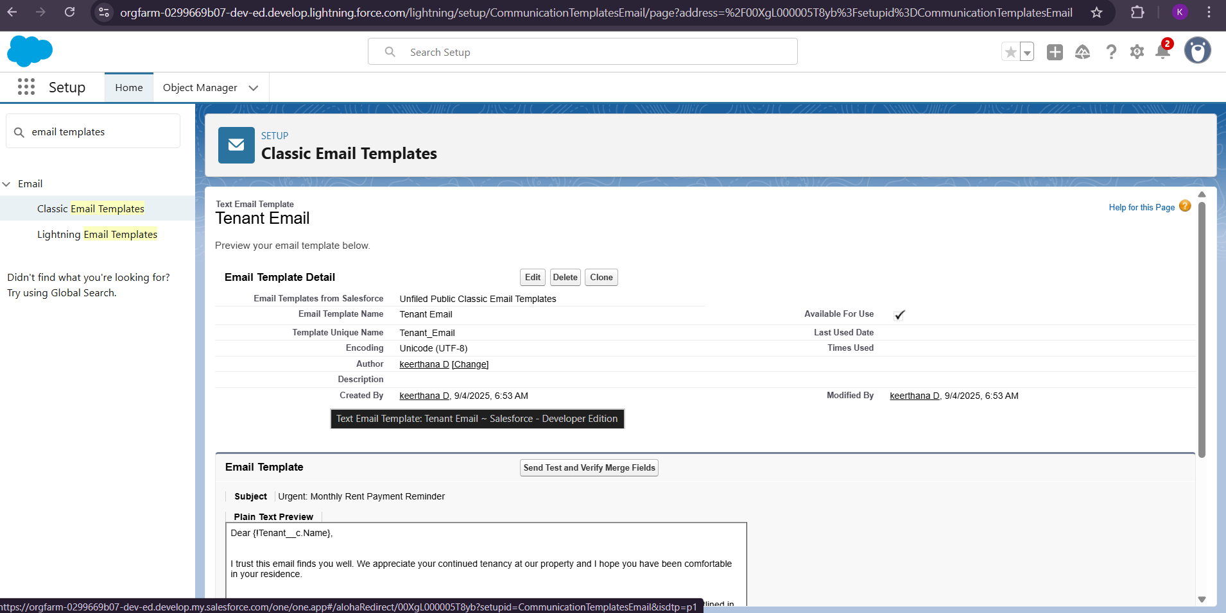

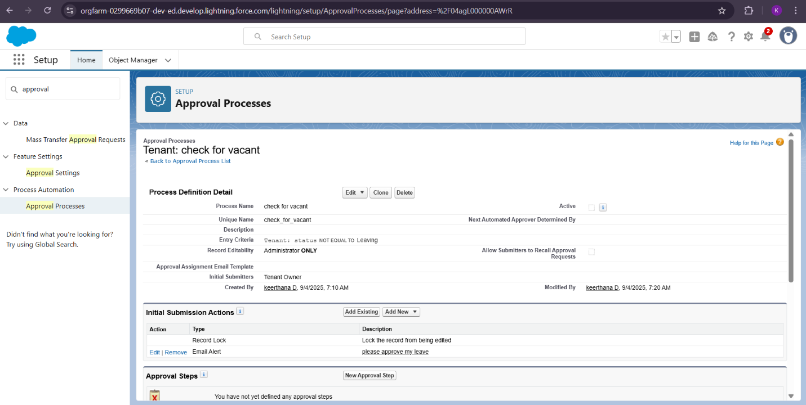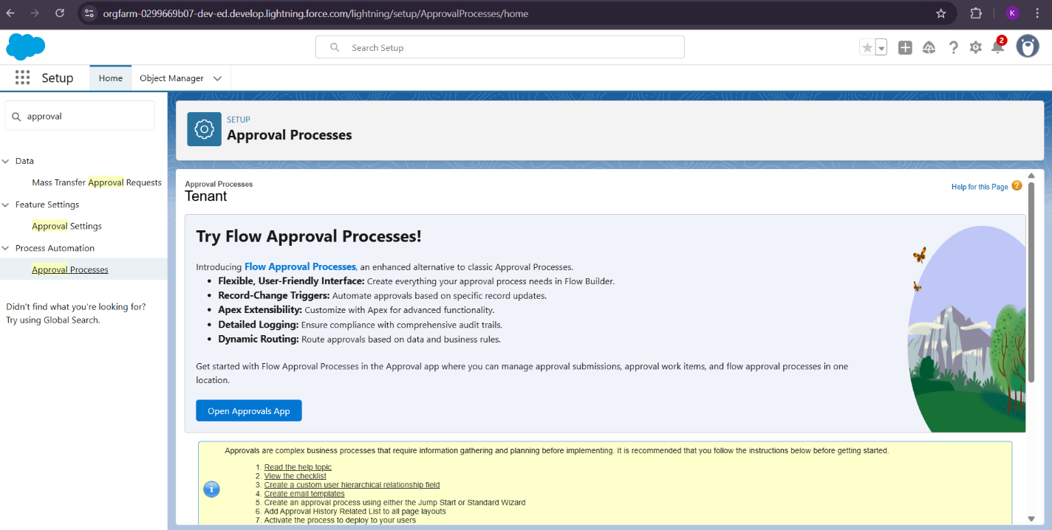

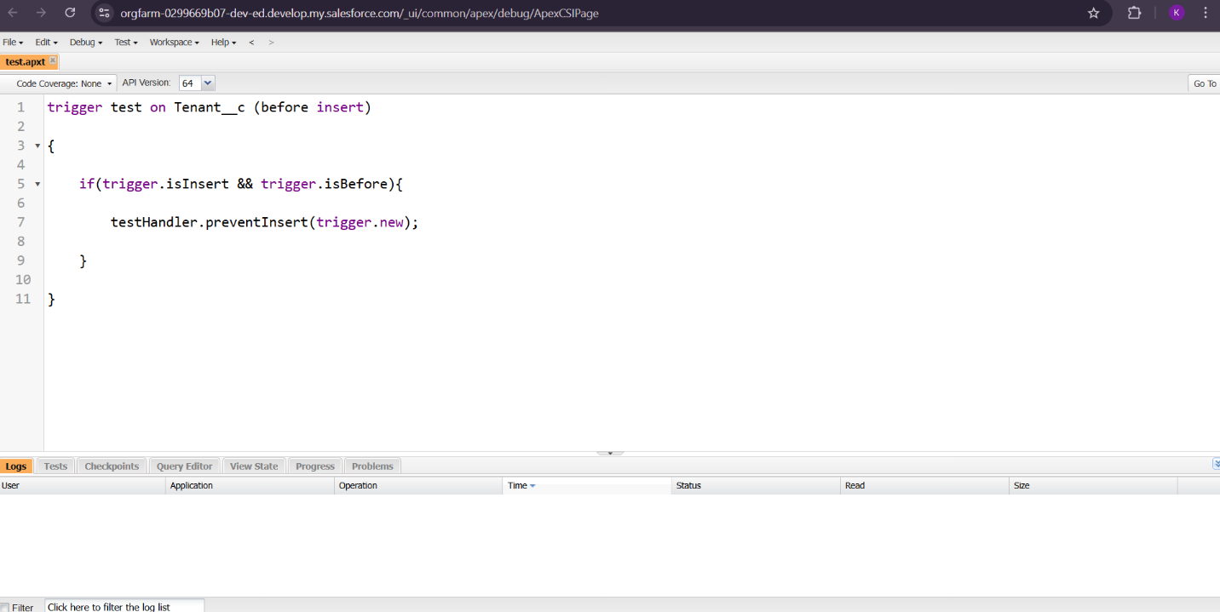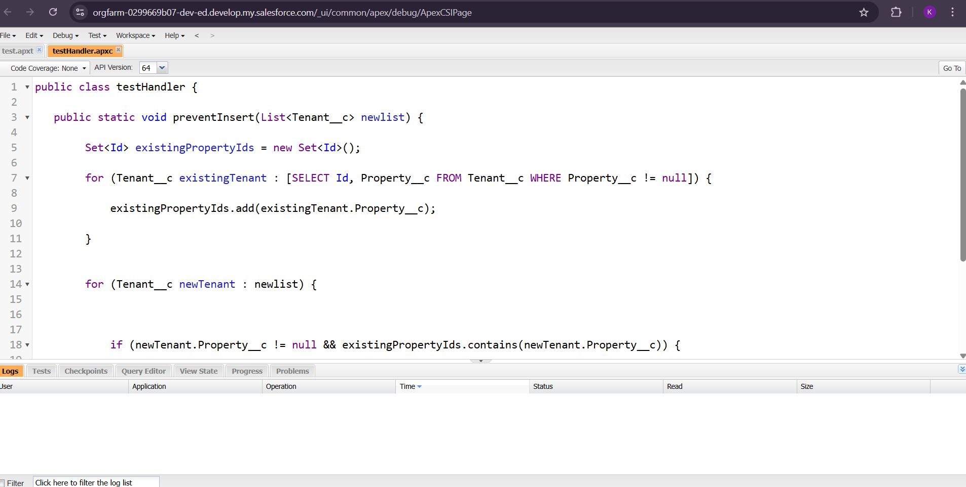

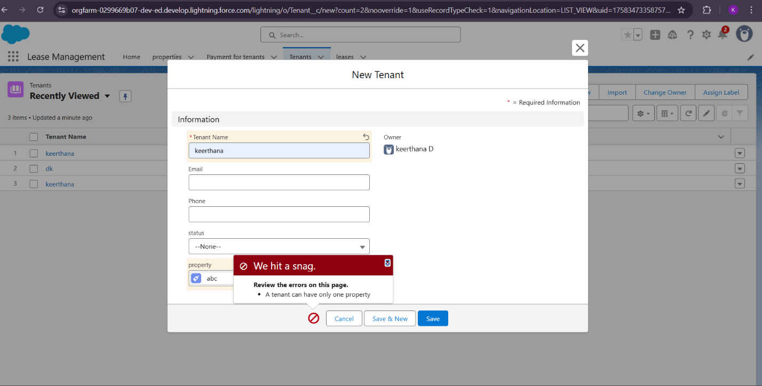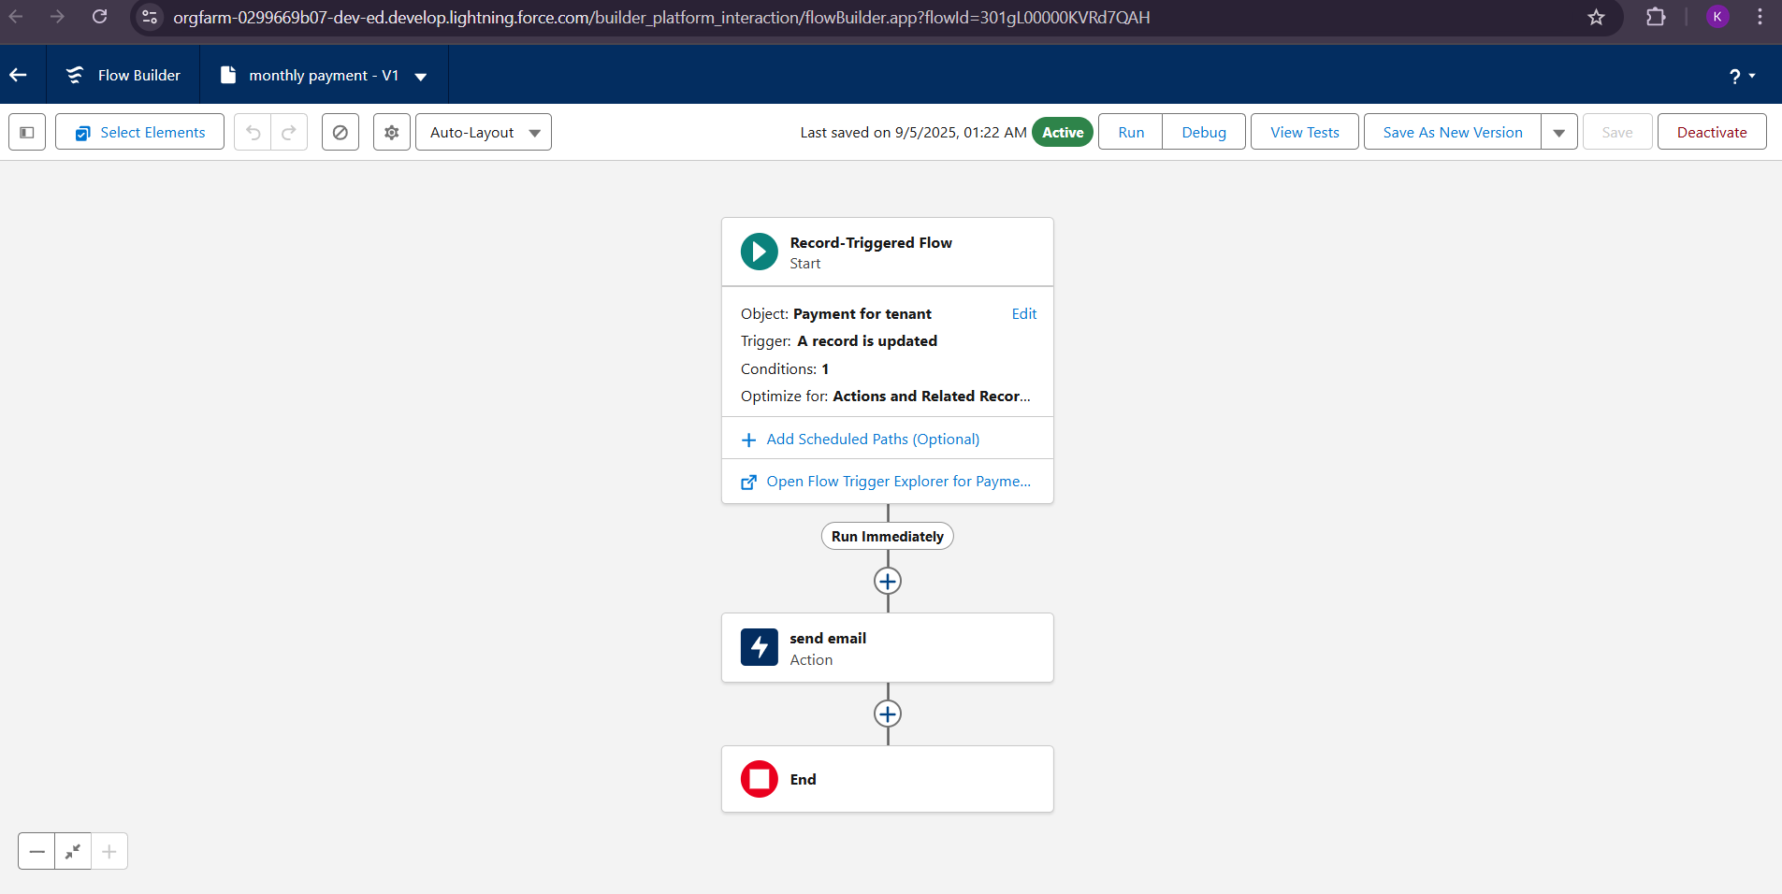

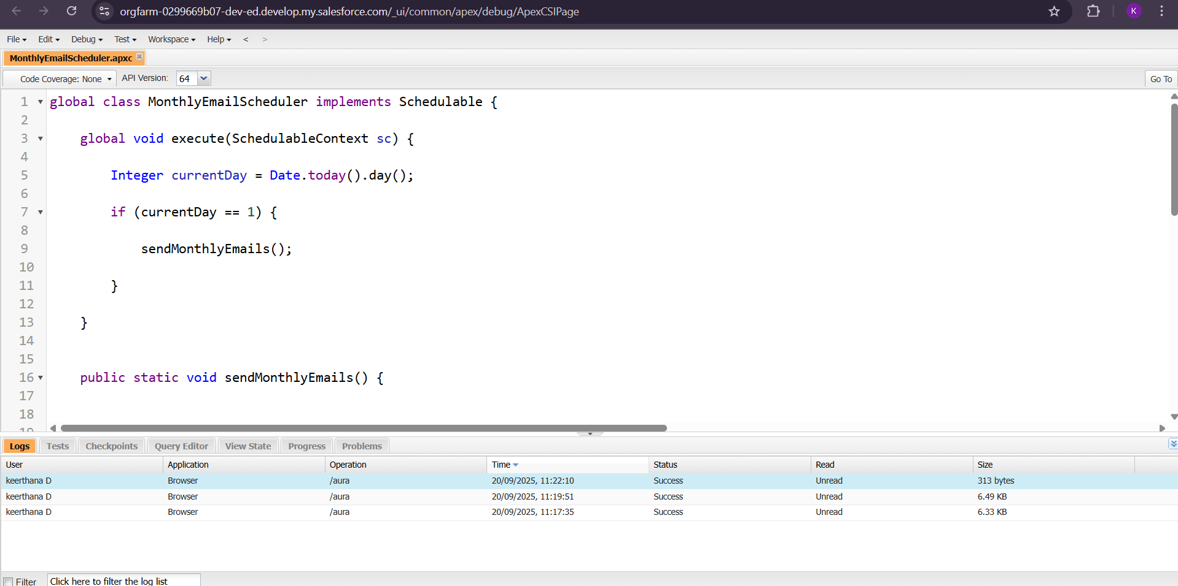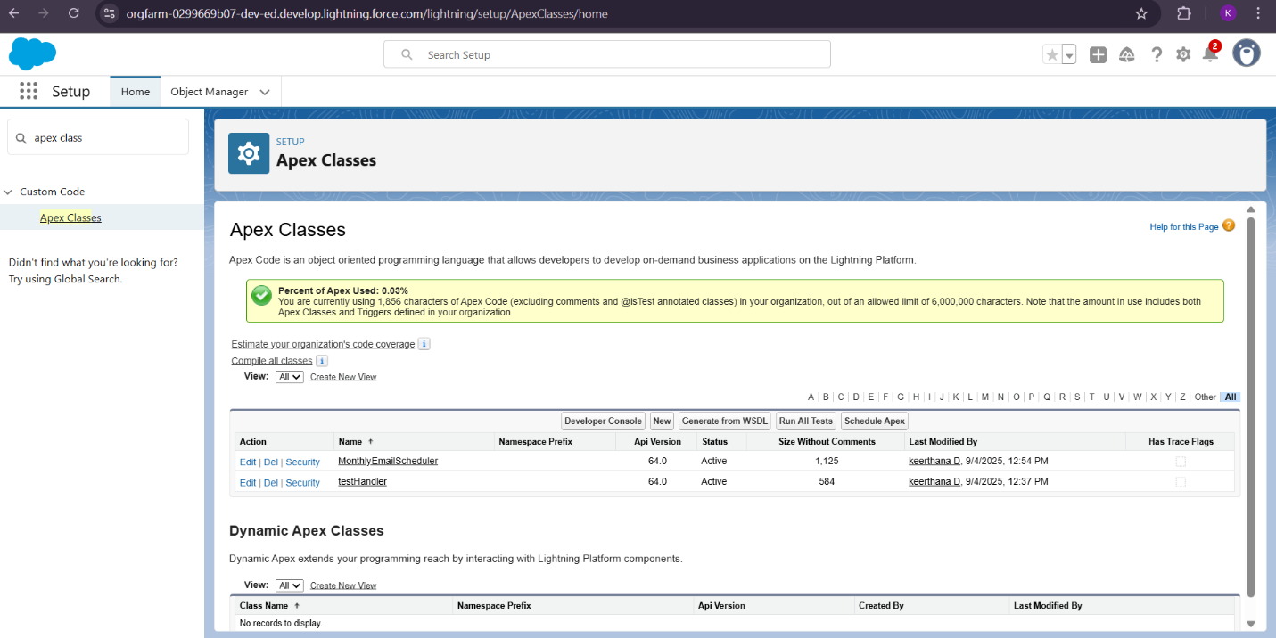

* Validation triggers prevented incorrect records.
* fully handled rent updates.

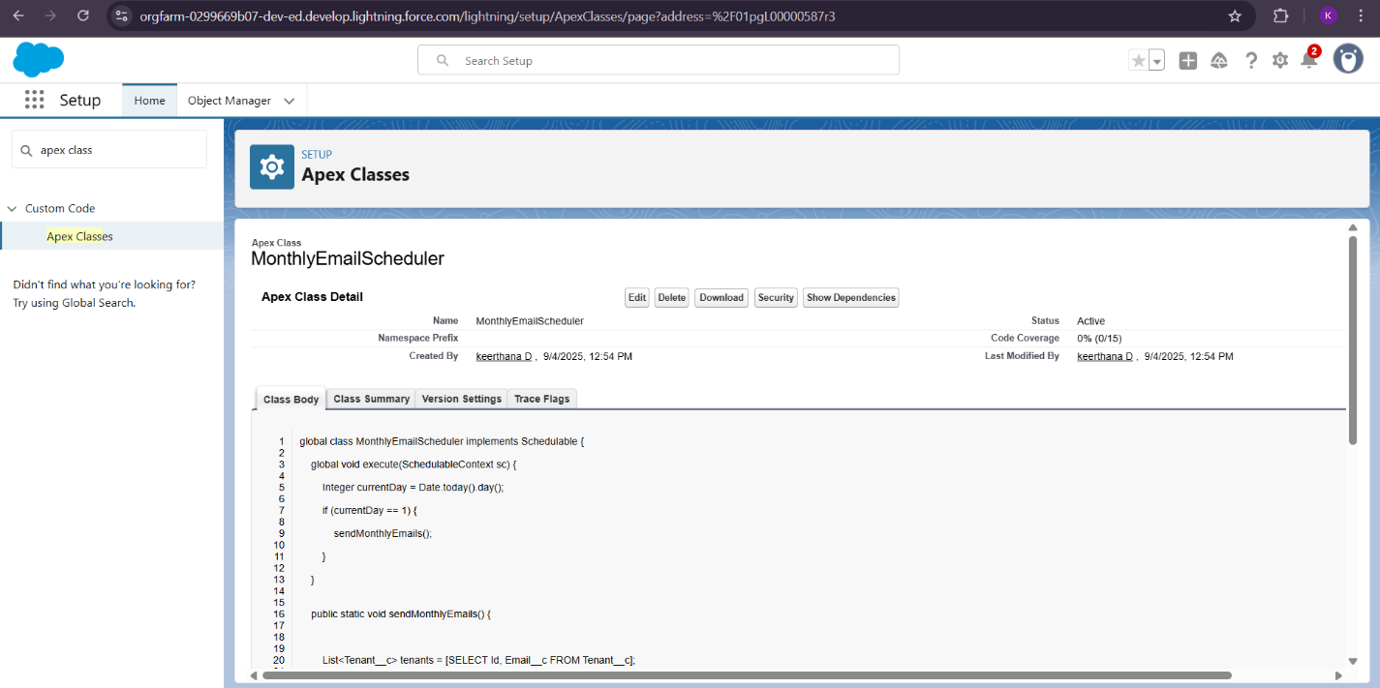

**4. ADVANTAGES & DISADVANTAGES**

**Advantages**

* Saves time and effort.
* Improves data accuracy.
* Provides real-time notifications.
* Scalable for multiple properties.

**Disadvantages**

* Dependent on Salesforce & internet.
* Requires training for non-technical users.

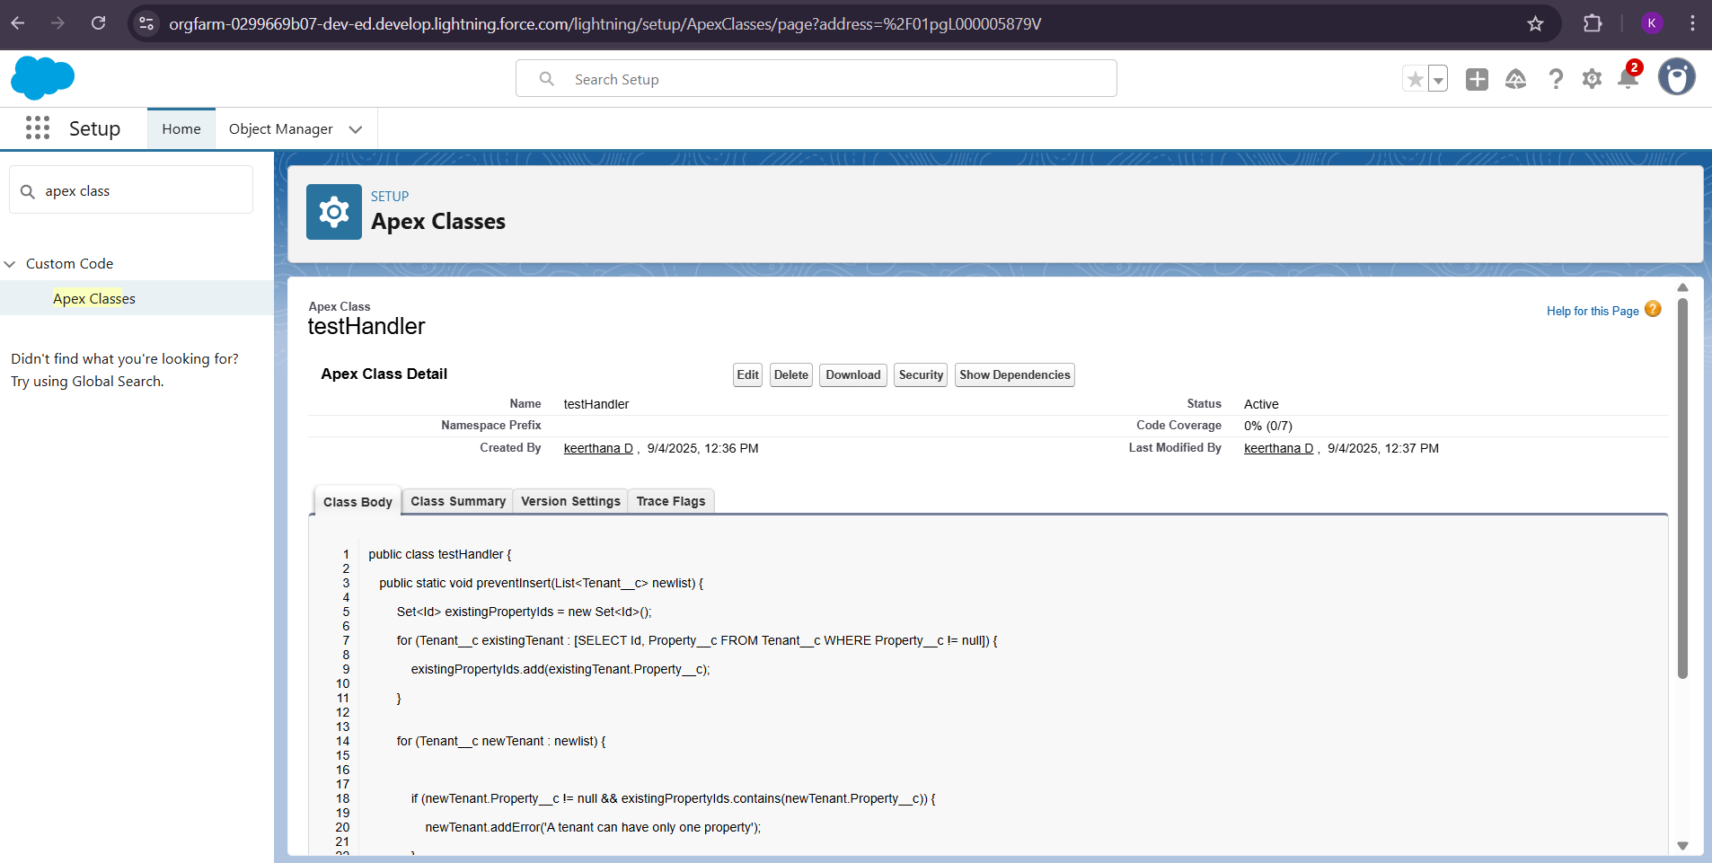

**5. CONCLUSION**

The Lease Management System, developed on the Salesforce platform, successfully provides a comprehensive, automated solution for managing properties, tenants, leases, and payments. Unlike traditional manual methods, which rely heavily on spreadsheets and paperwork, this system centralizes all key operations in a single, cloud-based environment, ensuring accuracy, efficiency, and real-time accessibility.

By integrating custom objects, validation rules, flows, approval processes, and Apex triggers, the system automates critical tasks such as:

* Assigning tenants to properties while preventing duplicate occupancy,
* Calculating and tracking monthly rent payments,
* Sending automated reminders and notifications to tenants and administrators,
* Managing lease approvals, leave requests, and terminations in a structured workflow.

The system’s design emphasizes data integrity, communication efficiency, and security, ensuring that property managers can make informed decisions and tenants are consistently updated about lease and payment status. Its user-friendly interface, built on Salesforce Lightning, allows users with minimal technical knowledge to interact with the system effectively.

Moreover, the Lease Management System demonstrates scalability and adaptability, making it suitable for small, medium, and large property management organizations. The inclusion of dashboards, reporting tools, and automated alerts ensures that administrators can monitor occupancy, payments, and lease expirations at a glance, minimizing errors and improving operational efficiency.

While there are some limitations, such as dependency on internet connectivity, learning curves for new users, and limited offline functionality, the future enhancements suggested — including mobile integration, AI-based notifications, advanced analytics, and payment gateway support — promise to further enhance the system’s usability, performance, and appeal.

In conclusion, the Lease Management System is not just a tool for managing properties and tenants; it represents a step toward digital transformation in real estate management. By reducing manual interventions, preventing errors, and providing actionable insights, the system ensures a smooth, transparent, and efficient leasing process. Its modular design and automated processes make it a valuable asset for property managers, tenants, and organizations seeking to streamline operations while maintaining high levels of accuracy and reliability.

The success of this project reflects the power of cloud-based platforms like Salesforce in solving real-world business problems, demonstrating that technology can significantly improve traditional administrative tasks, enhance communication, and provide a professional, scalable solution for property management.