PROJECT DOCUMENTATION

1.INTRODUCTION
PROJECT TITLE : AI BLOGNEST API
- Team Id :
- Team leader : Keerthana
- Email Id : keerthanaraj876@gmail.com
- Team Members :
1.Divya dharshini & Email Id: divyadharshini6727@gmail.com
2.Devi & Email Id:
deviramani089@gmail.com
3.Joice & Email Id:
joice200618@gmail.com
2.PROJECT OVERVIEW
AI BlogNest is an AI-powered blogging platform designed to help users create, manage, and publish blog content easily. The system uses Artificial Intelligence to assist users in generating blog ideas, creating content, improving written text, and organizing blog posts.
The main purpose of AI BlogNest is to reduce the time and effort required to create quality blog content. It provides a simple and user-friendly environment where users can write, edit, save, and manage their blogs.

3.PROBLEM STATEMENT
Traditional blogging requires users to spend considerable time generating ideas, writing content, correcting grammar, and organizing blog posts. Beginners may also find it difficult to create well-structured and engaging articles.
AI BlogNest addresses these problems by providing AI-based assistance for content creation and blog management.

4.OBJECTIVES
- To provide an easy-to-use blogging platform.
- To assist users in generating blog content using AI.
- To generate blog ideas based on user requirements.
- To improve and refine written content.
- To allow users to create, edit, save, and manage blog posts.
- To provide organized access to published and saved blogs.
- To reduce the time required for content creation.

5.SCOPE OF THE PROJECT
AI BlogNest can be used by students, bloggers, content creators, and general users who want to create blog content.
The system can support:
- AI-based blog generation
- Blog idea generation
- Content editing
- Blog creation and management
- User authentication
- Saving and updating blog posts
- Publishing blog posts
- Managing personal blog content

6. EXISTING SYSTEM
- Search for topics manually.
- Generate their own content.
- Check grammar and writing quality separately.
- Organize blog posts manually.
- Use multiple tools
Limitations of Existing System
- Time-consuming content creation.
- Requires manual research and writing.
- Limited AI assistance.
- Multiple tools may be required.
- Difficult for beginners to create structured content.

7.PROPOSED SYSTEM
- The proposed AI BlogNest system combines blogging features with AI assistance. Users can enter a topic or requirement, and the system can assist in generating suitable blog content.
- Users can also edit, save, update, and manage their blog posts through a single platform.
Advantages:
- Easy content creation.
- AI-assisted writing.
- Saves time.
- User-friendly interface.
- Centralized blog management.
- Suitable for beginners and experienced bloggers.

8.SYSTEM MODULES
8.1 User Authentication Module
This module manages user registration and login.
Functions:
- User registration
- User login
- Authentication
- User account management
8.2 AI Content Generation Module
This is the main module of AI BlogNest.
Functions:
- Generate blog ideas.
- Generate blog content.
- Create content based on user prompts.
- Assist users in improving their content.
8.3 Blog Management Module
This module allows users to manage their blog posts.
Functions:
- Create blog
- View blog
- Edit blog
- Update blog
- Delete blog
- Save blog
8.4 Blog Publishing Module
This module allows users to publish completed blog posts.
Functions:
- Review content
- Publish blog
- View published blogs
- Manage published content
8.5 User Dashboard Module
The dashboard provides users with a centralized view of their blog activities.
It can display:
- Total blogs
- Draft blogs
- Published blogs
- Recently created blogs
- User profile information
9.FUNCTIONAL REQUIREMENTS
The system should provide the following functionalities:
1. User registration and login.
2. Secure user authentication.
3. Blog creation.
4. AI-assisted content generation.
5. Blog editing and updating.
6. Blog deletion.
7. Blog saving as draft.
8. Blog publishing.
9. Viewing existing blogs.
10. Managing user-specific blog content.
10.NON-FUNCTIONAL REQUIREMENTS
- Performance
The system should respond to user requests within a reasonable time.
- Security
User authentication and blog data should be protected from unauthorized access.
- Usability
The interface should be simple and easy to understand.
- Reliability
The system should provide consistent results and prevent accidental data loss.
- Scalability
The system should be capable of supporting additional users and features in the future.
11.SYSTEM ARCHITECTURE
AI BlogNest follows a client-server based architecture.
Main Components
User → Frontend → Backend/API → AI Service → Database
12.API OVERVIEW
The backend provides APIs for handling users and blog operations.
Authentication APIs
- User Registration
- User Login
- User Authentication
Blog APIs
- Create Blog
- Get Blogs
- Get Blog by ID
- Update Blog
- Delete Blog
- Publish Blog
AI APIs
- Generate Blog Idea
- Generate Blog Content
- Improve Blog Content
13.DATABASE
The database is used to store application data.Important data may include.
- User information
- Login/authentication details
- Blog title
- Blog content
- Blog status
- Creation date
- Updated date
14.TECHNOLOGY USED
Frontend
- HTML, CSS and JavaScript / modern frontend framework.
Backend
- Node.js and Express.js.
Database
- MongoDB.
15.ADVANTAGES OF AI BLOGNEST
- AI-assisted blog writing.
- Reduces content creation time.
- Simple blog management
- Easy-to-use platform.
- Supports content improvement.
- Centralized blog management.
- Can be extended with additional AI features.
PROJECT SETUP AND CONFIGURATION
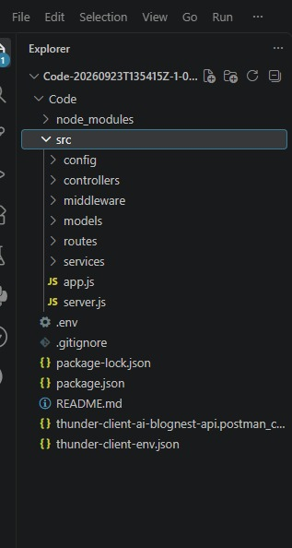

CREATE BLOG

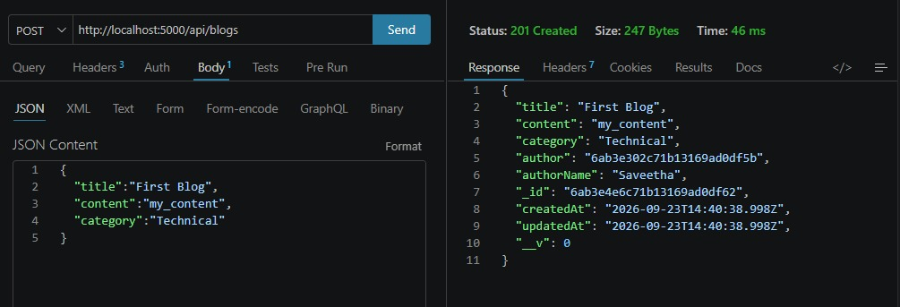

LOGIN PAGE
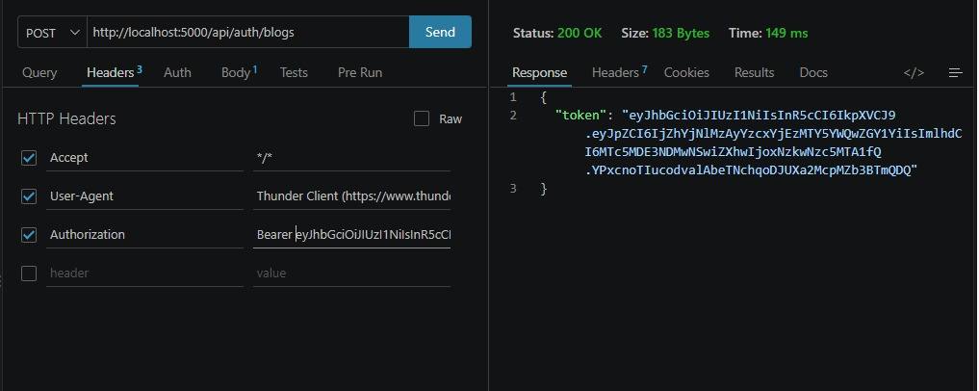
GET BLOGS
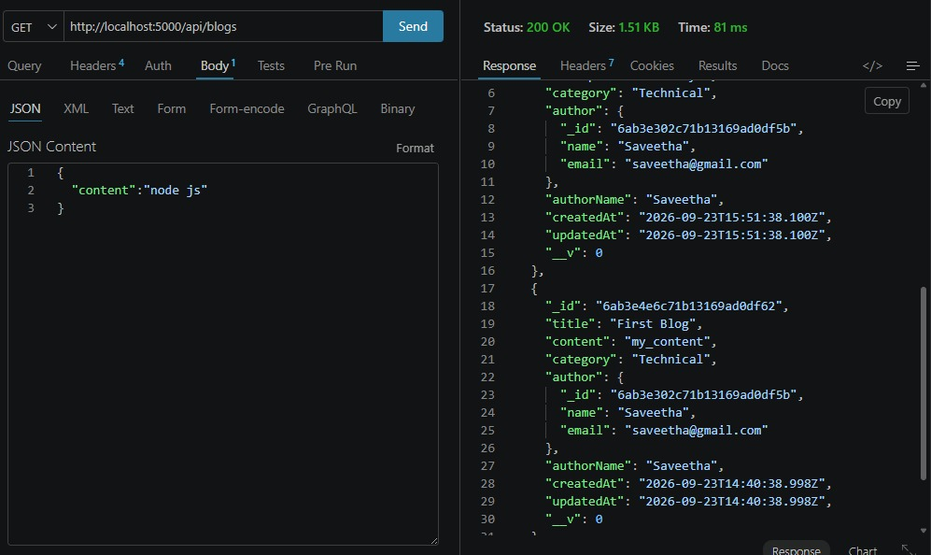

AI GENERATE BLOG

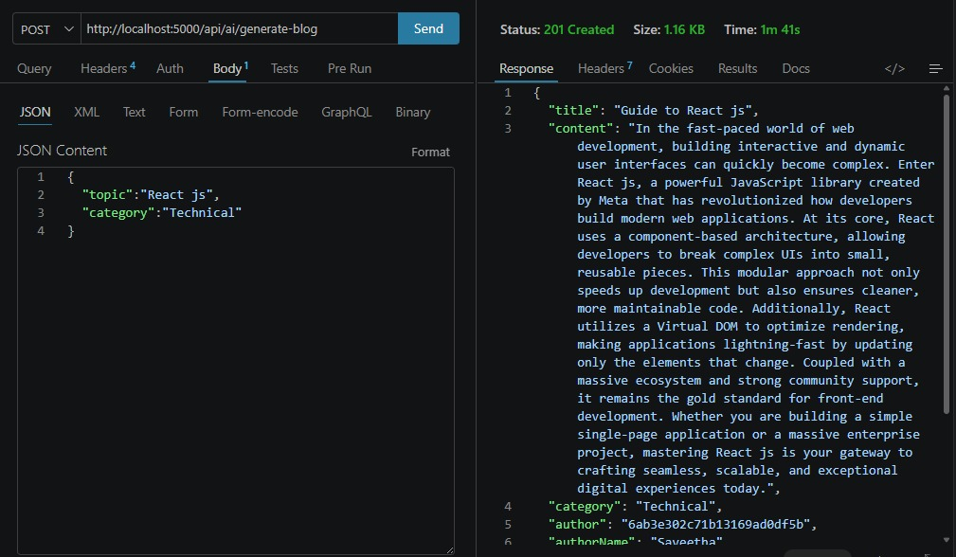
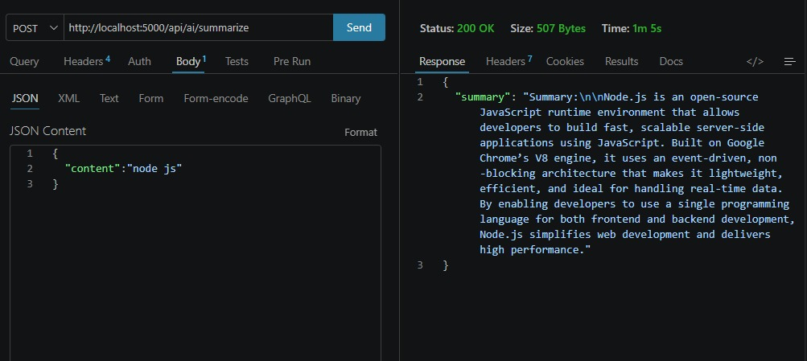

AI SUMMARIZE

PROJECT EXECUTION
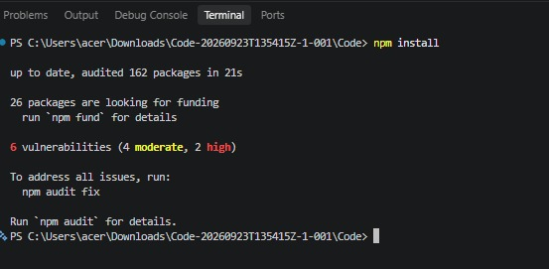

USER MODEL

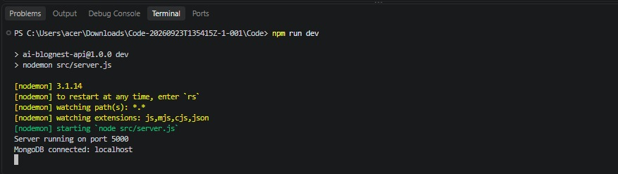

16. FUTURE ENHANCEMENTS
- AI image generation for blogs.
- Multilingual blog generation.
- Grammar and plagiarism checking.
- SEO optimization.
- Automatic keyword suggestions.
- Social media sharing.
- Voice-to-blog functionality.
17.CONCLUSION
AI BlogNest is an AI-powered blogging platform that combines artificial intelligence with blog management features. The system helps users generate ideas, create content, edit blogs, and manage their posts efficiently.

