INCIDENT RESPONSE SIMULATION

STUDENT NAME: KEERTHANAA A

INTERNSHIP ID: BS/REG/121557

PROJECT: INCIDENT RESPONSE SIMULATION

TABLE OF CONTENTS:
1. Task Overview 2
2. Tools & Technology Stack 2
3. Project Structure 2
4. Simulated Cybersecurity Incident 3
4.1 Scenario 3
4.2 Attack Chain Simulated 3
5. Analysis Findings 3
5.1 Detection Rules Applied 4
5.2 IOCs Identified 4
6. Response Steps & Containment Actions 4
6.1 Containment 4
6.2 Eradication & Recovery 5
6.3 Recommendations 5
7. Deliverables Produced 5
8. Scripts & Execution 5
9.EVIDENCES . 6
10. Conclusion 7

1. Task Overview
This document is the submission report for Task 4 of the Cybersecurity Internship. The goal was to simulate a small cybersecurity incident and perform basic analysis. The following requirements were fulfilled:
- Analyze suspicious log activity (Windows logs / SIEM sample logs)
- Identify possible Indicators of Compromise (IOCs)
- Document response steps and containment actions
- Produce an Incident Report (PDF/DOC) and a List of Detected Anomalies

2. Tools & Technology Stack
The following tools and libraries were used to build and run the simulation:

Tool / Library | Version | Purpose
Python | 3.14.2 | Core programming language for all scripts
pandas | 2.3.3+ | Log parsing, filtering, and anomaly detection
matplotlib | 3.10.9+ | Security charts and data visualizations
seaborn | Latest | Chart theme and styling
fpdf2 | 2.8.1+ | PDF generation for anomalies list
python-docx | 1.1.0+ | DOCX incident report generation
faker | 26.0.0+ | Realistic log data simulation
Git | Latest | Version control and code management
VS Code | Latest | Development IDE

3. Project Structure
The project was organized into the following folder structure:

File / Folder | Purpose
logs/generate_logs.py | Simulates 175 realistic Windows Event Log entries including a full attack chain
logs/windows_events.csv | Generated CSV log file with timestamps, event IDs, usernames, IPs, hostnames
analysis/analyze.py | Parses logs and applies 7 detection rules to identify IOCs and anomalies
analysis/visualize.py | Generates 4 security charts using matplotlib and seaborn
analysis/generate_report.py | Builds the full incident report as a DOCX file
analysis/generate_anomalies_pdf.py | Builds the anomalies list as a color-coded PDF
iocs/anomalies_list.csv | 66 flagged anomalous events extracted from the log data
iocs/ioc_summary.json | Structured JSON summary of all detected IOCs
assets/*.png | 4 security charts embedded in the incident report
reports/incident_report.docx | DELIVERABLE 1 - Full incident report with timeline and recommendations
reports/anomalies_list.pdf | DELIVERABLE 2 - Color-coded list of all detected anomalies

4. Simulated Cybersecurity Incident

4.1 Scenario
A simulated 24-hour Windows Event Log dataset was generated using Python. The dataset contains 175 log entries covering both normal user activity and a simulated attack chain originating from an external IP address.

4.2 Attack Chain Simulated
Time | Event ID | Action | Description
T+00:00 | 4625 x20 | Brute Force | 20 failed login attempts against admin from 203.0.113.77
T+00:21 | 4624 | Successful Login | Attacker gains access to admin account after brute force
T+00:22 | 4672 | Privilege Escalation | Special privileges assigned to attacker's session
T+00:25 | 4720 | Backdoor Created | New user account hacker_acct created by attacker
T+00:30 | 7045 | Persistence | Malicious service installed on SERVER-DC01
T+00:35 | 1102 | Evidence Tampering | Audit log cleared to cover attacker's tracks

5. Analysis Findings

5.1 Detection Rules Applied
The analyze.py script applied 7 detection rules against the 175-event log dataset:

# | Detection Rule | Result | Finding
1 | Brute Force (5+ failed logins from same IP) | 2 IPs detected | 203.0.113.77 (external), 192.168.1.25 (internal)
2 | Successful login from brute-force IP | 3 events | admin account accessed from flagged IPs
3 | Privilege Escalation (Event ID 4672) | 1 event | Special privileges assigned to attacker session
4 | New User Account Created (Event ID 4720) | 1 event | Backdoor account hacker_acct created
5 | New Service Installed (Event ID 7045) | 1 event | Malicious service installed on SERVER-DC01
6 | Audit Log Cleared (Event ID 1102) | 1 event | Evidence tampering attempt detected
7 | Unknown User Activity | 0 events | No UNKNOWN_USER events in this dataset

5.2 IOCs Identified
IOC Type | Value | Significance
Malicious External IP | 203.0.113.77 | Primary attacker - brute force + full attack chain
Suspicious Internal IP | 192.168.1.25 | Flagged for 5+ failed logins - requires investigation
Compromised Account | admin | Accessed by attacker after brute force success
Backdoor Account | hacker_acct | Created by attacker for persistent access
Malicious Service | Event ID 7045 | Persistence mechanism installed on SERVER-DC01
Evidence Tampering | Event ID 1102 | Attacker cleared audit logs to hide activity

6. Response Steps & Containment Actions

6.1 Containment
- Block 203.0.113.77 at perimeter firewall and all network ACLs immediately
- Investigate and block 192.168.1.25 pending internal review
- Disable and lock admin and hacker_acct accounts domain-wide
- Isolate SERVER-DC01 from the network pending full forensic analysis
- Stop and remove the malicious service installed via Event ID 7045
- Force password reset for ALL privileged accounts across the domain
- Restore and verify integrity of audit logging on all systems

6.2 Eradication & Recovery
- Remove malicious service from SERVER-DC01 registry and filesystem completely
- Delete hacker_acct and audit all AD group memberships for unauthorized changes
- Restore SERVER-DC01 from last known-good backup prior to the incident
- Run full AV/EDR scan on all hosts that communicated with attacker IPs
- Re-enable server only after full IOC sweep returns clean

6.3 Recommendations
- Enforce MFA on ALL administrative accounts - no exceptions
- Implement account lockout after 3 failed logins with 30-minute lockout duration
- Deploy SIEM alerting rules for Event IDs: 4625, 4672, 4720, 7045, 1102
- Restrict RDP/SSH access to known internal IPs only via firewall rules
- Enable Windows Defender Credential Guard on all domain controllers
- Conduct quarterly penetration testing and log review audits
- Investigate source of excessive failed logins from internal IP 192.168.1.25

7. Deliverables Produced
# | Deliverable | File | Contents
1 | Incident Report | reports/incident_report.docx | Executive summary, timeline, IOCs, containment steps, recommendations, 4 security charts
2 | List of Detected Anomalies | reports/anomalies_list.pdf | 66 flagged events color-coded by severity with IOC summary and legend

8. Scripts & Execution
All scripts were run in order from the project root inside the Python virtual environment:

Order | Command | Output
1 | python logs/generate_logs.py | Generated 175 log entries -> logs/windows_events.csv
2 | python analysis/analyze.py | Detected IOCs, saved 66 anomalies -> iocs/
3 | python analysis/visualize.py | Generated 4 charts -> assets/
4 | python analysis/generate_report.py | Built incident report -> reports/incident_report.docx
5 | python analysis/generate_anomalies_pdf.py | Built anomalies PDF -> reports/anomalies_list.pdf

9.EVIDENCES .

A.
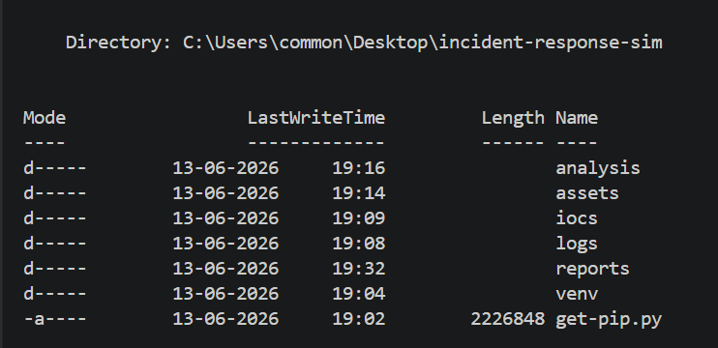

B.
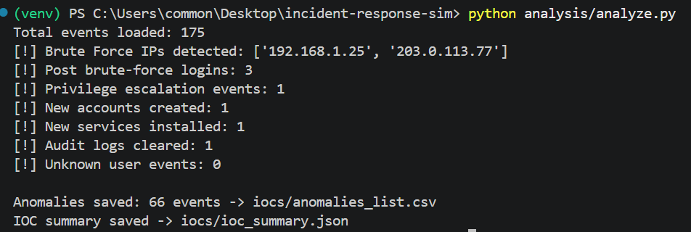

C.
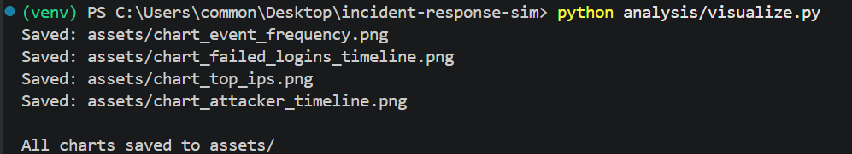

D.

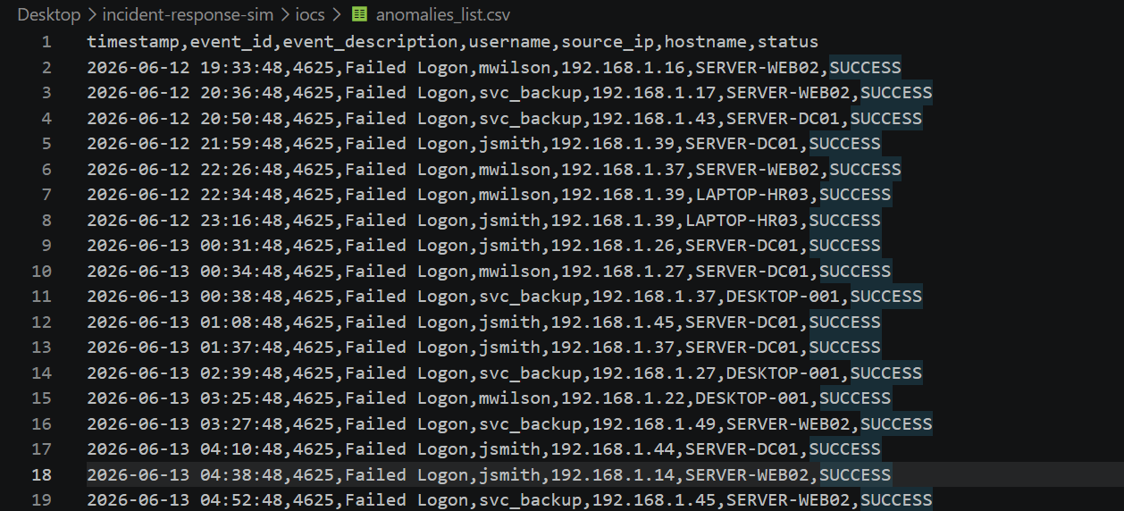

10. Conclusion
This task successfully demonstrated the complete incident response lifecycle: from log generation and suspicious activity detection, through IOC identification and response documentation, to final deliverable production.

Key outcomes:
- 175 realistic Windows Event Log entries were simulated covering normal and attack traffic
- A complete attack chain was embedded: brute force, login, privilege escalation, backdoor, persistence, log clearing
- 7 detection rules were applied identifying 66 anomalous events and 6 distinct IOCs
- 4 security visualizations were produced to support the incident report
- 2 professional deliverables were generated: an Incident Report (DOCX) and an Anomalies List (PDF)
- All code was version-controlled using Git and organized in a clean project structure

The simulation highlights how automated log analysis with Python can rapidly surface critical IOCs that would be difficult to detect manually in large log datasets.

