

NAME: K.KEERTHANAA

DEPT: B.TECH cse

REG NO: 122011012805

SEM NO:06

ASSIGNMENT NO:1

TOPIC:TYPES OF SENSORS[1]

**IoT Sensors types:**

1. **Air quality sensors**
2. **Biomedical sensors**
3. **Cameras**
4. **Chemical sensors**
5. **Electric current sensors**

**1.Air Quality Sensors**

**Air quality sensors are being used in homes as well, detecting harmful particulates that could be indoors from appliances like**[**gas stoves**](https://www.nbcnews.com/politics/politics-news/gas-stove-debate-reignites-energy-department-proposes-new-rules-rcna68728)**, which could warn residents to open a window or turn on an exhaust fan.**

**How is the data from these IoT sensors used?**

**Cities typically use devices with air quality sensors so they can access real-time air quality conditions to issue warnings to residents if needed and track trends for study.**

**Working principal:**

* **Light scattering:**

**Most commonly used for particulate matter detection, where a laser beam is shone through the air and the amount of scattered light is measured, indicating the concentration of particles present.**

* **Electrochemical detection:**

**For gases like ozone or nitrogen dioxide, a chemical reaction occurs on the sensor electrode when the gas interacts with it, generating an electrical current proportional to the gas concentration.**

* **Non-dispersive infrared (NDIR):**

**This method is used to detect specific gases like carbon dioxide by measuring how much infrared light is absorbed by the gas molecules.**

**Circuit diagram:**

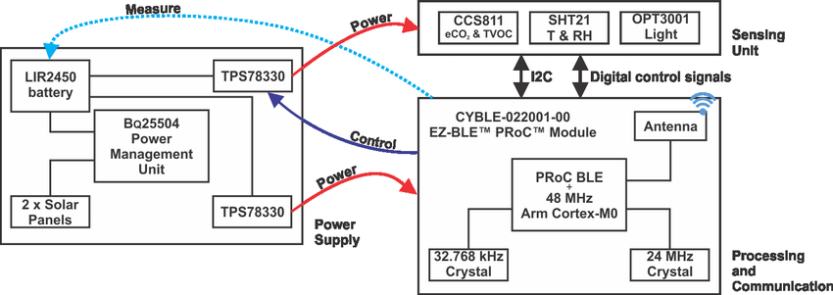**2.Biomedical sensors**

**These devices communicate the data they collect back to the wearer so they can**[**monitor their own health**](https://builtin.com/hardware/electronic-tattoo)**, or to a caregiver or medical staffer monitoring a patient or loved one remotely.**

**How is the data from these IoT sensors used?**[**Wearable devices**](https://builtin.com/articles/protect-wearables-rugged-devices)**like smart watches and arm bands can be equipped with biomedical sensors.**

**Working principal:**

* **Optical sensors:**

**Utilize changes in light absorption, fluorescence, or scattering to detect analytes, like in fiber optic sensors for measuring blood oxygen levels.**

* **Piezoelectric sensors:**

**Generate an electrical charge when mechanical stress is applied, used for measuring pressure or blood flow.**

* **Thermal sensors:**

**Detect temperature changes, often used in monitoring body temperature.**

**Circuit diagram:**

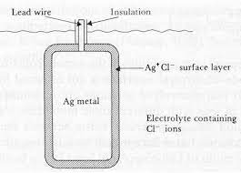**3.Cameras**

**Cameras also play a role in factory and warehouse automation, helping perform tasks like product inspections.**

**How is the data from these IoT sensors used? Everything from**[**smart refrigerators**](https://justenergy.com/blog/smart-refrigerators/)**to**[**autonomous vehicles**](https://builtin.com/iot-internet-things/self-driving-cars)**relies on cameras to detect objects and monitor their surroundings. Cameras are also critical to**[**smart cities**](https://builtin.com/articles/iot-smart-city-applications)**as well as home and business security — think Ring cameras notifying a homeowner when someone is at their door, even if they aren’t there themselves.**

**Working principal:**

* **Aperture: Controls how much light enters the camera**
* **Shutter: Controls how long light falls on the light-sensitive surface**
* **Viewfinder: Shows the scene to be recorded**
* **Focus: Adjusts the focus of the image**
* **Aperture: Adjusts the amount of light that enters the camera**
* **Shutter speed: Adjusts how long light falls on the light-sensitive surface**

**Circuit diagram:**

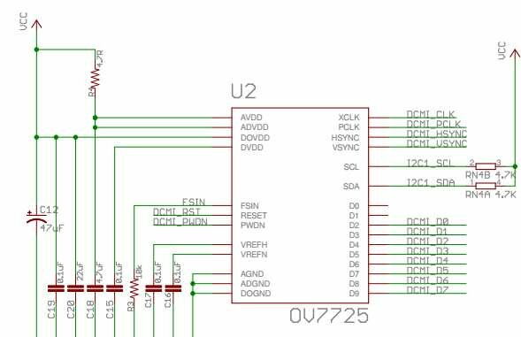

**4.Chemical sensors:**

**They’re also being integrated into**[**wearable devices**](https://www.sciencedirect.com/science/article/abs/pii/S2211285520307333)**to monitor the**[**chemical makeup of sweat**](https://today.ucsd.edu/story/finger-wrap-uses-sweat-to-provide-health-monitoring-at-your-fingertipsliterally)**, saliva and even tears for more timely treatment and therapeutic care.**

**How is the data from these IoT sensors used?**

**Chemical sensors are used for environmental monitoring, like detecting chemical leaks in factories.**

**Working principal:**

* **Electrochemical sensors**

**Use two electrodes and a thin layer of electrolyte to detect chemicals based on their electrochemical properties**

* **Semiconductor gas sensors**

**Use a semiconductor element to detect gases by measuring the change in resistance when the gas reacts with the semiconductor**

* **Optical sensors**

**Detect chemicals by measuring how light interacts with the chemical**

* **Biosensors**

**Use biological responses to detect chemicals, such as electrolyte concentration, pH, and specific proteins**

**Circuit diagram:**

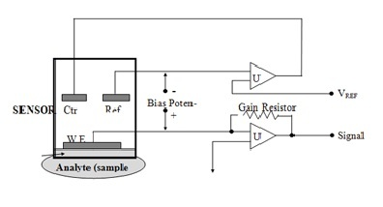

**5.Electric current sensors:**

**Electric sensors measure the**[**amount of electricity**](https://builtin.com/hardware/electrical-charge)**running through a wire by monitoring the**[**magnetic field**](https://builtin.com/hardware/emp)**the current generates along the wire.**

**How is the data from these IoT sensors used?**

**Electric current sensors are often used to monitor**[**energy consumption**](https://builtin.com/articles/ai-energy-consumption)**. They provide real-time, remote tracking of power systems, helping to manage energy usage in places like data centers.**

**Working principal:**

* **Current Transformer (CT):**

**A widely used type where the primary winding carries the full current and the secondary winding with many turns produces a smaller, measurable voltage.**

* **Hall Effect Sensor:**

**This sensor directly measures the magnetic field strength using the Hall effect, where a voltage is generated across a conductor when a magnetic field is applied perpendicular to the current flow.**

**Circuit diagram:**

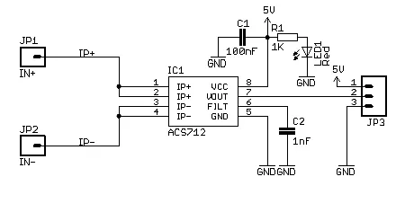

1.