PROJECT 1

*TEAM NAME: PACERS*

TEAM MEMBERS:

Megha Varshini M

Aluru Keerthana

Chekka V B Krishna Harshith Babu

Yogitha Prakash

Overview

Structured Query Language, abbreviated as SQL, is a domain-specific language used in programming and designed for managing data held in a relational database management system, or for stream processing in a relational data stream management system. We have performed queries, joins, sub queries and aggregate functions.

**Problem Statement**

# **Student Management System:** Develop System application to manage student basic info records in to the Database and along with the library, performance and attendance record information to the database. Implement all the checks so that there are no errors and no duplicates are created.

Q1. Develop student management system and

maintain all data in the SQL.

create table student (

rno varchar(10),

fname varchar(20),

lname varchar(20),

dno int

);

ALTER TABLE student ADD PRIMARY KEY

(rno);

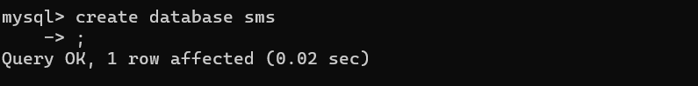

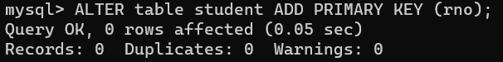

create table performance (

srno varchar(10),

tm_sem1 int,

tm_sem2 int,

tm_sem3 int,

tm_sem4 int,

tm_sem5 int,

tm_sem6 int,

tm_sem7 int,

tm_sem8 int,

FOREIGN KEY (srno) REFERENCES

student(rno)

);

create table attendance(

srno varchar(10),

ta_sem1 int,

ta_sem2 int,

ta_sem3 int,

ta_sem4 int,

ta_sem5 int,

ta_sem6 int,

ta_sem7 int,

ta_sem8 int,

FOREIGN KEY (srno) REFERENCES

student(rno)

);

Q2. Insert Student basic record into database

using Student “Roll No.” as unique Id.

insert into student values("SID1","Ajay","Jain",1);

insert into student values("SID2","Yash","Mehta",2);

insert into student values("SID3","Raj","Garg",2);

insert into student values("SID4","John","krasinski",1);

insert into student values("SID5","Rohit","Bajaj",3);

Q2. Insert Student basic record into database

using Student “Roll No.” as unique Id.

insert into performance values("SID1",90,99,98,88,85,91,89,90);

insert into performance values("SID2",99,89,72,68,75,81,79,80);

insert into performance values("SID3",89,81,70,64,79,83,71,96);

insert into performance values("SID4",70,69,68,78,65,71,59,70);

insert into performance values("SID5",63,59,62,61,65,51,59,60);

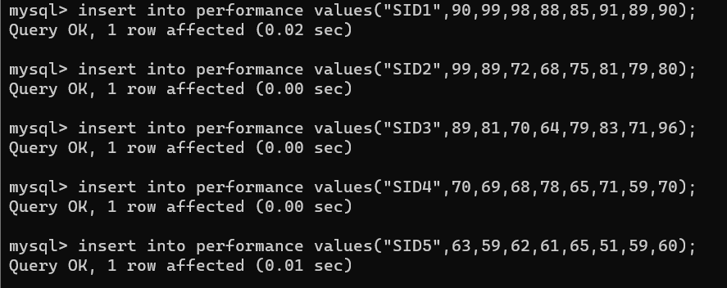

insert into attendance values("SID1",80,79,78,78,85,81,79,90);

insert into attendance values("SID2",91,83,77,76,75,83,89,90);

insert into attendance values("SID3",81,83,76,73,79,77,76,76);

insert into attendance values("SID4",76,89,88,79,85,76,75,70);

insert into attendance values("SID5",88,78,88,81,76,77,76,75);

Q3. Database maintains different table for

Student information for all admissions are

maintained in a table, Performance records in

all semesters maintained in a table and

Attendance record in a table.

select * from student;

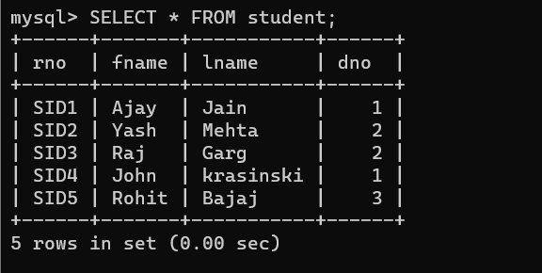

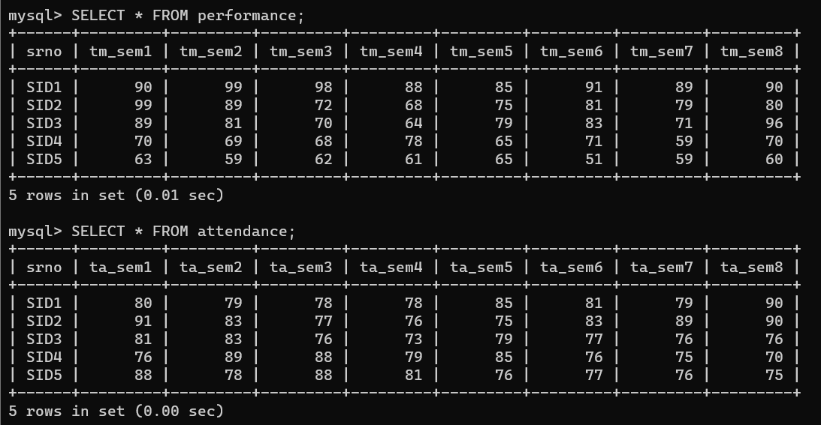

Q4. Create a combined table to provide a

consolidated report for the course.

CREATE TABLE consolidated_report AS SELECT s.rno,

s.dno,

p.tm_sem1,a.ta_sem1,p.tm_sem2,a.ta_sem2,p.tm_sem3,

a.ta_sem3,p.tm_sem4,a.ta_sem4,p.tm_sem5,a.ta_sem5,p

.tm_sem6,a.ta_sem6,p.tm_sem7,a.ta_sem7,p.tm_sem8,a.

ta_sem8 FROM

student s JOIN performance p ON s.rno= p.srno JOIN

attendance a ON a.srno = p.srno;

Q5. User defined function and store procedure is to be

developed for the accumulate the data required into a

single table named “Cumulative Grade

Sheet_<Department name>” Department wise.

CREATE TABLE CGS_1 AS select * from consolidated_report

where dno=1;

CREATE TABLE CGS_2 AS select * from consolidated_report

where dno=2;

CREATE TABLE CGS_3 AS select * from consolidated_report

where dno=3;

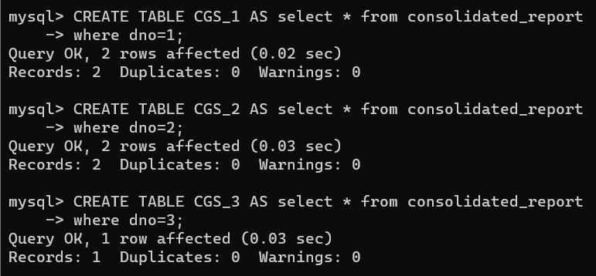

Q6. The New tables should contain Student Id, Department id, Total Marks scored by each student during each semester (Add each paper marks semester wise)., Attendance for each semester. i.e., the fields in the new table are Student id, Department id, Sem_1 Total marks,

Sem_1 Attendance, Sem_2 Total marks, Sem_2 Attendance, Sem_3 Total marks, Sem_3 Attendance, Sem_4 Total marks, Sem_4 Attendance, Sem_5 Total marks, Sem_5 Attendance, Sem_6 Total marks, Sem_6 Attendance, Sem_7 Total marks, Sem_7 Attendance, Sem_8 Total marks, Sem_8 Attendance.

select * from consolidated_report;

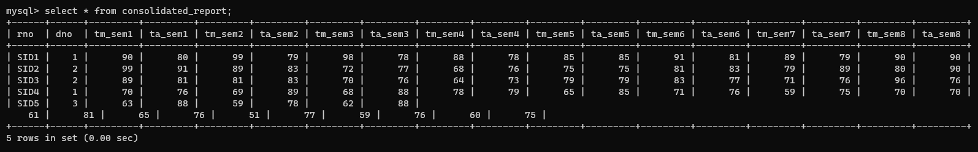

Q7. The User has option to include new

students’ detail in the student information table

using Student Enrolment option

insert into student values("SID7","Shubham","Jain",3);

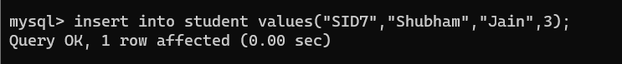

Q8. Similarly, The Attendance records and

performance records can also be updated into

the table using student course update option

which will prompt the user to select between

performance and Attendance records.

UPDATE performance SET tm_sem5=90 WHERE srno='SID5';

UPDATE attendance SET ta_sem5=88 WHERE srno='SID5';

Q9. When User selects Cumulative Grade sheets, List all departments for user selection. Single department or all departments can be selected.

select DISTINCT(dno) from consolidated_report;

Q10.If user selects all, all department table are to be displayed.

select * from consolidated_report ORDER BY dno;

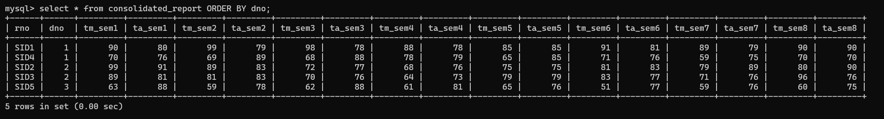

Q11.If Single records is selected, Prompt the user for Student id. Else if all records are selected display all in a particular department.

select * from consolidated_report where dno=2 AND rno="SID2";



Q12.If Single records is selected, Prompt the user for Student id. Else if all records are selected display all in a particular department.

select * from consolidated_report where dno=1;

select * from consolidated_report where dno=2;

select * from consolidated_report where dno=3;

