PROJECT 3

*TEAM NAME: PACERS*

TEAM MEMBERS:

Megha Varshini M

Aluru Keerthana

Chekka V B Krishna Harshith Babu

Yogitha Prakash

**CASE STUDY 1**

Daniel got selected by a IT-Company and is appointed as a Manager. He wants to know about the different departments and the employees in each department and also each employee’s salary. He has approached you to help him get the information. you are given a sample Employee data.

ER Diagram:

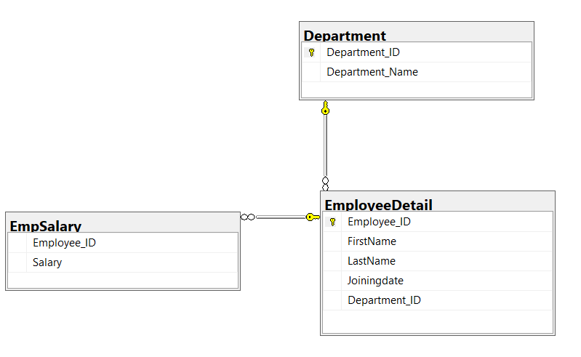

EmployeeDetail Data

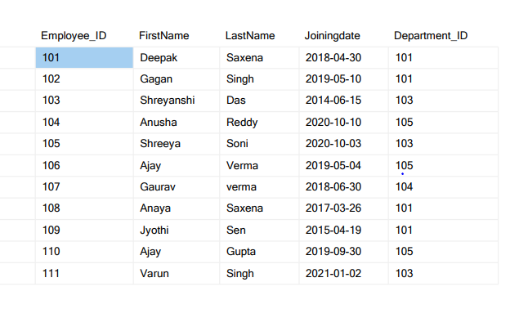

Department Data

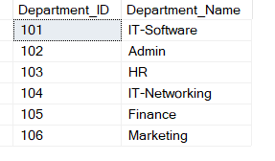

EmpSalary Data

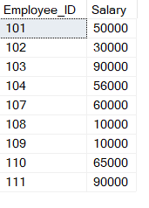

Cases:

1. Create a database to store all the tables

**QUERY :**

create database EMPLOYEE;

use EMPLOYEE;

**OUTPUT:**

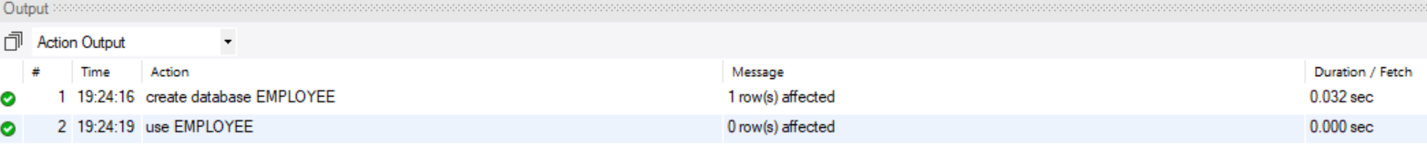

1. Create Employeedetail , EmpSalary , Department tables with attributes and their relation as given in the ER diagram.

**QUERY :**

DEPARTMENT TABLE:

create table Department (

departmentID int NOT NULL,

departmentName varchar(255),

PRIMARY KEY(departmentID)

);

EMPLOYEEDETAIL TABLE:

create table EmployeeDetail (

employeeID int NOT NULL,

firstName varchar(255),

lastName varchar(255),

joiningDate date,

departmentID int NOT NULL,

PRIMARY KEY(employeeID),

FOREIGN KEY(departmentID) REFERENCES Department(departmentID)

);

EMPLOYEESALARY TABLE:

create table EmpSalary(

employeeID int not null,

FOREIGN KEY(employeeID) REFERENCES

EmployeeDetail(employeeID),

salary int

);

**OUTPUT:**

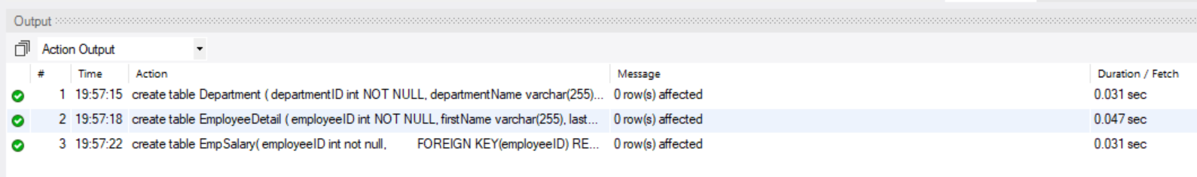

1. Insert the values in each of table from the data given above.

Inserting values into Department table :

**QUERY :**

insert into Department VALUES(101, "IT-Software");

insert into Department VALUES(102, "Admin");

insert into Department VALUES(103, "HR");

insert into Department VALUES(104, "IT-Networking");

insert into Department VALUES(105, "Finance");

insert into Department VALUES(106, "Marketing");

**OUTPUT:**

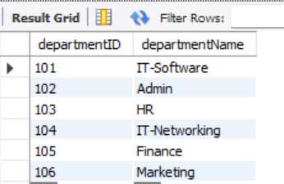

Inserting values into EmployeeDetail table:

**QUERY :**

insert into EmployeeDetail values(101, "Deepak", "Saxena", '2018-04-30', 101);

insert into EmployeeDetail values(102, "Gagan" ," Singh", '2019-05-10', 101);

insert into EmployeeDetail values(103, "Shreyanshi","Das", '2014-06-15', 103);

insert into EmployeeDetail values(104, "Anusha", "Reddy", '2020-10-10', 105);

insert into EmployeeDetail values(105, "Shreeya", "Soni", '2020-10-03', 103);

insert into EmployeeDetail values(106, "Ajay", "Verma", '2019-05-04', 105);

insert into EmployeeDetail values(107, "Gaurav", "Verma", '2018-06-30', 104);

insert into EmployeeDetail values(108, "Anaya", "Saxena", '2017-03-26', 101);

insert into EmployeeDetail values(109, "Jyothi", "Sen", '2015-04-19', 101);

insert into EmployeeDetail values(110, "Ajay","Gupta", '2019-09-30', 105);

insert into EmployeeDetail values(111, "Varun", "Singh", '2021-01-02', 103);

**OUTPUT :**

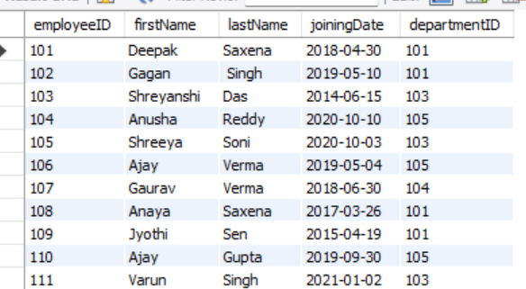

Inserting values into EmpSalary table:

**QUERY :**

insert into EmpSalary values(101,50000);

insert into EmpSalary values(102,30000);

insert into EmpSalary values(103,90000);

insert into EmpSalary values(104,56000);

insert into EmpSalary values(107,60000);

insert into EmpSalary values(108,10000);

insert into EmpSalary values(109,10000);

insert into EmpSalary values(110,65000);

insert into EmpSalary values(111,90000);

**OUTPUT :**

1. Write a query to show the employee belong to which department.

**QUERY:**

select e.employeeID, e.firstName, e.lastName, d.departmentName

from EmployeeDetail e, Department d

where e.departmentID = d.departmentID;

**OUTPUT :**

1. Write a query to display the employee fullname(FirstName + lastName), department, salary for each employee.

**QUERY :**

select e.employeeID, concat(e.firstName,' ', e.lastName) as FullName, d.departmentName, s.salary

from EmployeeDetail e, Department d, EmpSalary s

where e.departmentID = d.departmentID AND e.employeeID = s.employeeID ;

**OUTPUT:**

1. Write a query to display the employee with highest salary from each department.

**QUERY:**

SELECT Department.departmentName, max(empSalary.Salary)

FROM employeeDetail

JOIN Department ON EmployeeDetail.departmentId = Department.departmentID

JOIN Empsalary ON EmployeeDetail.employeeID = empSalary.employeeID

group by Department.departmentName;

**OUTPUT:**

1. Write a query to show the department that has the highest number of employees.

**QUERY :**

select d.departmentID, d.departmentName from Department d where d.departmentID = (select departmentID from EmployeeDetail group by departmentID order by count(departmentID) desc limit 1);

**OUTPUT :**

1. Create a stored procedure to update the salary of employee whose ID is 108 to 50000(Use parameters)

**Stored Procedure:**

**OUTPUT:**

1. Write a query to find the employees who have maximum and minimum salary

**QUERY:**

**Select concat(e.Firstname,e.LastName) as fullname,s.Salary**

**from EmployeeDetail e inner join EmpSalary s on s.EmployeeID=e.EmployeeID**

**where s.Salary in**

**(select max(s.Salary) from EmployeeDetail e inner join EmpSalary s on e.EmployeeID=s.EmployeeID )**

**union**

**select concat(e.Firstname,e.LastName),s.Salary from EmployeeDetail e inner join EmpSalary s on s.EmployeeID=e.EmployeeID where s.Salary in**

**( select min(s.Salary) from EmployeeDetail e inner join EmpSalary s on e.EmployeeID=s.EmployeeID ) ;**

**OUTPUT:**

1. Create a function which outputs the names of the employee whose name (Firstname) starts with A or ends with i.

**QUERY:**

select firstName from EmployeeDetail

where firstName LIKE "A%" or firstName LIKE "%i" order by firstName;

**OUTPUT:**

