**References to derived class instances**

**Coding Snippets:**

1. **Creating reference variable of Super class and object of subclass.**

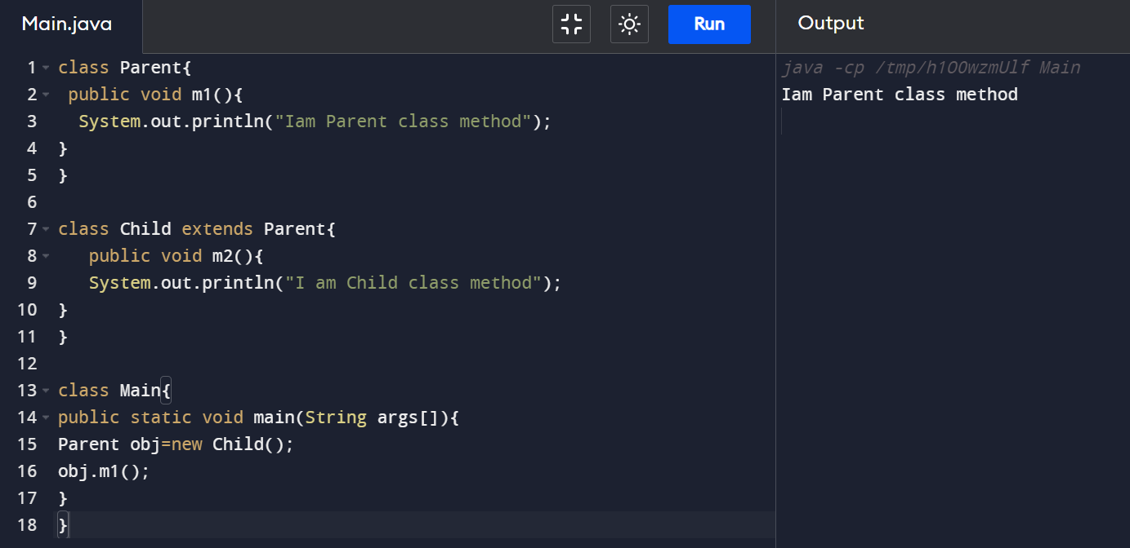

1. **With reference variable of Super class trying to access method present in Subclass.**

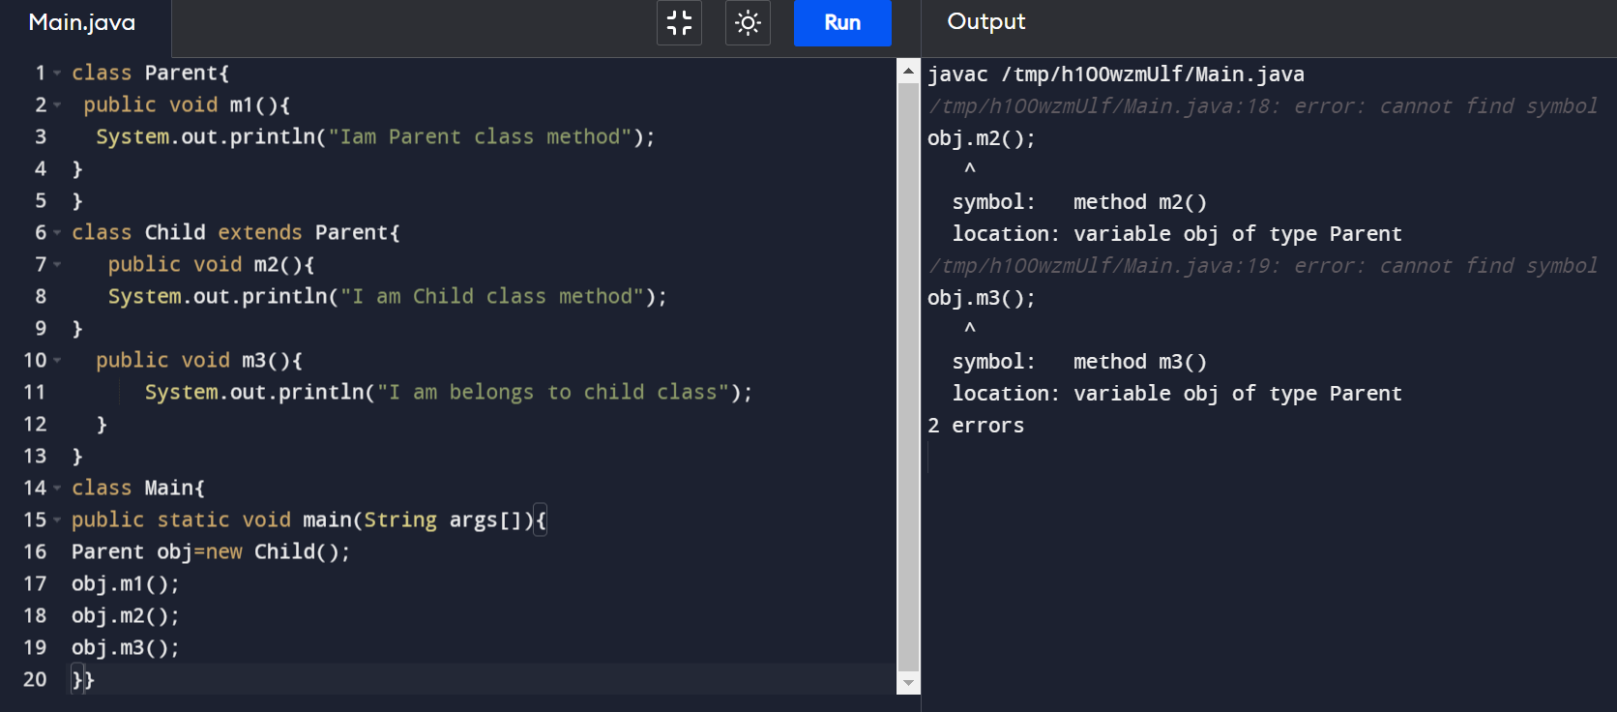

**Explanation:** With the reference of Super class, we can only access methods available in Super class. We cannot access methods available in Sub class.

1. **Creating reference variable of Super class and object of Super class.**

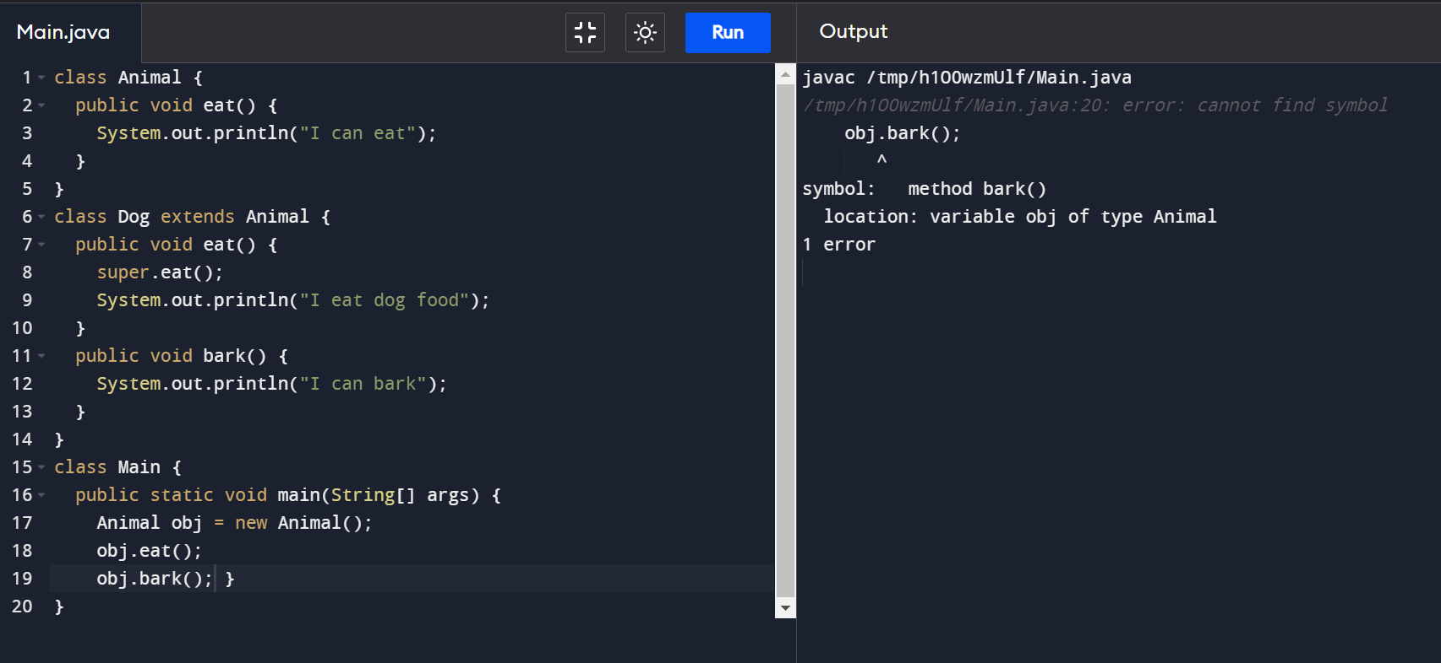

**Explanation:** When we create reference for Super class and object of Super class, we can only access methods available in Super class. We cannot access methods available in Sub class.

4)**Creating reference variable of Sub class and object of Sub class.**

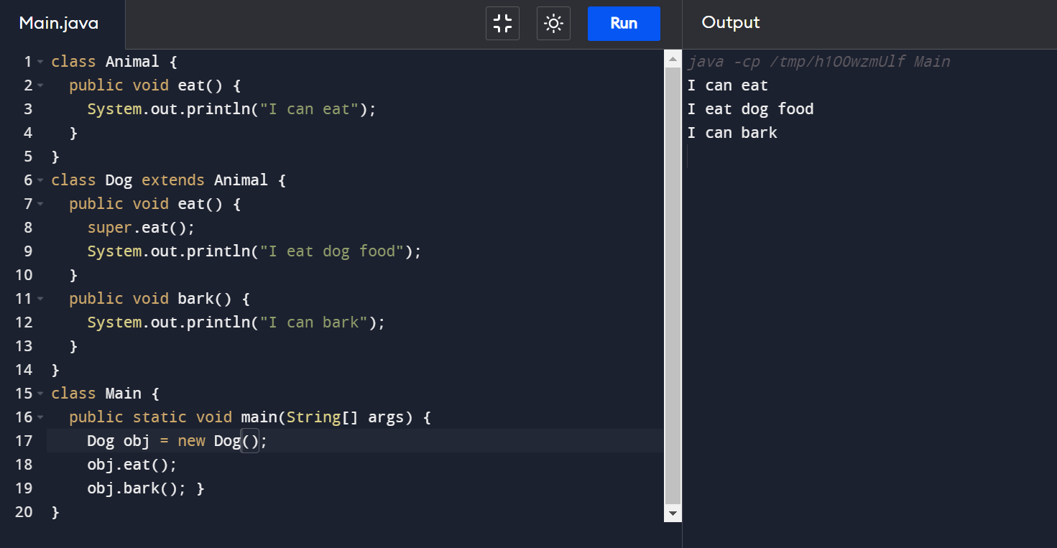

**Explanation:** By creating reference of Sub class, we can access both Super class and Sub class members.

1. **Creating reference of Sub class and object of Super class.**

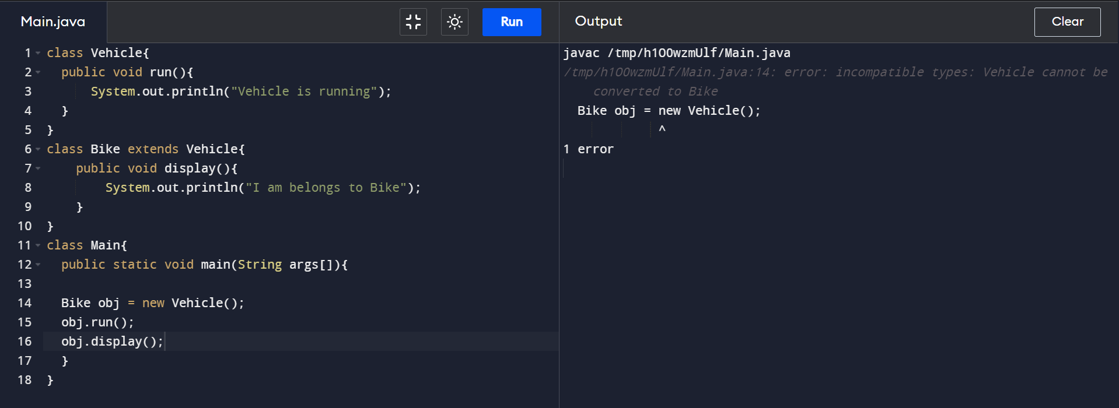

**Explanation:** In java we cannot create Sub class reference.