**References to derived class instances**

**Q&A**

1. **Which keyword is used to identify derived class?**

**Ans:** extends Keyword is used to identify derived class.

1. **Can child class reference hold base class object?**

**Ans:** No, In Java, the reference variable of the Parent class is capable to hold its object reference as well as its child object reference.

1. **What can be derived by a derived class from a base class?**

**Ans:** The derived class inherits “**all members and member functions”** of a base class.

1. **Can we create object of parent class with child class reference?**

**Ans:** No. Will get compilation error.

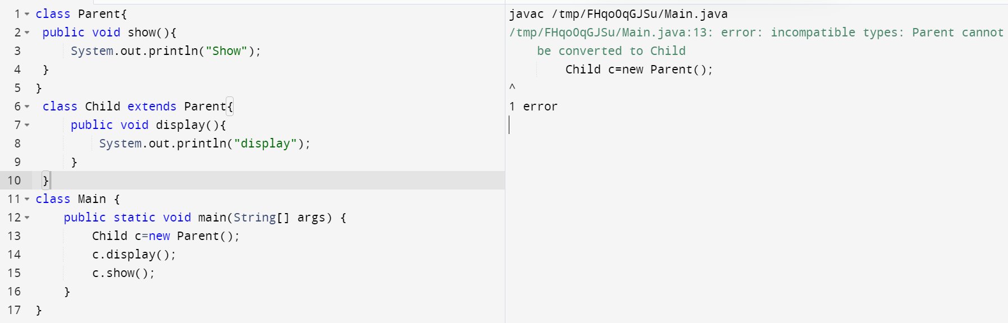

1. **When is a parent class reference used to refer to a child class object?**

**Ans**: when we don’t know exact run time type of object, we go for Parent class reference.

**Explanation:** If we are working with Array List, we don’t know exactly which type of object present in different index, in this case will use Parent class reference.