FINAL PROJECT REPORT

School Bus Route Planner
Algorithm-based route planning using BFS, Dijkstra and Greedy
Submitted By
Team Members:
R. Shravya Sri (25MVCSMR0710)
E. Gangothri (25MVCSMR0642)
K. Keerthana (25MVCSMR0648)
T. Sai Hansika (25MVCSMR0703)
Department: CSE – AI & ML
College / University: Malla Reddy Vishwavidyapeet
Guide Name
__________________________

Academic Year: 2026–2027

2. Abstract & Introduction

2.1 Project Overview
The School Bus Route Planner is a web application that creates efficient school-bus pickup routes. The user enters the number of students, the bus capacity and a planning priority, and the system produces a route for every bus together with its distance, estimated travel time and safety buffer. The routes are drawn on an interactive route canvas and can be exported as a CSV file.

2.2 Problem Background
School transportation is a daily responsibility for school administration. A school may have hundreds of students spread across many locations, served by several buses with fixed seating capacity. Choosing which stops each bus visits, and in what order, affects ride time, fuel cost and student safety. Planning this by hand is slow, and the number of possible routes grows very quickly as stops are added, so trial and error does not scale.

2.3 Proposed Solution
The road network is modelled as a weighted graph in which stops are nodes and roads are edges weighted by distance. Three classic Design and Analysis of Algorithms (DAA) techniques solve the problem:
- Breadth-First Search (BFS) checks that every stop is reachable from the school.
- Dijkstra's algorithm computes the true shortest road distance between stops.
- A priority-aware Greedy strategy builds routes stop by stop without exceeding bus capacity.
Every decision is recorded and shown to the user, so the plan is explainable rather than a single unexplained result.

2.4 Purpose of the Project
The purpose is to demonstrate how DAA concepts solve a practical transportation problem, to reduce the manual effort of route planning, and to provide a clear, easy-to-use tool for school transport planners.

3. Problem Statement, Objectives & Scope

3.1 Problem Statement
Create efficient school-bus pickup routes considering stops, road distances, capacity and approximate pickup priorities.
Poorly planned routes lead to long travel times, overloaded or under-used buses, higher transport cost and difficulty keeping safety buffers.

3.2 Project Objectives
- To minimize the total travel distance of school-bus routes.
- To compute true shortest road distances using Dijkstra's algorithm.
- To verify that every stop is reachable using BFS.
- To ensure that no bus exceeds its capacity.
- To take pickup priority into account when choosing stops.
- To record and explain the decision behind each selected stop.
- To present routes, distance, time and safety buffer clearly.
- To demonstrate the selected DAA algorithms and their complexity.

3.3 Project Scope
The current version is a single-page planning tool. It generates a sample road network for the chosen school and plans routes on it. It does not use real map data, live traffic or GPS. These are listed as future enhancements.

3.4 Target Users
- School transport coordinators
- Bus fleet managers
- School administration teams
- Students and educators learning DAA concepts

4. Features & Functional Requirements

4.1 Main Features
- Planning form: school campus, number of students, bus capacity and planning priority (Balanced, Fastest trips, Safest ride).
- Planning options: Cluster stops, Balance capacity and Safety buffers.
- Route canvas: SVG map showing the school, numbered stops, roads and one animated route per bus.
- Summary: recommended number of buses, average route time, safety buffer and number of stops.
- Route cards: students, stops, distance, estimated time and safety buffer for each bus.
- Planning insight: a plain-language explanation of the result.
- Algorithm log: BFS, Dijkstra and Greedy steps with operation counts.
- Export of the route plan as a CSV file.

4.2 User Functionalities
- Select the school campus.
- Enter the number of students and the bus capacity.
- Choose the planning priority and toggle planning options.
- Run the optimization.
- View routes on the canvas and in route cards.
- Read the planning insight and algorithm log.
- Reset the planner to default values.
- Export the plan as CSV.

4.3 CRUD Operations
The current version keeps all data in memory and has no database, so CRUD is applied to the plan rather than to stored records:
Operation | Meaning in this application
Create | Generate a new route plan from the entered inputs
Read | View routes, summary, insight and algorithm log
Update | Change inputs or options and re-run the optimization
Delete | Reset the planner to its default state

Persistent storage of stops, buses and plans is planned as a future enhancement.

4.4 Authentication & Validation
Authentication: the current version is a single-user planning tool and has no login. Role-based login for administrators and transport staff is a future enhancement.
Validation:
- The number of students is limited to 10–200 and bus capacity to 10–60; values outside the range are corrected.
- Empty or invalid entries fall back to default values.
- School and priority are chosen from fixed lists, so invalid options cannot be entered.
- BFS validates that all stops are reachable before routes are trusted.
- The Greedy planner never loads a bus beyond its capacity limit.

4.5 System Requirements
Type | Requirement
Hardware | Any computer, tablet or smartphone
Operating system | Windows, macOS, Linux, Android or iOS
Software | Modern web browser (Chrome, Edge, Firefox or Safari)
Network | Internet only for hosting; the file also runs offline
Development | Text editor, Hatchable account (optional hosting)

5. Algorithms & Methodology

5.1 System Workflow
Input → Processing → Algorithm → Output
Stage | Description
Input | School, number of students, bus capacity, priority and options
Processing | Inputs validated; a weighted graph of stops and roads is built; BFS checks reachability
Algorithm | Dijkstra computes distances; Greedy selects stops under the capacity limit
Output | Route for each bus, distance, time, safety buffer, insight and CSV export

5.2 Algorithms Used

5.2.1 Breadth-First Search (BFS)
BFS explores the graph level by level from the school. It finds every reachable stop and the minimum number of road hops to it. Stops that are never visited are reported as unreachable.
BFS(graph, school):
queue = [school]; visited = {school}
while queue not empty:
u = queue.pop_front()
for each neighbour v of u:
if v not in visited:
visited.add(v); queue.push(v)
return visited

5.2.2 Dijkstra's Algorithm
Dijkstra's algorithm finds the least-cost path from a source to all nodes when edge weights are non-negative, which holds for road distances. It keeps a tentative distance for each node, repeatedly takes the cheapest unexplored node from a min-heap (priority queue) and relaxes its edges. The path is rebuilt from stored predecessors.
Dijkstra(graph, source):
dist[all] = infinity; dist[source] = 0
heap = [(0, source)]
while heap not empty:
d, u = heap.pop_min()
if d > dist[u]: continue
for (v, w) in graph[u]:
if dist[u] + w < dist[v]:
dist[v] = dist[u] + w; prev[v] = u
heap.push((dist[v], v))
return dist, prev

5.2.3 Greedy Stop Selection
Each bus route is built one stop at a time. The first stop is the farthest unassigned stop from the school. After that, the best locally feasible stop is chosen using the Dijkstra distances:
score(stop) = distance from current stop − (priority weight × pickup priority × 0.5)
The stop with the lowest score that still fits within the capacity limit is added. When nothing fits, the bus ends at the school and the next bus begins. The priority weight depends on the chosen planning priority (Fastest trips 0.2, Balanced 0.8, Safest ride 1.6). Each choice is written to the algorithm log.
Greedy(stops, capacity):
while unassigned stops remain:
load = 0; route = []
while some unassigned stop fits (load + students <= limit):
pick stop with lowest score from current position
route.append(stop); load += students(stop)
log the reason
add route; (the bus then goes to school)
return routes

Algorithm | Role | Why chosen | Time complexity
BFS | Reachability and minimum hops | Fast; flags unreachable stops | O(V + E)
Dijkstra | Shortest road distance | Road weights are non-negative | O((V + E) log V)
Greedy | Choose next stop within capacity | Quick and easy to explain | O(n log n)-style selection

5.3 Development Methodology
The project followed an iterative, incremental prototyping approach:
- Requirement analysis from the problem statement.
- Design of the graph model and the three algorithms.
- Implementation of the algorithms in JavaScript.
- Development of the user interface and route canvas.
- Testing with different student counts, capacities and options.
- Refinement of the interface, explanations and documentation.

5.4 Data Flow
User inputs (school, students, capacity, priority, options)
|
v
Input validation
|
v
Build graph: stops (nodes) + roads (weighted edges)
|
v
BFS -> reachability check
|
v
Dijkstra -> shortest distances and paths
|
v
Greedy planner -> routes within capacity + decision log
|
v
Distance -> time, safety buffer, summary
|
v
SVG route canvas | route cards | insight | CSV export

6. Technologies & Implementation

6.1 Frontend Technologies
- HTML5 – page structure
- CSS3 – responsive layout, animations and light/dark theme
- JavaScript – user interaction and the algorithm engine
- SVG – route canvas with roads, stops, routes and animated buses

6.2 Backend Technologies
The algorithms run in the browser, so no backend is needed for planning. An optional Hatchable backend function can be connected through the AI_ENDPOINT setting to return an AI-written explanation of the plan.

6.3 Database
The current version uses no database; sample data is generated in memory for the selected school. PostgreSQL or another database can be added in future to store stops, buses and plans.

6.4 Tools & APIs
Tool | Purpose
Web browser developer tools | Debugging and testing
Hatchable | Hosting of the web app (optional)
Hatchable AI function (optional) | AI-written explanation of the plan
Browser Blob API | Creating the CSV export file

6.5 Implementation Details
- A sample road network is generated for the selected school: stops with student counts and pickup priorities, joined by weighted roads (distance in km).
- Each stop is connected to its nearest stop that is closer to the school, plus two nearest neighbours, so the graph is always connected.
- BFS checks reachability; Dijkstra uses a binary min-heap and caches results for each source.
- The Greedy planner builds routes within the capacity limit (optionally balanced across buses) and logs each decision.
- Estimated time = distance × 2.4 minutes per km + 1 minute per stop; the safety buffer is 40% of the time when enabled.
- Routes are drawn on the SVG canvas with animated dashed lines and moving buses.
- Route cards, summary, insight and algorithm log are generated from the plan.
- The plan is exported as CSV using a downloadable Blob.

7. Results, Testing & Performance

7.1 Project Results
For a sample school with 84 students and bus capacity 32, the application recommends 4 buses with an average route time of 31 minutes, a safety buffer of 12 minutes and 24 stops. No bus exceeds capacity.
Route | Students | Stops | Time | Safety Buffer
North Loop | 22 | 6 | 28 min | 11 min
East Loop | 21 | 7 | 34 min | 12 min
South Loop | 20 | 6 | 31 min | 13 min
West Loop | 21 | 5 | 30 min | 12 min

These values come from the prototype run shown in the screenshots; update them if your final run differs.

7.2 Test Cases
ID | Test case | Expected result | Status
TC01 | Open application | Interface loads with default plan | To verify
TC02 | Enter 84 students, capacity 32 | Plan generated; no bus over 32 | To verify
TC03 | Increase students to 120, capacity 40 | More buses recommended; capacity respected | To verify
TC04 | Enter value outside the allowed range | Value corrected to the allowed limit | To verify
TC05 | Select each planning priority | Routes change according to priority | To verify
TC06 | Toggle Cluster / Balance / Safety options | Routes, loads and buffers update | To verify
TC07 | Shortest path on a small known graph | Dijkstra matches the hand-computed distance | To verify
TC08 | Stop disconnected from the school | BFS reports it as unreachable | To verify
TC09 | Click Reset | Default values restored | To verify
TC10 | Click Export plan | CSV file with all routes downloaded | To verify

7.3 Testing Methods
- Functional testing – every button, option and input checked against expected behaviour.
- Boundary testing – minimum and maximum students and capacity.
- Algorithm verification – results compared with hand-computed shortest paths on small graphs.
- Manual UI testing – layout and animations on desktop and mobile screen sizes.
- Browser compatibility testing – Chrome, Edge and Firefox.

7.4 Performance Analysis
Algorithm | Time | Space | Notes
BFS | O(V + E) | O(V) | Each node and edge visited once
Dijkstra (binary heap) | O((V + E) log V) | O(V + E) | Run once per source, cached
Greedy selection | O(n log n)-style | O(n) | n = number of stops

For the number of stops handled by the application (up to 40), planning is effectively instantaneous in the browser. The algorithm log also reports how many Dijkstra runs and heap operations were used. The Greedy rule gives a good but not guaranteed optimal assignment; exact Capacitated Vehicle Routing Problem (CVRP) methods could improve it at higher computational cost.

7.5 Screenshots / Output
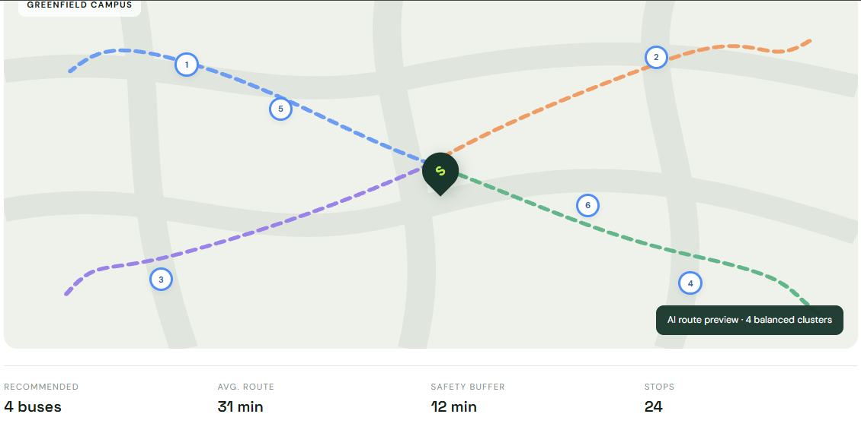
Figure 1: Route canvas and summary
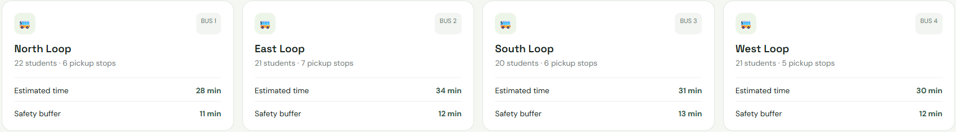
Figure 2: Route plan cards

8. Conclusion, Future Scope & References

8.1 Project Conclusion
The School Bus Route Planner shows how three classic algorithms combine to solve a practical transport problem. BFS validates the road network, Dijkstra supplies exact shortest distances, and a priority-aware Greedy strategy builds capacity-safe routes whose every step can be explained. The interactive interface, animated route canvas and CSV export make the result easy to understand and use.

8.2 Future Enhancements
- Real maps and road data with live traffic weights.
- GPS tracking and parent notifications.
- Driver dashboard with assigned routes and pickup lists.
- Database storage of students, stops, buses and plans.
- User authentication with administrator and staff roles.
- Time-window pickups and multi-school support.
- Advanced optimization such as VRP/CVRP and multi-objective methods.
- Optional AI-generated explanations through a Hatchable backend function.

8.3 References / Documentation
- T. H. Cormen, C. E. Leiserson, R. L. Rivest, C. Stein, Introduction to Algorithms, MIT Press.
- E. W. Dijkstra, "A note on two problems in connexion with graphs", Numerische Mathematik, 1959.
- Vehicle Routing Problem (VRP) – standard optimization problem for vehicle route planning.
- MDN Web Docs – HTML, CSS, JavaScript and SVG: https://developer.mozilla.org
- Hatchable documentation – https://hatchable.site

— End of Report —

