1. Difference between HTTP1 AND HTTP2

HTTP:

* Hypertext Transfer Protocol was created in 1997.
* It is the method computers and servers use to request and send information.
* HTTP responses with the text, images and formatting that the brower diplays to the user.

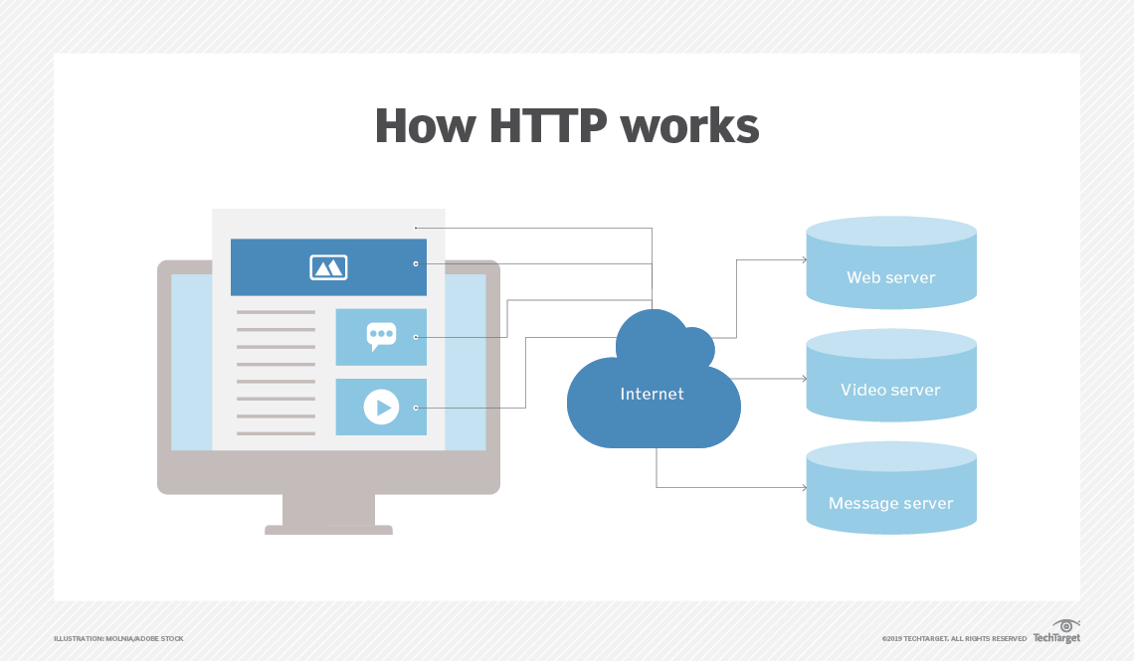

|  |  |
| --- | --- |
| HTTP1 | HTTP2 |
| It loads the resources one after the other | It is able to connect multiple streams of data |
| It is little slow when compare to HTTP2 | It is much faster and more efficient |
| It uses in a textual format | It works in a binary protocol |
| It uses requests resources inlining for use getting multiple pages. | It uses PUSH frame by server that collects all multiple pages. |

1. Objects and its internal representation in JavaScript

JavaScript object is a collection of named values having properties and methods. It will call by key: value.

Example:

Person

1. All the person are human, but there name and there characters are different.

The name: value pairs (In JavaScript Objects) are called properties

Code:

Var person= {

FirstName: ‘Keerthana’,

Age: ‘24years’;

eyeColor: ‘Black’

}

This is how we will create an object code for JavaScript.

Console.log(Person.Firstname)

If we call as FirstName then the output will be Keerthana.