PROJECT DOCUMENTATION
A CRM Application for THE CHAI SHOP & CO
Team Leader: Keerthana A
Team Members:
B Keerthika
Kirubaran S
Kishore P
Madhan F
1. ABSTRACT
The CRM Application for CHAI SHOP & CO is a simple web-based system used to manage customer details, products, orders, sales, and feedback. It reduces manual work, saves time, and helps the shop maintain records easily.
2. INTRODUCTION
CHAI SHOP & CO serves tea, beverages, and food items. Managing customer and order details manually can be difficult. This CRM application stores the information digitally and helps staff manage shop activities in an organized way.
3. PROBLEM STATEMENT
• Customer details are maintained manually.
• Searching records takes more time.
• Order and sales records may be difficult to manage.
• Feedback is not easy to track.
• Manual work may cause errors.
4. OBJECTIVES
• To store customer details digitally.
• To manage products and orders.
• To maintain sales records.
• To store customer feedback.
• To reduce paperwork and save time.
• To improve customer service.
5. MODULES
Admin Module:
Manages customers, products, employees, orders, sales, and reports.

Customer Module:
Allows registration, profile management, menu viewing, order placement, and feedback.

Product Module:
Allows adding, updating, deleting, and viewing products.

Order Module:
Manages customer orders and order status.

Feedback Module:
Stores ratings, reviews, and suggestions.

Sales and Reports Module:
Displays sales details and useful reports.
6. SYSTEM REQUIREMENTS
Hardware:
• Intel Core i3 or above
• 4 GB RAM or above
• 100 GB hard disk
• Keyboard, mouse, and monitor

Software:
• Windows 10/11
• HTML, CSS, JavaScript, Bootstrap
• PHP
• MySQL
• XAMPP
• Google Chrome or Microsoft Edge
7. SYSTEM FLOW
Start → Login / Registration → Authentication → Dashboard → Manage Customers / Products / Orders → Store Data in Database → View Reports → Logout → End
8. CONCLUSION
The CRM Application for CHAI SHOP & CO helps manage customer information, products, orders, sales, and feedback. It reduces manual work, saves time, improves accuracy, and provides better customer service.

9. SALESFORCE PROJECT DETAILS
The CRM Application for THE CHAI SHOP & CO is developed as a Salesforce-based group project. The project uses Salesforce features to manage customer information, products, orders, sales, feedback, and customer engagement in an organized way.
10. SALESFORCE FEATURES USED
• Salesforce Developer Account
• Objects and custom data management
• Tabs and Lightning App
• Global Picklist
• Fields and Relationships
• Page Layouts
• Record Types
• Validation Rules
• Email Templates
• Flows and process automation
• Reports and Dashboards
11. AUTOMATION
The application includes automation using Salesforce Flow. Email notifications can be automated for customers on their birthdays, along with special offers. This helps improve customer engagement and loyalty.
12. SKILLS REQUIRED
• Salesforce
• Flow Designer and Process Automation
• Data Modelling
• Data Validation
• Page Layout
13. PROJECT WORK / TASKS
• Creating Salesforce Developer Account
• Activating the Salesforce Account
• Creating and managing Salesforce Objects
• Creating Tabs and the Lightning App
• Configuring Global Picklist
• Creating Fields and Relationships
• Designing Page Layouts
• Creating Record Types
• Adding Validation Rules
• Creating Email Templates
• Creating Flows for automation
• Creating Reports and Dashboards
14. PROJECT PROGRESS
The project dashboard shows approximately 90% project progress. The project contains 13 epics and 25 stories/subtasks.
15. TEAM
Team Leader: Keerthana A
• B Keerthika
• Kirubaran S
• Kishore P
• Madhan F
16. FINAL CONCLUSION
The Salesforce CRM application provides a simple and organized way to manage THE CHAI SHOP & CO. It combines customer management, product and order management, sales reports, feedback, and automation in one system. Salesforce features such as Objects, Flows, Validation Rules, Email Templates, Reports, and Dashboards help improve the overall management of the shop.

17. PROJECT SCREENSHOTS
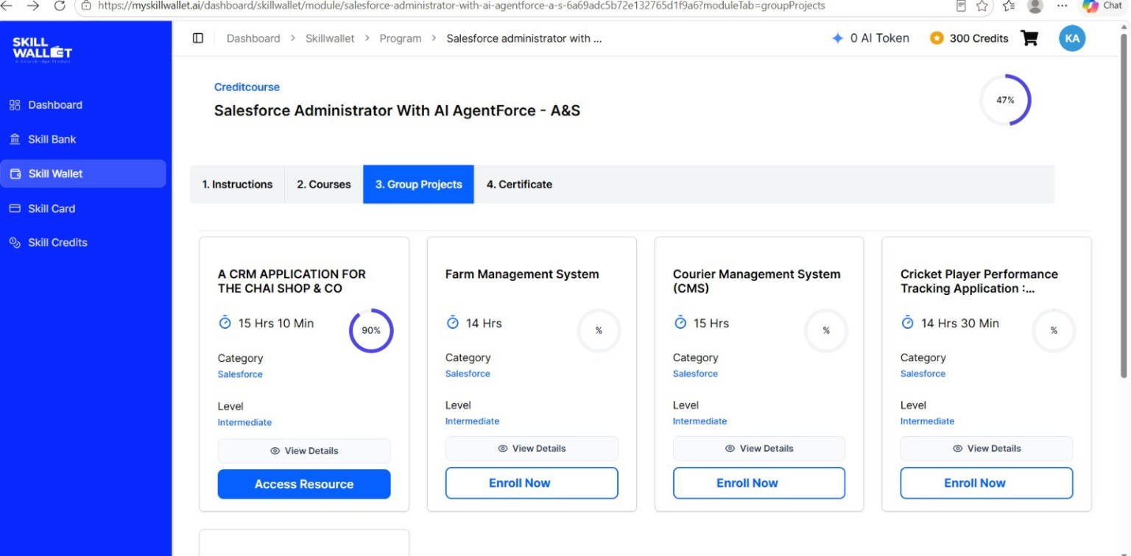
Figure 1: Group Project Selection – A CRM Application for THE CHAI SHOP & CO
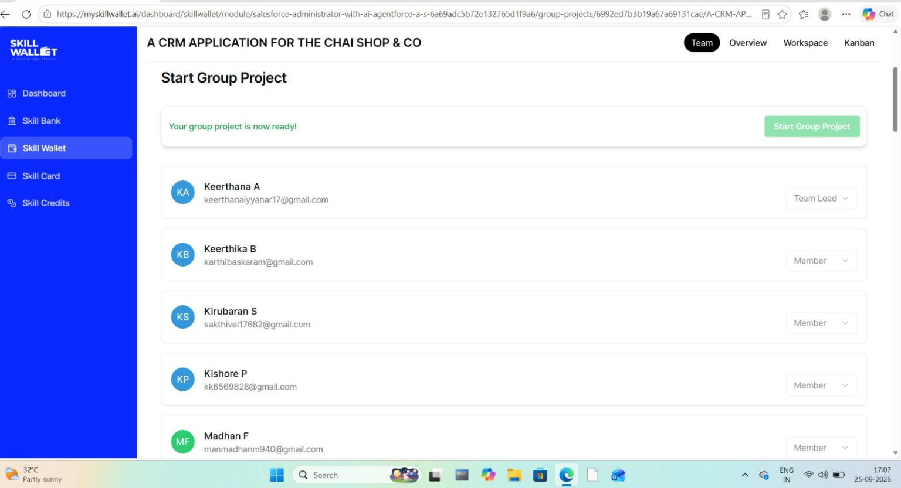
Figure 2: Group Project Team Members and Project Start Page

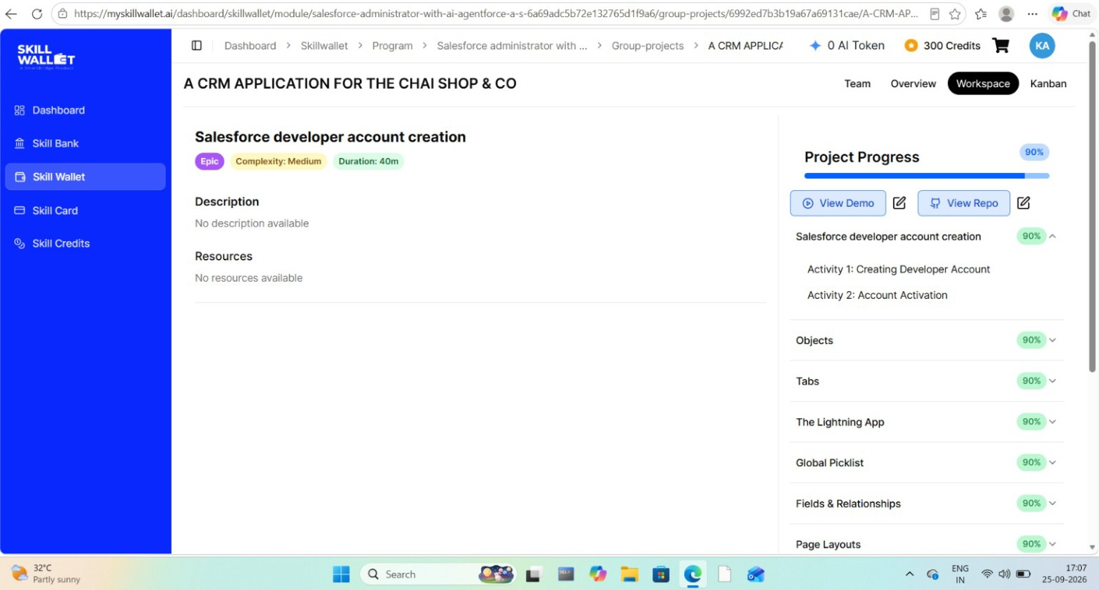
Figure 3: Salesforce Workspace and Project Progress
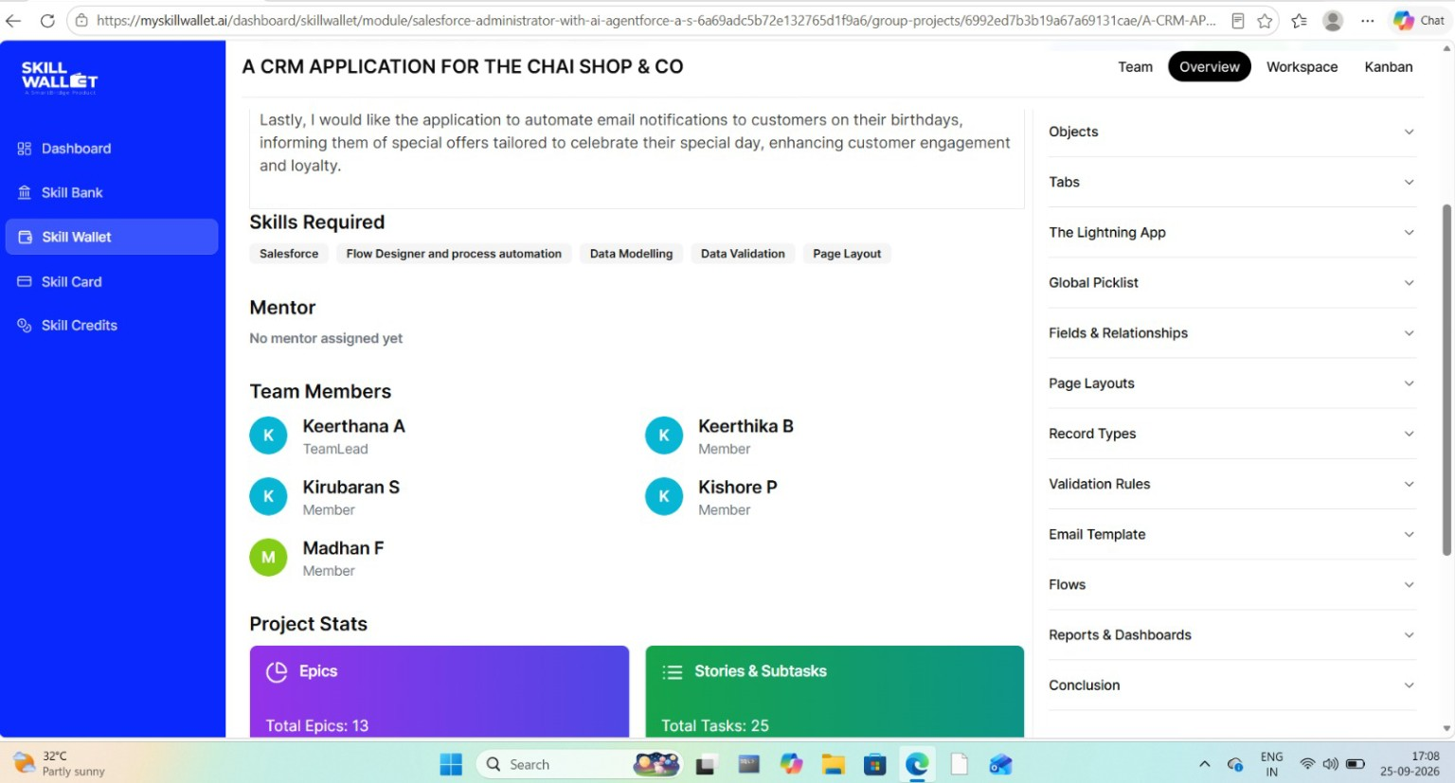
Figure 4: Project Overview, Skills Required, Team Members and Project Statistics

