WEEK 3

**Spring Core and Maven & Spring Data JPA with Spring Boot, Hibernate**

**Spring Core and Maven**

**Exercise 1: Configuring a Basic Spring Application**

**Scenario:**

Your company is developing a web application for managing a library. You need to use the Spring Framework to handle the backend operations.

**Steps:**

1. **Set Up a Spring Project:**
   * Create a Maven project named **LibraryManagement**.
   * Add Spring Core dependencies in the **pom.xml** file.
2. **Configure the Application Context:**
   * Create an XML configuration file named **applicationContext.xml** in the **src/main/resources** directory.
   * Define beans for **BookService** and **BookRepository** in the XML file.
3. **Define Service and Repository Classes:**
   * Create a package **com.library.service** and add a class **BookService**.
   * Create a package **com.library.repository** and add a class **BookRepository**.
4. **Run the Application:**
   * Create a main class to load the Spring context and test the configuration.

CODE

**Main.java**

package com.library.main;

import com.library.service.BookService;

import org.springframework.context.ApplicationContext;

import org.springframework.context.support.ClassPathXmlApplicationContext;

public class MainApp {

public static void main(String[] args) {

ApplicationContext context = new ClassPathXmlApplicationContext("applicationContext.xml");

BookService bookService = context.getBean("bookService", BookService.class);

bookService.addBook("The Great Gatsby");

}

}

**BookRepository.java**

package com.library.repository;

public class BookRepository {

public void saveBook(String title) {

System.out.println("Saving book: " + title);

}

}

**BookService.java**

package com.library.service;

import com.library.repository.BookRepository;

public class BookService {

private BookRepository bookRepository;

public void setBookRepository(BookRepository bookRepository) {

this.bookRepository = bookRepository;

}

public void addBook(String title) {

System.out.println("Adding book: " + title);

bookRepository.saveBook(title);

}

}

**OUTPUT:**

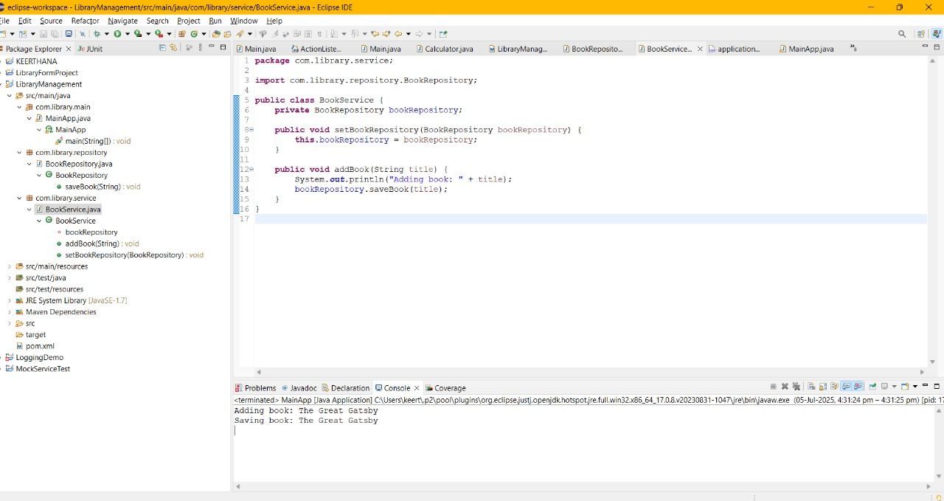

**Exercise 2: Implementing Dependency Injection**

**Scenario:**

In the library management application, you need to manage the dependencies between the BookService and BookRepository classes using Spring's IoC and DI.

**Steps:**

1. **Modify the XML Configuration:**
   * Update **applicationContext.xml** to wire **BookRepository** into **BookService**.
2. **Update the BookService Class:**
   * Ensure that **BookService** class has a setter method for **BookRepository**.
3. **Test the Configuration:**
   * Run the **LibraryManagementApplication** main class to verify the dependency injection.

**CODE:**

**Main.java**

package com.library.main;

import com.library.service.BookService;

import org.springframework.context.ApplicationContext;

import org.springframework.context.support.ClassPathXmlApplicationContext;

public class MainApp {

public static void main(String[] args) {

ApplicationContext context = new ClassPathXmlApplicationContext("applicationContext.xml");

BookService bookService = context.getBean("bookService", BookService.class);

bookService.addBook("She Stood by Me");

}

}

**BookService.java**

package com.library.service;

import com.library.repository.BookRepository;

public class BookService {

private BookRepository bookRepository;

public void setBookRepository(BookRepository bookRepository) {

this.bookRepository = bookRepository;

}

public void addBook(String title) {

System.out.println("Adding book: " + title);

bookRepository.saveBook(title);

}

}

**ApplicationContext.xml**

<?xml version="1.0" encoding="UTF-8"?>

<beans xmlns="http://www.springframework.org/schema/beans"

xmlns:xsi="http://www.w3.org/2001/XMLSchema-instance"

xsi:schemaLocation="

http://www.springframework.org/schema/beans

http://www.springframework.org/schema/beans/spring-beans.xsd">

<bean id="bookRepository" class="com.library.repository.BookRepository" />

<bean id="bookService" class="com.library.service.BookService">

<property name="bookRepository" ref="bookRepository" />

</bean>

</beans>

**OUTPUT:**

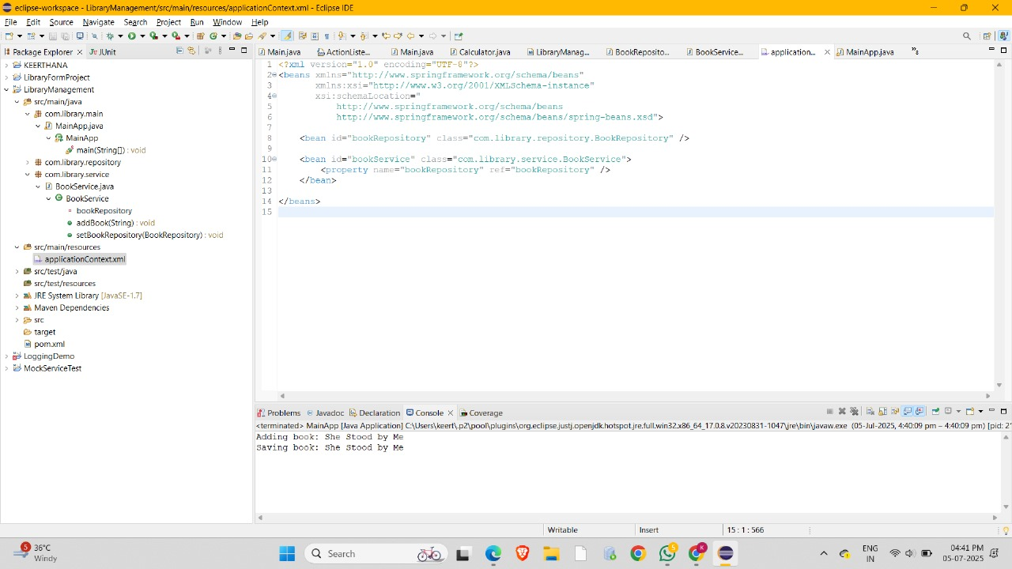

**Exercise 4: Creating and Configuring a Maven Project**

**Scenario:**

You need to set up a new Maven project for the library management application and add Spring dependencies.

**Steps:**

1. **Create a New Maven Project:**
   * Create a new Maven project named **LibraryManagement**.
2. **Add Spring Dependencies in pom.xml:**
   * Include dependencies for Spring Context, Spring AOP, and Spring WebMVC.
3. **Configure Maven Plugins:**
   * Configure the Maven Compiler Plugin for Java version 1.8 in the pom.xml file.

**CODE:**

**Pom.xml**

<project xmlns="http://maven.apache.org/POM/4.0.0" xmlns:xsi="http://www.w3.org/2001/XMLSchema-instance" xsi:schemaLocation="http://maven.apache.org/POM/4.0.0 https://maven.apache.org/xsd/maven-4.0.0.xsd">

<dependencies>

<!-- Spring Context (Core IoC container) -->

<dependency>

<groupId>org.springframework</groupId>

<artifactId>spring-context</artifactId>

<version>5.3.34</version>

</dependency>

<!-- Spring AOP (for aspect-oriented programming) -->

<dependency>

<groupId>org.springframework</groupId>

<artifactId>spring-aop</artifactId>

<version>5.3.34</version>

</dependency>

<!-- Spring Web MVC (for web development with Spring) -->

<dependency>

<groupId>org.springframework</groupId>

<artifactId>spring-webmvc</artifactId>

<version>5.3.34</version>

</dependency>

</dependencies>

<build>

<plugins>

<!-- Compiler plugin to use Java 1.8 -->

<plugin>

<groupId>org.apache.maven.plugins</groupId>

<artifactId>maven-compiler-plugin</artifactId>

<version>3.11.0</version>

<configuration>

<source>1.8</source>

<target>1.8</target>

</configuration>

</plugin>

</plugins>

</build>

<modelVersion>4.0.0</modelVersion>

<groupId>com.library</groupId>

<artifactId>LibraryManagement2</artifactId>

<version>0.0.1-SNAPSHOT</version>

</project>

**Main.java**

package com.library.main;

import com.library.service.BookService;

import org.springframework.context.ApplicationContext;

import org.springframework.context.support.ClassPathXmlApplicationContext;

public class MainApp {

public static void main(String[] args) {

ApplicationContext context = new ClassPathXmlApplicationContext("applicationContext.xml");

BookService bookService = context.getBean("bookService", BookService.class);

bookService.addBook("Return to Me");

}

}

**OUPUT:**

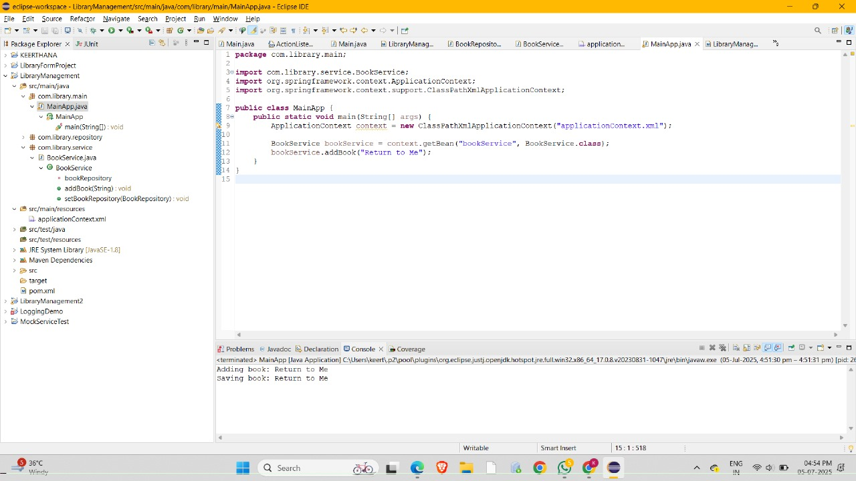

**Spring Data JPA with Spring Boot, Hibernate**

**HandsON 1**

**Spring Data JPA - Quick Example**

**CODE**

**OrmLearnApplication.java**

package com.cognizant.ormlearn;

import com.cognizant.ormlearn.model.Country;

import com.cognizant.ormlearn.repository.CountryRepository;

import org.springframework.beans.factory.annotation.Autowired;

import org.springframework.boot.CommandLineRunner;

import org.springframework.boot.SpringApplication;

import org.springframework.boot.autoconfigure.SpringBootApplication;

@SpringBootApplication

public class OrmLearnApplication implements CommandLineRunner {

@Autowired

private CountryRepository countryRepository;

public static void main(String[] args) {

SpringApplication.run(OrmLearnApplication.class, args);

}

@Override

public void run(String... args) throws Exception {

Country country1 = new Country();

country1.setCode("IN");

country1.setName("India");

Country country2 = new Country();

country2.setCode("US");

country2.setName("United States");

countryRepository.save(country1);

countryRepository.save(country2);

System.out.println("Country saved. Code = " + country1.getCode() + ", Name = " + country1.getName());

System.out.println("Country saved. Code = " + country2.getCode() + ", Name = " + country2.getName());

}

}

**Country.java**

package com.cognizant.ormlearn.model;

import jakarta.persistence.*;

@Entity

@Table(name = "country")

public class Country {

@Id

@Column(name = "code")

private String code;

@Column(name = "name")

private String name;

public String getCode() { return code; }

public void setCode(String code) { this.code = code; }

public String getName() { return name; }

public void setName(String name) { this.name = name; }

@Override

public String toString() {

return "Country [code=" + code + ", name=" + name + "]";

}

}

**CountryRepository.java**

package com.cognizant.ormlearn.repository;

import com.cognizant.ormlearn.model.Country;

import org.springframework.data.jpa.repository.JpaRepository;

public interface CountryRepository extends JpaRepository<Country, String> {

}

**Application.properties**

# H2 DB Configuration

spring.datasource.url=jdbc:h2:mem:ormlearn

spring.datasource.driver-class-name=org.h2.Driver

spring.datasource.username=sa

spring.datasource.password=

# Hibernate

spring.jpa.hibernate.ddl-auto=create

spring.jpa.database-platform=org.hibernate.dialect.H2Dialect

# H2 Console

spring.h2.console.enabled=true

spring.h2.console.path=/h2-console

# Logging

logging.level.org.hibernate.SQL=OFF

logging.level.root=ERROR

logging.level.org.hibernate.type.descriptor.sql.BasicBinder=trace

**OUTPUT :**

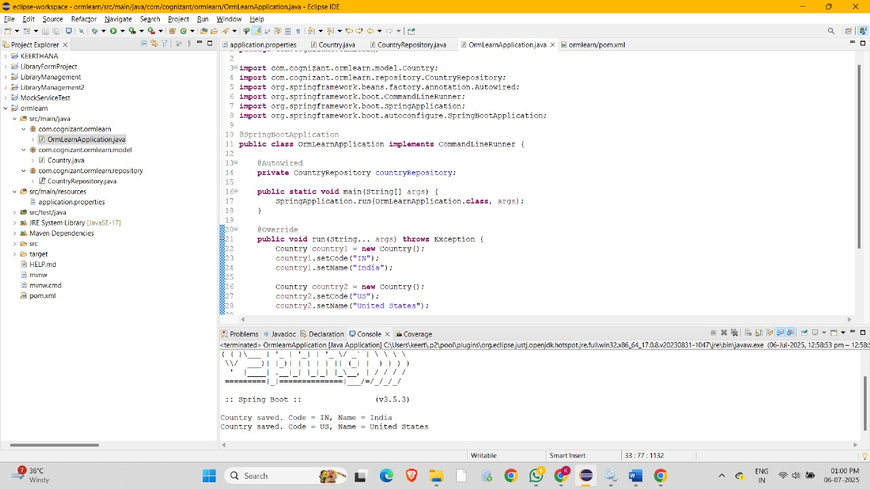

**Hands On 4**

**Difference between JPA, Hibernate and Spring Data JPA**

**CODE :**

**OrmlearnApplication.java**

package com.cognizant.ormlearn;

import com.cognizant.ormlearn.model.Country;

import com.cognizant.ormlearn.model.Employee;

import com.cognizant.ormlearn.repository.CountryRepository;

import com.cognizant.ormlearn.repository.EmployeeRepository;

import org.springframework.beans.factory.annotation.Autowired;

import org.springframework.boot.CommandLineRunner;

import org.springframework.boot.SpringApplication;

import org.springframework.boot.autoconfigure.SpringBootApplication;

@SpringBootApplication

public class OrmLearnApplication implements CommandLineRunner {

@Autowired

private CountryRepository countryRepository;

@Autowired

private EmployeeRepository employeeRepository;

public static void main(String[] args) {

SpringApplication.run(OrmLearnApplication.class, args);

}

@Override

public void run(String... args) throws Exception {

// --- Country Saving ---

Country country1 = new Country();

country1.setCode("IN");

country1.setName("India");

Country country2 = new Country();

country2.setCode("US");

country2.setName("United States");

countryRepository.save(country1);

countryRepository.save(country2);

System.out.println("Country saved. Code = " + country1.getCode() + ", Name = " + country1.getName());

System.out.println("Country saved. Code = " + country2.getCode() + ", Name = " + country2.getName());

// --- Employee Saving ---

Employee emp1 = new Employee();

emp1.setName("Keerthana");

emp1.setSalary(75000.0);

Employee emp2 = new Employee();

emp2.setName("Jothi");

emp2.setSalary(50000.0);

employeeRepository.save(emp1);

employeeRepository.save(emp2);

System.out.println("Employee saved. ID = " + emp1.getId() + ", Name = " + emp1.getName());

System.out.println("Employee saved. ID = " + emp2.getId() + ", Name = " + emp2.getName());

}

}

**Employee.java**

package com.cognizant.ormlearn.model;

import jakarta.persistence.*;

@Entity

@Table(name = "employee")

public class Employee {

@Id

@GeneratedValue(strategy = GenerationType.IDENTITY)

private int id;

private String name;

private double salary;

// Getters and Setters

public int getId() {

return id;

}

public void setId(int id) {

this.id = id;

}

public String getName() {

return name;

}

public void setName(String name) {

this.name = name;

}

public double getSalary() {

return salary;

}

public void setSalary(double salary) {

this.salary = salary;

}

@Override

public String toString() {

return "Employee [id=" + id + ", name=" + name + ", salary=" + salary + "]";

}

}

**Country.java**

package com.cognizant.ormlearn.model;

import jakarta.persistence.*;

@Entity

@Table(name = "country")

public class Country {

@Id

@Column(name = "code")

private String code;

@Column(name = "name")

private String name;

public String getCode() { return code; }

public void setCode(String code) { this.code = code; }

public String getName() { return name; }

public void setName(String name) { this.name = name; }

@Override

public String toString() {

return "Country [code=" + code + ", name=" + name + "]";

}

}

**CountryRepository.java**

package com.cognizant.ormlearn.repository;

import com.cognizant.ormlearn.model.Country;

import org.springframework.data.jpa.repository.JpaRepository;

public interface CountryRepository extends JpaRepository<Country, String> {

}

**EmployeeRepository.java**

package com.cognizant.ormlearn.repository;

import com.cognizant.ormlearn.model.Employee;

import org.springframework.data.jpa.repository.JpaRepository;

import org.springframework.stereotype.Repository;

@Repository

public interface EmployeeRepository extends JpaRepository<Employee, Integer> {

}

**OUTPUT :**

