**REACT COMPONENTS (CARD AND BUTTON)**

NAME : KEERTHANA KUCHIPUDI

EMAIL : keerthychowdary863@gmail.com

PHONE NO :8790141066

ROLL NO : 20T91A0547(CSE)

COLLEGE NAME : GIET Engineering College

**CARD COMPONENT:**

**SOURCE CODE:**

**CardComponent.jsx :**

import React from 'react'

export default function Home({img, title, description}) {

  return (

    <div className='shadow-xl border-blue-500/30 border-2 m-11 rounded w-64 bg-white'>

      <div className='h-48 '>

        <img src={img} alt="placeholder" />

      </div>

      <div className='p-4'>

        <h1 className='text-black font-bold '>{title}</h1>

        <p className='text-black'>{description}</p>

      </div>

    </div>

  )

}

**Page.js:**

"use client"

import CardComponent from "./components/CardComponent";

import { useState } from "react";

export default function Home(){

  return (

    <div>

    <CardComponent

    img="https://www.euroschoolindia.com/wp-content/uploads/2023/10/importance-of-eating-a-variety-of-fruits-for-kids-health-jpg.webp"

    title="fruits"

    description= "A fruit is the ripened ovary of a flowering plant that contains seeds. Fruits can be fleshy or dry, and are usually sweet or sour. They can be found in three main anatomical categories: aggregate fruits, multiple fruits, and simple fruits."/>

    </div>

  )

}

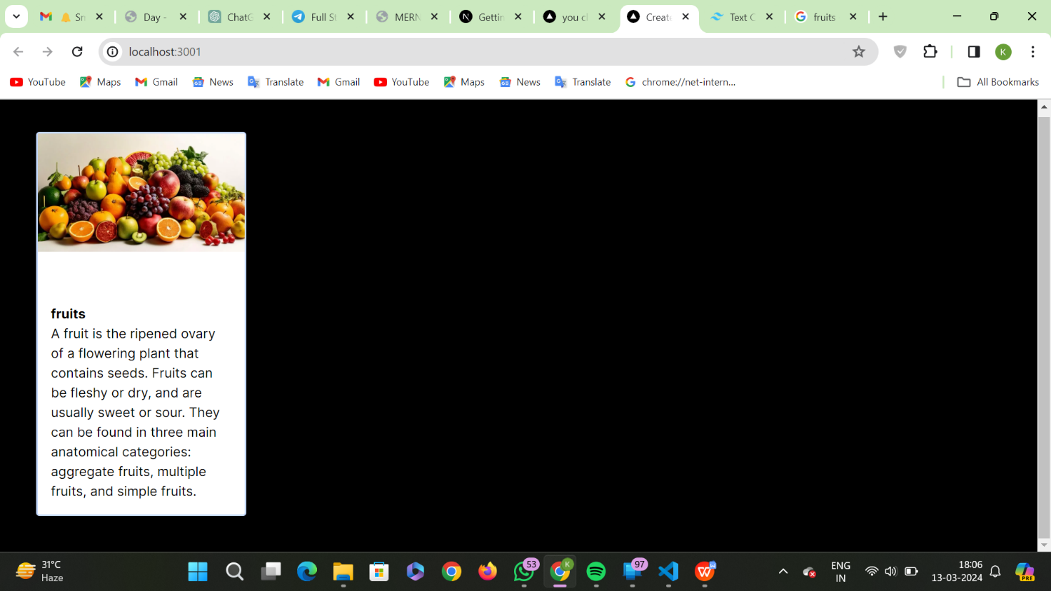**Output :**

**BUTTON COMPONENT:**

**SOURCE CODE:**

**Page.js :**

import React from 'react'

import Button from './components/Button'

function page() {

  return (

    <div >

        <Button >Hello</Button>

        <Button >World</Button>

      </div>

  );

}

export default page;

**Button.jsx:**

import React from 'react'

function Button(props) {

  const {children} = props

  return (

    <div>

      <button className='text-black border border-white rounded m-5 bg-white '>{children}</button>

    </div>

  )

}

export default Button

**Output:**

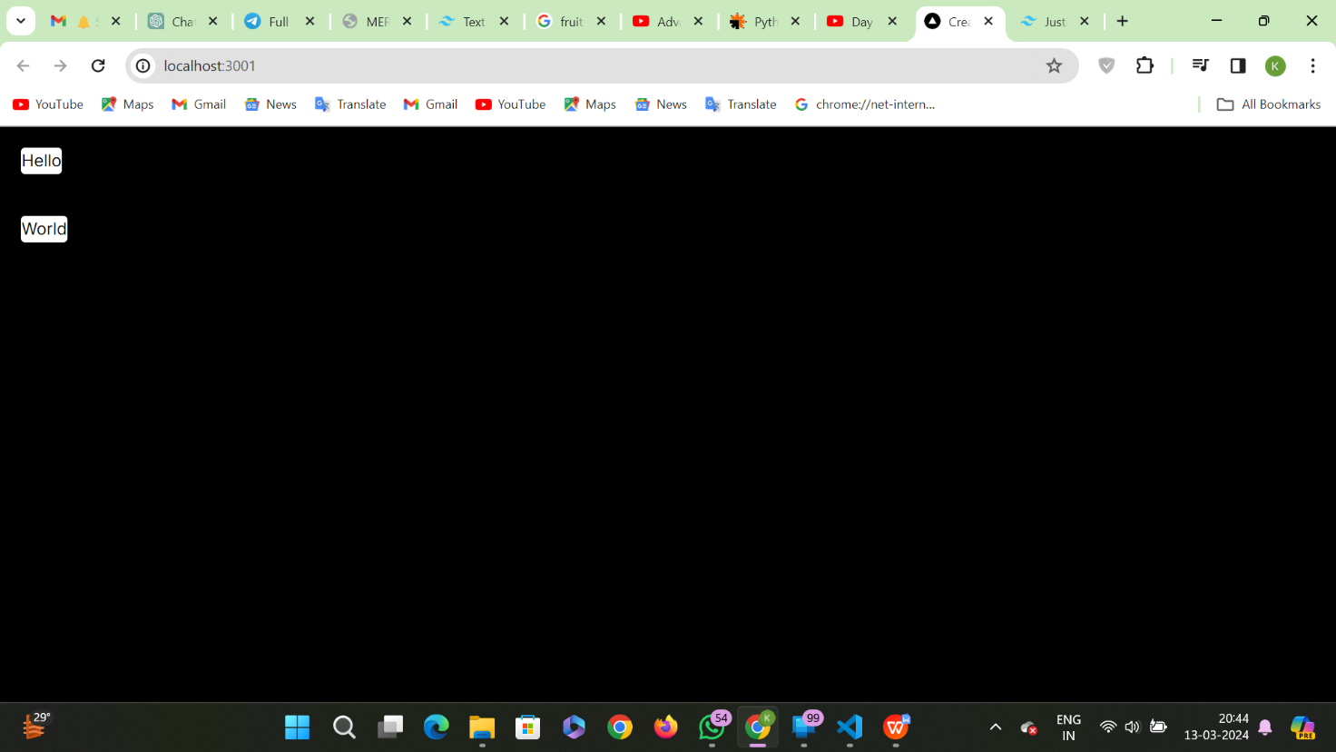

**Component Integration:**

**Page.js:**

"use client"

import CardComponent from "./components/CardComponent";

import Button from "./components/Button";

import { useState } from "react";

export default function Home(){

  const [label, setlabel] =useState("continue");

  const clickme = ()=> {

    alert("Hello");

  };

  return (

    <div>

    <CardComponent

    img="https://www.euroschoolindia.com/wp-content/uploads/2023/10/importance-of-eating-a-variety-of-fruits-for-kids-health-jpg.webp"

    title="fruits"

    description= "A fruit is the ripened ovary of a flowering plant that contains seeds. Fruits can be fleshy or dry, and are usually sweet or sour. They can be found in three main anatomical categories: aggregate fruits, multiple fruits, and simple fruits."/>

    </div>

  );}

**CardComponent.jsx:**

import React, { Children } from 'react'

export default function Home({img, title, description}) {

  return (

    <div className='shadow-xl border-blue-500/30 border-2 m-11 rounded w-64 bg-white'>

      <div className='h-48 '>

        <img src={img} alt="placeholder" />

      </div>

      <div className='p-4'>

        <h1 className='text-black font-bold '>{title}</h1>

        <p className='text-black'>{description}</p>

        <button className='text-black border bg-yellow-200 border-black rounded m-3 px-2'> button 1</button><br />

        <button className='text-black border bg-yellow-200 border-black rounded m-3 px-2 '> button 2</button>

      </div>

    </div>

  );

}

**Output:**

