**Creating a RESTful API using express.js and creating a database and index in MongoDB.**

NAME : KEERTHANA KUCHIPUDI

EMAIL : keerthychowdary863@gmail.com

PHONE NO :8790141066

ROLL NO : 20T91A0547(CSE)

COLLEGE NAME : GIET Engineering College

**RESTful API :**

**Source code:**

route.js :

import { NextResponse } from "next/server";

export async function POST(request){

    const data = await request.json()

    console.log(data)

    return NextResponse.json({

        data : "hey developer"

    })

}

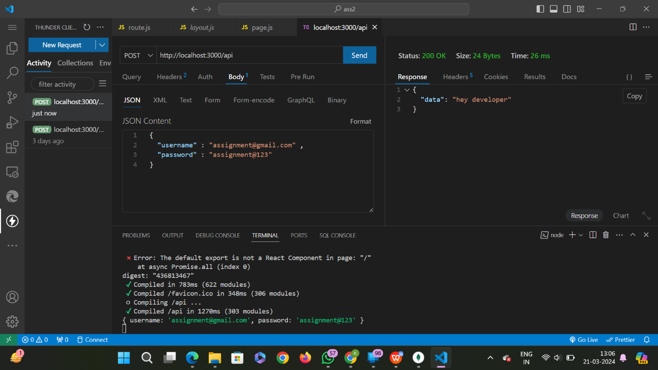Output:

**Creating Database using mongodb:**

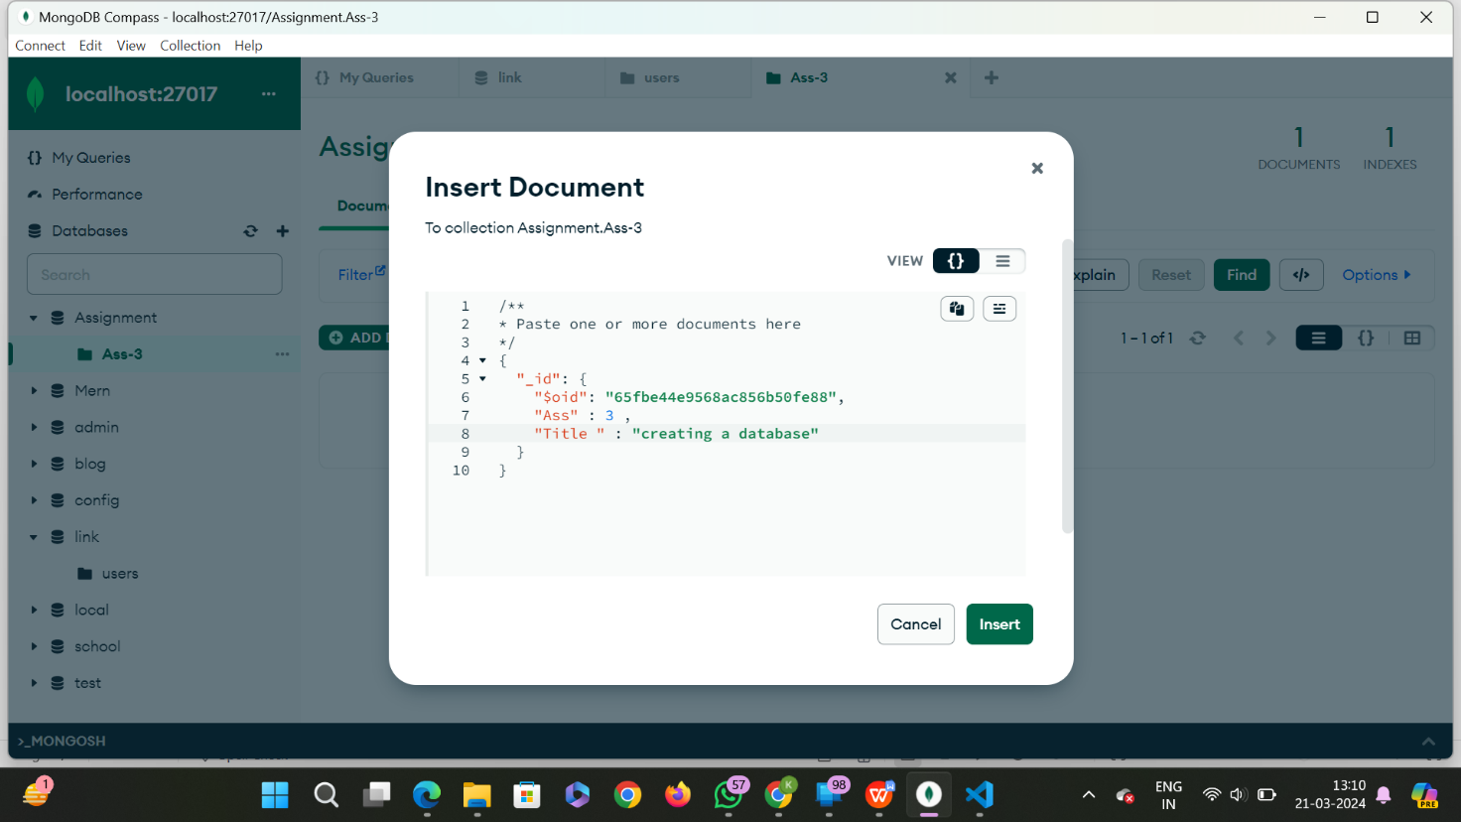

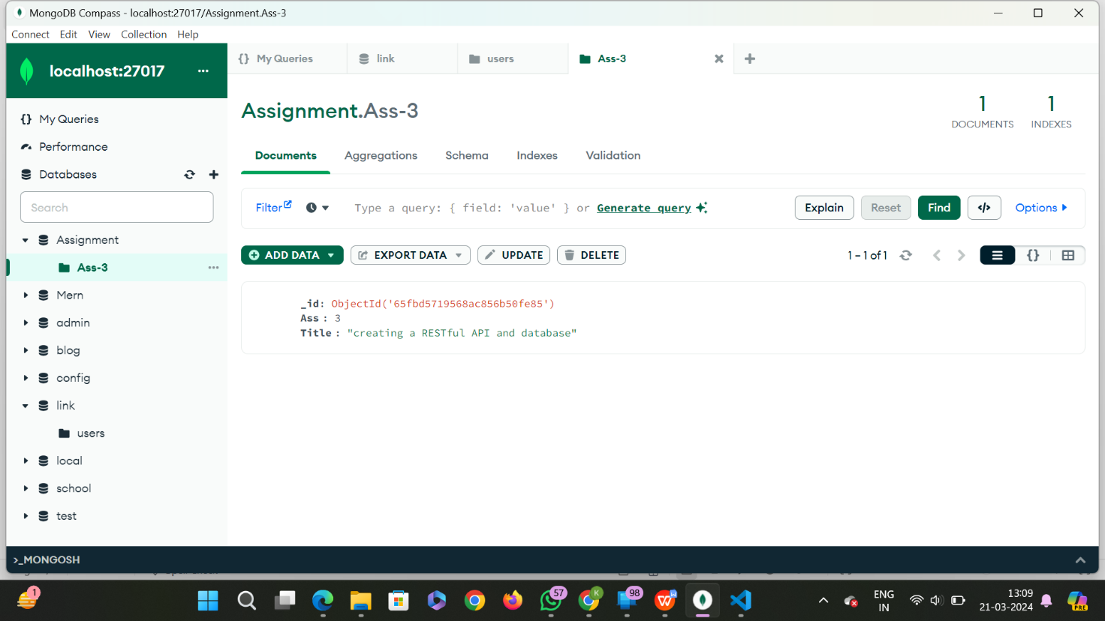

**Creating index in mongodb:**

