**Creating a database using mongodb and mongoose:**

NAME : KEERTHANA KUCHIPUDI

EMAIL : keerthychowdary863@gmail.com

PHONE NO :8790141066

ROLL NO : 20T91A0547(CSE)

COLLEGE NAME : GIET Engineering College

**Database using mongoose:**

1. **Creating database and collection:**

**Used commands:**

-use (database name): To create database

-db.createCollection.(“collection name”) : To create collection

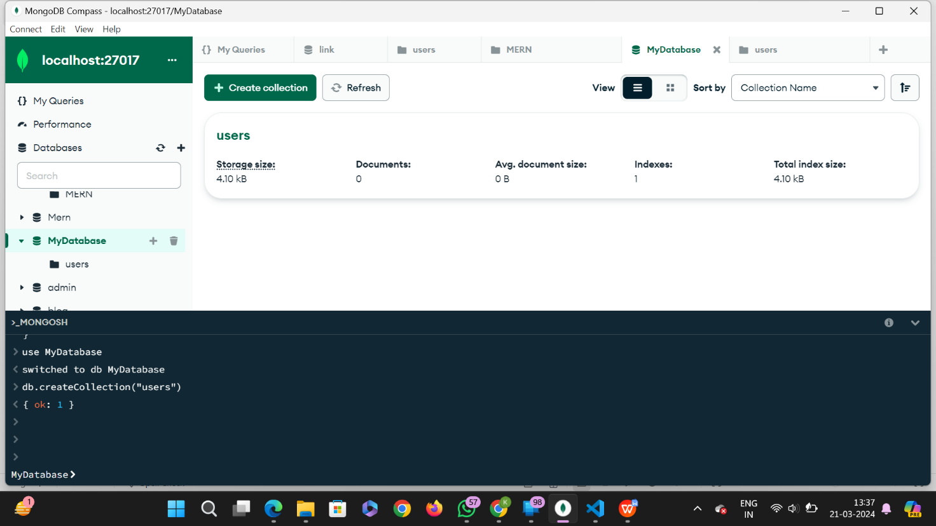

1. **Inserting documents:**

**Used commands:**

-db.collectionName.insertMany([{data1},{data2},{data3}]) : To insert multiple data into the database.

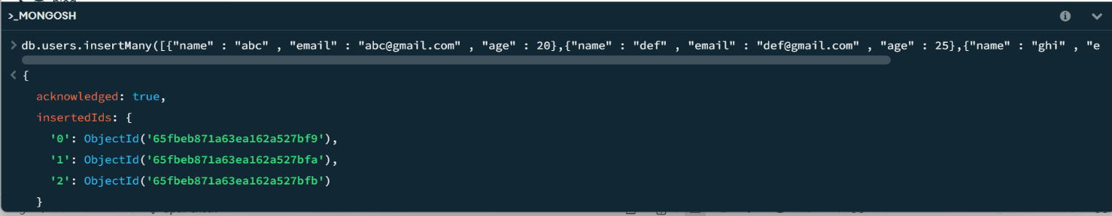

**Output:**

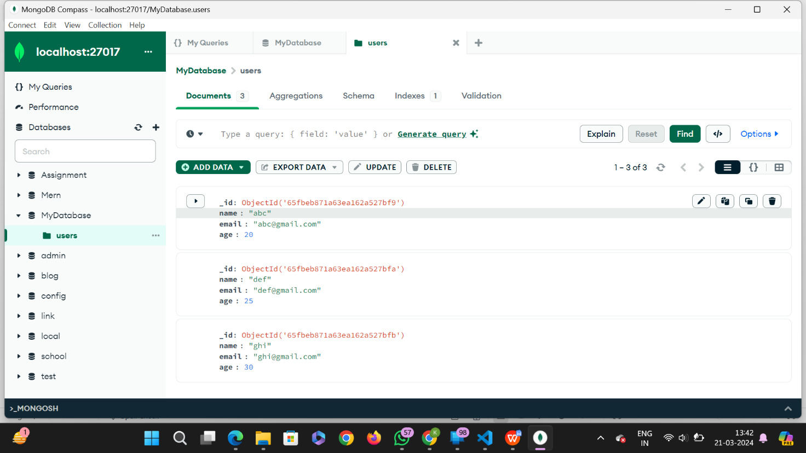

1. **mongoose query to retrieve “all users from the users collection“:**

**Used commands:**

**-**db.users.find({}) : To retrive all the users data from the database.

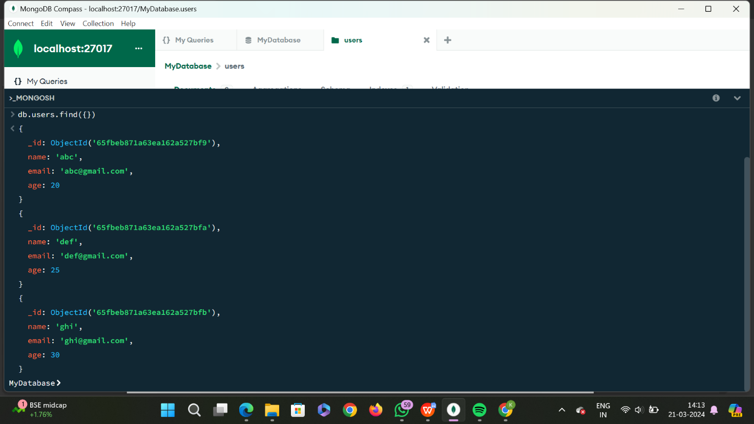

1. **mongoose query to “Users with an age greater than or equal to 30. ” :**

**Used commands:**

**-db.collectionName.find({parameters}) :** To retrieve data from the users with an age greater than or equal to 30.

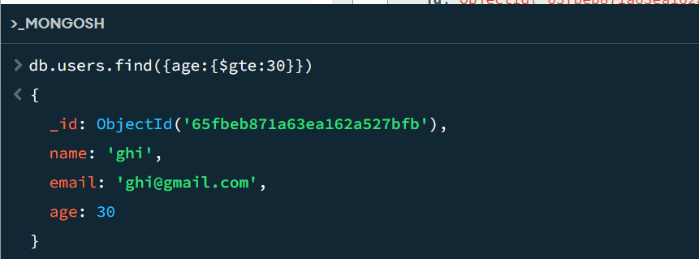

1. **Update the age of a user with a specific email address.**

**Used commands:**

-db.collectionName.updateOne({default value}, {update value}) :

To update the age of a user with a specific email address.

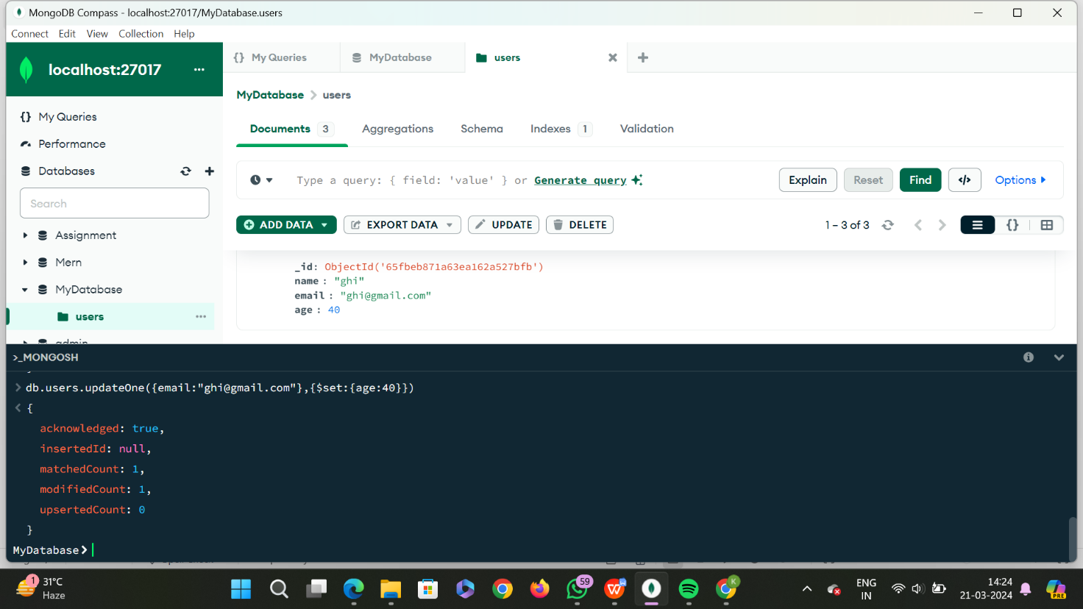

1. **Delete a user document based on a specific email address.**

**Used commands:**

-db.collectionName.deleteOne : To delete a user document based on a specific email address.

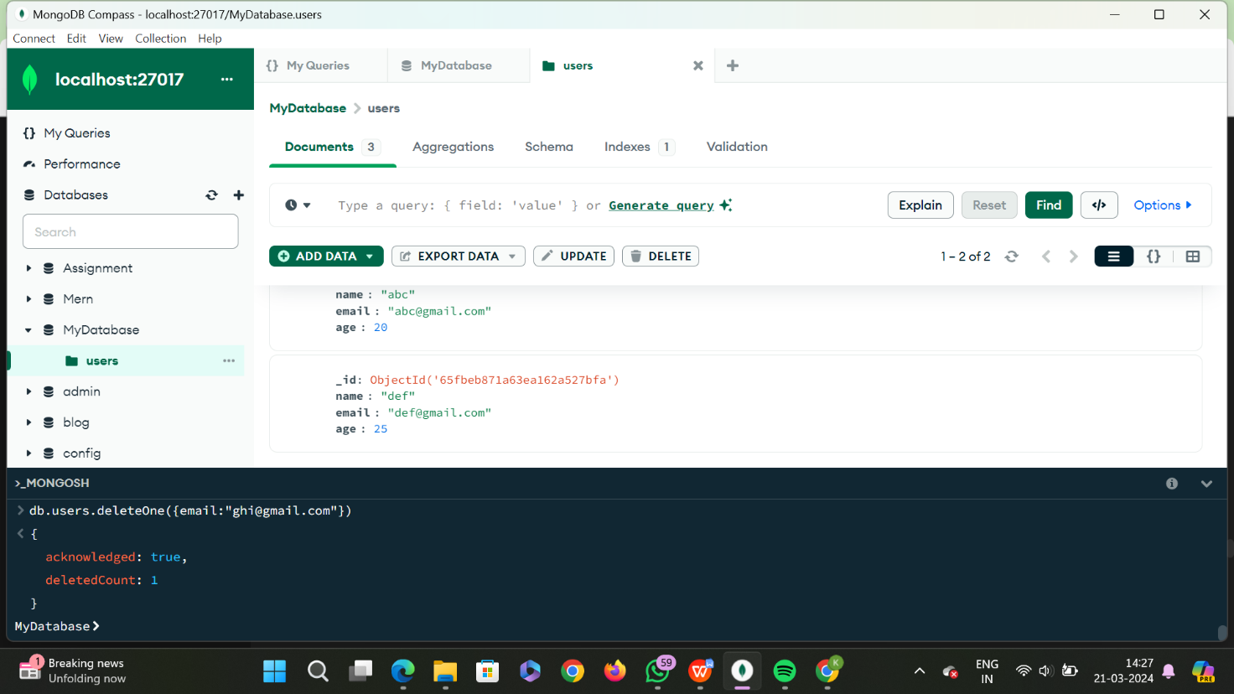

1. **Create an index on the email field of the users collection.**

