

**SEMISTER INTERNSHIP PROJECT REPORT ON**

**Dissecting the Digital landscape:**

**A Comprehensive Analysis of social media**

Submitted in partial fulfilment of the requirements for the award of the degree

**BACHELOR OF TECHNOLOGY**

**In**

**COMPUTER SCIENCE AND ENGINEERING**

Submitted by

**Team ID: LTVIP2023TMID05776**

Team Leader: Kuchipudi Keerthana -20T91A0547

Team member: Korumilli Siri Chandana -20T91A0546

Team member: Guthula Venkata Suresh -20T91A0531

Team member: Jureddy Venkatalova Saikumar -20T91A0532

Team member: Chokkakula Sai Aravind -20T91A0517

Under the Esteemed Guidance of **Mr**. **G. Kishore**

**DEPARTMENT OF COMPUTER SCIENCE AND ENGINEERING**

**GIET ENGINEERING COLLEGE**

Accredited by NAAC, Affiliated to JNTUK, Kakinada, Chaitanya Knowledge City Velugubanda, Rajamahendravaram – 533 296, Andhra Pradesh, India.

# Dissecting the Digital landscape:

# A Comprehensive Analysis of social media

**A PROJECT REPORT**

***submitted by***

**Team ID: LTVIP2023TMID05776**

Team Leader: Kuchipudi Keerthana -20T91A0547

Team member: Korumilli Siri Chandana -20T91A0546

Team member: Guthula Venkata Suresh -20T91A0531

Team member: Jureddy Venkatalova Saikumar -20T91A0532

Team member: Chokkakula Sai Aravind -20T91A0517

*In Partial fulfilment for the award of*  *the degree of*

**BACHELOR OF TECHNOLOGY**

***IN***

**COMPUTER SCIENCE AND ENGINEERING**

## *Under the Guidance of Mr.G. Kishore*



**GIET ENGINEERING COLLEGE, RAJAHMUNDRY**

## *CERTIFICATE*

This is to Certify that project of 6th Semester entitled “**Dissecting the Digital landscape: A Comprehensive Analysis of social media**” has been successfully completed by

**Team ID: LTVIP2023TMID05776**

Team Leader: Kuchipudi Keerthana -20T91A0547

Team member: Korumilli Siri Chandana -20T91A0546

Team member: Guthula Venkata Suresh -20T91A0531

Team member: Jureddy Venkatalova Saikumar -20T91A0532

Team member: Chokkakula Sai Aravind -20T91A0517

under my guidance in partial fulfilment of the Bachelor of technology in computer science and engineering of Giet Engineering college in Academic year.

|  |  |
| --- | --- |
| **Project Guide**    **Mr. G. Kishore** | **Project Coordinator** |

**Head of Department**

**Dr. Sk. Meera Sharif, M. Tech, Ph.D.**

**ACKNOWLEDGEMENT**

Behind any major work undertaken by an individual there lies the contribution of the people who helped him to cross all the hurdles to achieve his goal.

It gives me the immense pleasure to express my sense of sincere gratitude towards my respected guide **Mr. *G. KISHORE,*** for his persistent, outstanding, invaluable co-operation and guidance. It is my achievement to be guided under him. He is a constant source of encouragement and momentum that any intricacy becomes simple. I gained a lot of invaluable guidance and prompt suggestions from him during entire project work. I will be indebted of him forever and I take pride to work under him.

**Place: RAJAHMUNDRY**

**Date: 13-08-2023**

# ABSTRACT

My data analytics represents a diverse and dynamic collection of my work, showcasing my skills, experiences, and accomplishments across various disciplines. Through this compilation, I aim to provide a comprehensive overview of my professional journey and personal growth. In the realm of software development, my portfolio features projects that demonstrate my proficiency in programming languages such as Python, Java, and JavaScript. These projects range from web applications, mobile apps, to data analysis tools. Additionally, I have highlighted my involvement in open-source contributions, which reflect my commitment to collaborative and community-driven development.

As an aspiring data scientist, I have included analyses and visualizations that showcase my ability to extract valuable insights from complex datasets. My projects encompass machine learning applications, predictive modelling, and exploratory data analysis. Moreover, I emphasize the importance of data-driven decision-making and its relevance in solving real-world problems.

To underscore my creative inclinations, my data analytics also encompasses various design and multimedia projects. These include graphic designs, digital illustrations, and video editing. I believe that fostering creativity not only enhances problem-solving but also contributes to effective communication and user engage

Furthermore, my data analytics incorporates a section dedicated to my academic journey and research endeavours. I outline my educational qualifications, coursework, and research papers. This section demonstrates my dedication to lifelong learning and my passion for exploring emerging technologies and scientific advancements.

Lastly, I provide insights into my personal interests and extracurricular activities, which showcase my adaptability, teamwork, and leadership qualities beyond

volunteering, and community initiatives are integral parts of my identity, and I believe they contribute to a well-rounded personality.

Overall, my data analytics reflects my drive for continuous improvement, adaptability, and passion for embracing challenges. I hope it serves as a testament to my capabilities and potential, and I am eager to explore new opportunities and collaborations that align with my values and aspiration

**Documentation Index**

|  |  |  |
| --- | --- | --- |
| **S.NO** | **Learning Outcome** | **Page count** |
| **1** | INTRODUCTION | 8 |
| **2** | LITERATURE SURVEY | 12 |
| **3** | THEORITICAL ANALYSIS  ➔ DIAGRAMMATIC VIEW OF PROJECT  ➔ REQUIREMENTS OF PROJECT | 13 |
| **4** | RESULT | 19 |
| **5** | ADVANTAGES AND DISADVANTAGES OF PROJECT | 21 |
| **6** | CONCLUSION | 22 |
| **7** | FUTURE SCOPE | 23 |

**Dissecting the Digital Landscape:**

**A Comprehensive Analysis of social media**

**INTRODUCTION**

**Project Description:**

Dissecting the Digital landscape: A Comprehensive Analysis of social media is a research article or paper that provides a detailed and in-depth analysis of various social media platforms, including Facebook, Twitter, Instagram, YouTube, and LinkedIn.

The analysis covers a wide range of topics related to social media, such as the history and evolution of social media, the demographics of social media users, the impact of social media on communication and society, the role of social media in politics and activism, and the challenges and opportunities of social media for businesses and organizations.

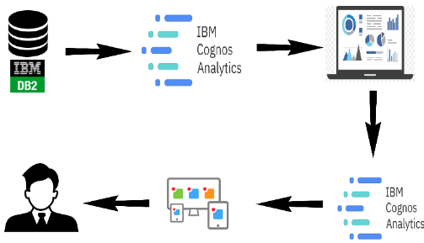

The paper draws on a wide range of research studies, surveys, and data sources to provide a  
comprehensive overview of the digital landscape and its implications for individuals, organizations, and society as a whole. Overall, the paper aims to provide a comprehensive and up-to-date understanding of the complex and dynamic world of social media (twitter as an example), and to inform future research, policy, and practice in this rapidly evolving field.

**PURPOSE OF THE PROJECT**

The purpose of Dissecting the Digital Landscape: A Comprehensive Analysis of Social Media project is to conduct an in-depth and thorough examination of the social media land scape. This analysis aims to gain a comprehensive under- standing of various aspects related to social media platforms, their impact on society, and their implications for individuals, businesses, and governments. The project may involve studying multiple social media platforms, such as Facebook, Twitter, Instagram, LinkedIn, YouTube, TikTok, etc., and could cover several key areas:

**User Behaviour and Engagement:**

Understanding how users interact with social media platforms, the patterns of content consumption, and the factors that influence engagement.

**Content Analysis:**

Analysing the types of content shared on different platforms, the prevalence of misinformation, hate speech, and other potentially harmful content.

**Societal Impact:**

Examining the effects of social media on society, including its role in shaping public opinion, political discourse, and social movements.

**Privacy and Data Security:**

Investigating the privacy policies and data security practices of various social media platforms, and how user data is collected, stored, and used.

**Business and Marketing:**

Assessing the impact of social media on businesses and marketing strategies, including influencer marketing, brand reputation

management, and customer engagement.

**Mental Health and Well-being:** Exploring the relationship between social media usage and mental health issues, such as anxiety, depression, and self-esteem.

**Regulatory and Ethical Considerations:**

Investigating the regulatory landscape and ethical dilemmas surrounding social media, including discussions about content moderation, data privacy laws, and freedom of expression.

**Future Trends:**

Identifying emerging trends in social media, such as the rise of

new platforms, the adoption of augmented reality (AR) and virtual reality (VR) technologies, and potential shifts in user behaviour.

By conducting a comprehensive analysis of these aspects, the project aims to provide valuable insights that can help individuals, businesses, policymakers, and other stakeholders make informed decisions regarding social media usage, regulation, and their overall approach to navigating the digital landscape. It may also contribute to academia and further research in the field of social media studies.

|  |
| --- |
|  |

**LITERATURE SURVEY**

Literature Survey on the Dissecting the Digital landscape: A Comprehensive Analysis of social media.

**PROBLEM SOLUTION:**

Problem Statement

**Idea/Solution Description**

**sentiment analysis:**

Displays the sentiment of social media data, showing proportion of positive, negative sentiment in conversation.

**Heat Maps:**

displays geographic distribution of social media data, showing where conversation and engagement are happening In real- time. This can

help to identify regional trends.

**Customer Satisfaction**:

-By analyzing the behavior of the user on the platform, business organizations target their customer based on their interests.

**Business Model:**

-By analysis social media engagement and user behavior, business can optimize their advertising campaigns to reach their target audience more effectively.

**THEORETICAL ANALYSIS**

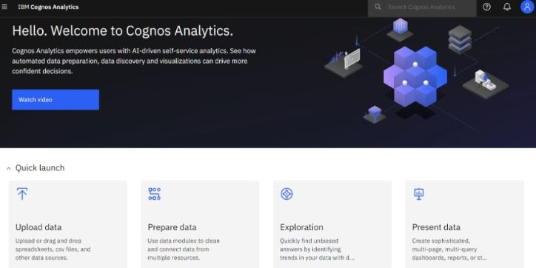.

**Dataset:**

The dataset is taken from the social are import the in IBM database.

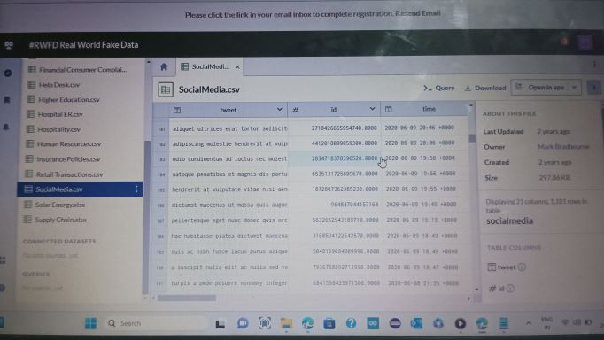

**Connect db2 with Cognos:**

To connect IBM DB2 and IBM Cognos Analytics, you'll need to set up a data source connection in Cognos Analytics to access the DB2 database. Here's a step-by-step guide on how to do it: Ensure Prerequisites:

● Make sure you have the necessary credentials (username and password) to access the DB2 database.

● Obtain the DB2 database connection details, including the hostname or IP address, port number, and database name.

● Launch IBM Cognos Analytics:

● Log in to IBM Cognos Analytics with your credentials.

**Access the Administration Console**:

● In the Cognos Analytics user interface, click on the "Hamburger" menu icon (three horizontal lines) in the top-left corner.

● From the menu, select "Mange."

● In the Administration Console, expand the "Configuration" section in the left

pane. Click on "Data server" under "Configuration."

**Add a New Server**:

● On the "Data Server" page, click the "Add" button to create a new data source connection

● In the "Select the type of data source" window, choose "IBM DB2" from the list of available data sources.

● Click "Next" to proceed.

**Provide Connection Details:**

Fill in the required connection details for the DB2 database:

● Enter a name for the data source connection (e.g., "My DB2 Connection").

● Specify the hostname or IP address of the DB2 server.

● Enter the port number on which DB2 is listening.

● Provide the database name.

● Input your DB2 username and password for authentication.

**Test the Connection**:

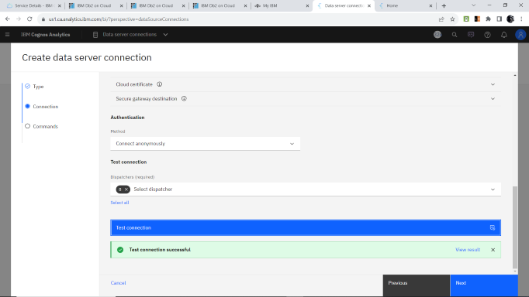

➢ Click the "Test" button to verify if the connection to the DB2 database is successful. Cognos Analytics will attempt to establish a connection using the provided details.

➢ If the test is successful, select command type and click "create" to create the Data server connection.

**Prepare the Data for Visualization:**

To prepare the data for visualization in IBM Cognos Analytics, you need to perform certain data preparation steps to ensure the data is in the right format and structure for effective visualization. Here's a guide to prepare the data:

**Data Source Connection:** Connect IBM Cognos Analytics to the data source where your data is stored. This could be a relational database like IBM DB2, a data warehouse, Excel files, or other data repositories.

**Data Import:**

Import the required data into Cognos Analytics. This involves creating a new data module or importing data directly from the data source. The data module allows you to combine data from different sources if needed.

**Data Quality Check**:

Perform data quality checks to identify and handle any missing values, anomalies, or inconsistencies in the data. Clean the data by handling missing values appropriately (e.g., inputting, removing, or leaving)

**DATA VISUALIZATION**

Data visualization is the process of creating graphical representations of data in order to help people understand and explore the information. The goal of data visualization is to make complex data sets more accessible, intuitive, and easier to interpret. By using visual elements such as charts, graphs, and maps, data visualizations can help people quickly identify patterns, trends, and outliers in the data.

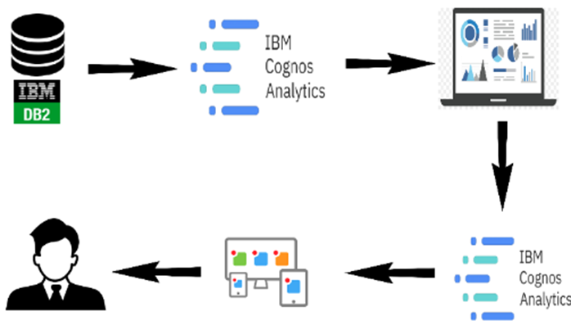

**HARDWARE USED**:

Laptop, Smart Phone.

**SOFTWARE USED**:

IBM COGNOS, ANACONDA, PYTHON.

**RESULT:**

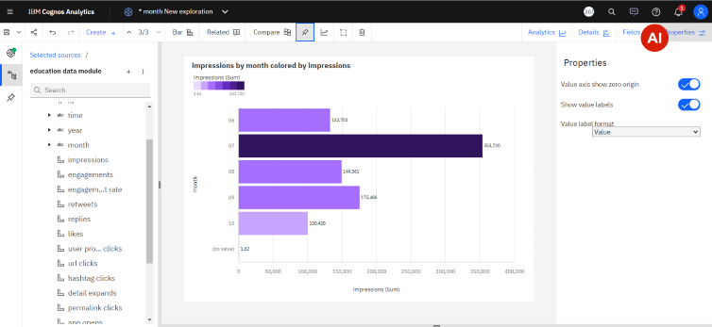

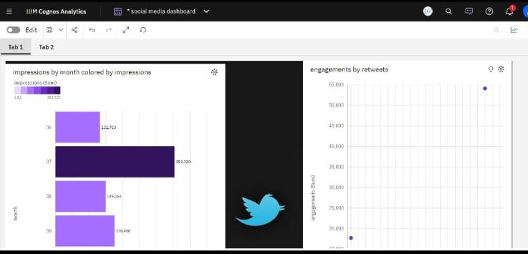

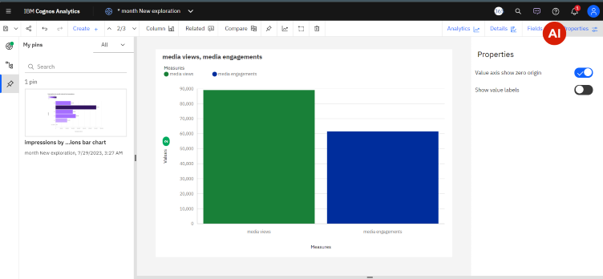

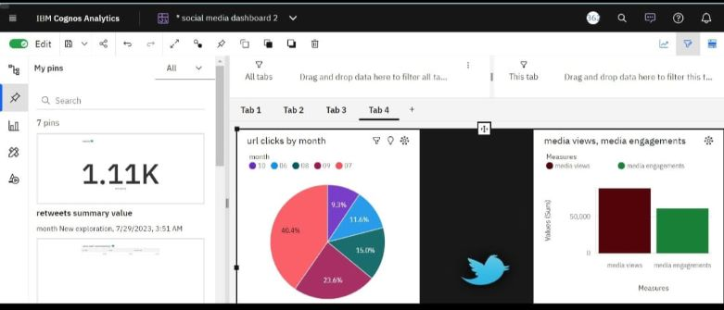

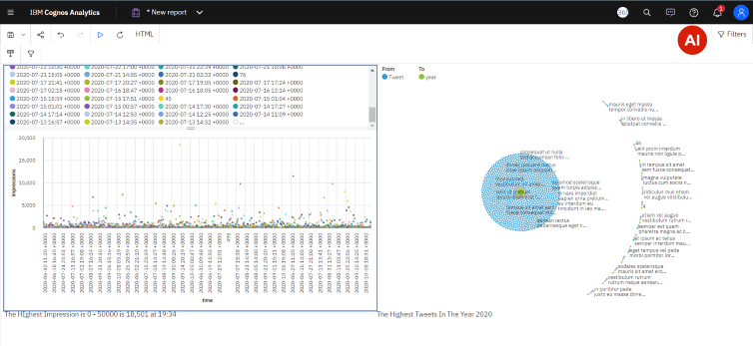

**ADVANTAGES AND DISADVANTAGES**

**ADVANTAGES**:

* Understanding user behavior
* Audience segmentation
* Identifying trends
* Competitive analysis
* Brand reputation management
* Influencer identification
* Measuring campaign effectiveness

**DISADVANTAGES**:

* Information overload
* Privacy concern
* Bias and misinterpretation
* Rapidly evolving landscape
* Incomplete data picture
* Recourse intensive
* Negative feedback amplification
* Ethical consideration
* Lack of context

**CONCLUSION**

The analysis of social media within the context of digital marketing strategies reveals its significant impact and potential for businesses. Business should also be mindful of the ethical implications and challenges that comes with social media marketing.

Business Organizations must stay updated on emerging trends, algorithm changes, and user behavior to adapts their strategies effectively.

**FUTURE SCOPE**

The Future scope of dissecting the digital landscape and conducting a comprehensive analysis of social media is promising, as business and organizations increasingly recognize the importance of leveraging social media data for strategic decision - making. Here are some potential areas of future growth and development.

-Integration of Multiple Data Sources.

-Advanced Data Visualization and Reporting.

-Deep Learning and Natural Language processing

- Predictive Analysis and Trend Forecasting

-Integration with AI -Powered chat bots and Virtual assistants.

# 