**MINI PROJECT**

## TITLE: ONLINE MOBILE SEARCH

**PROBLEM STATEMENT:**

Automate Search Mobile phones functionality on Online shopping Website

Get mobiles smart phones from Amazon online store, which has:

1. Price less than Rs.30000
2. Mobiles which are newly arrived

**Suggested site:** Amazon however you are free to choose any other legitimate shopping site.

**DETAILED DESCRIPTION:**

* Launch the browser using the configuration settings Firefox/Chrome.
* Read the application URL from configuration settings. (e.g. [**https://www.amazon.in**](https://www.amazon.in/))
* Open the URL. User will navigate to home page of website.
* Enter the search text in search box “mobile smartphones under 30000”
* Application displays the follow message similar to following-

o    1-24 of over 1,000 results for "mobile smartphones under 30000"  (1-24 and 1000 numbers will change according to stock available on site that at the time of execution)

* In the above text, validate the search string, number of pages( e.g. 1-16), number of items (over 90,000)
* Click on “Sort by list” listbox.
* Application should display four sort by options in the list. Check the count of options displayed.
* Select option “Newest Arrivals”
* Verify that  “Newest Arrivals” option got selected correctly or not.
* Close the browser.

**STEPS TO IMPLEMENT THE PROJECT:**

1. Create a maven Project from File -> New -> other -> Java Project.
2. Import Selenium.
3. Setup Webdriver in Eclipse.
4. Create a package seleniumniniproject.
5. Create a class Amazon.
6. Implement the test case using selenium .
7. Validate the results and close the browser.

**FILE STRUCTURE:**

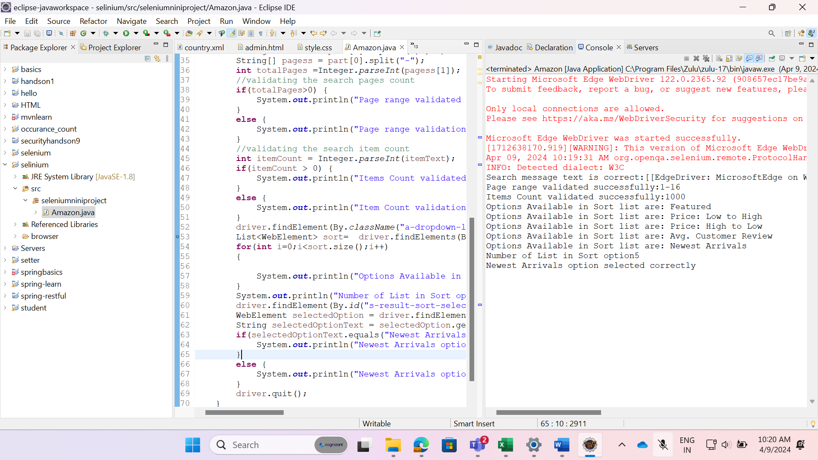

**CODE:**

**package** seleniumniniproject;

**import** java.time.Duration;

**import** java.util.ArrayList;

**import** java.util.List;

**import** java.util.Set;

**import** org.openqa.selenium.By;

**import** org.openqa.selenium.WebDriver;

**import** org.openqa.selenium.WebElement;

**import** org.openqa.selenium.edge.EdgeDriver;

**import** org.openqa.selenium.support.ui.ExpectedConditions;

**import** org.openqa.selenium.support.ui.WebDriverWait;

**public** **class** Amazon {

**public** **static** **void** main(String[] args) {

System.*setProperty*("webdriver.edge.driver","C:\\Users\\2317303\\eclipse-javaworkspace\\selinium\\browser\\msedgedriver.exe");

WebDriver driver= **new** EdgeDriver();

driver.manage().window().maximize();

driver.get("https://www.amazon.in");

driver.findElement(By.*id*("twotabsearchtextbox")).sendKeys("mobile smartphones under 30000");

driver.findElement(By.*id*("nav-search-submit-button")).click();

WebDriverWait wait = **new** WebDriverWait(driver,30);

WebElement searchMessage = wait.until(ExpectedConditions.*visibilityOfElementLocated*(By.*xpath*("//*[@class='a-section a-spacing-small a-spacing-top-small'][1]")));

String searchMessageText = searchMessage.getText() ;

//validating the search message

**if**(searchMessageText.contains("mobile smartphones under 30000")) {

System.***out***.println("Search message text is correct:"+searchMessage);

}

**else** {

System.***out***.println("Search message text is Incorrect:"+searchMessage);

}

String[] part = searchMessageText.split(" ");

String pages = part[0];

String itemText = part[3].replace(",","");

String[] pagess = part[0].split("-");

**int** totalPages =Integer.*parseInt*(pagess[1]);

//validating the search pages count

**if**(totalPages>0) {

System.***out***.println("Page range validated successfully:"+pages);

}

**else** {

System.***out***.println("Page range validation failed:"+pages);

}

//validating the search item count

**int** itemCount = Integer.*parseInt*(itemText);

**if**(itemCount > 0) {

System.***out***.println("Items Count validated successfully:"+itemText);

}

**else** {

System.***out***.println("Item Count validation failed:"+itemText);

}

driver.findElement(By.*className*("a-dropdown-label")).click();

List<WebElement> sort= driver.findElements(By.*xpath*("//div[@class='a-popover-inner']//li[@class='a-dropdown-item']"));

**for**(**int** i=0;i<sort.size();i++)

{

System.***out***.println("Options Available in Sort list are: "+sort.get(i).getText());

}

System.***out***.println("Number of List in Sort option"+sort.size());

driver.findElement(By.*id*("s-result-sort-select_4")).click();

WebElement selectedOption = driver.findElement(By.*cssSelector*("#s-result-sort-select option:checked"));

String selectedOptionText = selectedOption.getText();

**if**(selectedOptionText.equals("Newest Arrivals")) {

System.***out***.println("Newest Arrivals option selected correctly");

}

**else** {

System.***out***.println("Newest Arrivals option not selected ");

}

driver.quit();

}

}

**OUTPUT:**



