E – Air Ticket

User Manual

*Important Note:*

*Please do the following settings in case of Internet Explorer.*

*Go to Settings -> Compatibility View Settings*

*Uncheck Display Intranet sites in Compatibility View*

*Uncheck Use Microsoft compatibility lists*

*Close and Refresh Page*

**Purpose of the document:**

*Intention of this document is to guide the user to effectively use the application. The logical arrangement of the information and screen prints shall enable the user to understand the sequence and navigation of the system.*

1. *Connecting to the application :*

*You must connect to the application using the following address:*

*http://* *ctsc00849530701:9000/AirTicket*

1. 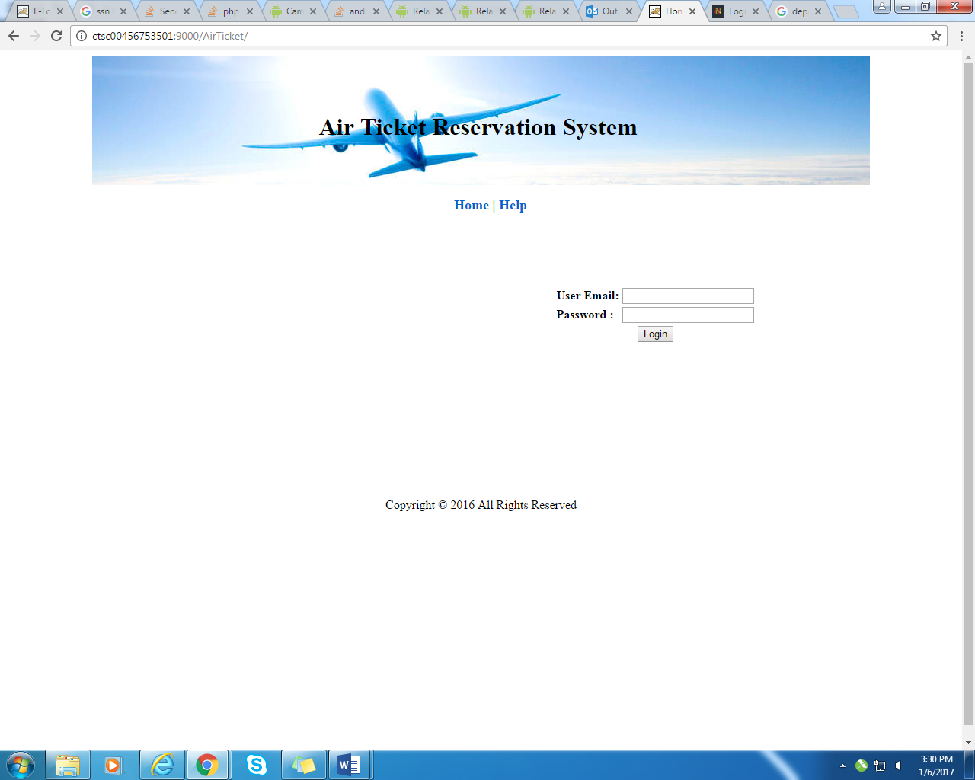 *Fig 1*
2. *Authentication :*

*User has been categorized into 2 roles : Admin and Customer .User can login with his/her registered email id and password and check all the functionality from the menu. Refer fig 1 for the User login.*

### Sample Data:

|  |  |  |
| --- | --- | --- |
| Role | Name | Password |
| Admin | admin@gmail.com | Password1 |
| Customer | ctsuser@gmail.com | pass@123 |

1. *Admin Role :User in admin role can register a new user, Search an Book ticket for user .Refer fig 2*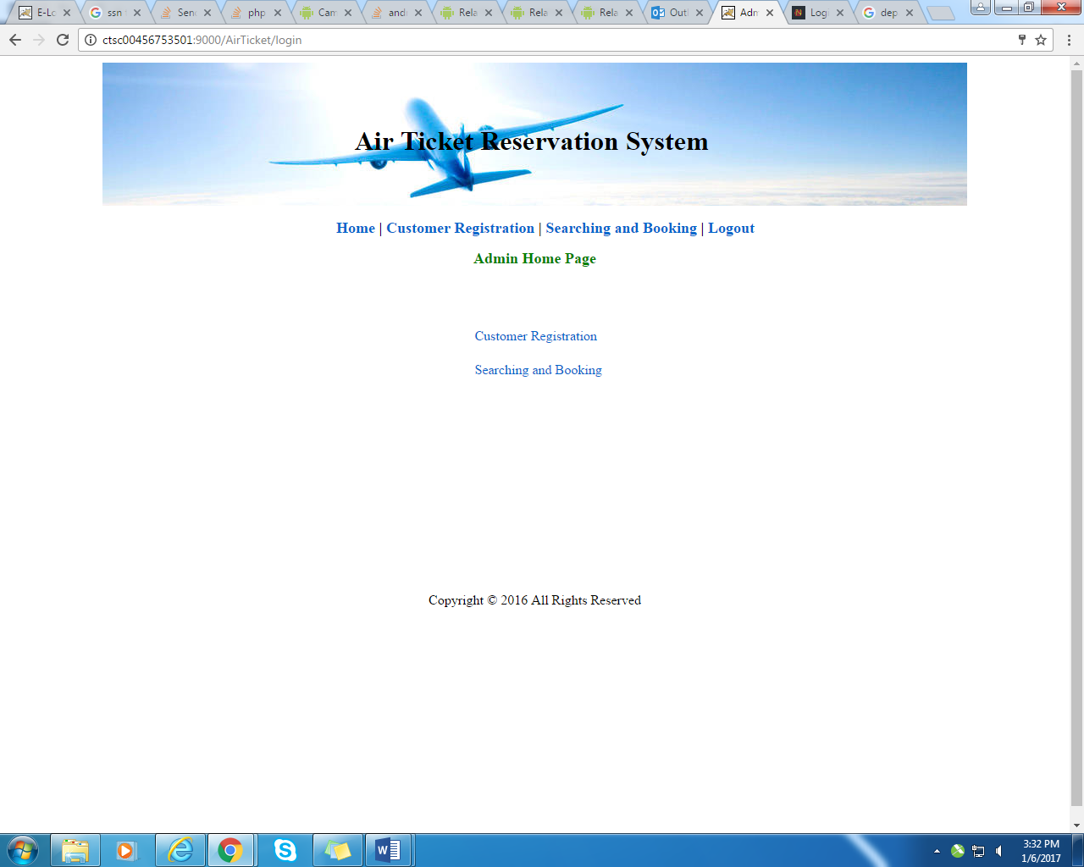

*Fig 2*

* 1. *New Customer Registration :*

*Admin can register a new customer by clicking Customer Registration. Refer fig 3*

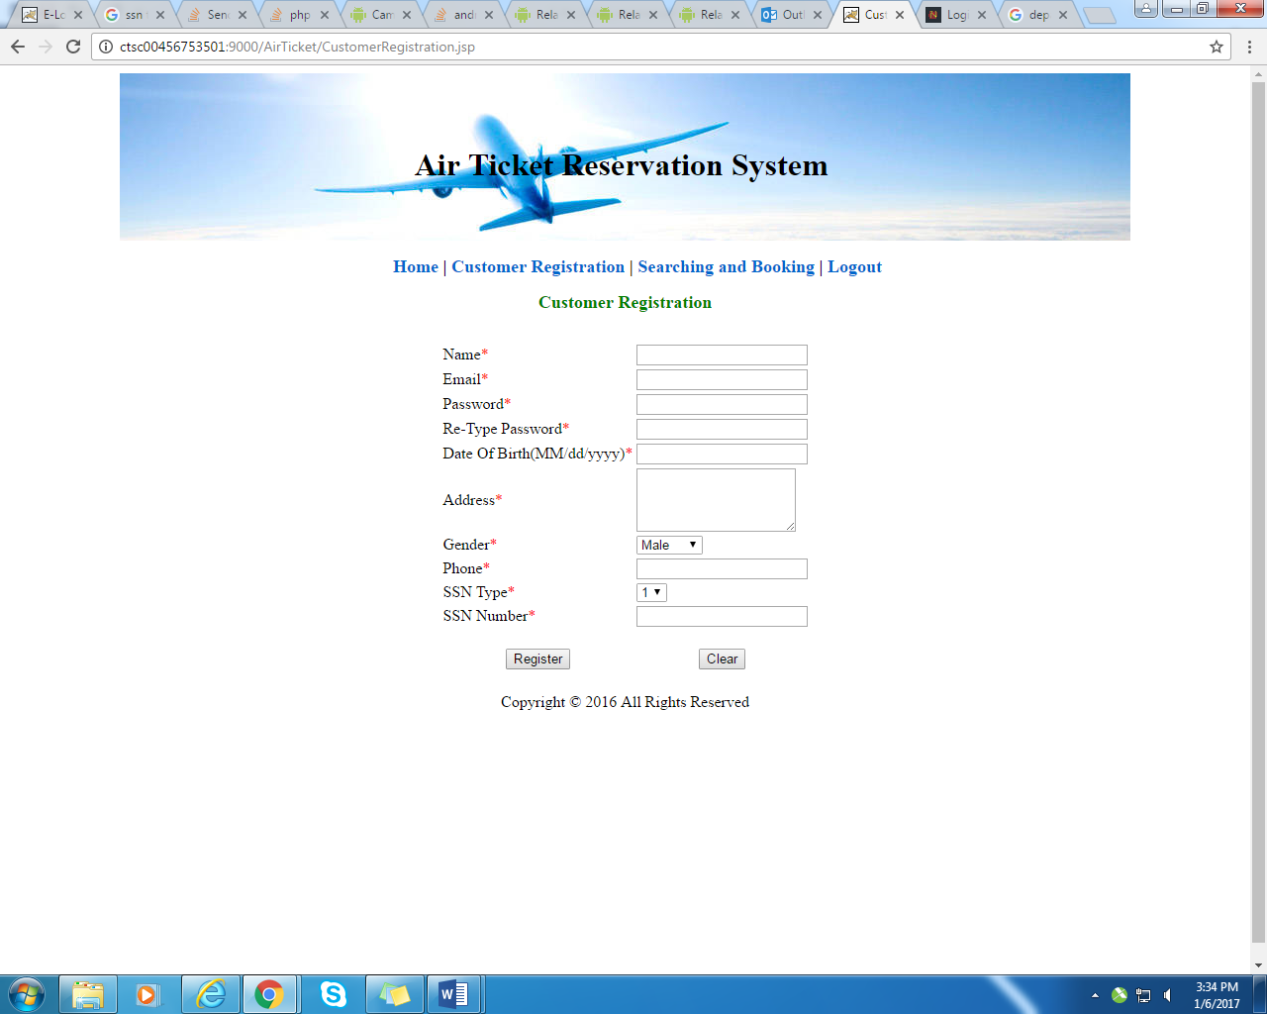

*Fig 3*

### Sample Data:

|  |  |  |  |  |  |  |  |  |  |
| --- | --- | --- | --- | --- | --- | --- | --- | --- | --- |
| Name | Email | Password | Re-Type Password | Date of Birth | Address | Gender | Phone | SSN Type | SSN Number |
| john | john@gmail.com | pass@123 | pass@123 | 01/02/1985 | 6 main road , chennai | Male | 9789993662 | 1 | 123562854 |

* 1. *Searching and Booking :*

*Admin can search and book for flight for customer by clicking searching and booking link .*

*Ref fig 4*

### Sample Data:

|  |  |  |  |  |
| --- | --- | --- | --- | --- |
| Leaving From | Going To | Departure Date | Departure Time | Seats To Book |
| Mumbai | Chennai | 01/01/2017 | 04:00 | 5 |

*.* 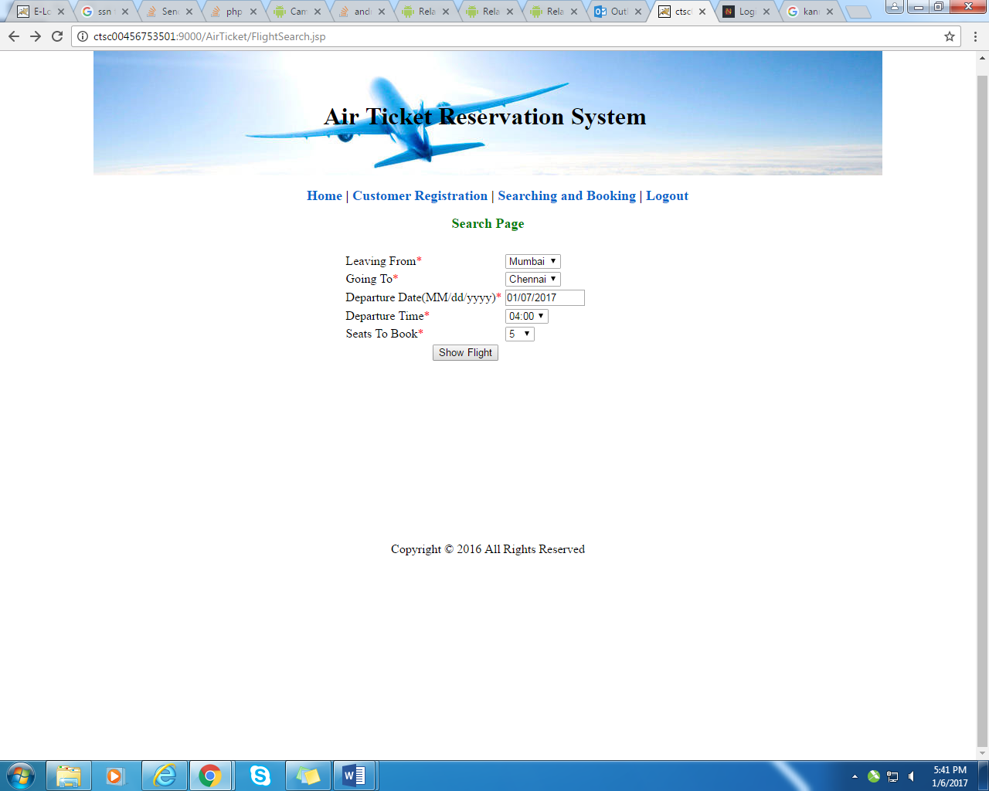

*Fig 4*

* + 1. *Book Page :*

*Admin can book ticket from Book Page ,He/She can select the appropriate flight number,*

*Customer id from drop down and click book button. Ref fig 5*

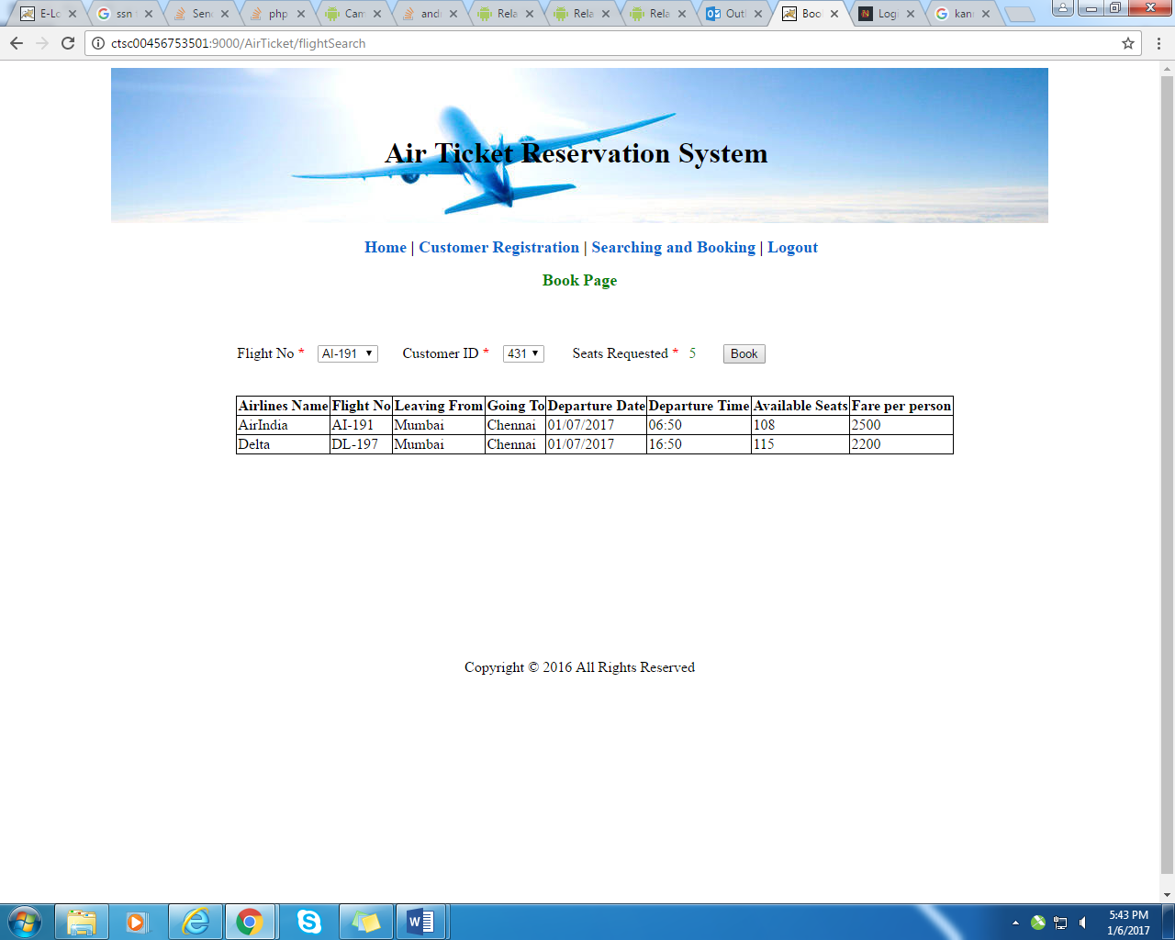

*Fig 5*

*4 . Customer Role :*

*Customer can log in with his respective user name and password , once logged in he/she*

*can check booking invoice , edit profile and cancel ticket. Ref fig 6*

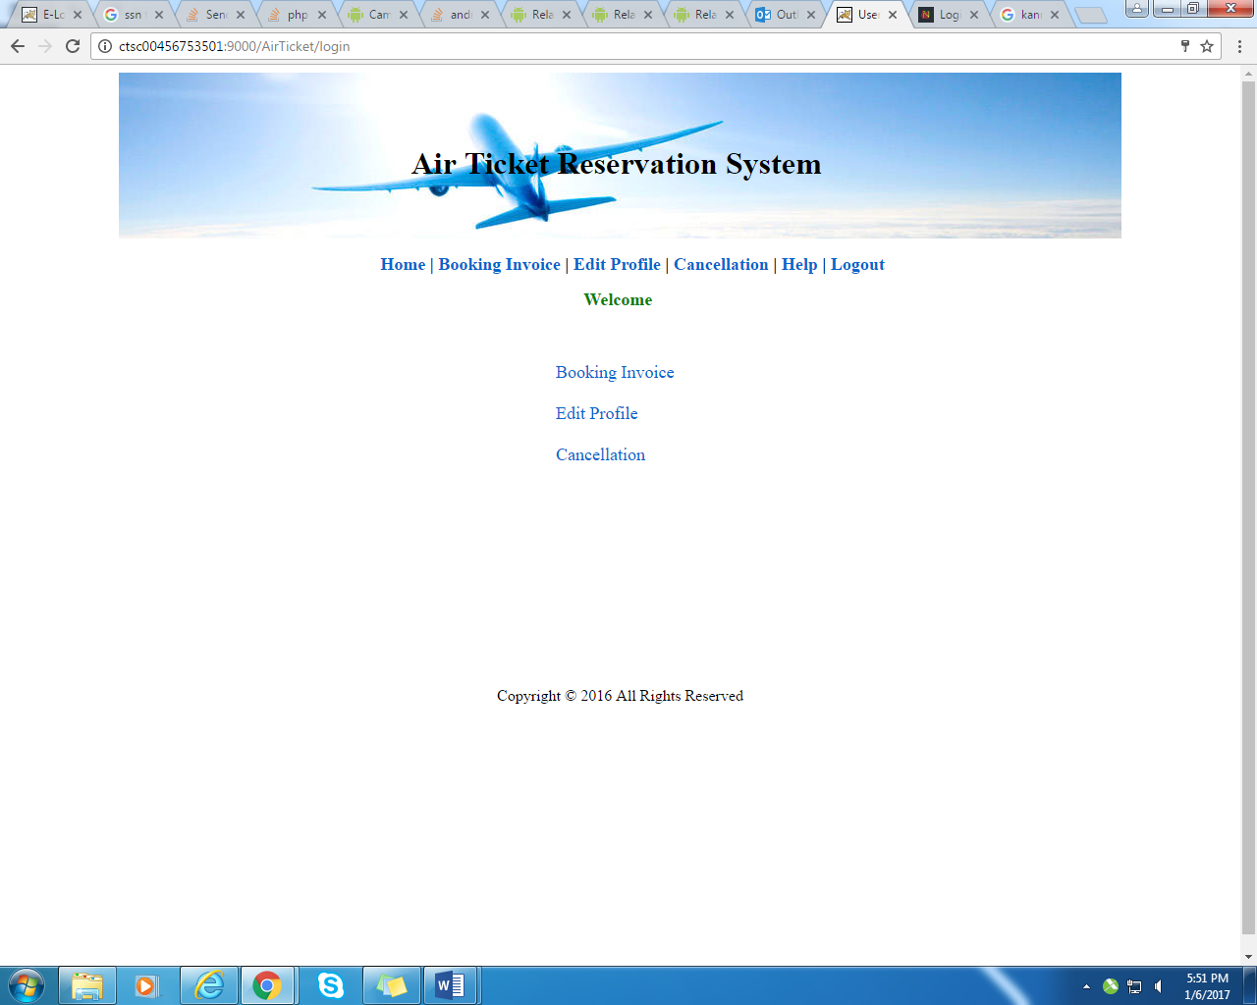

*Fig 6*

*4.1 Booking Invoice :*

*Customer can check invoice by clicking booking invoice. Refer fig 7*

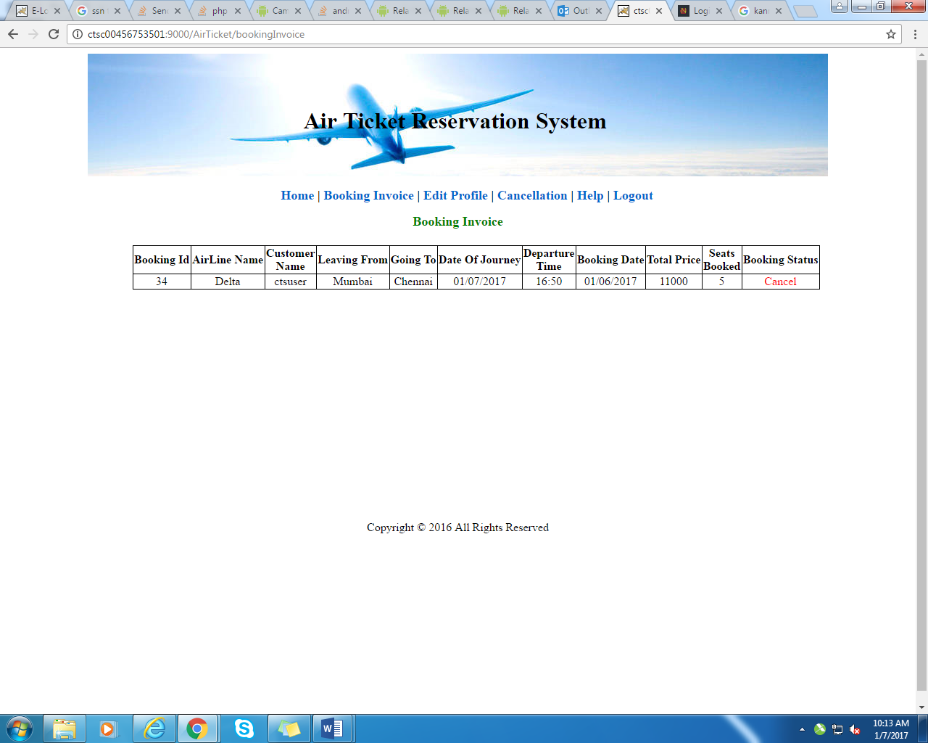

*Fig 7*

*4.2 Edit Profile:*

*Customer can edit his profile by clicking edit profile link .Refer fig 8.*

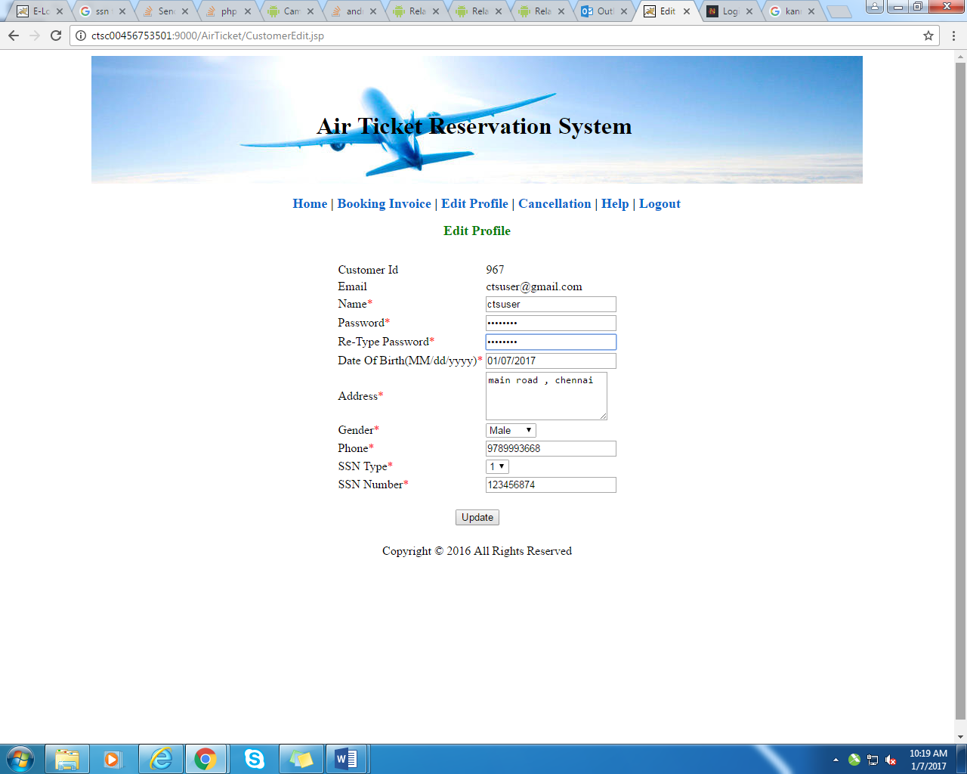

*Fig 8*

*4.3 Cancellation:*

*Customer can cancel his ticket by clicking cancellation link .Refer fig 9 .*

*He/She will be redirected to Cancellation of ticket page wherein he can enter*

*His booking id and click submit button to check all his booking details. Ref fig 10*

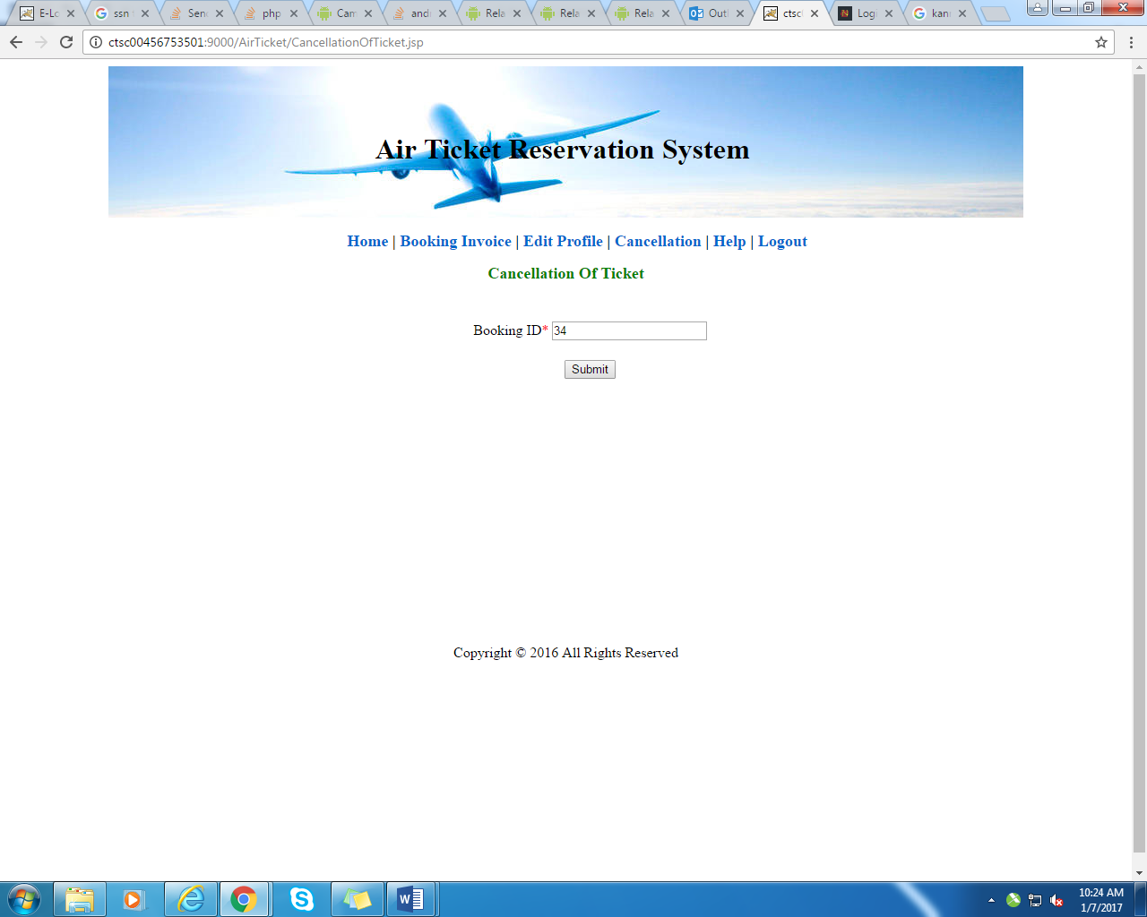

*Fig 9*

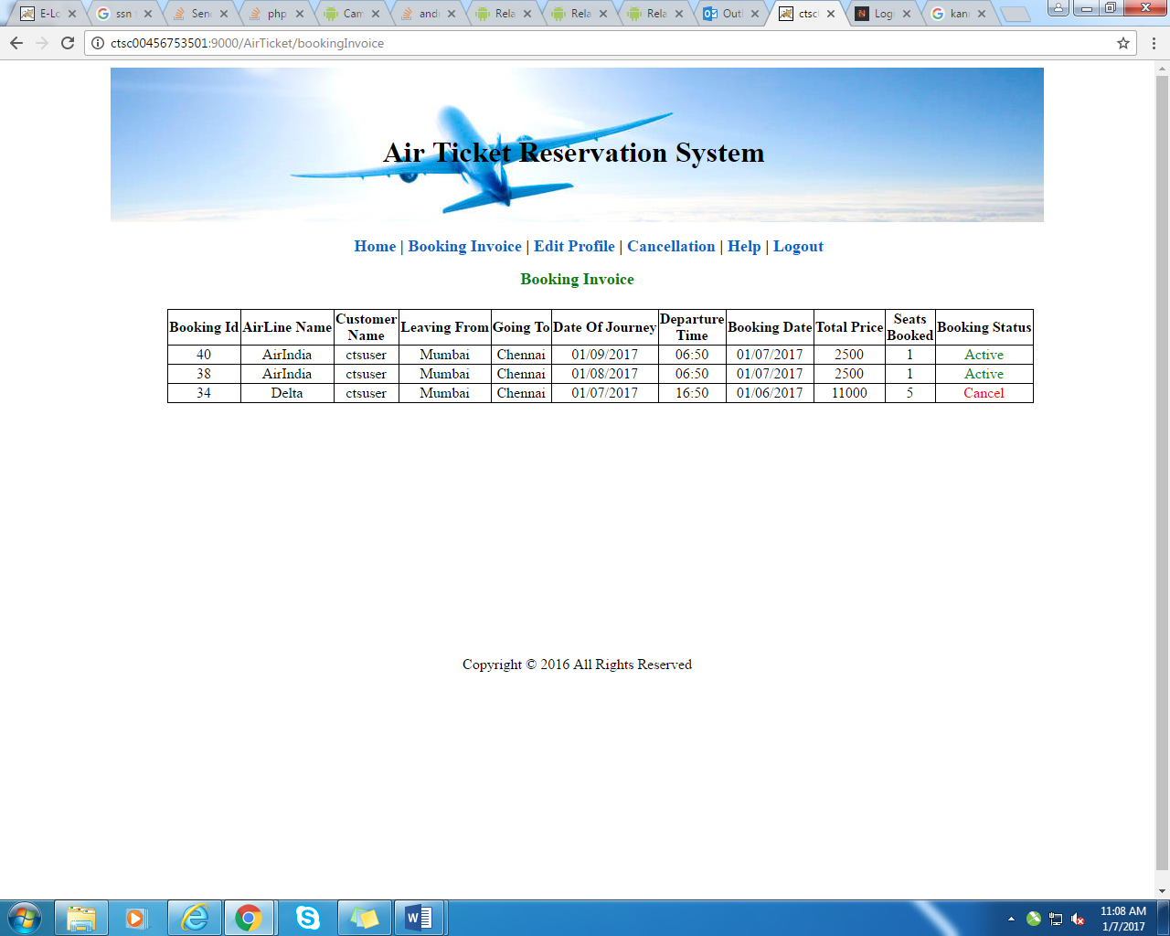

*Fig 10*