**Greatest of three numbers:**

a=12

b=25

c=8

d=max(a,b,c)

print d

**output:**

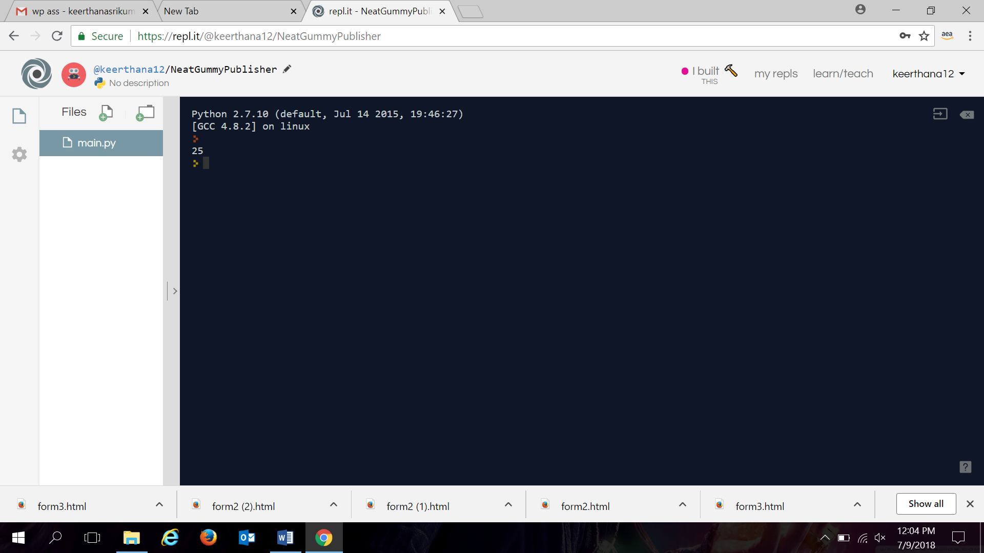

**subtraction:**

a=56

b=30

c=a-b

print c

**output:**

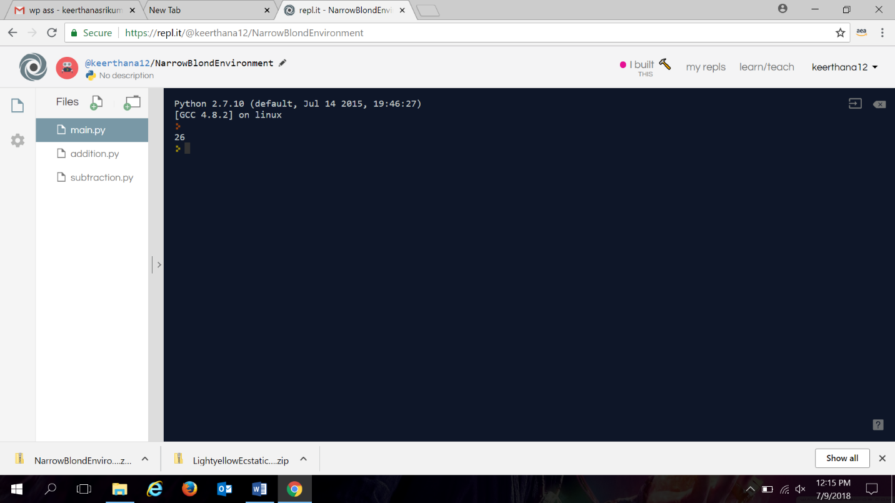

**addition:**

a=12

b=9

c=a+b

print c

**output:**

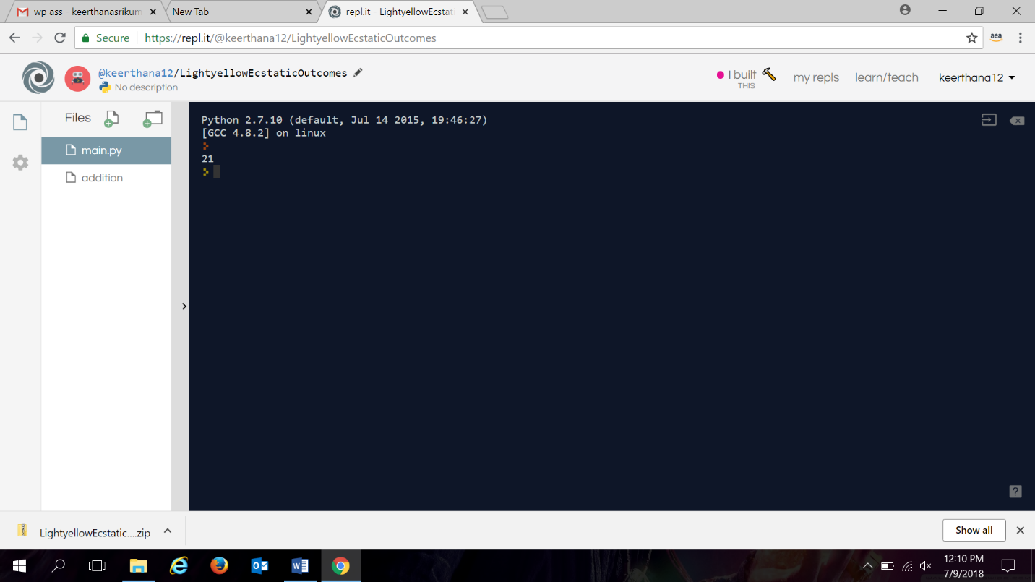

**multiplication:**

a=12

b=30

c=a*b

print c

**output:**

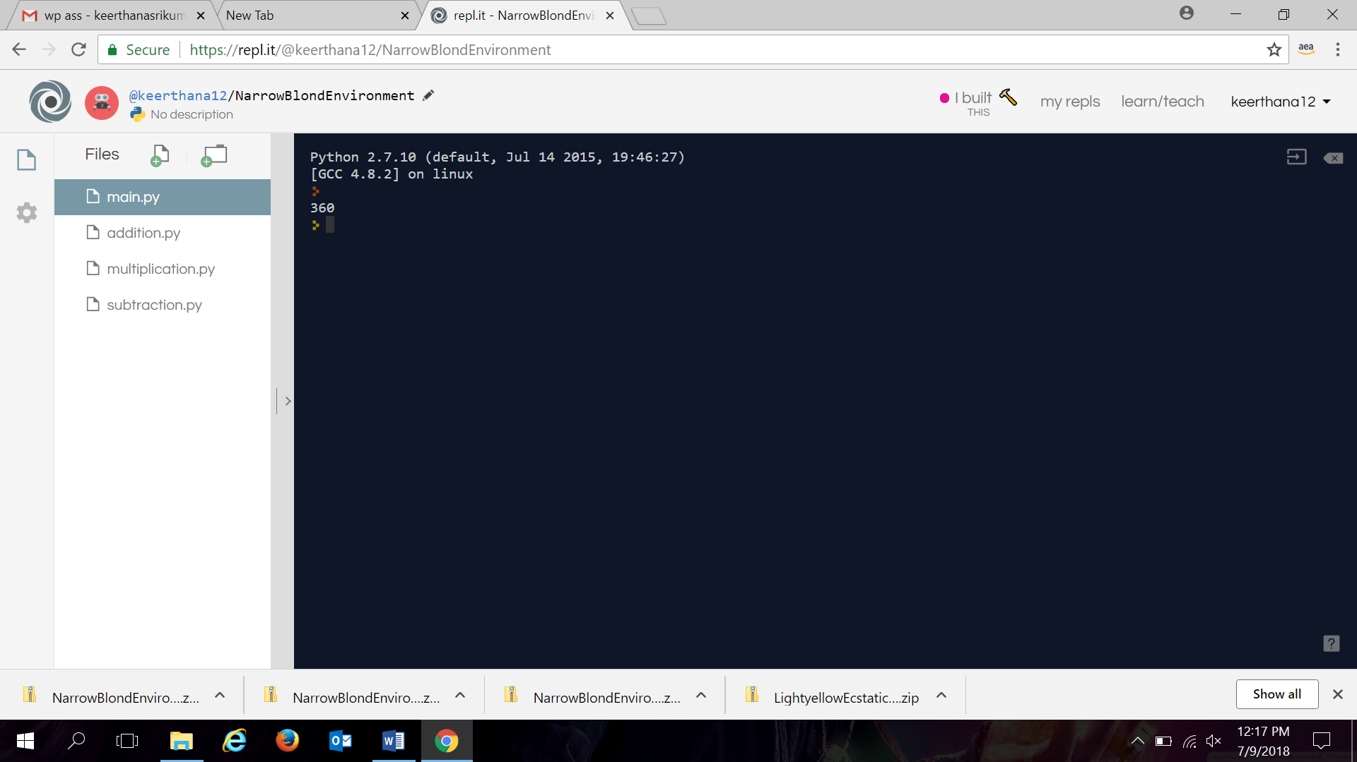

**division:**

a=12

b=3

c=a/b

print c

**output:**

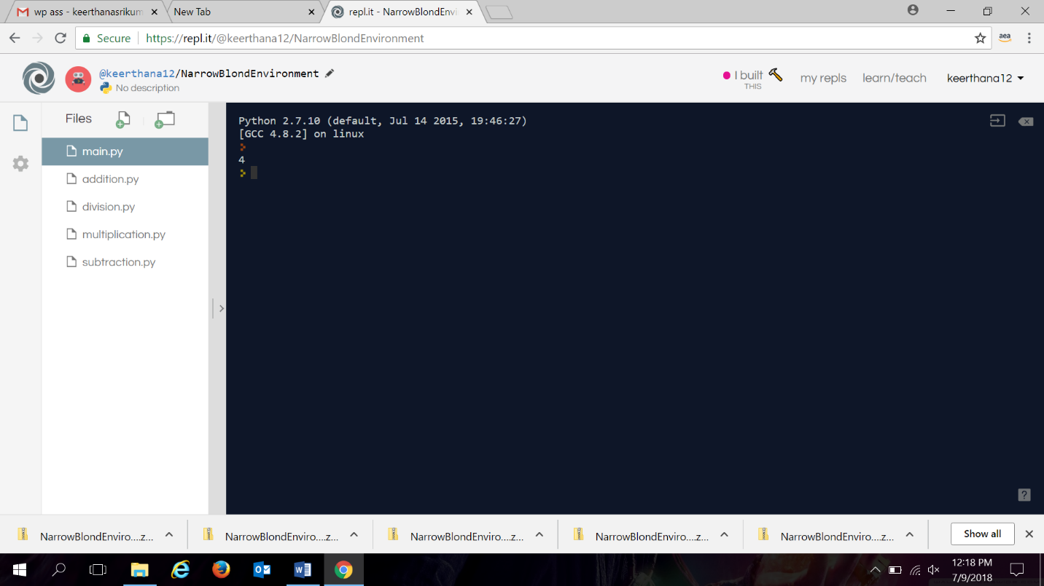

**modulus:**

a=12

b=6

c=a%b

print c

**output:**

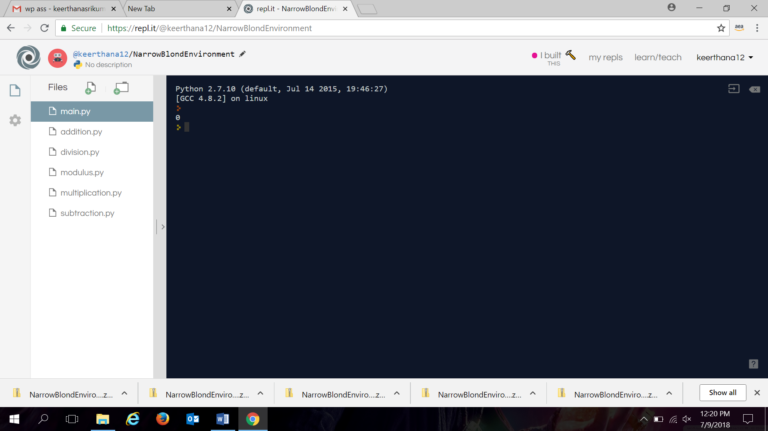

**Input from user program:**

number = raw_input("enter your name: ")

print(number)

**output:**

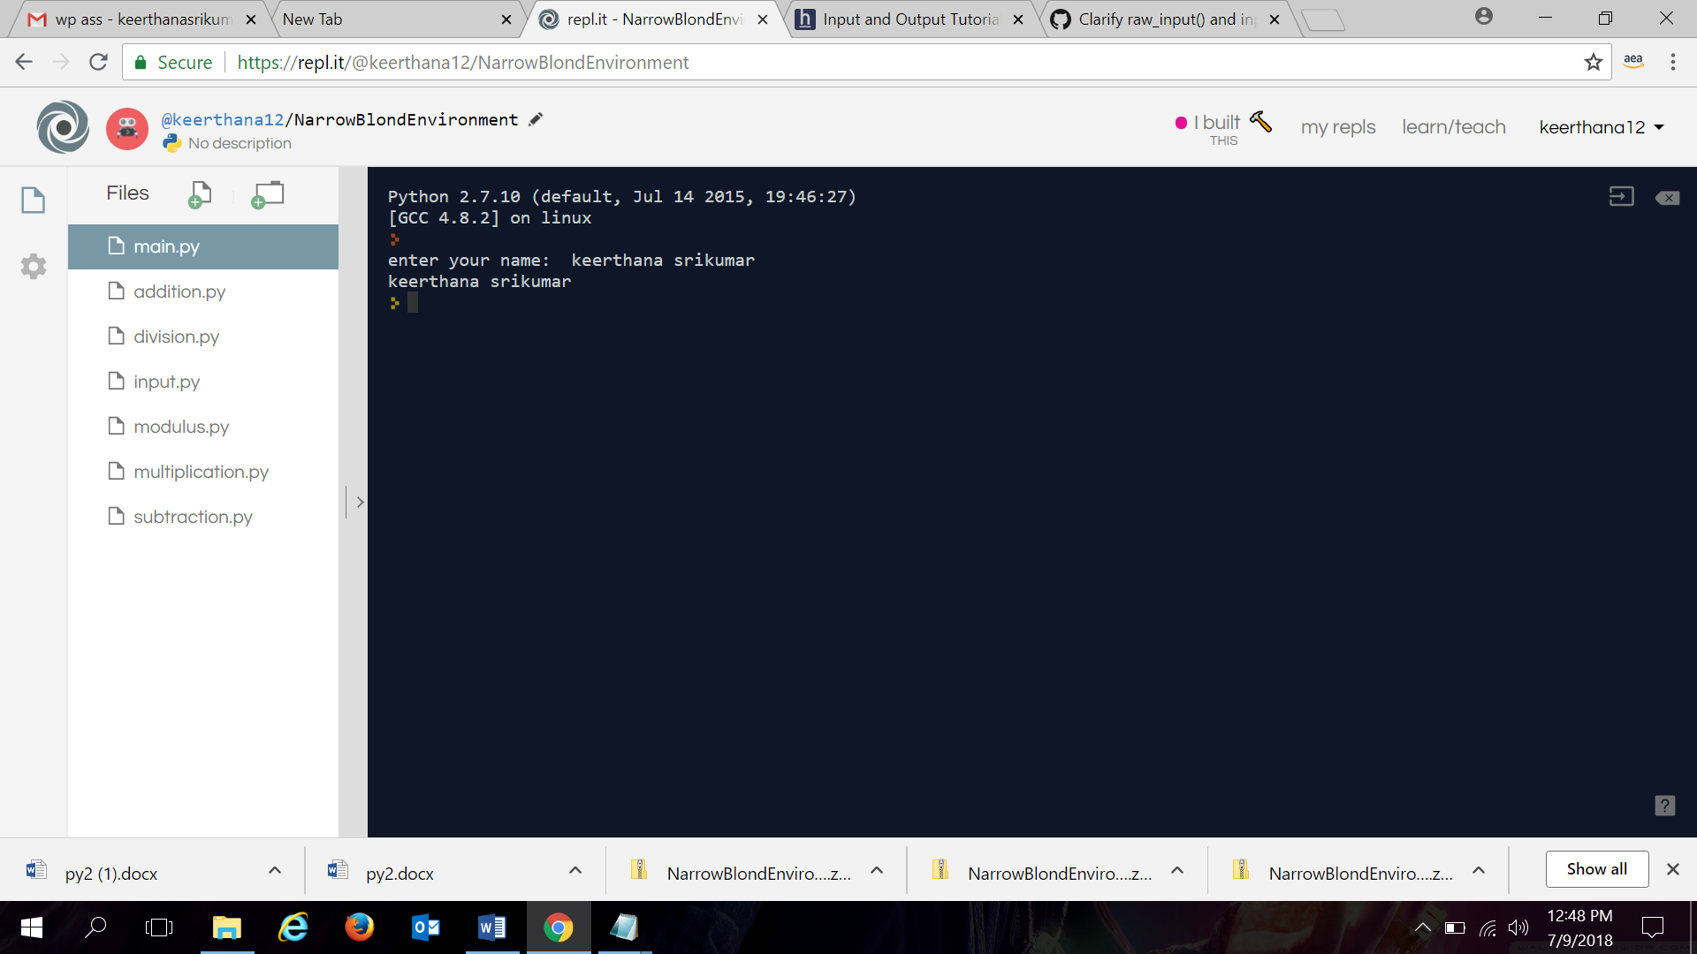

**Prime number in an interval:**

lower_limit=input("enter low:")

upper_limit=input("enter high:")

print("Prime numbers between",lower_limit,"and",upper_limit,"are:")

for num in range(lower_limit,upper_limit + 1):

if num > 1:

for i in range(2,num):

if (num % i) == 0:

break

else:

print(num)

**output:**

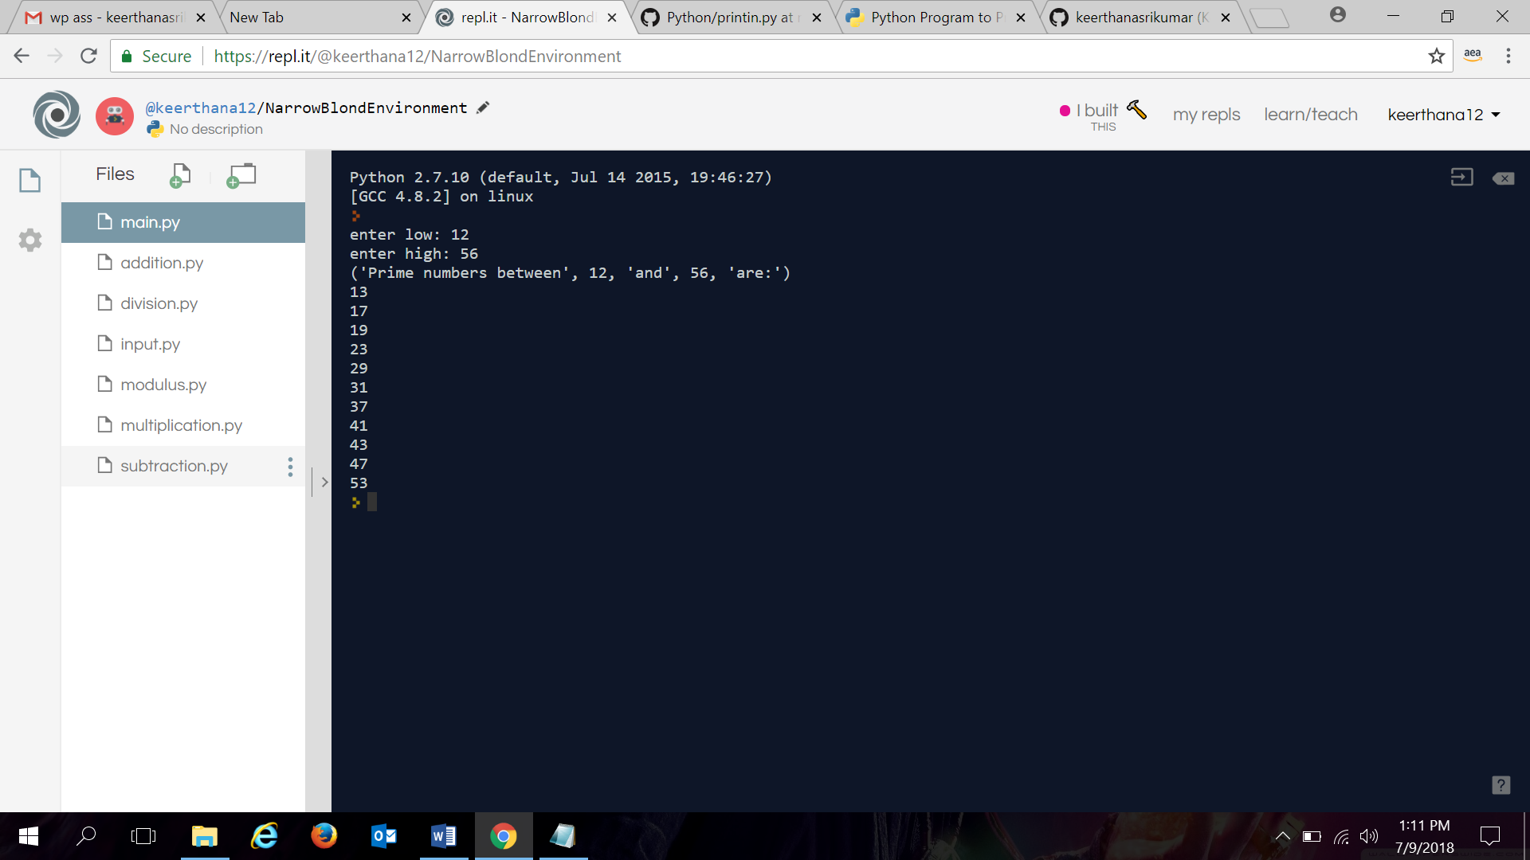

**Fibonacci series:**

upper=input("enter the upper limit:")

print("fibonacci series for",upper,"numbers:")

a=0

b=1

for i in range(0,upper):

c=a+b

a=b

b=c

print(c)

**output:**

