**REG NO : 727721EUIT076**

**NAME : KKEERTHANA S**

**CC2**

**TASK1**

**CODE**

package yatra;  
  
import [org.openqa.selenium.By](http://org.openqa.selenium.by/);  
import org.openqa.selenium.WebDriver;  
import org.openqa.selenium.WebElement;  
import org.openqa.selenium.chrome.ChromeDriver;  
import org.openqa.selenium.chrome.ChromeOptions;  
  
import io.github.bonigarcia.wdm.WebDriverManager;  
  
public class task1 {  
public static void main(String[] args)  
{  
WebDriverManager.chromedriver().setup();  
WebDriver driver;  
ChromeOptions co=new ChromeOptions();  
co.addArguments("--remote-allow-origins=*");  
driver=new ChromeDriver(co);  
driver.manage().window().maximize();  
driver.get("<https://www.yatra.com/>");  
WebElement flight = driver.findElement(By.xpath("//*[@id=\"booking_engine_flights\"]"));  
flight.click();  
WebElement rtrip = driver.findElement(By.xpath("//*[@id=\"BE_flight_form_wrapper\"]/div[1]/div[1]/ul[1]/li[2]/a"));  
rtrip.click();  
}  
}}

OUTPUT

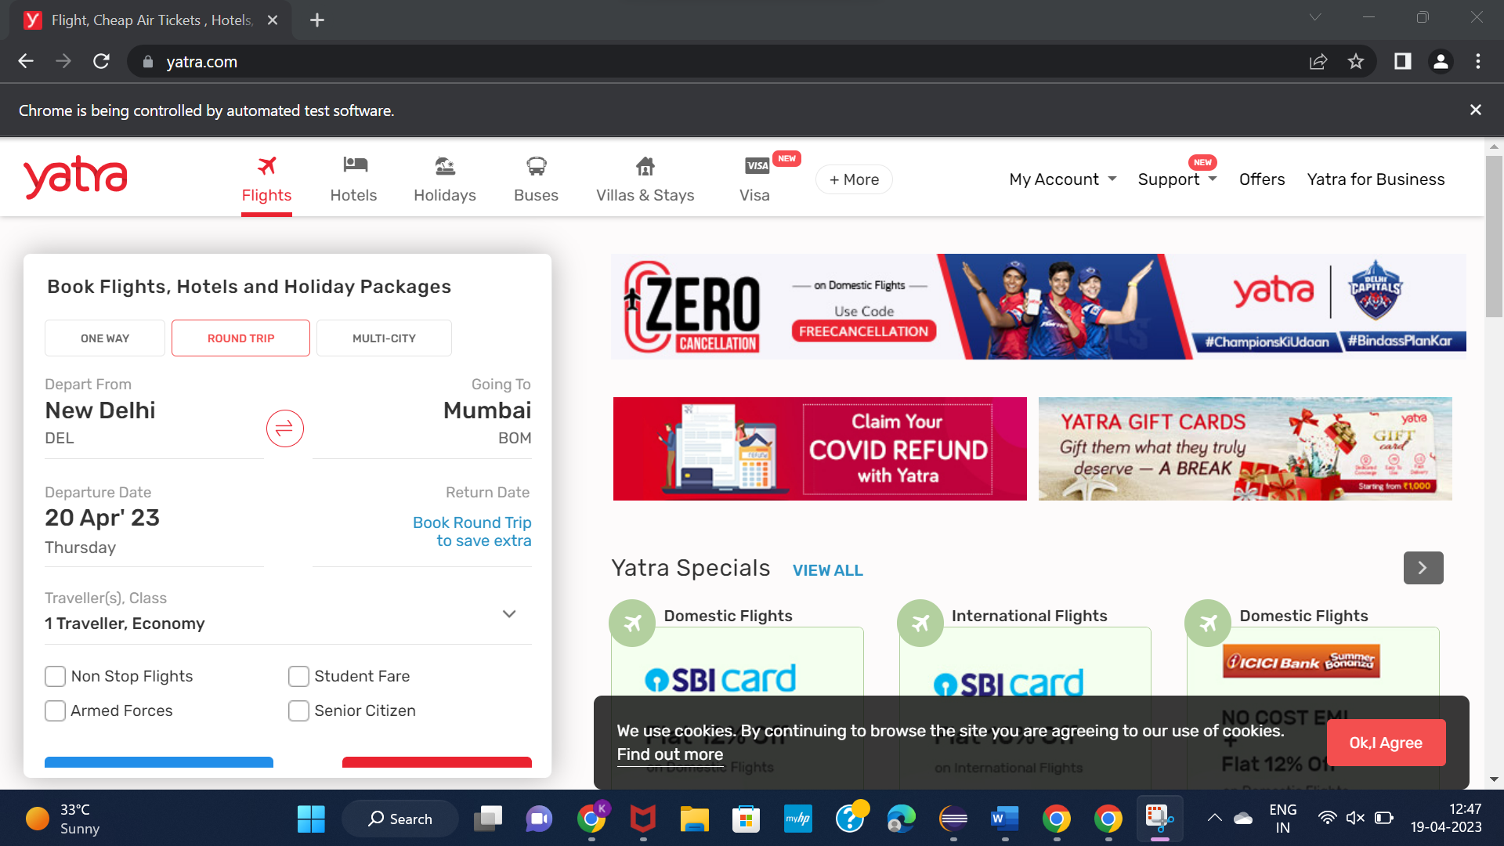

TASK2

CODE

import [org.openqa.selenium.By](http://org.openqa.selenium.by/);  
import org.openqa.selenium.WebDriver;  
import org.openqa.selenium.chrome.ChromeDriver;  
import org.openqa.selenium.chrome.ChromeOptions;  
import org.testng.annotations.Test;  
  
import io.github.bonigarcia.wdm.WebDriverManager;  
  
public class Ques {  
  WebDriver d;  
  @Test  
  public void f() throws InterruptedException {  
 ChromeOptions co=new ChromeOptions();  
 co.addArguments("--remote-allow-origins=*");  
 WebDriverManager.chromedriver().setup();  
 d=new ChromeDriver(co);  
 d.get("<https://www.yatra.com/flights>");  
 d.manage().window().maximize();  
 Thread.sleep(4000);  
 d.findElement(By.xpath("//*[@id=\"booking_engine_flights\"]")).click();  
 Thread.sleep(2000);  
 d.findElement(By.xpath("//*[@id=\"BE_flight_form_wrapper\"]/div[1]/div[1]/ul[1]/li[2]/a")).click();  
 Thread.sleep(2000);  
 d.findElement(By.xpath("//*[@id=\"BE_flight_origin_city\"]")).click();  
 Thread.sleep(2000);  
 d.findElement(By.xpath("//*[@id=\"BE_flight_form_wrapper\"]/div[1]/div[2]/ul/li[1]/ul/li[1]/div/div/ul/div/div/div/li[3]")).click();  
 Thread.sleep(2000);  
 d.findElement(By.xpath("//*[@id=\"BE_flight_form_wrapper\"]/div[1]/div[2]/ul/li[1]/ul/li[3]/div/div/ul/div/div/div/li[4]")).click();  
 Thread.sleep(2000);  
 d.findElement(By.xpath("//*[@id=\"BE_flight_origin_date\"]")).click();  
 Thread.sleep(2000);  
 d.findElement(By.xpath("//*[@id=\"20/04/2023\"]")).click();  
 Thread.sleep(2000);  
 d.findElement(By.xpath("//*[@id=\"BE_flight_arrival_date\"]")).click();  
 Thread.sleep(2000);  
 d.findElement(By.xpath("//*[@id=\"24/04/2023\"]")).click();  
 Thread.sleep(2000);  
 d.findElement(By.xpath("//*[@id=\"BE_flight_paxInfoBox\"]/i")).click();  
 Thread.sleep(2000);  
 d.findElement(By.xpath("//*[@id=\"BE_flight_passengerBox\"]/div[1]/div[1]/div/div/span[2]")).click();  
 Thread.sleep(2000);  
 d.findElement(By.xpath("//*[@id=\"flight_class_select_child\"]/ul/li[3]")).click();  
 Thread.sleep(2000);  
 d.findElement(By.xpath("//*[@id=\"BE_flight_form_wrapper\"]/div[3]/div[1]/div[1]/a/i")).click();  
 Thread.sleep(2000);  
 d.findElement(By.xpath("//*[@id=\"BE_flight_flsearch_btn\"]")).click();  
    
  }  
}

OUTPUT

