SIMATS ENGINEERING (SAVEETHA SCHOOL OF ENGINEERING)
Department of Artificial Intelligence and Data Science
ASSESSMENT TOOL 2 – Pseudocode Writing Task (Algorithm Design)

Course Code: | DSA03 | Course Title: | Natural Language Processing
CO Assessed: | CO5 – Articulation | Assessment: | Assessment Tool 2 – Pseudocode Writing Task (Algorithm Design)
Weightage: | 35% of CIA
CO5 Statement: | Implement semantic models using predicate logic, word sense disambiguation and validate information retrieval techniques. (BL-5)
Student Name: | K.KEERTHANA SAI | Reg. No.: | 192425143
Section / Batch: | SLOT-D/2024 | Date:

Code of Conduct
I K.Keerthana Sai (Name / Reg No) certify that this submission is my original work and that I have adhered to the guidelines specified for this assessment. I understand that any violation of academic integrity rules will result in disciplinary action.
Signature of the Student:

Instructions
- Draw necessary diagrams such as constraint graphs, coreference chains, discourse trees, or predicate logic representations wherever applicable.
- Generate solutions that fully satisfy all given constraints and provide clear evaluation of the output.
- Answers should be concise, well-structured, and supported by evidence from the given text/scenario.
- Duration: 30 minutes.

Section / Topic | Focus | Question No.
Reference Resolution, Discourse | Entity Linking Algorithm | Q1
Text Coherence, Discourse Structure | Coherence Analysis Algorithm | Q2
Dialog Acts, Conversational Agents | Intent Recognition Algorithm | Q3
Language Generation, Surface Realization | NLG Pipeline Design | Q4
Machine Translation, Interlingua, Statistical Approaches | Translation Workflow Algorithm | Q5

Annexure A – Pseudocode Writing Task (Algorithm Design)
1. Reference Resolution Using Multiple Constraints
Design an algorithm to perform Reference Resolution by identifying pronouns and selecting the most appropriate antecedent using gender, number, recency, and semantic compatibility.
Apply your algorithm to the discourse:
"Meena gave Kavya a laptop because she needed one for her project. She thanked her and started using it."
Perform the following steps:
- Identify all entities and referring expressions.
- Generate possible antecedents for each pronoun.
- Apply gender, number, recency, and semantic constraints.
- Select the most appropriate antecedent.
- Generate the resolved discourse.
Finally, explain how your algorithm avoids incorrect resolution when multiple antecedents have similar grammatical properties.

2. Algorithm for Entity Chains and Discourse Coherence
Design an algorithm to identify entity chains in a discourse and use them to evaluate text coherence.
Apply your algorithm to the following text:
"Anjali bought a new laptop. The laptop had a powerful processor. She installed Python on it. Later, Anjali used the computer to develop a machine learning application."
Perform the following steps:
- Identify all entities and referring expressions.
- Link expressions referring to the same entity.
- Construct entity chains.
- Calculate or estimate the continuity of entities across sentences.
- Determine whether the discourse is coherent.
Finally, explain how breaking an entity chain could reduce discourse coherence.

3. Algorithm for Identifying Discourse Relations
Design an algorithm to identify discourse relations between consecutive sentences using discourse markers and contextual meaning.
Apply your algorithm to:
"The server crashed unexpectedly. As a result, users could not access the application. The technical team restarted the server. After that, the system became available again."
Your algorithm should identify relations such as:
- Cause–Effect
- Sequence
- Problem–Solution
- Elaboration
Perform the following steps:
- Divide the discourse into individual discourse units.
- Identify explicit discourse markers.
- Analyze the semantic relationship between units.
- Assign an appropriate discourse relation.
- Construct a discourse structure representation.
Finally, justify how the identified relations make the discourse logically coherent.

4. Algorithm for Dialogue Act Classification
Design an algorithm to recognize Dialogue Acts in a conversation.
Apply your algorithm to:
User: "Hello, I need help with my assignment."
Agent: "Sure, what problem are you facing?"
User: "I do not understand machine learning."
Agent: "I can explain the basic concepts to you."
Classify each utterance into one of the following:
- Greeting
- Request
- Question
- Inform
- Offer
- Confirmation
Perform the following steps:
- Preprocess each utterance.
- Extract relevant linguistic features.
- Identify the communicative intention.
- Assign a dialogue act.
- Generate the dialogue-act sequence.
Finally, explain how dialogue-act recognition helps a conversational agent select an appropriate next response.

5. Algorithm for Dialogue State Tracking
Design an algorithm for a Conversational Agent that maintains dialogue state while collecting information from a user.
Apply your algorithm to:
User: "I want to book a flight."
Agent: "Where would you like to travel?"
User: "I want to go to Delhi."
Agent: "From which city?"
User: "From Chennai."
Your algorithm should maintain the following slots:
Departure City
Destination City
Travel Date
Number of Passengers
Perform the following steps:
- Initialize the dialogue state.
- Identify information provided in each utterance.
- Update the corresponding slot.
- Identify missing information.
- Generate the next appropriate question.
Finally, explain how dialogue state tracking improves coherence in a multi-turn conversation.

ANSWERS:

Q1. Reference Resolution Using Multiple Constraints

Explanation
Reference resolution means finding which entity a pronoun refers to.

In the given sentence:
“Meena gave Kavya a laptop because she needed one for her project. She thanked her and started using it.”

The pronouns are:
- she
- her
- She
- her
- it
The algorithm considers:
- Gender
- Number
- Recency
- Semantic compatibility
Both Meena and Kavya are female and singular, so gender and number alone are not enough. Therefore, context and semantic meaning are also considered.

Pseudocode

ALGORITHM ReferenceResolution

INPUT: Discourse
OUTPUT: Resolved discourse

1. Identify all entities and pronouns.
2. For each pronoun:
Find possible antecedents.
3. Check gender compatibility.
4. Check number compatibility.
5. Check recency.
6. Check semantic compatibility.
7. Calculate the score of each candidate.
8. Select the candidate with highest score.
9. Replace the pronoun with the selected antecedent.
10. Return resolved discourse.

END

OUTPUT:
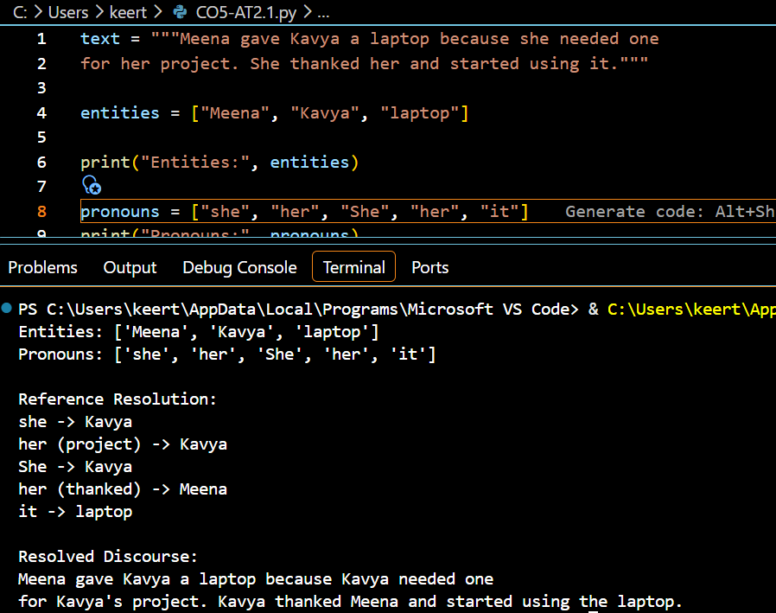

Final Answer
The algorithm successfully resolves the pronouns by considering gender, number, recency and semantic compatibility. Semantic context helps distinguish between Meena and Kavya when grammatical features are identical. Hence, incorrect antecedent selection is reduced.

Q2. Entity Chains and Discourse Coherence

Explanation
An entity chain is a sequence of words or expressions that refer to the same entity.
Given:
“Anjali bought a new laptop. The laptop had a powerful processor. She installed Python on it. Later, Anjali used the computer to develop a machine learning application.”
The two major entity chains are:
Person Chain
Anjali → She → Anjali
Laptop Chain
laptop → The laptop → it → the computer
Because these entities continue across sentences, the paragraph is coherent.

Pseudocode
ALGORITHM EntityChainAnalysis

INPUT: Discourse
OUTPUT: Entity chains and coherence

1. Divide text into sentences.
2. Extract entities and referring expressions.
3. Compare expressions using lexical and semantic similarity.
4. Link expressions referring to the same entity.
5. Construct entity chains.
6. Measure entity continuity across sentences.
7. If important entities continue across sentences:
Mark discourse as COHERENT.
Else:
Mark discourse as LESS COHERENT.
8. Display entity chains and result.

END

OUTPUT:
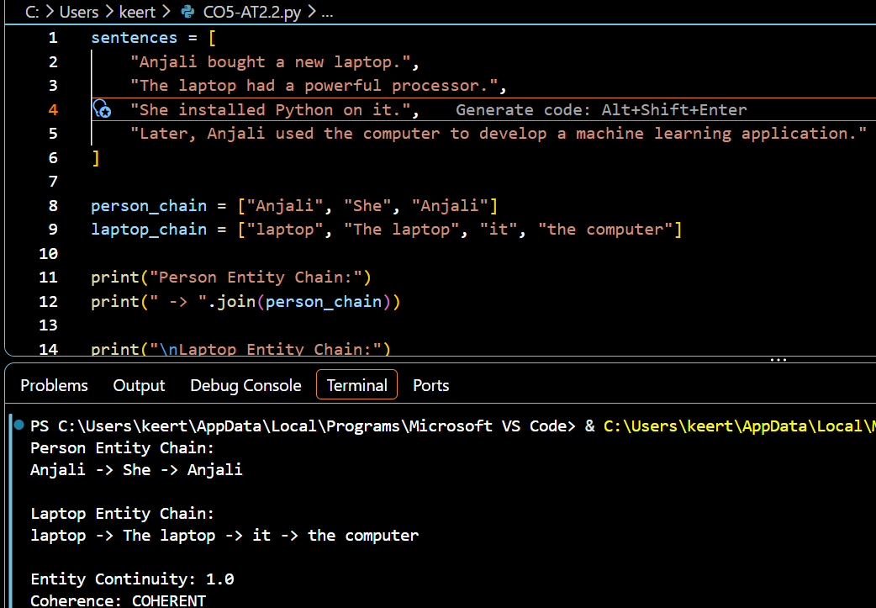
Final Answer
The discourse is coherent because the main entities, Anjali and the laptop, are continuously maintained through referring expressions. If the entity chain were broken, the reader could lose track of the topic, thereby reducing discourse coherence.

Q3. Algorithm for Identifying Discourse Relations

Explanation
Discourse relation identifies the logical relationship between sentences.
Given:
“The server crashed unexpectedly. As a result, users could not access the application. The technical team restarted the server. After that, the system became available again.”
The relations are:
- Server crashed → users couldn't access → Cause–Effect
- Access problem → server restarted → Problem–Solution
- Server restarted → system available → Sequence
Important discourse markers are:
- As a result → Cause–Effect
- After that → Sequence

Pseudocode
ALGORITHM DiscourseRelation

INPUT: Discourse
OUTPUT: Relations between sentences

1. Divide discourse into sentences.
2. Identify discourse markers.
3. For each consecutive pair:
Analyze contextual meaning.
4. If marker indicates a consequence:
Assign Cause-Effect.
5. If one sentence solves a problem:
Assign Problem-Solution.
6. If marker indicates order:
Assign Sequence.
7. Construct discourse structure.
8. Return relations.

END

OUTPUT:
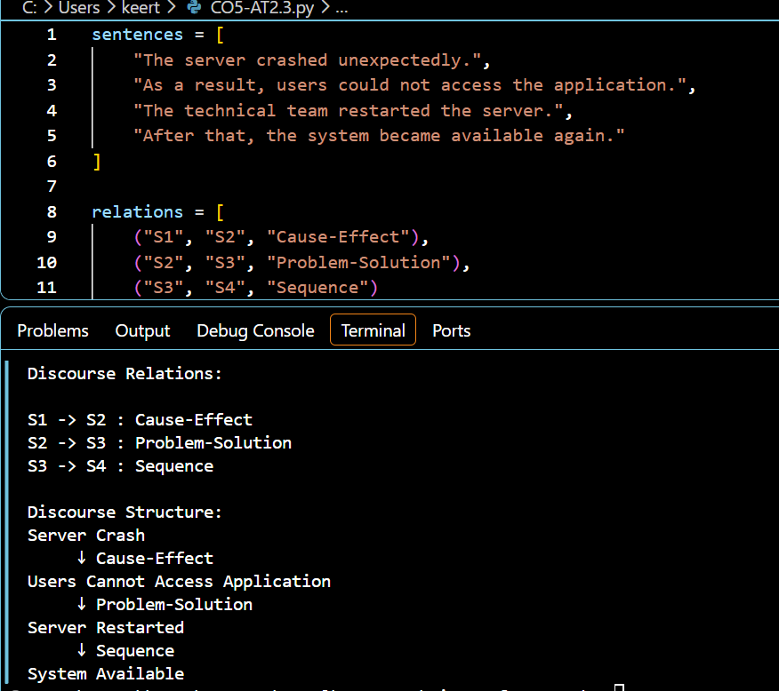
Final Answer
The discourse is logically coherent because the events form a meaningful chain:
Problem → Effect → Solution → Result
The markers “As a result” and “After that” provide explicit evidence for the identified relations.

Q4. Algorithm for Dialogue Act Classification
Explanation
A dialogue act represents the purpose or intention of an utterance.
For example:
- “Hello” → Greeting
- “I need help” → Request
- “What problem are you facing?” → Question
- “I do not understand machine learning.” → Inform
- “I can explain...” → Offer
The system identifies keywords and sentence patterns to determine the dialogue act.

Pseudocode
ALGORITHM DialogueActClassification

INPUT: Conversation
OUTPUT: Dialogue act of each utterance

1. Read each utterance.
2. Convert text to lowercase.
3. Extract keywords and sentence patterns.
4. If greeting word exists:
Assign Greeting.
5. Else if request expression exists:
Assign Request.
6. Else if question pattern exists:
Assign Question.
7. Else if offer expression exists:
Assign Offer.
8. Else:
Assign Inform.
9. Store the dialogue act.
10. Return dialogue-act sequence.

END

OUTPUT:
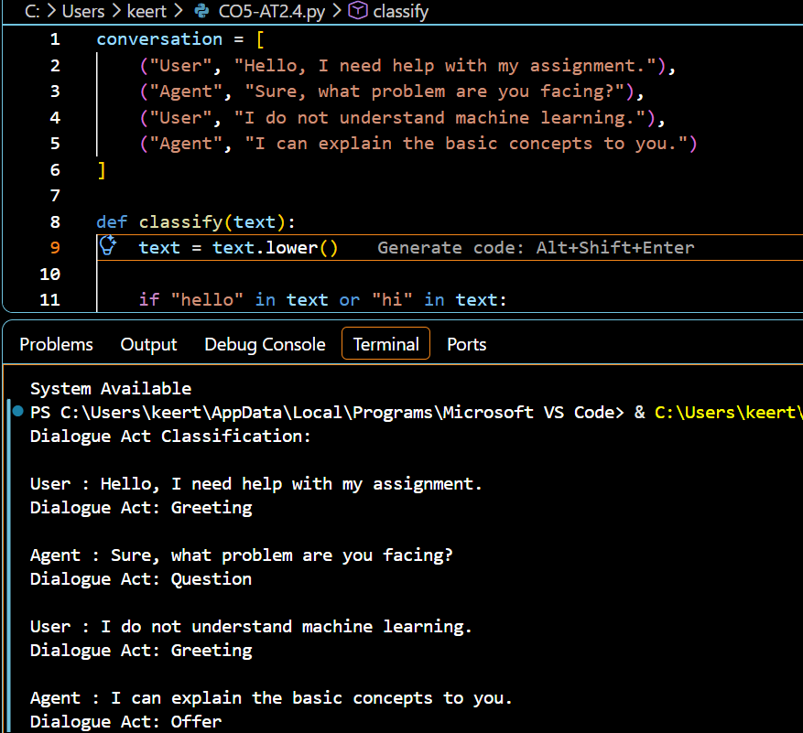
Final Answer
Dialogue-act recognition helps a conversational agent understand the user's communicative intention. It enables the system to choose an appropriate response, such as answering a question, fulfilling a request, or offering assistance.

Q5. Dialogue State Tracking

Explanation
Dialogue State Tracking maintains information collected during a multi-turn conversation.
The required slots are:
- Departure City
- Destination City
- Travel Date
- Number of Passengers
Conversation:
User: I want to book a flight.
Agent: Where would you like to travel?
User: I want to go to Delhi.
Agent: From which city?
User: From Chennai.
After processing the conversation:
Destination = Delhi
Departure = Chennai
Travel Date = Unknown
Passengers = Unknown
The next question should therefore be:
“What is your travel date?”

Pseudocode
ALGORITHM DialogueStateTracking

INPUT: User conversation
OUTPUT: Updated dialogue state and next question

1. Initialize all slots as UNKNOWN.
2. Read each user utterance.
3. Extract destination city.
4. Extract departure city.
5. Extract travel date.
6. Extract number of passengers.
7. Update the corresponding slots.
8. Find missing slots.
9. Ask a question for the next missing slot.
10. If no slot is missing:
Confirm all booking details.
11. Return dialogue state.

END

OUTPUT
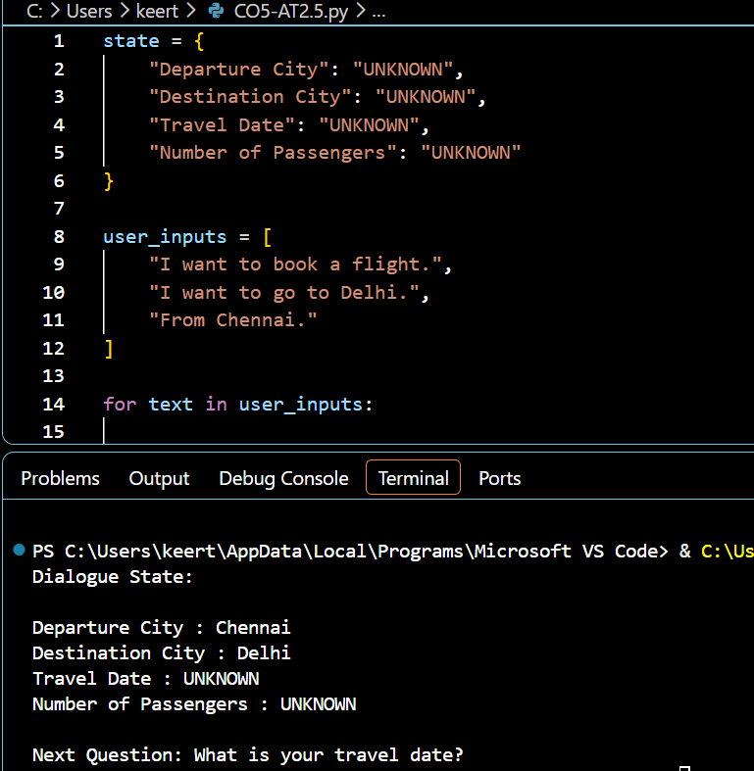
Final Answer
Dialogue State Tracking successfully stores information from previous turns and identifies missing information. Therefore, the agent does not repeatedly ask for information already provided and can continue the conversation coherently.

Rubrics for Calculation

Criteria | Weightage | Level 4 – Exemplary | Level 3 – Proficient | Level 2 – Developing | Level 1 – Beginning
Problem Understanding | 20% | Identifies all inputs, outputs, constraints accurately | Minor missing elements | Partial understanding | Incorrect interpretation
Algorithm Design | 30% | Complete, correct, and logically sound solution | Minor logical gaps | Partially correct logic | Incorrect approach
Use of Control Structures | 20% | Efficient and appropriate use of loops, conditions, functions/modules | Minor inefficiencies | Limited or basic usage | Incorrect or missing constructs
Pseudocode Structure | 10% | Well-structured, clear, consistent format, easy to follow | Mostly clear with minor issues | Difficult to follow in parts | Poorly structured and unclear
Completeness | 20% | Handles all cases; optimized approach | Handles most cases; reasonable efficiency | Handles basic cases only | Incomplete or inefficient

Q. No. / Criteria Level | Problem Understanding | Algorithm Design | Use of Control Structures | Pseudocode Structure | Completeness | Sub. Total | Total %
1
2
3
4
5

Faculty In-charge | Course Coordinator | Program Director
Signature: _______________ | Signature: _______________ | Signature: _______________
Date: ___________________ | Date: ___________________ | Date: ___________________

