FULL STACK APPLICATION DEVELOPMENT
s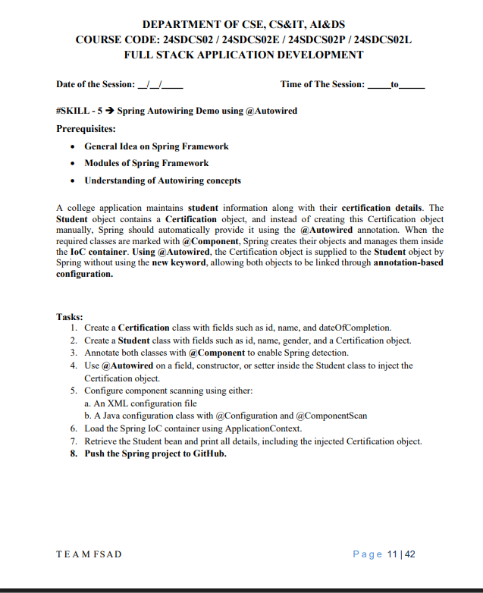Aim:-
To demonstrate Spring Autowiring using the @Autowired annotation by injecting a Certification object into a Student object using annotation-based configuration.
- Prerequisites:-
- Basic knowledge of Spring Framework
- Understanding of Spring modules
- Knowledge of Autowiring concepts

Enter details:
- Group Id: com.klu
- Artifact Id: Spring-Autowiring
- Packaging: com.klu
- Finish

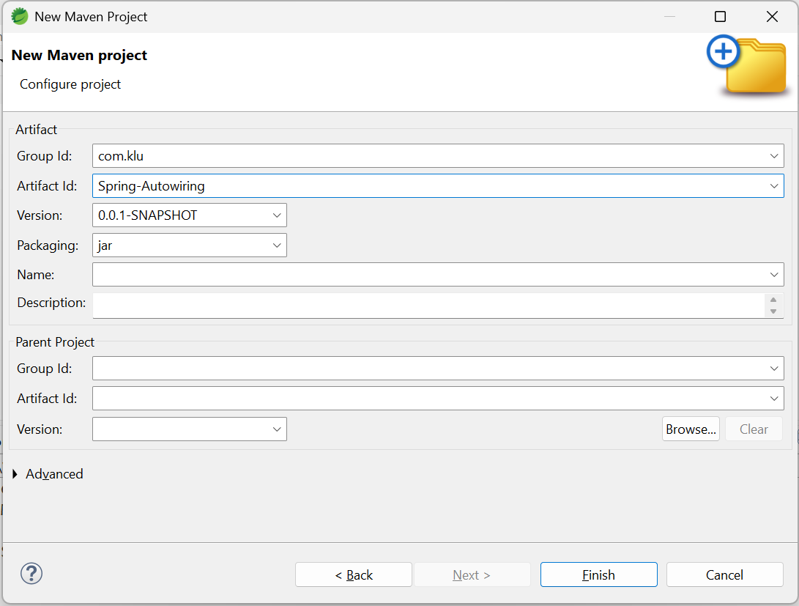

- Project Structure:-
com.klu
├── App.java
├── Student.java
├── Certification.java
src/main/resources
---applicationContext.xml

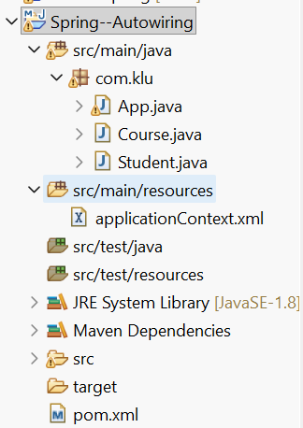

Add Spring Dependency (pom.xml):-
<!-- Spring Context -->
<dependency>
<groupId>org.springframework</groupId>
<artifactId>spring-context</artifactId>
<version>5.3.30</version>
</dependency>
Course.java:-
package com.klu;

import org.springframework.stereotype.Component;

@Component
public class Course {

private int id = 301;
private String course = "Spring Core";
private String dateOfCompletion = "25-Jan-2026";

@Override
public String toString() {
return "Course [id=" + id +
", course=" + course +
", dateOfCompletion=" + dateOfCompletion + "]";
}
}
=========================================================
Student.java:-
package com.klu;

import org.springframework.beans.factory.annotation.Autowired;
import org.springframework.stereotype.Component;

@Component
public class Student {

private int id = 10;
private String name = "Divya";
private String gender = "Female";

@Autowired
private Course course;

public void display() {
System.out.println("Student ID : " + id);
System.out.println("Student Name : " + name);
System.out.println("Gender : " + gender);
System.out.println("Course : " + course);
}
}
===========================================================
applicationContext.xml
📁 src/main/resources/applicationContext.xml

<?xml version="1.0" encoding="UTF-8"?>
<beans xmlns="http://www.springframework.org/schema/beans"
xmlns:xsi="http://www.w3.org/2001/XMLSchema-instance"
xmlns:context="http://www.springframework.org/schema/context"
xsi:schemaLocation="
http://www.springframework.org/schema/beans
https://www.springframework.org/schema/beans/spring-beans.xsd
http://www.springframework.org/schema/context
https://www.springframework.org/schema/context/spring-context.xsd">

<context:component-scan base-package="com.klu"/>

</beans>
========================================================================
App.java:-
package com.klu;

import org.springframework.context.ApplicationContext;
import org.springframework.context.support.ClassPathXmlApplicationContext;

public class App {

public static void main(String[] args) {

ApplicationContext context =
new ClassPathXmlApplicationContext("applicationContext.xml");

Student student = context.getBean(Student.class);
student.display();
}
}
================================================================
Run the Application:
- Right-click App.java
- Run As → Java Application
OUTPUT on the console:
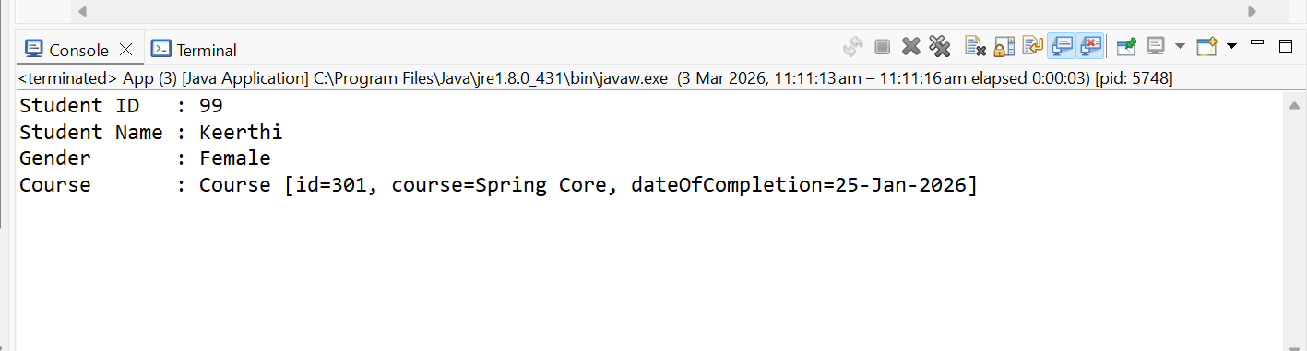

8. Push the Spring project to GitHub.
git init
git add .
git commit -m "Spring Autowiring Demo using @Autowired"
git branch -M main
git remote add origin https://github.com/your-username/Spring-Autowiring-Demo.git
git push -u origin main

