House Price Prediction using Machine Learning
Project Overview
In this project, the House Prices – Advanced Regression Techniques dataset was used to build and evaluate multiple regression models for predicting residential property prices. The target variable of the dataset is SalePrice, which represents the final selling price of each house.

Business Understanding
House price prediction helps buyers, sellers, and real estate companies estimate property values based on various house features. Accurate price prediction supports better investment decisions and improves the efficiency of the real estate market.

Problem Definition
The main objective of this project is to predict the selling price of a house using machine learning regression algorithms. Different models are trained and compared to identify the model that provides the highest prediction accuracy.

Project Goals
- Understand the housing dataset.
- Clean and preprocess the data.
- Perform exploratory data analysis.
- Create useful features.
- Train multiple regression models.
- Compare model performance.
- Select the best-performing model.
- Deploy the final model using Flask.

Dataset Overview
The dataset contains detailed information about residential properties, including physical characteristics, location, quality, condition, and sale information. Each row represents one house, while each column represents a specific property attribute.

Attribute | Description
Dataset Name | House Prices – Advanced Regression Techniques
Dataset Type | Structured Tabular Dataset
Domain | Real Estate
Machine Learning Task | Regression
Target Variable | SalePrice
Number of Records | 1460
Number of Features | 81
Numerical Features | 38
Categorical Features | 43
File Used | train.csv

Phase 1 -Data Understanding
The House Prices – Advanced Regression Techniques dataset contains 1,460 records and 81 columns, comprising 38 numerical features, 43 categorical features, and 1 target variable (Sale Price). The dataset includes property-related information such as location, size, construction quality, condition, and sale details, which are used to predict the final selling price of a house.

Missing Values

The dataset contains missing values in several features. Missing data can negatively affect model performance if not handled properly. Appropriate imputation techniques were applied based on the type and characteristics of each feature.
Major Columns with Missing Values
- LotFrontage
- Alley
- MasVnrType
- MasVnrArea
- BsmtQual
- BsmtCond
- BsmtExposure
- FireplaceQu
- GarageType
- GarageFinish
- GarageQual
- GarageCond
- PoolQC
- Fence
- MiscFeature
Numerical columns were imputed using the median where appropriate, while categorical columns were filled using the mode or suitable placeholder values such as "None" for missing categorical information.

Duplicate Records

The dataset was checked for duplicate records, and no duplicate entries were found. Therefore, no rows were removed before further preprocessing and analysis.

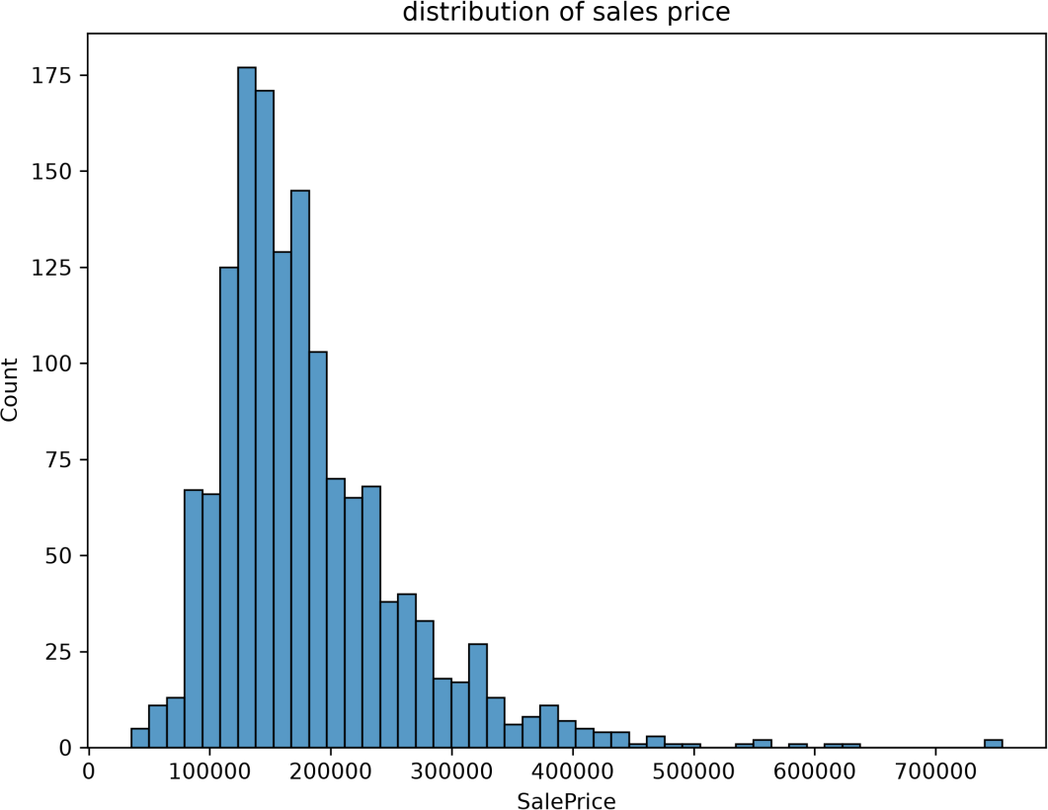

Figure 1:Saleprice Distribution

Phase 2 – Data Preprocessing
- Handled missing values
- Removed duplicates
- Treated outliers using IQR
- Encoded categorical variables
- Applied Log Transformation to skewed features
- Applied Standard Scaling to numerical features
- Performed Feature Engineering

Feature Engineering
New informative features were created by combining existing variables to improve predictive performance.

Examples include:
- TotalSF
- TotalBathrooms
- TotalPorchSF
- TotalLivingSF
- HouseAge
- RemodelAge
These engineered features captured additional information not directly available in the original dataset.

Phase 3 – Exploratory Data Analysis(EDA)
Exploratory Data Analysis (EDA) helps understand the structure of the dataset, identify important features, detect anomalies, and discover relationships between variables before model development.
Various visualization techniques were used to analyze feature distributions, correlations, and feature importance.
- Feature vs Target Analysis
- Correalation Analysis
- outlier analysis
- Feature Importance Exploration
- Relation Between variables

Feature Importance Exploration
Feature importance analysis was performed to identify the variables that contribute most to prediction accuracy.
The most influential features included:
- OverallQual
- GrLivArea
- TotalSF
- GarageCars
- TotalBathrooms
- YearBuilt
These features played a significant role in predicting house prices.

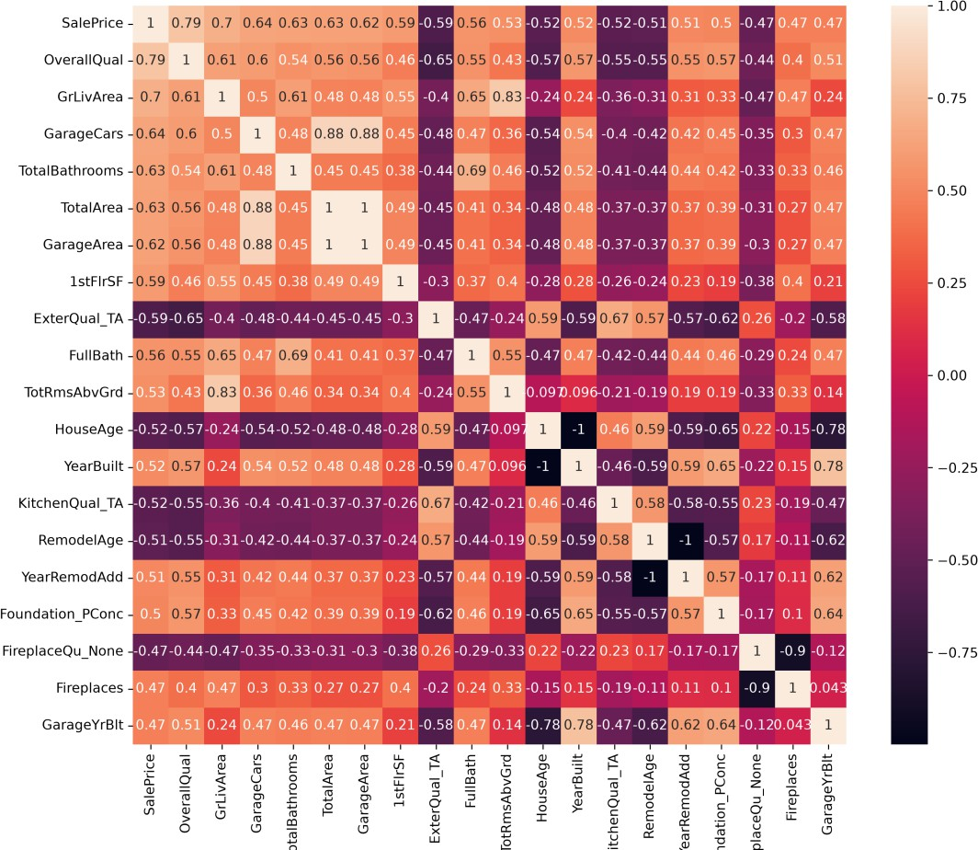
Figure 2: Correlation Heatmap

Phase 4 - Model Development
- Train Test Split
- Linear Regression
- Decision Tree
- Random Forest
- Gradient Boosting
- XGBoost
- LightGBM
- CatBoost

Model Comparison

S.No | Model | MAE | MSE | RMSE | R² Score
1 | Linear  Regression | 21057.156714 | 1.669732e+09 | 40862.356958 | 0.782313
2 | Decision Tree | 25757.880137 | 1.454466e+09 | 38137.464508 | 0.810378
3 | Random Forest | 17462.501986 | 8.304393e+08 | 28817.344387 | 0.891734
4 | Gradient  Boosting | 17468.047031 | 7.199775e+08 | 26832.397177 | 0.906135
5 | XGBoost | 16524.613281 | 5.605974e+08 | 23676.938991 | 0.892776
6 | LightGBM | 15909.718895 | 5.848068e+08 | 24182.779722 | 0.894206
7 | CatBoost | 13834.611536 | 3.772849e+08 | 19423.822517 | 0.915016

Outcome
CatBoost achieved the best performance.
A CatBoost Regressor was trained using the training dataset. CatBoost is an advanced gradient boosting algorithm that provides strong predictive performance and reduces overfitting. The model was evaluated using MAE, MSE, RMSE, and R² Score.

Model Evaluation Metrics
The following metrics were used to evaluate the performance of all regression models:
- Mean Absolute Error (MAE)
- Mean Squared Error (MSE)
- Root Mean Squared Error (RMSE)
- R² Score
- Adjusted R² Score
- Cross Validation Score
Lower values of MAE, MSE, and RMSE indicate better prediction accuracy, whereas higher values of R², Adjusted R², and Cross Validation Score indicate better model performance.

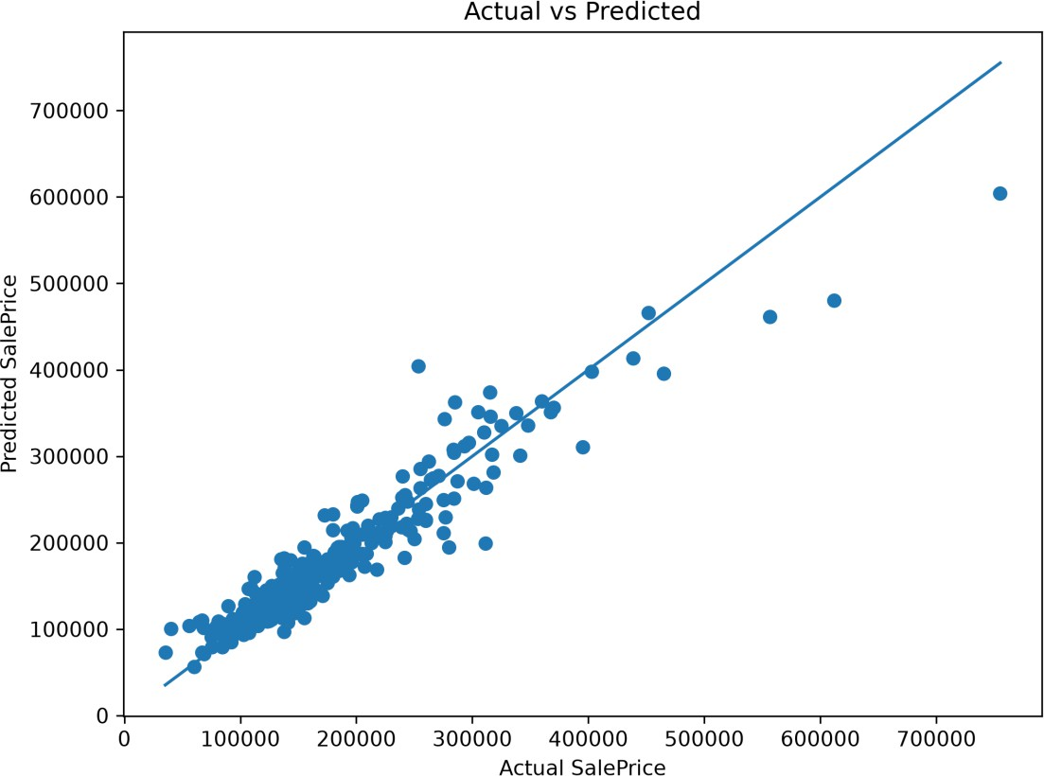

Figure 3: Actual VS Predicted

Phase 5 – Model Improvement & Optimization

Multicollinearity(VIF)
Variance Inflation Factor (VIF) analysis was performed to detect multicollinearity among independent variables.
Features with high VIF values indicate strong linear relationships with other variables. During analysis, some engineered features showed high VIF values because they were derived from existing variables. These features were retained since they contributed significantly to prediction accuracy.

Cross Validation

To ensure that the models generalize well to unseen data, 5-fold Cross Validation was performed on all regression algorithms.Cross-validation provides a more reliable estimate of model performance by repeatedly training and testing the model on different subsets of the dataset.
The following models were validated:
- Linear Regression
- Decision Tree
- Random Forest
- Gradient Boosting
- XGBoost
- LightGBM
- CatBoost
The average R² score obtained across the folds was used to compare model stability.

Validation Table

No | Model | Mean R² | Std Dev
1 | Linear Regression | 0.902705 | 0.011296
2 | Decision Tree | 0.743312 | 0.023186
3 | Random Forest | 0.876992 | 0.008083
4 | Gradient Boosting | 0.902667 | 0.005530
5 | XGBoost | 0.885854 | 0.007263
6 | LightGBM | 0.899311 | 0.005988
7 | CatBoost | 0.914009 | 0.004822

Hyperparameter Tuning
Hyperparameter tuning was performed to improve the performance of the regression models. Linear Regression was trained using its default configuration, as it does not have significant hyperparameters to optimize. The Decision Tree Regressor, Random Forest Regressor, Gradient Boosting Regressor, XGBoost Regressor, LightGBM Regressor, and CatBoost Regressor were optimized using GridSearchCV with 5-fold cross-validation. The R² score was used as the evaluation metric to identify the optimal hyperparameter combinations and improve the models' predictive performance.

Hyperparameter Search Space for Regression Models :

Model | Hyperparameters Tuned
Linear Regression | Default parameters (no hyperparameter tuning)
Decision Tree Regressor | max_depth, min_samples_split, min_samples_leaf
Random Forest Regressor | n_estimators, max_depth, min_samples_split,  min_samples_leaf
Gradient Boosting Regressor | n_estimators, learning_rate, max_depth
XGBoost Regressor | n_estimators, learning_rate, max_depth
LightGBM Regressor | n_estimators, learning_rate, max_depth
CatBoost Regressor | iterations, learning_rate, depth

No | Model | MAE | MSE | RMSE | R2
1 | Decision Tree (Tuned) | 23058.125753 | 9.746211e+08 | 31218.921788 | 0.785219
2 | Random Forest (Tuned) | 16336.485458 | 6.067234e+08 | 24631.756382 | 0.893179
3 | Gradient Boosting (Tuned) | 15037.077031 | 4.668676e+08 | 21607.119068 | 0.915012
4 | XGBoost (Tuned) | 14809.859375 | 4.396696e+08 | 20968.300646 | 0.917849
5 | LightGBM (Tuned) | 15441.468325 | 4.997429e+08 | 22354.929249 | 0.882935
6 | CatBoost (Tuned) | 14311.229939 | 3.977711e+08 | 19944.198843 | 0.915590

Among the tuned regression models, XGBoost Regressor achieved the best performance with the highest R² score (0.9178) and the lowest MAE, MSE, and RMSE. Therefore, it was selected as the final model for deployment due to its superior prediction accuracy and overall performance.

Phase 6 - Model Evaluation & Comparison¶
The optimized regression models were evaluated using MAE, MSE, RMSE, R² Score, Adjusted R², and 5-fold Cross-Validation Score. These metrics were used to compare the predictive accuracy and generalization performance of each model on the test dataset.

Among all evaluated regression models, XGBoost achieved the best overall performance. It produced the highest R² Score (0.91784) while also achieving the lowest MAE, MSE, and RMSE values. The 5-fold Cross Validation Score of 0.909774 demonstrates that the model generalizes well to unseen data. Therefore, XGBoost was selected as the final model for house price prediction.

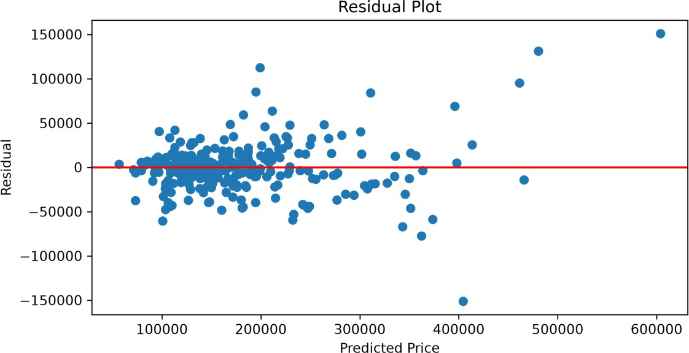

Figure 4: Residual Plot

Phase 7 – Model Interpretation

Business Objective
Develop and compare multiple regression models to accurately predict house prices. This identifies the best-performing model through preprocessing, optimization, and evaluation to support reliable property valuation.

Model Assumptions
- Historical data represents the housing market.
- Selected features influence house prices.
- Missing values and outliers are handled.
- Training and testing data have similar distributions.
- The model generalizes well to unseen data.

Feature Importance:

Feature importance was analyzed using the XGBoost model. TotalSF, OverallQual, HouseAge, TotalBathrooms, and GrLivArea were identified as the most influential features for predicting house prices.

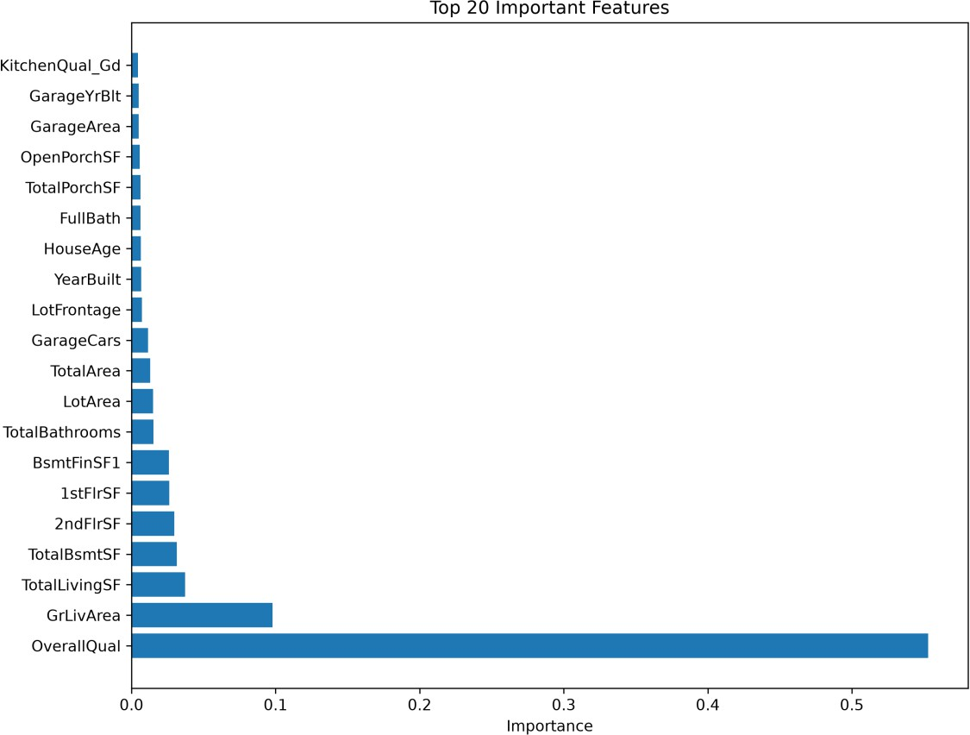

Figure 5: Important Features

Regression Model Comparison:

All models were evaluated using MAE, MSE, RMSE, R² Score and Cross-Validation Score. XGBoost achieved the best overall performance and was selected as the final model.

Advantages and Limitations
Model | Advantage | Limitation
Linear Regression | Simple and fast | Poor on non-linear data
Decision Tree | Easy to interpret | Overfitting
Random Forest | Robust and accurate | Higher training time
Gradient Boosting | High accuracy | Slower training
XGBoost | Highest accuracy | Complex tuning
LightGBM | Fast and efficient | Sensitive to parameters
CatBoost | Excellent performance | Higher computational cost

Business

Recommendations:
- Use XGBoost for house price prediction.
- Retrain the model with new market data.
- Focus on important features such as TotalSF and OverallQual.
- Deploy the model as a Flask web application for real-time predictions.

Phase 8 – Flask Web Application

Overview
The Flask web application provides an interactive platform for predicting house prices, comparing regression models, and exploring analytical insights using the trained XGBoost model.

Dashboard
  - Dataset Overview
  - Model Comparison Summary
  - Performance Metrics

Prediction Module
  - Property Details Input
  - House Price Prediction
  - Prediction Result
  - Important Feature Contribution

Model Comparison
  - Regression Model Comparison
  - Evaluation Metrics
  - Best Model Highlight

Analytics Dashboard
  - Interactive EDA
  - Correlation Heatmap
  - Feature Distributions
  - Feature Importance
  - Residual Analysis

Reports
  - Prediction Report
  - Model Evaluation Report
  - Model Comparison Report
  - EDA report
  - Data Preprocessing Report

Technologies Used
  - Python
  - Flask

  - Pandas
  - NumPy
  - Scikit-learn
  - XGBoost
  - LightGBM
  - CatBoost
  - Matplotlib
  - Seaborn
  - HTML5
  - CSS3
  - Bootstrap 5
  - Git
  - GitHub

Application Workflow

User Input
↓
Data Preprocessing
↓
XGBoost Model
↓
House Price Prediction
↓
Display Prediction

Screenshots

Home dashboard

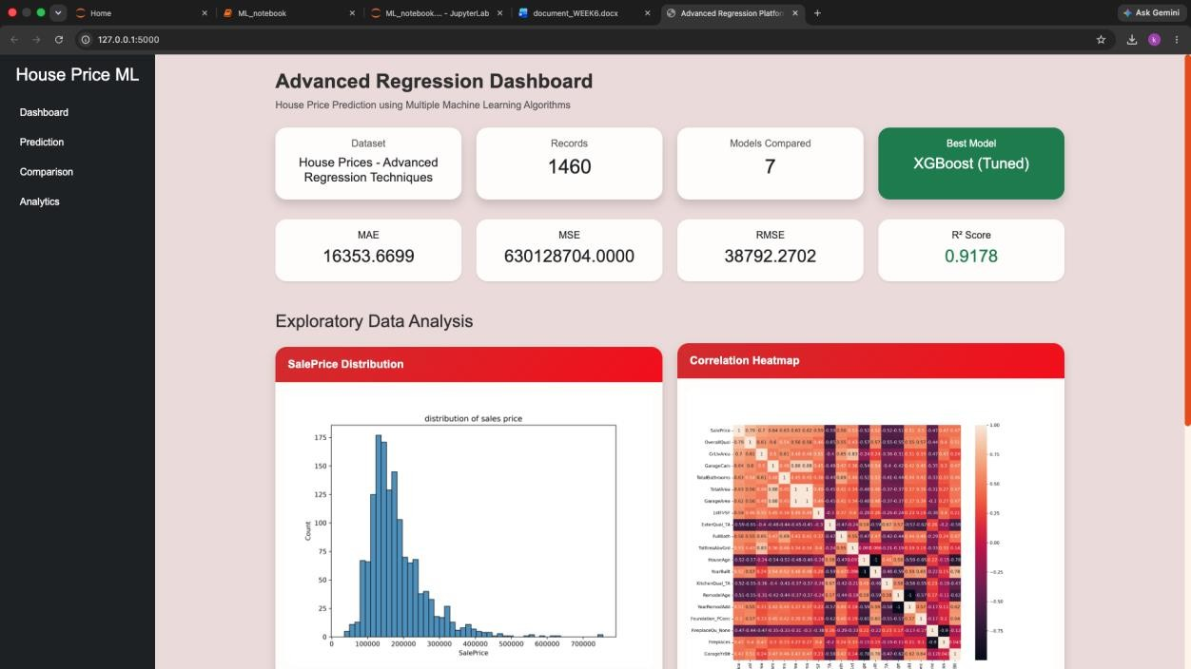

Prediction Page

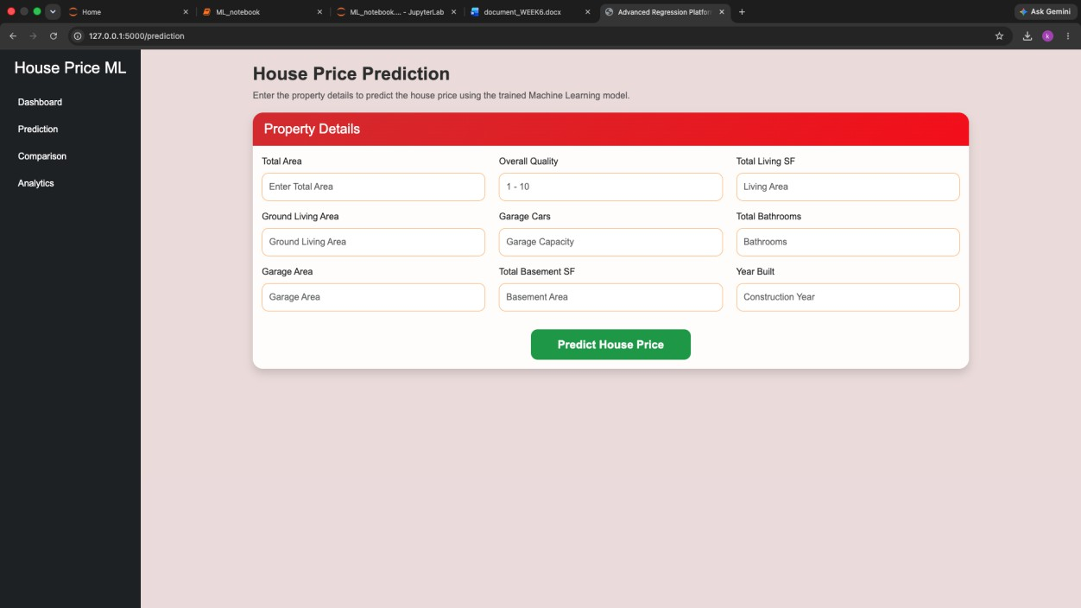

Model Comparison

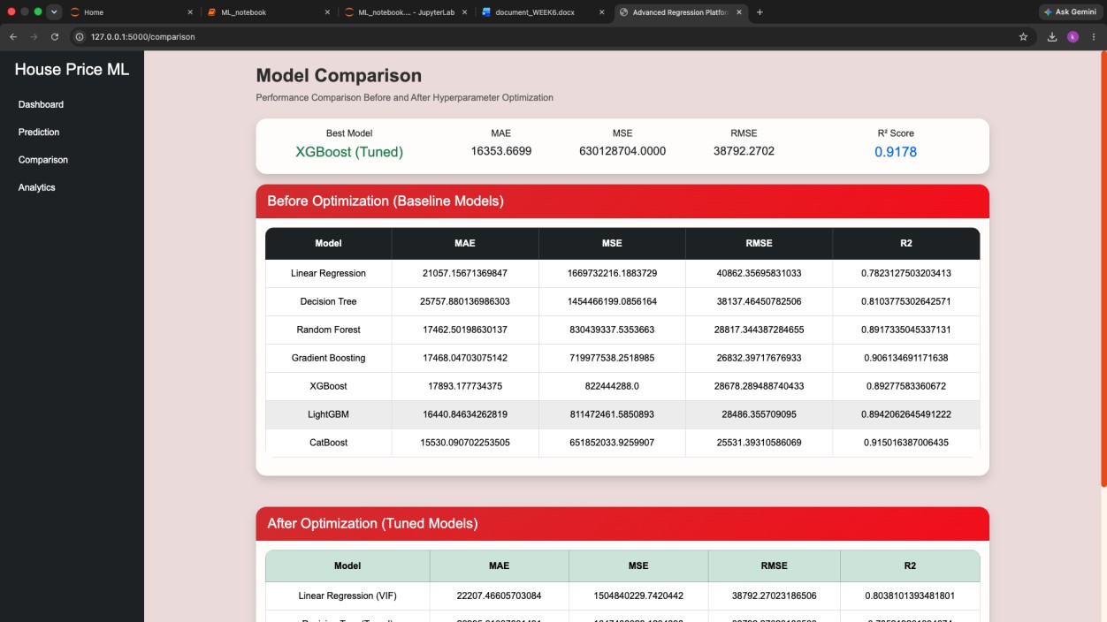

Analytics Dashboard
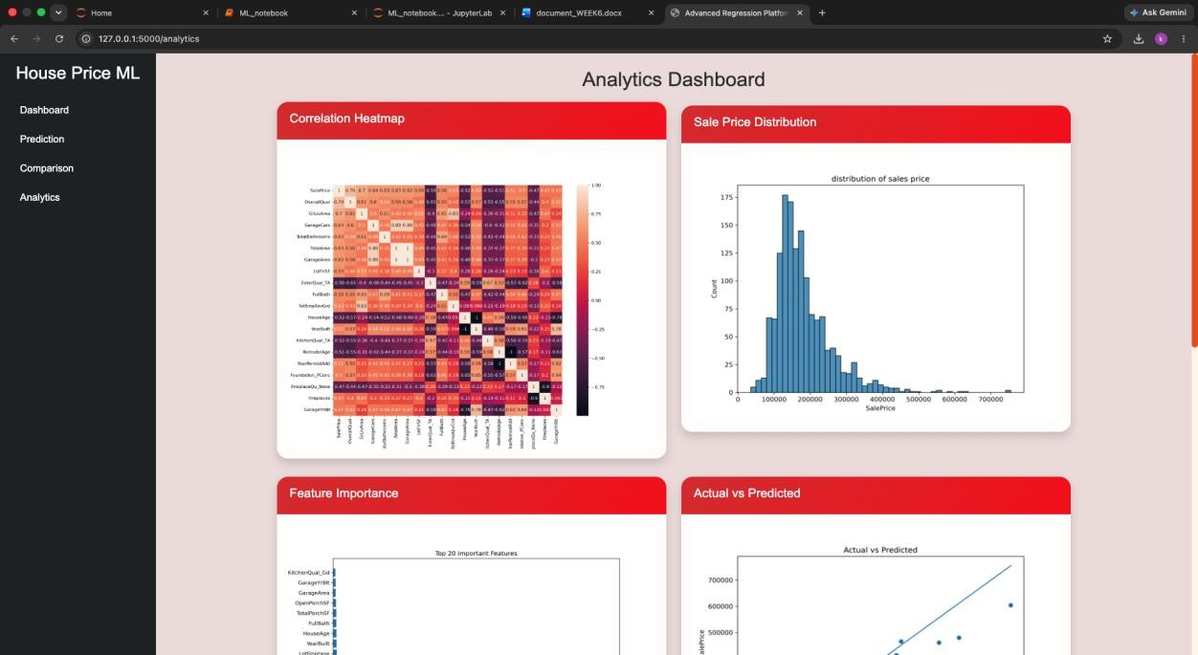

Reports

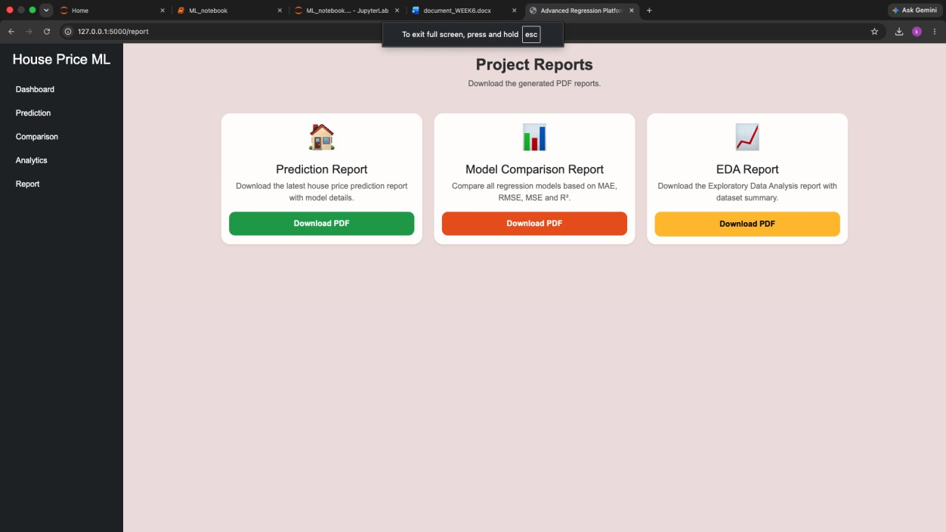

Conclusion
A complete machine learning solution was developed to accurately predict house prices using multiple regression models. After preprocessing, feature engineering, hyperparameter tuning, and performance evaluation, the XGBoost Regressor was selected as the final model due to its superior accuracy.

