Abstract-

India Has 9 Of The World's 10 most-Polluted Cities, But only a few Air Quality Monitoring centers are present here. Researches show that the number of air quality monitoring centers in India per million people is lower than in other highly populated countries in the world. Due to this India’s efforts in improving the air quality index(AQI) is unsuccessful. Despite the number of committees and national programs launched in recent years, the concentration of air pollutants has drastically increased.

The air quality index data is available from 2017 to 2022 with the concentration of the major pollutants like PM2.5, No2, No, So2, CO, Ozone, etc. The main goal is to analyze and interpret which of these pollutants play a crucial role in determining air quality. The period taken for analysis includes both pre-pandemic and pandemic eras, which will lead to an analysis of how the air quality is in India due to the Covid 19 pandemic. A simple Multiple regression model was created to understand the relationship between AQI and other pollutants.

Keywords— Pollution, Pollutant, Pandemic, Regression, Analysis, Air Quality Index(AQI).

Dataset—

The data is extracted from the Indian Government’s database of Air Quality Monitors

https://app.cpcbccr.com/ccr/#/caaqm-dashboard-all/caaqm-landing

I. Introduction

Globally, air pollution is a silent threat. The air pollution levels in India are among the highest in the world, posing a heavy risk to the country's health and economy. Almost all of India’s 1.4 billion people are exposed to unhealthy levels of ambient PM 2.5 – the most harmful pollutant - emanating from multiple sources.

With its size, population, and aggravating air pollution, India needs 1,600 to 4,000 air quality monitors but has only 850, most of which are concentrated in urban areas. This restricts India’s efforts and measures to specific geographical areas. India has reached an alarming stage putting people into greater exposure to respiratory diseases. Over 120,000 people died in India (at least 12,000 in Bengaluru alone) in 2020 as a result of air pollution and related problems, according to the Greenpeace Southeast Asia Analysis of IQAir data.

Clean air is a basic necessity for the sustainable and healthy well-being of humankind and it is the major backbone of the environmental ecosystem. Disruption of air quality will not only affect the environment but will increasingly dominate the health, economy, and agricultural sectors. The emission of poisonous gasses is largely due to industrialization and globalization. It is necessary to balance between growth and the environment.

Impact on Economy

In India, economic losses resulting from premature mortality and sickness due to air pollution totaled US$288 billion (21.4–37.4) and $8.0 billion (5.9–10.3), respectively, in 2019. This cumulative loss of $36.8 billion (27.4%–47.7% of India's GDP) amounted to 1.36 percent of the country's GDP (GDP). The economic loss as a percentage of state GDP ranged 3.2 times amongst states, ranging from 0.67 percent (0.47–0.91 percent) to 2.15 percent (1.60–2.77 percent), with the lowest per-capita GDP states of Uttar Pradesh, Bihar, Rajasthan, Madhya Pradesh, and Chhattisgarh suffering the most. In 2019, Delhi had the biggest per-capita economic loss owing to air pollution, followed by Haryana, with a 5.4-fold difference between the two states.

Impact on health

Air pollution has reached dangerous levels in recent years, and most Indian towns that monitor outdoor air pollution fail to satisfy WHO criteria for tolerable levels of pollution. The concentrations of dangerous carcinogenic substances such as Sulfur Dioxide (SO2) and Nitrogen Dioxide (NO2), as well as PM2.5 and PM10 (airborne particles smaller than 2.5 micrometers in diameter and 10 micrometers in diameter), have reached alarming levels in most Indian cities, putting people at an increased risk of respiratory diseases and other health problems. In addition, the problem of indoor air pollution has put women and children in danger.

Some of the human health hazards related to air pollution either directly or indirectly include respiratory infections, chronic obstructive pulmonary disease, pneumothorax, asthma, allergies, hyperthermia, and dehydration.
The majority of these deaths were caused by household air pollution (0.61 million [0.39–0.86]) and ambient particulate matter pollution (0.98 million [0.77–1.19]). Between 1990 and 2019, the mortality rate due to household air pollution fell by 64.2% (52.2–74.2), whereas the death rate due to ambient particulate matter pollution grew by 115.3% (28.3–344.4), and the death rate due to ambient ozone pollution climbed by 139.2% (96.5–195.8).

Impact on agriculture

Crop yields have suffered and will continue to suffer as a result of rising temperatures caused by higher emissions of long-lived greenhouse gasses (LLGHGs). The other climate changes are caused by short-lived climate pollutants (SLCPs), which have a considerable impact on agricultural production. Black carbon and ozone are SLCPs that affect temperature, precipitation, and radiation, whereas ozone is directly hazardous to plants. According to a recent study by scientists at the University of California, San Diego, "Recent climate and air pollution consequences on Indian agriculture," air pollution induced by Short-Lived Climate Pollutants harms agricultural productivity. They observed that the yield of wheat in 2010 has reduced by almost 36% and that of rice by 20% when compared to figures from 1980, negating climate change. SLCPs such as ozone and black carbon are released into the atmosphere by motor vehicles which remain in the atmosphere for short periods.

Impact on climate change

Climate change causes changes in temperature and precipitation, resulting in severe heat, extreme cold, and unpredictable rain. Extreme weather conditions such as increased temperature, precipitation, increased intensity and frequency of heatwaves, floods, droughts, high winds, and landslides harm human health. These climatic changes also cause water and air-borne infections, vector-borne infections, malnutrition, the incidence of diarrhoeal diseases, and heat-related morbidity and mortality.

Children, the elderly, and city dwellers are more exposed to these health consequences. Nearly 150,000 deaths and about 5 million illnesses have been reported per year due to climate change.

Droughts, floods, tsunamis, and cyclones are all known to be triggered by climate change and have detrimental human health consequences. Human health is harmed indirectly by urban droughts and floods caused by climate change due to a lack of or excess rainfall. In India, severe drought conditions resulted in food scarcity, resulting in a significant number of deaths from famine.

II. Literature Review

A statistical and regression-based model is built using remote sensing data to obtain information on air quality. In areas with sparse vegetation, dense development, and high surface temperature (LST), it has been observed that air pollutant concentrations have consistently increased. A high correlation coefficient of 0. 965 between the total API and API (PM10) indicates that PM10 has a significant impact on the overall air quality of the study area, followed by PM2. 5.

During the total lockdown, most of the sources of poor air quality were stopped in India. An analysis of air quality (particulate matter-PM2. 5, Air Quality Index, and tropospheric NO2) is made over India using ground and satellite observations. Significant reductions in PM2.5 and AQI were seen in Delhi, Mumbai, Hyderabad, Kolkata, and Chennai, and tropospheric NO2 concentrations were also rocked in 2020 compared to the same period observed in 2019. During the lockdown, air quality was significantly improved.

Exposure to ambient air pollution is a major threat to human health in most Indian cities. More than three-quarters of people in India are exposed to pollution levels higher than the limits recommended by the National Ambient Air Quality Standards. Despite the poor air quality, the monitoring of air pollution levels is limited even in large urban areas. The findings are important for framing state and regional level policies for addressing air pollution problems in cities. local and regional levels.

Air pollution and its prevention are still huge global problems. Many efforts are done to understand and predict the air quality index. This paper is one scientific contribution toward this challenge. Comparing four simple machine learning algorithms, k-nearest neighbor, decision tree and DT algorithm have maximum accuracy of 78.0%.

The global commercial and transportation activity has been drastically reduced as a result of the lockdown response to coronavirus disease (COVID-19) using satellite data and over 10,000 air quality stations. We find declines in population-weighted concentrations of ground-level nitrogen dioxide (NO2) and fine particulate matter (PM2.5) with marginal increases in ozone (O3) in 34 countries after accounting for meteorological variability.

Air pollution is believed to be one of the leading causes of death in the world. Bangalore is one of India's fastest-growing metropolises and has a rapidly deteriorating environment. This paper provides a critical analysis of the air pollution trend in the city over the period 2005-2011. It also discusses the potential health implications of exceeding levels of pollutants where these are applicable.

In 2016-2017, the air quality in Delhi deteriorated at an alarming rate due to rising levels of contaminants in the ambient air. The contaminants were analyzed using data analysis techniques to forecast future air quality. Sulfur dioxide (SO2), nitrogen dioxide (NO2), suspended particulate matter (PM), ozone (O3), carbon monoxide (CO), and benzene have all been studied and their future patterns predicted using descriptive and predictive analysis.

III. Motivation
Air pollution is one of the major concerns in India. It is important to maintain a pollution-free environment which is essential both in terms of human health and the country's economy.

The dataset taken for analysis is a time-series dataset so the main objective of the project is to analyze the variation in the concentration level of the pollutants over 5 years.
After data mining (from govt site) the data set was cleaned and missing values were imputed with the mean of the column so that there is no change in the statistical parameters. Data visualization was carried out using a tableau and four main cities of India were compared based on their air quality. significant results were drawn from the visualizations. The air quality index is a parameter that gives an overall value for air quality. To determine how the air quality index is affected by different pollutants, we used a simple multiple regression model.

IV. Methodology
Visualization:
- The concentration of the pollutants over different years was visualized and compared.
- To understand the effect of the pandemic on air pollution in India charts were built.
Multiple regression
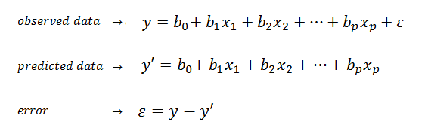
- Importing libraries and dataset
- Performing means imputation and handling missing data by analyzing the structure and columns present in the dataset.
- Determining the independent variables (PM2.5, NO2, NH3, CO, SO2, OZONE) and dependent variable(AQI).

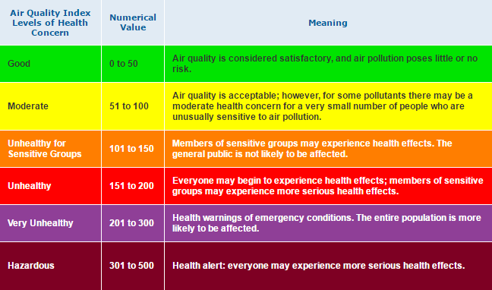
- Dividing the dataset into x train, y train and x test, y test using train test split library in python.
- Training the model by giving y train and x train as input.
- The regression coefficients are calculated for each pollutant concerning the AQI value.
- Y predict is calculated on the x test dataset and the actual and predicted value is compared.
- Regression score, accuracy, standard deviation, mean absolute error, mean squared error, and root mean squared error is calculated.

V. Data Visualization
Overview of changes in the quality of air over the years 2017-2022 in the 4 cities
From Fig 1,2,3 and 4, it is evident that over the past 5 years the level of pollutants in the air dripped during the period of lockdown due to the pandemic in all of the cities.
.

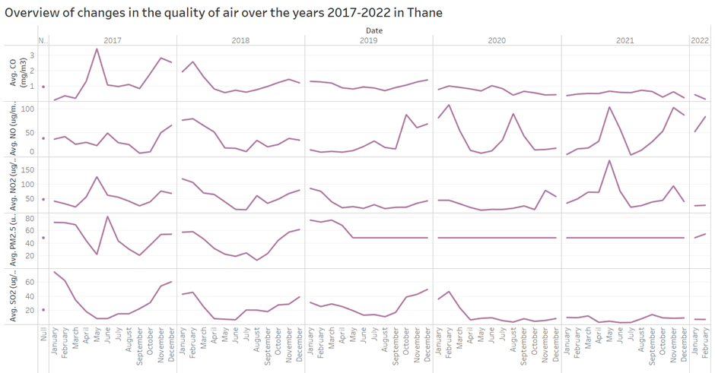Fig 1:Thane
No significant drop during mid-2020 while the other pollutants also showed some drop

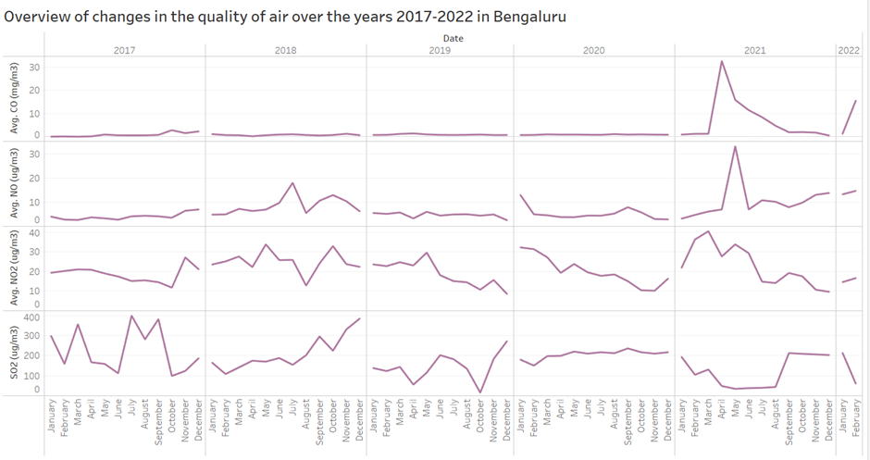
Fig 2: Bangalore

There is no major change in the pattern but compared to the other years 2020 has shown a less average concentration of pollutants.

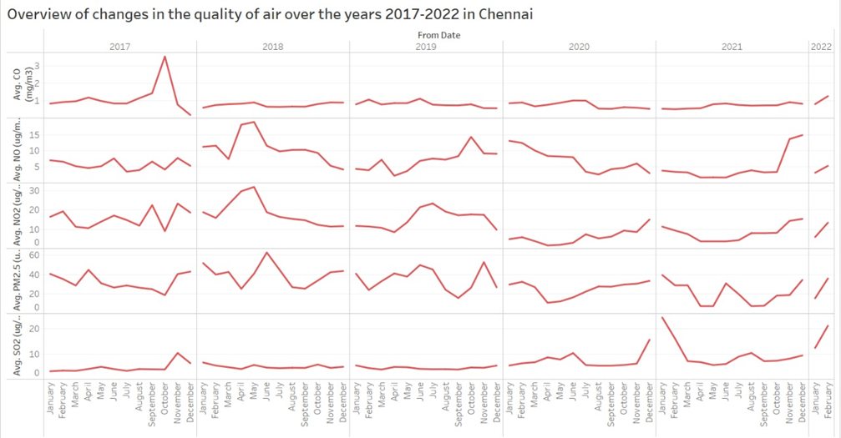
Fig 3: Chennai

Unlike the other years, there is no sharp rise in the number of contaminants present in the air during the start of the curfew.

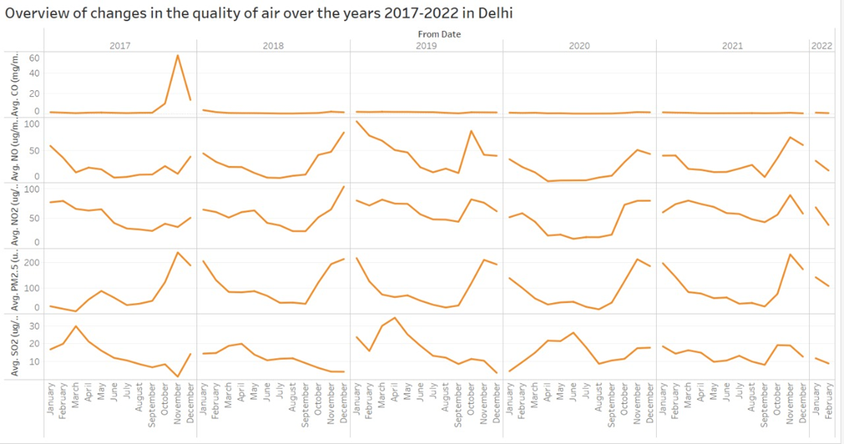
Fig4: Delhi

Delhi being the most polluted city in India didn’t show much variation in the quality of air but some pollutants did get lesser in amount during the pandemic

PM2.5 level before and during the pandemic

Since Thane has a lot of missing data, we cannot infer from it precisely but it is apparent in the other cities that the PM2.5 level came down, especially in mid-2020(when strict curfews were imposed). PM10 has a significant impact on the overall air quality of the study area, followed by PM2.5.

Hence, we have considered the same and tried to show its variation in concentration in the air before the pandemic came into the picture and during the pandemic situation in all the cities. Figures 5-12 show the same.

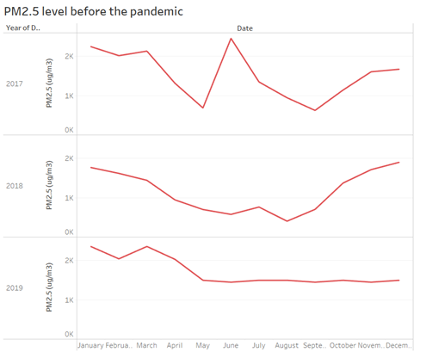

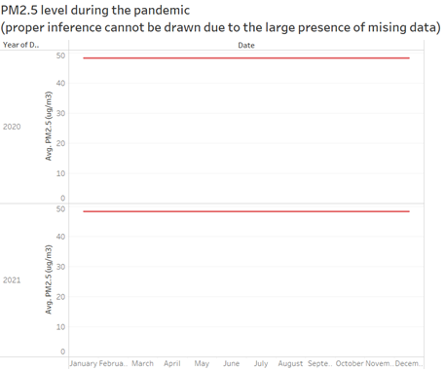Fig 5&6: Thane
An accurate inference could not be made since there are a lot of missing values in the data taken for the city of Thane.

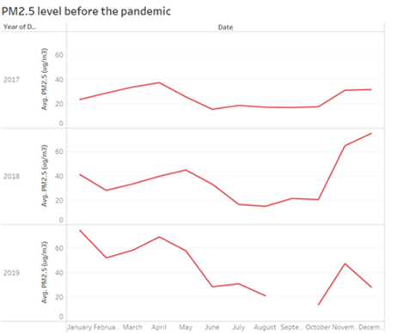
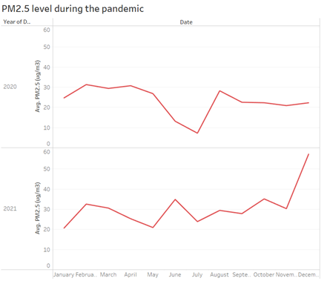
Fig7&8: Banglore
As visible from the second visualization there was a sharp decrease in the pollutant level in 2020.

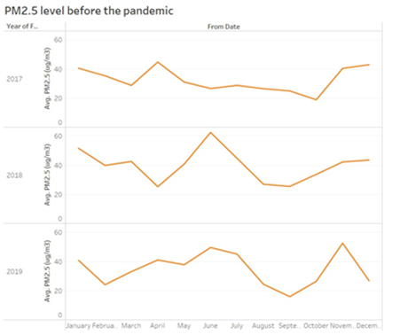
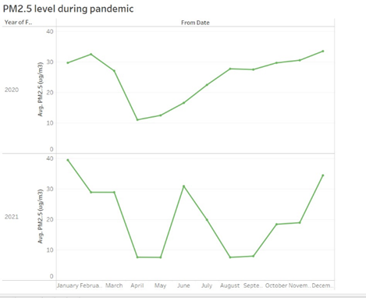
Fig 9&10: Chennai
The a sharp drop in the number of pollutants in the year 2020.
Delhi
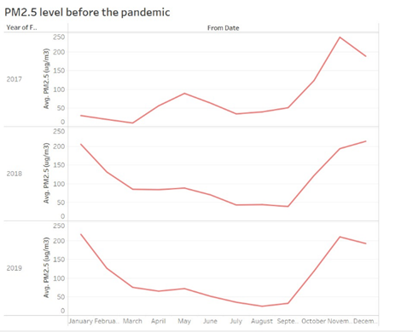
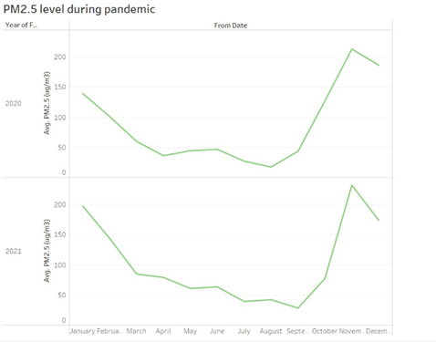
Fig 11&12: Delhi
During the pandemic in the years 2020-21 there has been a better quality of air until the winter season.
Variation in the concentration of pollutants over the months of the year 2019
It is observed that during the summer the cities have a bad quality of air which seems to get better during the mid-year, until September – October when there is a significant increase in the number of pollutants. Surprisingly, this pattern is the same for all the cities. Figures 13, 14,15, and 16 show this pattern.
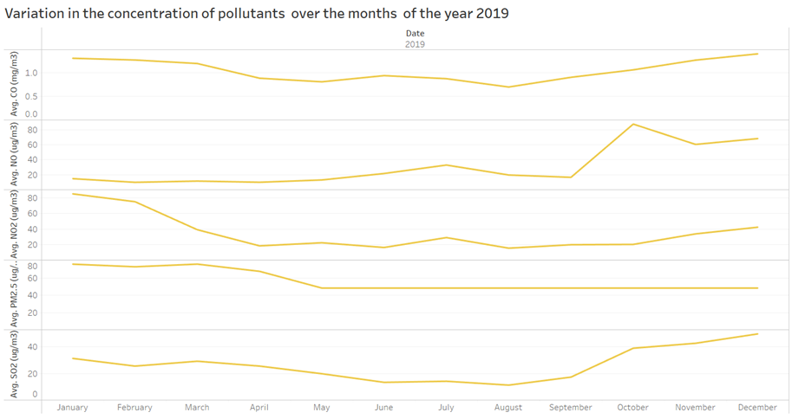
Fig 13: Thane
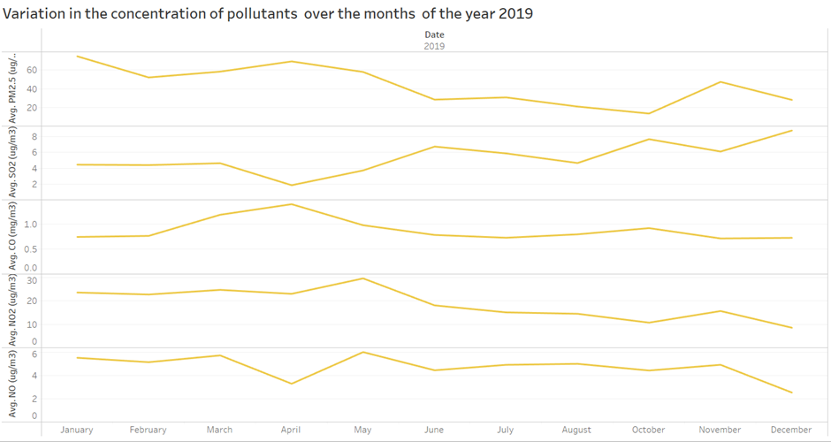Fig 14: Bangalore
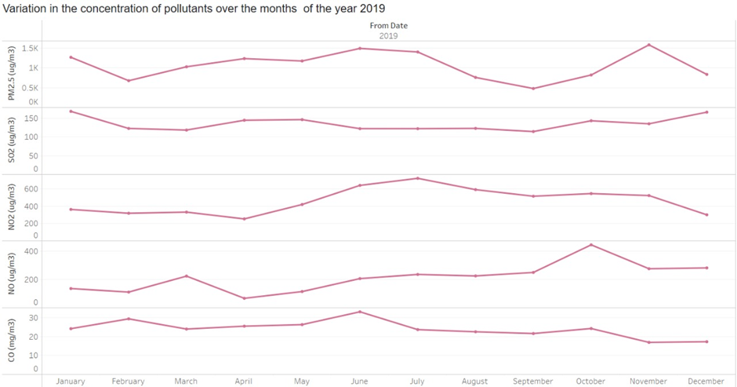
Fig 15: Chennai
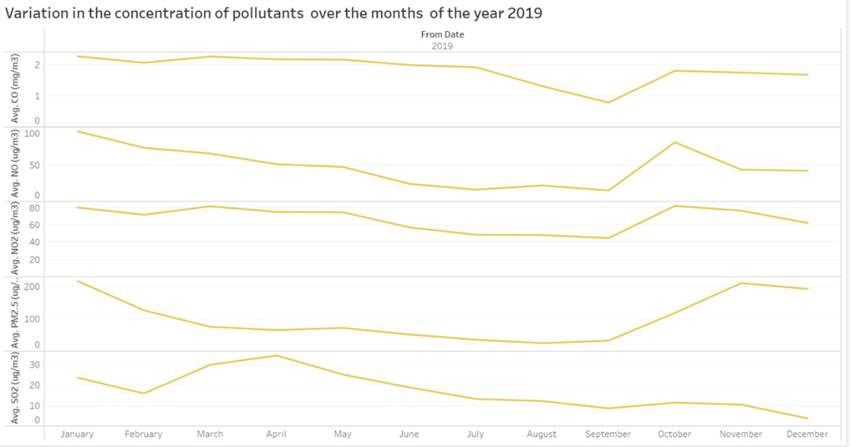Fig 16: Delhi
Analyzing the pollutants which are of the highest and lowest concentration over the taken period
In figures 17-20 we tried to show the average amount of all pollutants in a year over the years 2017-2022 to find out which pollutant is present significantly and which one seems to be minimum. For all the cities PM2.5 was the most prominent pollutant and CO has the least impact.
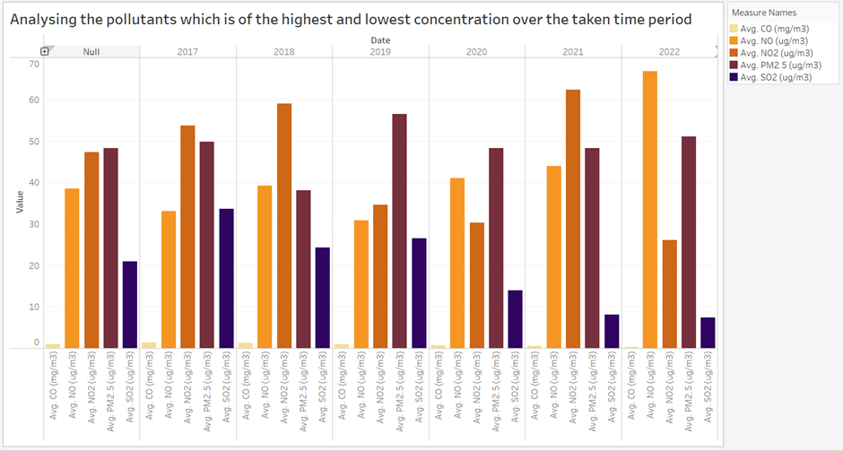
Fig 17: Thane
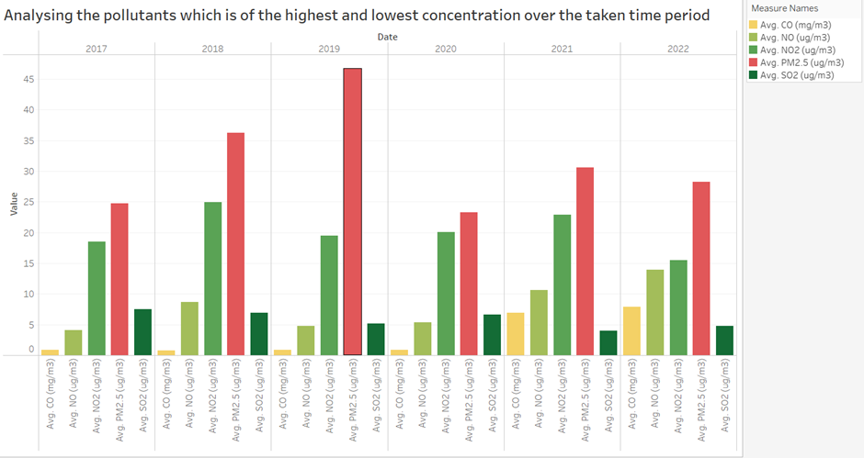
Fig 18: Bangalore
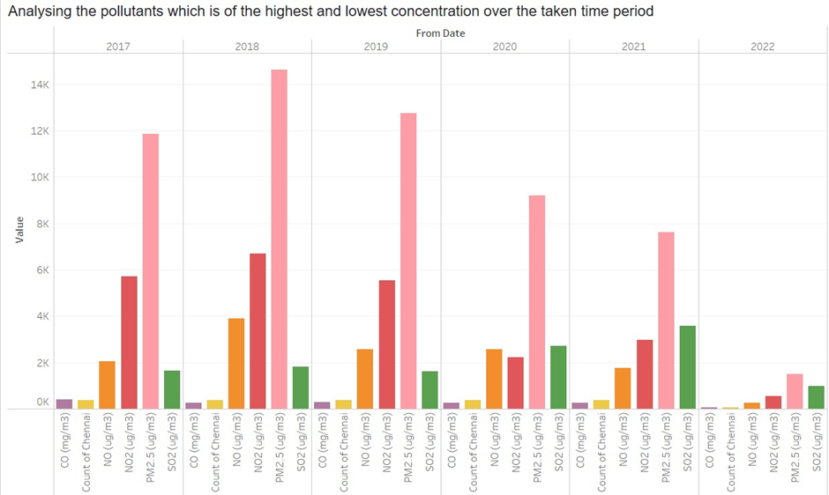
Fig 19: Chennai
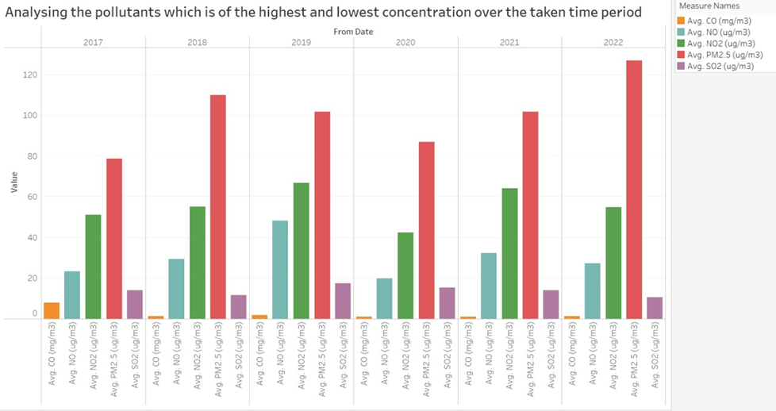
Fig 20: Delhi
The contrast between the pollutants which are observed to be the highest and least in concentration (based on the previous visualization)
At last, from analyzing and interpreting the pollutants which impact the quality of air the most and least. We showed the disparity between the two by visualizing the average concentration of each contaminant each year in figures 21-24.
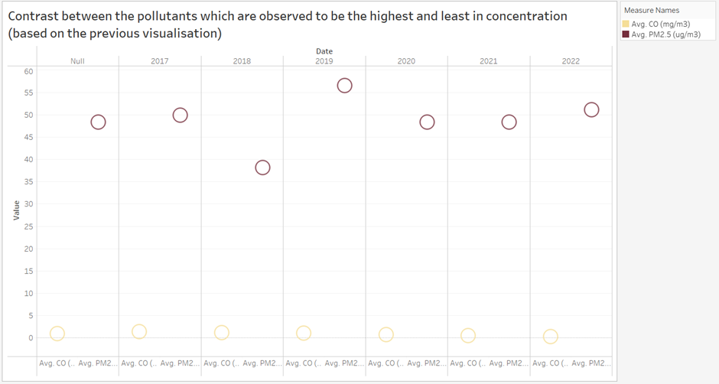Fig 21: Thane
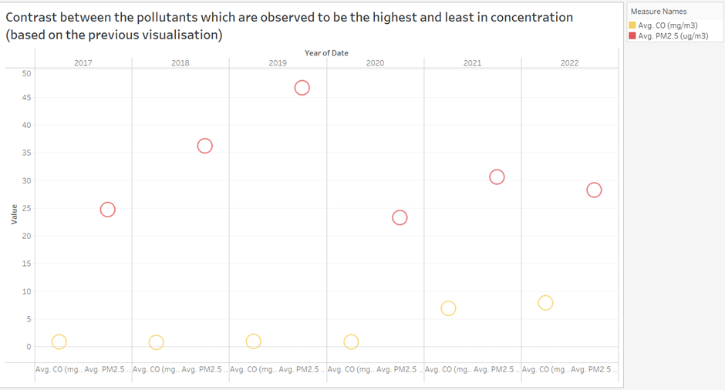
Fig 22: Bangalore
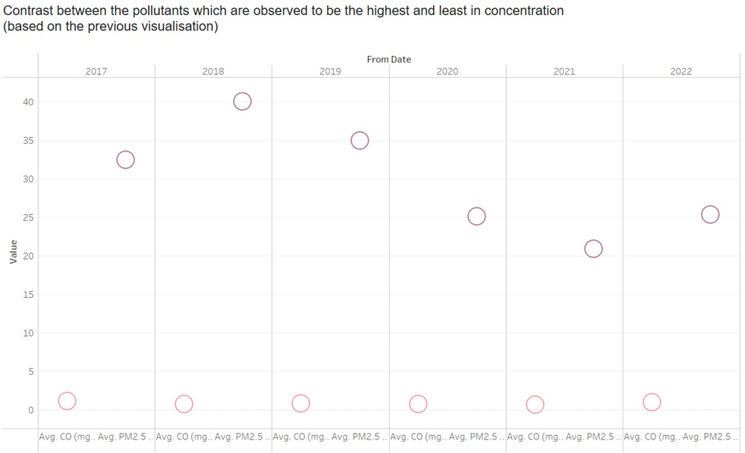Fig23: Chennai
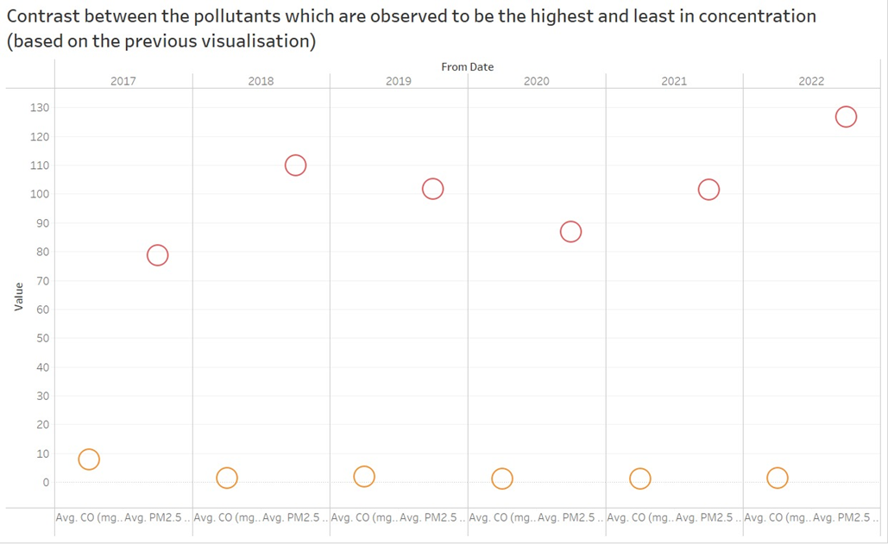
Fig24: Delhi
Tableau Public Link:
https://public.tableau.com/views/ivprojectbengaluru/Sheet6?:language=en-US&publish=yes&:display_count=n&:origin=viz_share_link
https://public.tableau.com/views/ivprojectthane/Sheet3?:language=en-US&publish=yes&:display_count=n&:origin=viz_share_link
https://public.tableau.com/views/Ivproj-chennai/Sheet6?:language=en-US&publish=yes&:display_count=n&:origin=viz_share_link
https://public.tableau.com/views/ivprojectdelhi/Sheet6?:language=en-US&publish=yes&:display_count=n&:origin=viz_share_link

VI. Multiple regression
Multiple regression is a statistical method for analyzing the correlation between multiple independent variables and a single dependent variable. The goal of multiple regression analysis is to predict the value of a specific dependent variable by using known independent variables.
Coefficient of regression
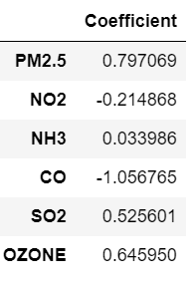
The actual and predicted value
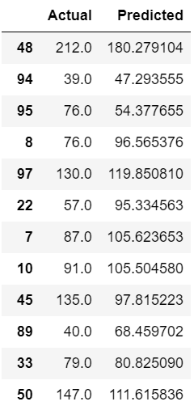
Regression score
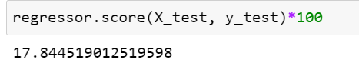
Accuracy and Standard deviation score
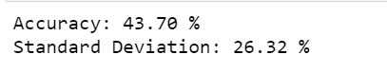
Accuracy is around 40% because of the missing data or due to the inconsistency pollutant concentration, which is certain in huge data sets.
Errors
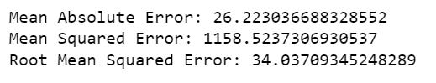
VII. Conclusions
The pandemic situation has made a huge impact on the world in many ways and one such thing is the quality of air. Curfews reduced the amount of pollution from vehicles used for travel and from factories and industries due to which AQI was good in all of the major cities. On no account has the quality of air improved in the past few decades and only did the pandemic could make a difference. We tried to analyze and show this shift through various visualizations using the acquired datasets for various cities in India from 2017-to 2022, and also those contaminants which seem to be significant. From the multiple regression model, we were able to analyze that there is no direct way to understand the dependency of pollutants on each other. Though the model has 40% of accuracy it is not much effective in real-time scenarios. Better models have to be created to predict and evaluate air quality in India. New methodologies and technologies should be involved consistently to maintain the air quality which is the need of the hour.

VIII. References

- Estimation of Air Pollution Using Regression Modelling Approach for Mumbai Region, Maharashtra, India
Maya Kumari, Shivangi S. Somvanshi, and Syed Zubair
September 2020

- Impact of lockdown on air quality in India during COVID-19 pandemic-Ramesh P. Singh & Akshansha Chauhan-7 July 2020

- Ambient air pollution in selected small cities in India: Observed trends and future challenges- Girish Agrawal, Dinesh Mohan Hifzur, Rahmanb- 26 March 2021

- Air Quality Index Prediction Using Simple Machine Learning Algorithms -Kostandina Veljanovska1, Angel Dimoski-1, January - February 2018

- COVID-19 lockdowns cause global air pollution declines- Zander S. Venter, Kristin Aunan, Sourangsu Chowdhury, and Jos Lelieveld- April 2020

- Air Pollution in Bangalore, India: A Six-Year Trend and Health Implication Analysis- A.K. Chinnaswamy1, R.N.G. Naguib2, Q.T. Nguyen2, L.O. Olayanju1, N. Trodd3, I.M. Marshall1, N. Yaacob1, G.N. Santos4, E.A. Vallar4, M.C. Galvez4, M.H. Shaker5 and T.N. Ton6-November 2014

- Forecasting air pollution load in Delhi using data analysis tools.-Nidhi Sharmaa, Shweta Tanejab*, Vaishali Sagarc, Arshita Bhattd-2018

