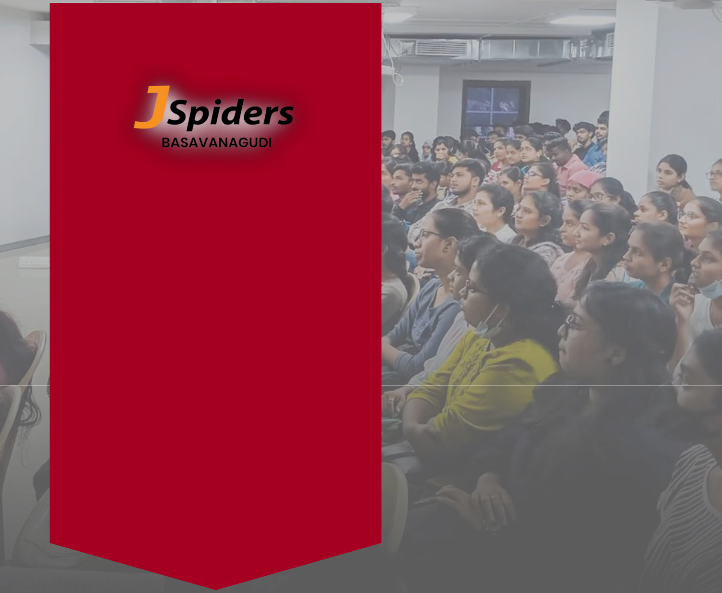

-------------------------------------

BROCHURE

-------------------------------------

18, Brigade Seshmahal,

Vasavi Temple St, V V puram,

Basavanagudi, Bengaluru,

Karnataka 560004

ABOUT JSPIDERS

THE WORLD’S LARGEST JAVA TRAINING ORGANIZATION

JSpiders is the world’s ace software course training organization with an aim to bridge the gap between the demands of the industry and the curriculum of educational institutions.

With centers across the Globe, the institute is a platform where young minds are given the opportunity to build successful careers.

” JSpiders is a place where businesses find
talent and dreams take flight."

About Jspiders Basavanagudi

Courses & Syllabus

Placement Activities

New Batches

Placement Statistics

Testimonials


ABOUT

JSPIDERS BASAVANAGUDI

- Jspiders originated in Basavanagudi

- Lakhs of students got job from Jspiders Basavanagudi.

- Courses are designed separately for freshers & experienced candidates.

- Very close to City Bus Stand, KSRTC Bus Stand & Railway Station.

TRAINERS
- Trainer team is led by senior most trainer having 20+ years in teaching.

- Trainer team is blended with experienced trainers, senior trainers and junior trainers.
- Dedicated mentoring team to nurture skills in students.

- Consultant from industry helps students to increment project & understand the concept in real time.
- Dedicated trainer team for weekend batches.

- Refreshing class / back up class facility.

INFRASTRUCTURE
- One of the biggest training centers in India.

- The premises consists of 7 big classrooms.

- Three classrooms with internet facility.

- 5 small classrooms.

- One open auditorium class.

- One big study center.

- More than 700 bike parking facility.

2


COURSES & SYLLABUS
DURATION: 4 - 5 MONTHS

 | JAVA FULL STACK |  | MERN STACK
➢ Core Java |  | ➢ Java till oops concept
• Basics of Java & Programming. |  | ➢ SQL
• | Object oriented programming | ➢ Web Technology
 | system (oops) | • | HTML & CSS
• | Java Library | • | JavaScript
➢ SQL |  | ➢ MongoDB
➢ Web Technology |  | ➢ Express JS
• HTML & CSS (Online, offline |  | ➢ React JS
 | (or) material) | ➢ Node JS

  - Basics of Java Script
- Frameworks
  - Springs framework
  - Hibernate

DEVOPS

- Core Java

  - Basics of Java & Programming.

  - Object oriented programming system (oops)
  - Java Library

- SQL
- Web Technology
  - HTML & CSS
  - Basics of Java Script

- Linux O S

- Virtual machines
- Git (Version control system)

- Maven (Build automation tool)

- Junit (Testing frameworks)

- AWS (Cloud computing)

- Ansible (Automation, configuration &
management tool)

- Dockers, Kubernetes & Jenkins –
CICD pipeline (Deployment Automations)

- Bash script, Groovy script, XML

ADVANCE COURSE

JAVA FULL STACK WITH LIVE PROJECT

FRONTEND | BACKEND
HTML | Java
CSS | SQL & PLSQL
SASS | Advance Java
JavaScript | Hibernate
ECMAScript | Spring MVC
Bootstrap | Spring Boot
React JS | Spring IOC
React Material UI | Web Services

2 Full Stack Corporate Projects

DEVELOPMENT TOOLS
- Git

- GitHub

- Bitbucket

- Jenkins

- Maven Tool

- Postman

- Junit

- VScode

- API

- Eclipse

AWS CLOUD COMPUTING

- Version controls
- Linux commands
- ➢ Jenkins, Dockers, Kubernetes s/w tools

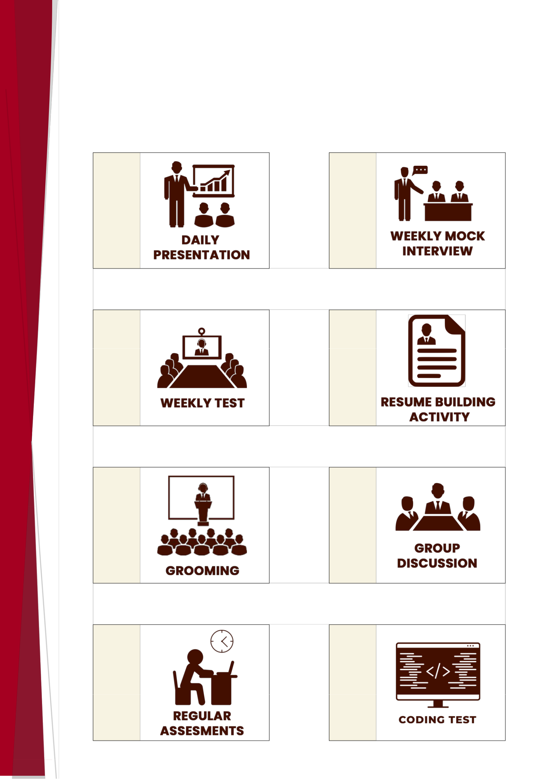
PLACEMENT RELATED ACTIVITIES

1 2

3 4

5 6

7 8

4

NOVEMBER MONTH NEW BATCHES

WEEKDAY

DATE | TIME
03-11-2022 | 11:30 AM
07-11-2022 | 11:30 AM
10-11-2022 | 11:30 AM
14-11-2022 | 11:30 AM
17-11-2022 | 11:30 AM
21-11-2022 | 11:30 AM
24-11-2022 | 11:30 AM
28-11-2022 | 11:30 AM
WEEKEND
DATE | TIME
05-11-2022 | 2:30 PM
12-11-2022 | 2:30 PM
19-11-2022 | 2:30 PM
26-11-2022 | 2:30 PM

EVENING

DATE | TIME
02-11-2022 | 6:30 PM
09-11-2022 | 6:30 PM
16-11-2022 | 6:30 PM
23-11-2022 | 6:30 PM
30-11-2022 | 6:30 PM

*Same for all courses

5

OCTOBER MONTH
PLACEMENT STATISTICS

Civil/Mechanical Stream Students

NAME | COMPANY CODE | PACKAGE
Pramod | DEA1022JSP01 | 6.5 LPA
Srinath | DEA1022JSP01 | 6.3 LPA
Susheel Tatuskar | SCR1022JSP01 | 6 LPA
Katari Pavan | MBA1022JSP01 | 5.5 LPA
Dheeraj Rathod | TOR1022JSP01 | 5 LPA
Madan Gowda | WIL1022JSP01 | 5 LPA
Manu T D | LOG1022JSP01 | 4.2 LPA
Nikhilsagar T C | AMA1022JSP01 | 4.15 LPA
Harish s | TOR1022JSP01 | 4 LPA
Ravi Teja | IDE1022JSP01 | 4 LPA
 | And more…

ECE/EEE/EIE Stream Students

NAME | COMPANY CODE | PACKAGE
Megha N Y | BRI1022JSP01 | 6.79 LPA
Pooja H S | ACC1022JSP01 | 4.2 LPA
Manoj S | RED1022JSP01 | 4 LPA
Padmavathi R B | BUF1022JSP01 | 3.5 LPA
Vijaykumar G N | MEG1022JSP01 | 3.5 LPA
Pratibha | NIN1022JSP01 | 3.5 LPA
Pratika Sharma | PLA1022JSP01 | 3.5 LPA
Akshay V | SMA1022JSP01 | 3.5 LPA
Ganesh G | SOL1022JSP01 | 3.5 LPA
Yashoda R | HEA1022JSP01 | 3 LPA
6 | And more…


CSE/ISE/IT Stream Students

NAME | COMPANY CODE | PACKAGE
S Madhu Sudhan | CAP1022JSP01 | 5 LPA
H S Darshini | TEK1022JSP01 | 5 LPA
Chaya. V | AEY1022JSP01 | 4.8 LPA
Darshan S N | THO1022JSP01 | 4.8 LPA
Rakesh C | HCL1022JSP01 | 4.25 LPA
Bhavana MA | NIN1022JSP01 | 4 LPA
Shashi Kumar A | SCR1022JSP01 | 4 LPA
S | SCR1022JSP01 | 4 LPA
Golla vivek | COV1022JSP01 | 3.6 LPA
Himadrish | QNA1022JSP01 | 3.5 LPA
Aralere | QNA1022JSP01 | 3.5 LPA
Deepika B S | SLK1022JSP01 | 3.5 LPA
 | And more…

BCA/BSc/MCA/MSc/Other Stream Students

NAME | COMPANY CODE | PACKAGE
Siddu Naykar | NIN1022JSP01 | 5 LPA
Niranjan K | WIP1022JSP01 | 4 LPA
Meghana Reddy | HAS1022JSP01 | 3.65 LPA
Shubha S R | REA1022JSP01 | 3.6 LPA
Adarsha S S | IMS1022JSP01 | 3.5 LPA
Aruna Kumar M | IOL1022JSP01 | 3.5 LPA
Unnathi. R. Bhat | AVA1022JSP01 | 3 LPA
Sameer | HYN1022JSP01 | 3 LPA
Chandra Sekhar | PAR1022JSP01 | 2.5 LPA
Vinod Kumar T | PAR1022JSP01 | 2.5 LPA
 | And more…

7
FEW TESTIMONIALS
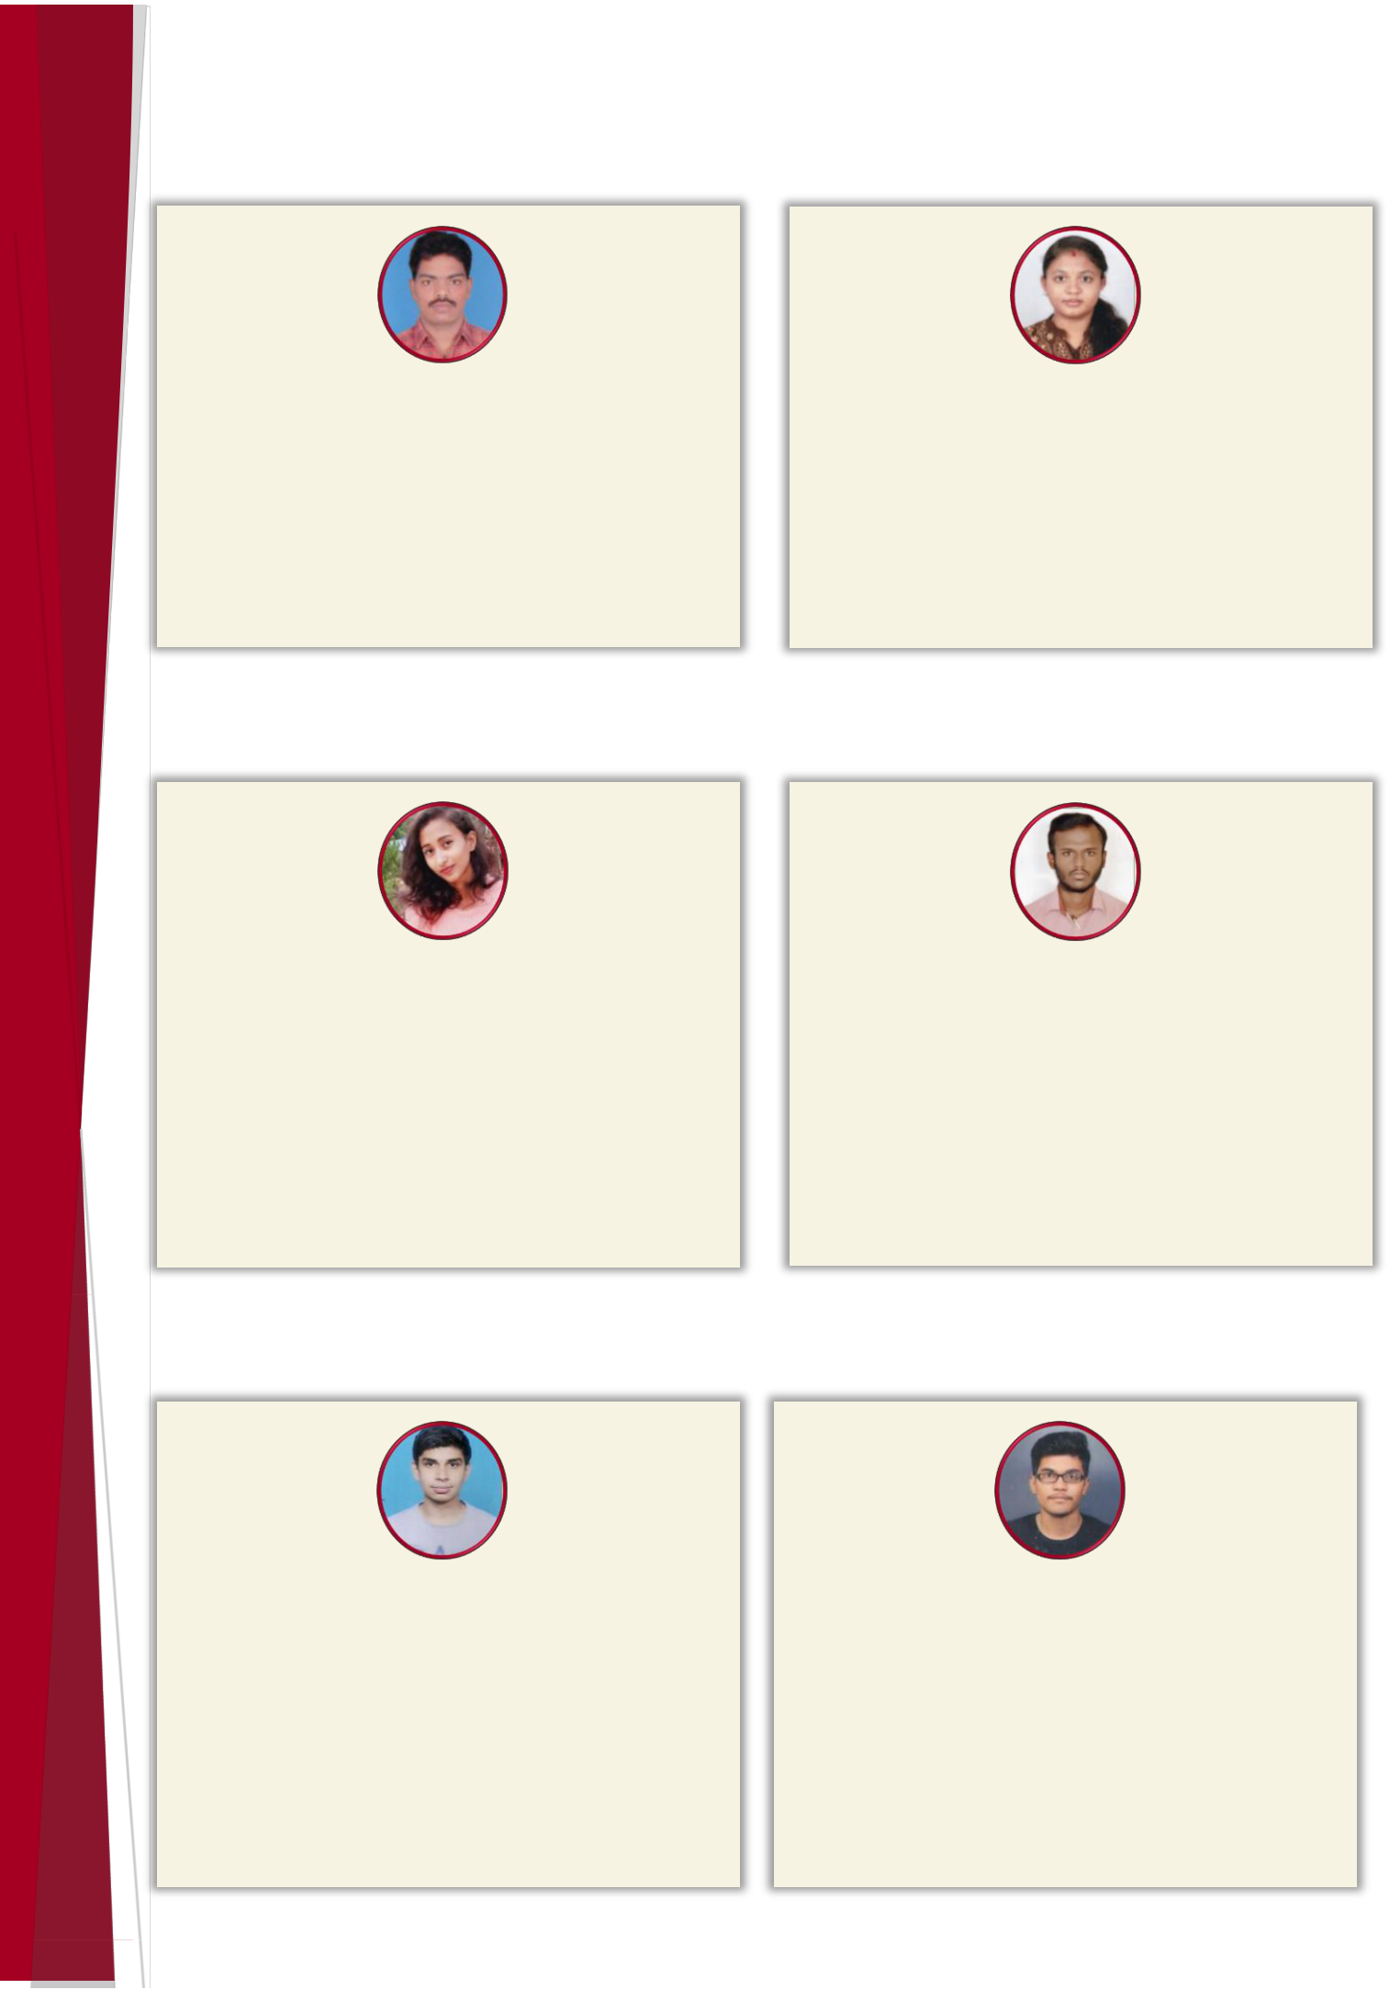

KATARI PAVAN

(Java Full Stack)
B. Tech – Civil
“All technical skills were taught very smoothly and

everything was easy when I started training at

JSpiders Basavanagudi.
I have got placed as a technical support engineer

with 5.5 LPA package.”

MEGHA N Y

(Java Full Stack)
BE - ECE
“Fabulous faculties they clear all the doubts at any point of time. They make sure students are perfect with concepts and make lots of revision activities. Mocks and test made us learn more and keep the concepts strong. Finally, I got placed with 6.79

LPA package.”

Himadrish Aralere
(MERN)
BE – ISE

“Syed sir helped me in gaining knowledge in JavaScript. This helped me to get my dream job as a frontend developer. JSpiders HRs helped me get companies. I got placed with 3.5 LPA package in a good MNC.”

UNNATHI R BHAT
(Java Full Stack)
BCA - CS
“JSpiders Basavanagudi is a great place to gain practical knowledge which we lack even after getting immense theory knowledge from colleges. I got placed with 3 LPA package.”

VARUN KUMAR M N
(Advance Course)
BE - Mechanical

“I am 2019 pass out. Syed sir and Navaneeth sir helped a lot. They gave in-depth knowledge on java, SQL and JavaScript. Navaneeth sir motivated me a lot and gave lot of support. It helped a lot to clear interview. Thanks to all JSpiders faculty for providing such amazing knowledge. I got placed with 3 LPA.”

SUSHEEL S TATUSKAR
(DevOps)
BE – Civil

“Good platform to gain the knowledge about Java, SQL, Web, and DEVOPS. Shariq sir taught me with core concepts of DEVOPS. Thank you Uday sir for teaching JAVA concepts and programming. I got placed with

4 LPA package.”

8

FOR MORE INFORMATION


CONTACT US ON

- 9686114422

- 9686995511

- 9740499385

- 9686949964

FOLLOW US ON

jspiders_basavanagudi Jspiders Basavanagudi JSPIDERS - Java Learning Platform  JSpidersBasavanagudi

9

